For immediate distribution

Powersoft Returns to NAMM with Training Sessions for New Armonia Version 2.11 and Full Range of Amplification Products

Marketing Initiative with Smaart® to Provide Training Session Attendees
with Software Discount Coupon

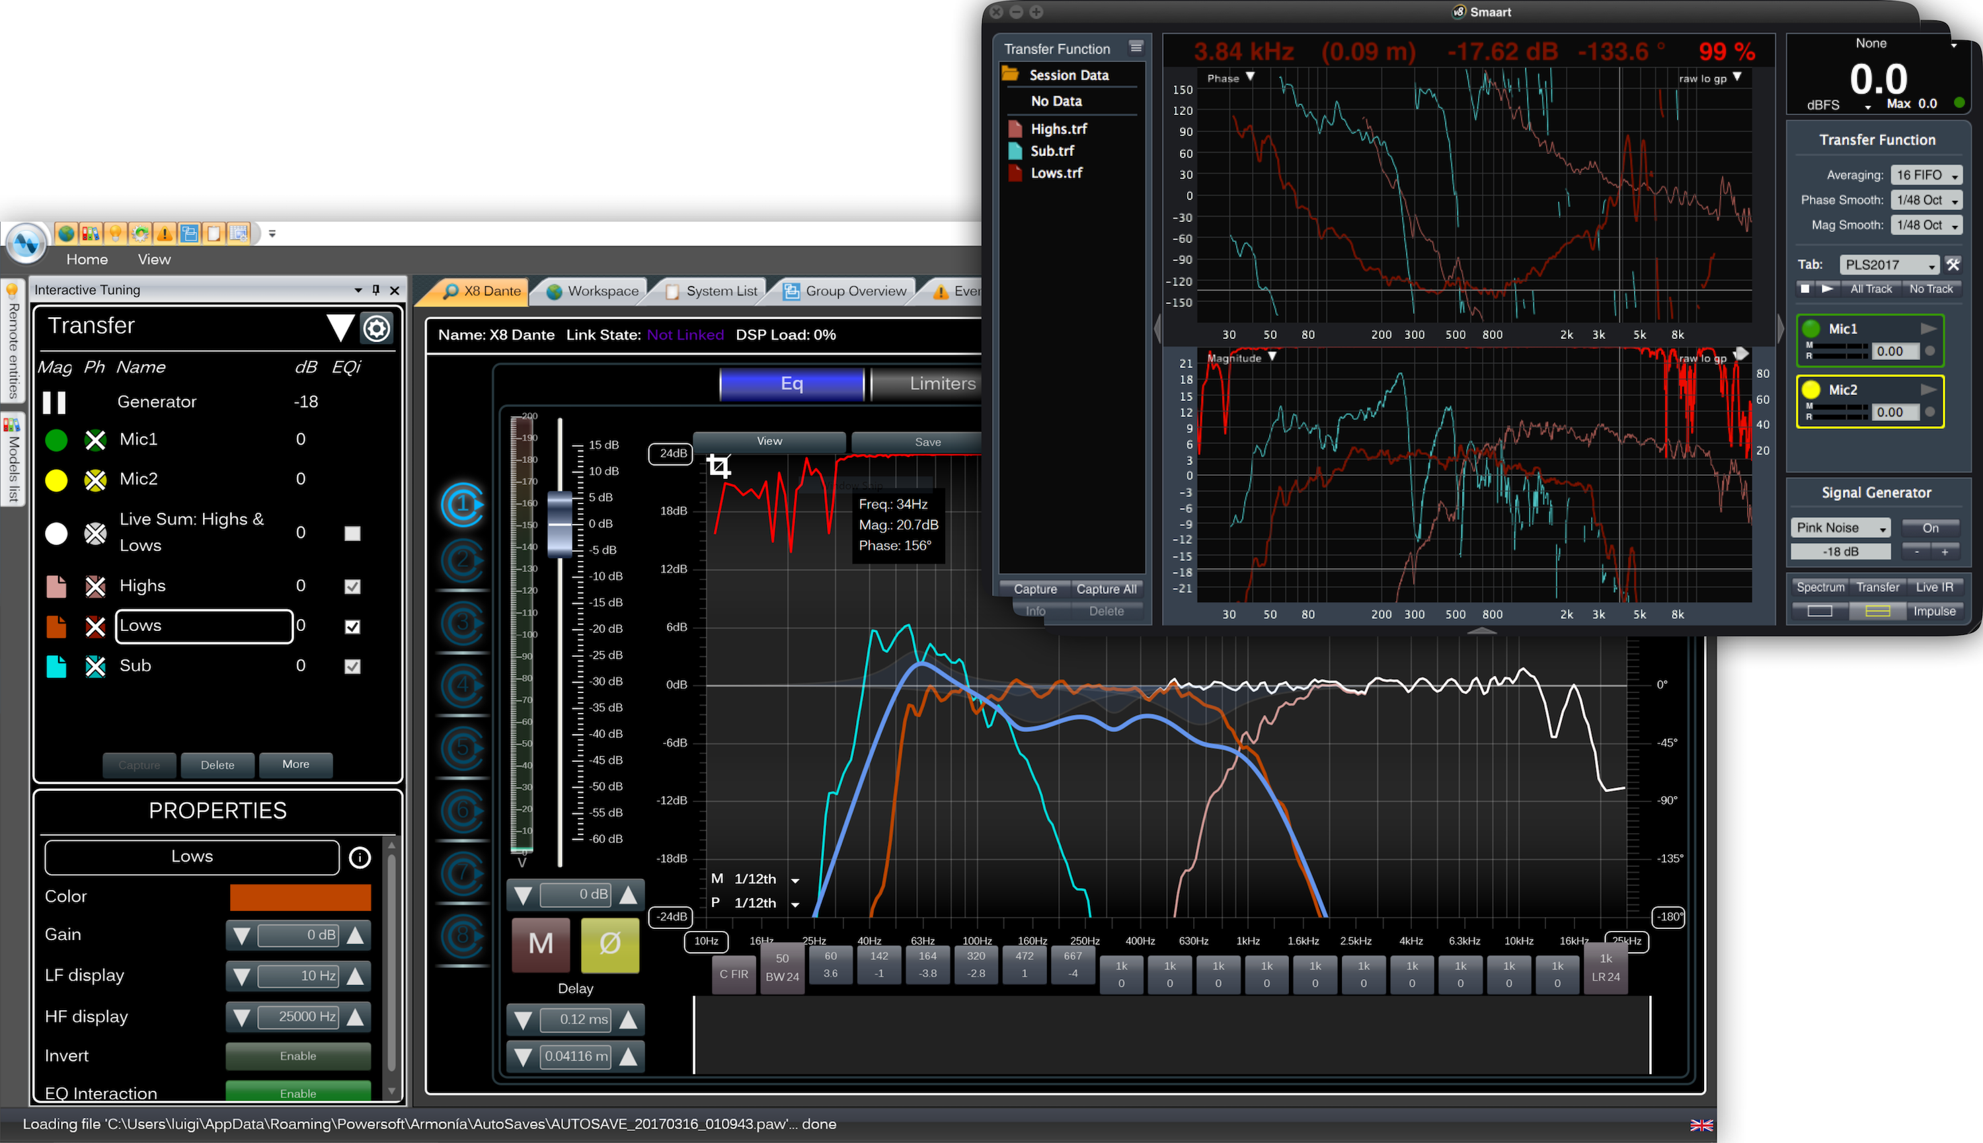
Anaheim, CA – January 16, 2018 – Powersoft [Booth 17701, Anaheim Convention Center], the world leader in lightweight, energy-efficient amplifier platforms, has announced that it will participate in this year’s NAMM convention in Anaheim, California for the first time since its inaugural appearance 13 years ago. Powersoft arrives at the 2018 NAMM show on the heels of significant gains in market share in 2017 around the globe. In addition to showcasing its range of amplification products, Powersoft will host training sessions at its booth and offer discount coupons for participants as part of a new marketing initiative with Rational Acoustics, makers of Smaart® measurement software.
Interactive Tuning
In the interest of helping its growing roster of international users take full advantage of their Powersoft products, the Powersoft NAMM booth will play host to three daily demonstrations focusing on the latest features packed into the newly updated Armonía Pro Audio Suite version 2.11. The demos, taking place each day of the convention at 11:00am, 1:00pm, and 3:00pm, will be led by Powersoft Applications Engineer Gino Pellicano. These features include the Powersoft Interactive Tuning plugin, a new functionality within Armonía that will streamline the process of measuring and aligning sound systems. The sessions will also explore loudspeaker analysis and optimization with multi-way, interactive simulated responses, and will provide attendees with tips and tricks for creating virtual anechoic measurement space.

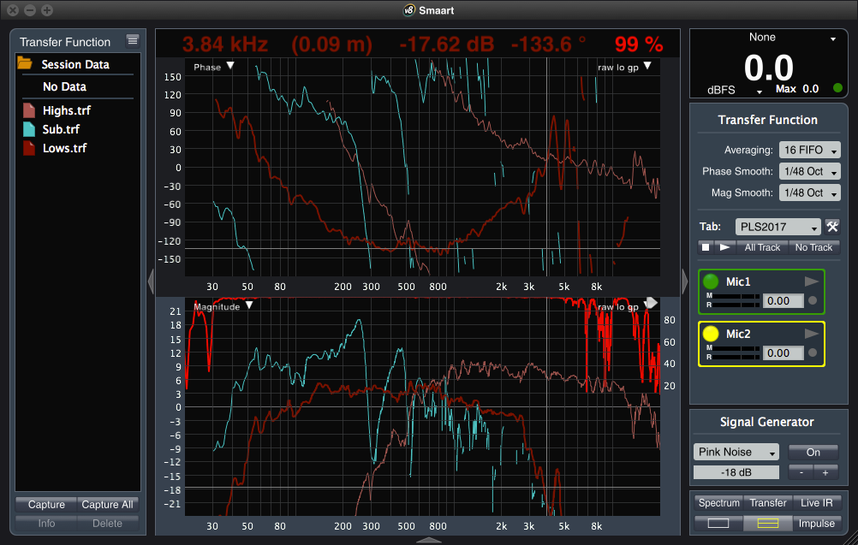
“By design, Armonía is packed with features that can transform the way our users deliver great sound wherever they operate Powersoft gear,” says Pellicano. “We’re constantly building on that feature set with new additions, and one of the ways we can ensure that our users are getting the most out of their Powersoft products is through in-person training sessions like those we will be holding at our NAMM booth.”

The Interactive Tuning Plugin in Armonia represents a revolutionary new approach to optimizing sound systems. EQ Interaction within Interactive Tuning enables the unique ability to manipulate stored transfer function traces, allowing the operator to view the simulated result of a transfer function with processing applied. By shifting part of the system optimization process offline, Interactive Tuning vastly improves and simplifies the tuning experience, allowing for complex measurement and analysis to be conducted with just a single microphone.

Powerful and Rational
Powersoft will also use the NAMM convention to launch a new marketing initiative with Smaart® developer Rational Acoustics. The two companies are teaming up to provide a coupon good for $100 off of any Smaart® v8 software product to all Powersoft training session attendees as well as any Powersoft users who register their touring amplifier to the Powersoft web site. The coupon can be redeemed at the Rational Acoustic web store for a new software license or an upgrade from previous versions of Smaart®, including v5, v6, v7 or v7 Di. The coupon is valid until December 2018 and cannot be shared or transferred.

"Powersoft’s use of the Smaart API to integrate Smaart measurement data into Armonia’s Interactive Tuning Plugin is among the best we have ever seen," commented Karen Anderson, COO of Rational Acoustics LLC "The integration is seamless, the user interface is gorgeous and it offers a really powerful set of features for the user. We are happy to partner with Powersoft to help showcase this new and exciting technology.”

Four on the Floor
During the four-day convention, Powersoft will showcase its high-performance amplification and multimedia products at its booth, which will be divided into four sections highlighting its technologies: the M-Force moving magnet acoustic transducer, the company’s range of OEM amplifier modules—including the new MiniMod 4 for low power applications, rack amplifiers for touring and installation, and the Deva outdoor multimedia unit, all encircled by a hospitality bar. Powersoft staff will be on hand to help walk attendees through each of the products and explain the many benefits of harnessing their superior performance.
Experience Galactic Power with M-Force
The innovative M-Force moving magnet design provides an alternative method of acoustic transduction that, when paired with Powersoft’s high-performance amplification module, allows unprecedented subwoofer performance. M-Force has already been adopted by some of the leading rental companies and speaker manufacturers including ATK, APIA, AURA Audio, D-BASS, DAS Audio, ENEWAVE, FUNKTION ONE, MAG Audio, PK SOUND, RAT SOUND, and STS Touring.

Powersoft Inside
In addition to M-Force, Powersoft provides a wide range of powerful amplification modules that fit every OEM application. Powersoft OEM amplifiers help address the needs of manufacturers and speaker designers by offering a range of power output specifications and channel counts, while always maintaining a high standard of sound quality, compactness, and efficiency. The OEM section at the Powersoft NAMM booth will showcase the widely used DigiMod PFC and high power-to-volume ratio LiteMod modules, including the new LiteMod 4HC module. It will also showcase the recently introduced MiniMod 4, designed specifically for low power applications.
From traditional amplifier to smart controllers
Powersoft’s unparalleled rack amplifiers offer superior performance in the areas of output, channel count, DSP and features while putting minimal strain on rack space and power resources. At NAMM 2018, Powersoft will showcase its X Series, K Series, Ottocanali, and Quattrocanali amplifiers.
The X Series and K Series are Powersoft’s industry-leading touring amplifiers, providing exceptional output and cutting down on touring rig size by reducing rack footprint. K20 and K10 amplifiers are capable of up to 18,000 W in a single rack space, while the single-space X4 and two-space X8 amplifiers offer up to eight channels of high output and pristine quality. All touring amplifiers include integration with Powersoft’s feature-rich Armonía software suite for maximum control and performance customization.
Powersoft Ottocanali and Quattrocanali amplifiers are tailored specifically for installed sound applications, offering eight and four channels respectively of crystal clear output and up to1200 W per channel. Like Powersoft’s touring amplifiers, Ottocanali and Quattrocanali are remarkably compact and energy efficient, providing significant long-term savings on operating costs. Built-in networking capabilities allow easy integration into network-based systems for remote performance monitoring, while optional DSP integration provides deeper control of amplifier performance and functionality.
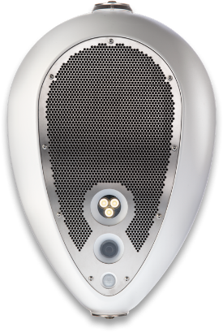
Powersoft’s DSP technology is recognised as an industry standard and can be found across our entire range, from the flagship touring product X Series to the eight- four- and two-channel fixed-install range. Powersoft offers the most advanced control and monitoring of the entire sound system with a matrix, raised cosine and FIR filters, delays and Powersoft’s unique active damping control, 5 limiters, live impedance monitoring and more.
Deva: Revolutionary Multimedia Solution
Powersoft will also showcase Deva, a powerful multimedia utility in a compact, egg-shaped, weatherproof enclosure. With applications including infotainment, entertainment, safety, and data gathering, Deva includes advanced networking capabilities that make it an all-in-one solution for spaces of all sizes. It features solar power operation, bi-directional wireless A/V communication, lighting capabilities, an ultra-efficient Class D amplifier, and much more. Deva is a powerful tool for from simple remote music playback to reporting local position weather conditions. Integrated Deva Software Manager (DSM) software makes remote management and monitoring a snap.
“We are very pleased to make our return to NAMM in 2018,” says Francesco Fanicchi, Brand & Communications Director, Powersoft. “Since our first appearance thirteen years ago, Powersoft has cemented its reputation as a leader in performance and innovation within our industry. We look forward to bringing our latest products to the show floor and providing NAMM attendees with an opportunity to experience their myriad capabilities and exceptional performance first hand.”

For information visit Powersoft at Booth 17701 at the Anaheim Convention Center or visit www.powersoft-audio.com
###

For further information, contact:

Jeff Touzeau (media contact)  Hummingbird Media  Tel : +1 (914) 602 2913  Email: jeff@hummingbirdmedia.com | Francesco Fanicchi  Powersoft (Florence, Italy)  Tel: +39 346 9719798  Email: francesco.fanicchi@powersoft.it

Or visit www.powersoft-audio.com
About Powersoft:
Powersoft is the world leader in lightweight, high power, single rack space, energy efficient amplifiers for the professional audio market. Founded in Italy in 1995, headquartered in Florence, Italy, with offices in Camarillo, CA, Powersoft couples the experience and precision of its production department with exceptional components to deliver products with perfect audio response and high-performance reliability. Its state-of-the-art amplifiers can be found in an array of markets, ranging from stadiums, sporting arenas, theme parks, performance venues and airports to convention centers, churches, and clubs, and are used by the world's leading tour sound companies. For more information, visit the Powersoft website @ www.powersoft-audio.com

