***UNDER EMBARGO UNTIL THURSDAY OCTOBER 15TH, AT 1 PM BST / ET 8AM

Beatport Next 2027: Applications Now Open

Championing breakthrough artists at the forefront of electronic music
Applications open today for the seventh year of Beatport's flagship artist development program, which will select 12 rising DJs and producers from around the world.

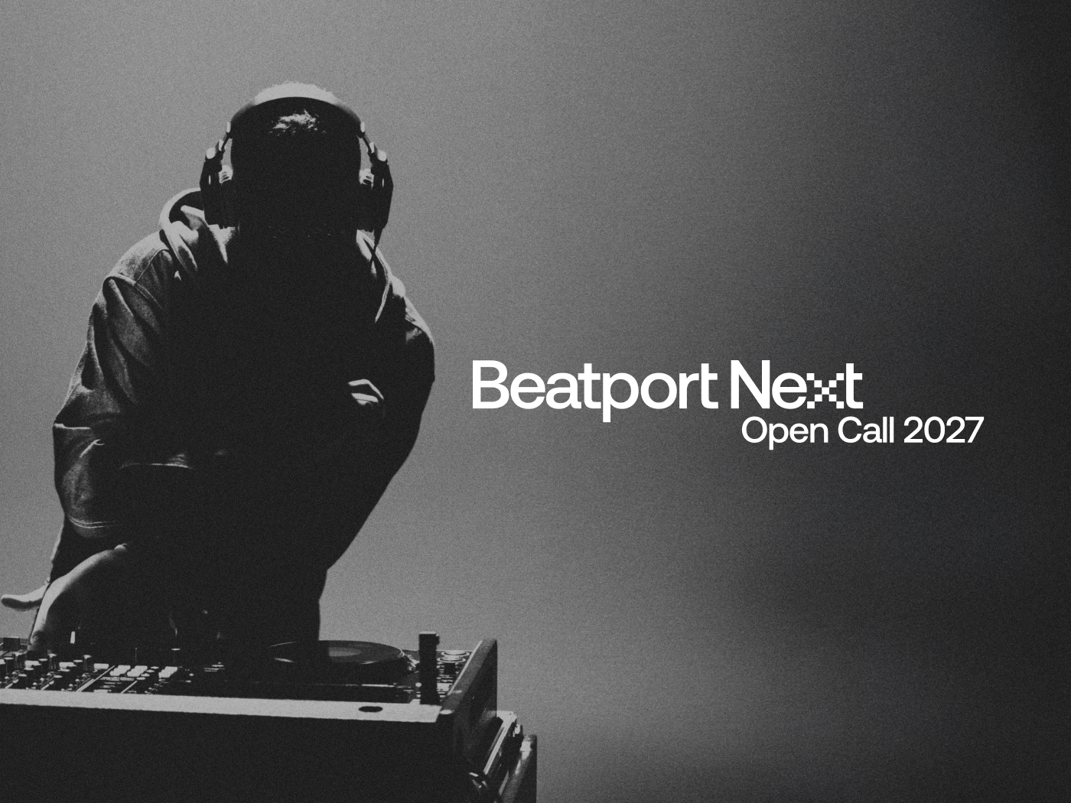
Download artwork

(WORLDWIDE, 15 OCTOBER 2026) - Beatport, the world's largest music store for DJs, today opened applications for Beatport Next 2027, its year-long artist development program for rising talent in electronic music. DJs and producers from any country can apply until 6 November 2026, with the class of 2027 announced in January 2027.

Since launching in 2021, Beatport Next has selected 12 artists each year who are on the verge of breaking through in their careers, giving them twelve months of support through a tailored program spanning content and promotional campaigns, live events and industry panels, editorial coverage, in-store features and more. The program provides year-round exposure and meaningful opportunities designed to help artists build their careers and connect with new audiences in ways they have not had the opportunity to before. It champions artists who represent the future of electronic music - those with diverse sounds and backgrounds, who push boundaries within their genres and reflect the global nature of today’s electronic music scene.
“Beatport Next gave me the tools to bring my musical ideas to life in ways I’d only dreamed about before.” – Dj Fucci
"Beatport Next has been an incredible support for my music, helping me reach audiences both online and in real life through features, interviews, and the opportunity to perform at the Beatport ‘The Block’ Stage. I’m so grateful for all the support I’ve received." - Ma Sha

“Beatport Next has given me the platform and confidence to push my sound further, from spotlighting my music to supporting live shows in various cities. It’s been a powerful way to expand my reach while championing artists shaping the future”. - Lou Nour (fka SICARIA)

Being part of Beatport Next has been a really special experience for me this year. I’ve had the chance to share my music with a new audience, but also my story as an artist. I’m really grateful to be part of the program and for all the opportunities it has brought me. - D Stone

“At Beatport, we’re committed to championing the next wave of talent, making sure the artists shaping the future of electronic music have the platform they deserve. What's missing for most artists at this stage is visibility and the right support at the right moment. Beatport Next exists to close that gap, and every year the applications show us how much talent is out there waiting to be heard.” - Teresa Aramburu, Vice President of Artist Marketing & Partnerships, Beatport

Beatport Next Artist Benefits
Participants of Beatport Next receive year-long support that spans every corner of the music ecosystem from in-store promotion, artist bookings, livestreaming opportunities, editorial coverage, brand partnerships and content marketing, to product and music development collaborations.
Examples of benefits include:
- Social Media and Editorial: Curated features across Beatport’s platforms, plus exclusive stories and coverage on Beatportal. Including Beatport Next: Stories, an interview series in which we shine a light on the current Next Class.
- Live Opportunities: DJ sets, panel talks, workshops, livestreams and brand partnerships.
- In-Store Promotion on Beatport.com: Homepage placements, banners, playlists, DJ charts and featured releases.
- Networking and Development: Direct access to Beatport’s label, marketing, product and community teams through artist development sessions.
- Music Tools: Free access and partner discounts across The Beatport Group’s brands such as Loopcloud, Plugin Boutique, LabelRadar and more.

Alumni
Over the years, Beatport Next has helped spotlight some of today’s most exciting names in electronic music, including Nia Archives, TSHA, Lou Nour (FKA SICARIA), Omar+, Sam Alfred, Lens, HoneyLuv and Kilimanjaro. Each of these artists joined the program early in their journey, with Beatport providing ongoing support as they’ve risen to international stages and reached global audiences.

Apply Now
Applications for Beatport Next 2027 are officially open here and close on 6th November 2026.
Don’t miss this chance to advance your career, connect with new fans, and join a global community that’s shaping the future of electronic music.

About The Beatport Group
The Beatport Group is the worldwide home of music for DJs, producers, and their fans. Founded in 2004, The Beatport Group's family of companies includes Beatport, the prominent store for electronic & open format music DJs, Plugin Boutique for music producers, ampsuite and LabelRadar for streamlining label management and demo submissions, and Beatport Live for all things events and fans of DJ culture. The Beatport Group’s portfolio of products includes an array of high-quality audio solutions to choose from, including full song downloads, exclusive content from leading labels, a streaming music service seamlessly integrated into DJ software and hardware (Streaming), and plugins. All of the content is expertly curated on a weekly basis by a global team that helps define DJ culture. With headquarters in LA and London, The Beatport Group’s teams reflect the culture they serve. A passionate collective of music professionals and technologists who serve the DJ and producer communities with pride by connecting artists with fans and providing the tools to build their careers.
Follow Beatport on YouTube, Instagram, Twitch, Facebook and TikTok.

Media Contacts: Roberta Hickey: roberta.hickey@beatport.com

