Voices from Masisi territory
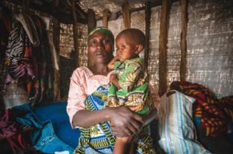 | « Poverty is going to kill us all »  Sifa, 32, has been living for the last four months in the displacement site of Katale with her husband and their 8 children. Originally from Kitchanga, in the north of Masisi, the family had to flee following the upsurge in armed clashes in the province between the M23 movement, armed groups and the Congolese armed forces.  "During the fighting, my aunt and cousin were hit by stray bullets and died. My husband and I didn't want to take any risks, especially with the children. So we fled ».  The displacement site in Katale, where they have settled, is the oldest site in the Masisi health zone. Set up in 2011, it now includes almost 5,000 people formerly or are newly displaced.  "Our life here is miserable, we all live together in a small hut built from wood and tarpaulins", explains Sifa. "It's hard to find food, clothes or any other necessities. My husband and I try to earn some money by carrying packages or working in the fields. But we can't find work every day. Hence, we can't buy anything to eat and our children sleep on an empty stomach. Sometimes they have no choice but to beg”.  Today, three of her children are suffering from malnutrition. Two of them have just been transferred to the Masisi general referral hospital, supported by MSF. The third, Tamuriza, 5 years old, has just come out of the Katale health centre, where she received treatment as part of the nutritional programme for children suffering from severe acute malnutrition without complications.  "This is the first time my children have suffered from malnutrition. Before fleeing, we worked in our fields, so we never went a day without eating. But here, I have nothing. I give my children the paste [plumpy'nut, a nutritional rehabilitation peanut-based paste] that the health centre has been giving us, but it is not enough as I don't have other foods to complement it".  Sifa is around 7 months pregnant. She would like to return home with her family and get back to their former life - far from the miserable conditions on this site and the tragedy that recently befell them. "Two months ago, my daughter Annicka died of malnutrition in hospital. She was 7 years old. We arrived too late.... we had to bury her at the Katale site. Let me tell you, poverty is going to kill us all".
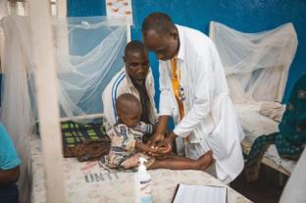 | "She swelled up in a few weeks".  Fourteen months ago, Mandela and his family fled the fighting in their village and came to take refuge with a host family, 18 kilometres away from the Masisi general referral hospital. A few days ago, this father of four children walked for three hours to bring his daughter Alice, 6 years old, to the hospital as she is severely malnourished with serious oedema.  " We could eat only once a day and yet Alice wasn't hungry and didn't eat. Then her face, feet, legs and hands gradually started to swell. I took her to the health centre in Shoa where they gave her a little bit of plumpy'nut [the nutritional rehabilitation peanut-based paste] but not enough to allow her to recover fast. Hence, on the fourth visit, as her condition worsened, the doctors referred her here to Masisi hospital".  "Before we fled, we grew peanuts and bananas in the fields. Today, to find food, I work in the fields for others and I'm paid between 2,000 and 10,000 francs a day [$0.79 to $3.94]. That's not enough to feed my family”.  Alice was admitted to the hospital with severe acute malnutrition, the Kwashiorkor type, a syndrome often linked to a very low level of protein in the diet, characterised by the appearance of oedemas in the lower limbs and face. She also suffered from anorexia (loss of hunger) and a pneumonia linked to her weakened immune system. To ensure that she was able to accept food, the doctors prescribed her therapeutic milk in progressive doses, until they can attempt to administer again the plumpy'nut. Then, Alice and her father will be able to return home, while she will continue to receive treatment in a health centre nutrition programme.
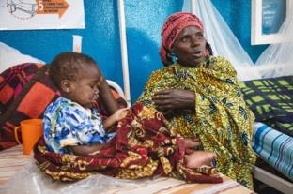 | “We have to give our harvest or money to access our fields”  Fourah, 36, lives with her 8 children and husband in a village 25 kilometres away from Masisi. 8 and a half months pregnant, she brought her daughter Chantal, 4 years old, to the Inpatient Therapeutic Feeding Center at the Masisi general referral hospital.  "Since she was born, her legs haven't moved, and she can't walk. We've already come here to the hospital to try and teach her to move her legs with the physiotherapy team. But this is the first time she has been admitted for malnutrition. She had stopped eating and was starting to develop lesions on her skin...".  "In my village, I farm my own fields to feed my family. But for the time being, it's difficult to get there because there are armed men on the road demanding money".
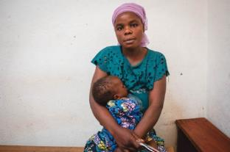 | "I can't always access the fields because of the armed men".  Fahida, 28, was born in Masisi and lives with her husband and their four children in a village 3 kilometres away from Masisi.  "Four days ago, I went to the Masisi health centre because Joel, my little boy [1 year old], had diarrhoea and was vomiting a lot. He is often ill. He's always very tired and just sleeps. When I haven't eaten enough, I don't have enough milk to breastfeed him and he doesn't eat anything else because he won't take the porridge”.  On his arrival at the hospital, Joel was placed in the inpatient therapeutic feeding center. The medical team feed him with a syringe with nutritious milk and they test with the plumpy'nut [the nutritional rehabilitation peanut-based paste]. As Joel is very fragile, the teams care to feed him gradually to ensure that Joel does not reject it.  "Joel is not the first to suffer from malnutrition in my family. Another of my children has also suffered from it, and I often see malnourished children in other families. In our village, we often welcome displaced families fleeing armed clashes. We try to help them feed themselves, even if it's difficult for us too...".  "In my village, everything I produce in the fields is used for our own food consumption. But I can't always get to the fields because of the armed men. I often don't go out there because it's too dangerous, especially since this year. We can only go when there's a lull in the fighting. Hence, we wait, sometimes for a fortnight. We're afraid to go because we might meet armed men on the way - they are taxing us and may even try to kill or rape us".
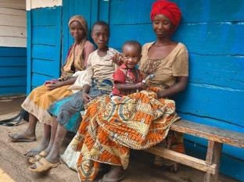 | "Before fleeing, we had enough to eat, even enough to sell at the market”  Iranda, 28, came to the Masisi health centre with three of her six children: Tuhibahe, aged 14; Zawadi, aged 10; and Samedi, aged 14 months. Since they fled their village because of the fighting, they have been living in a village about 15 kilometres away from Masisi. Iranda came for the second consultation of her youngest son, admitted a month ago in the nutritional programme for children suffering from severe acute malnutrition without complications.  "Where we found refuge, we don’t have our own fields so to find food, we work in other people's fields", she explains. "They pay each worker 2,000 francs a day [0,79 dollars]. We don't have enough to eat every day. A family took us in and gave us a free plot of land where we built a small house, temporarily".  "At home, we had our fields and our house. We had enough to eat - even enough harvest to sell on the market. But we had to flee because of the fighting, and it's still not safe enough for us to go back. The children went to school back home. That's no longer the case here, so they sometimes work in the fields with us, but we have no other choice because there is no assistance.
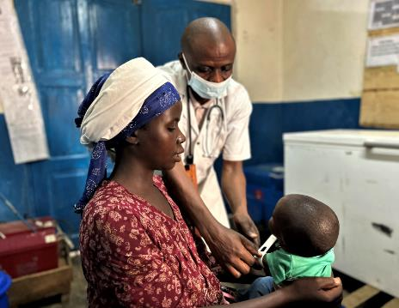 | "This is all new to us - at home, we had our own fields and we used to farm".  Alliance, 20, came with her son François, 12 months old, for a consultation as part of the nutrition programme at the Nyabiondo referral health centre. François had initially been admitted to the Inpatient Therapeutic Feeding Centre on 7 August for several days.  "He had a high fever, had lost weight and had an incipient abscess, so I came for a check-up", she explains. "After several days in hospital, he got better, so we were able to go home. We have to come back here for consultations every week to check that his health is holding up".  Since they fled the fighting in their village and came to Nyabiondo - also a highly volatile area of the Masisi territory - Alliance has been living with her husband and their three children near the health centre. A family has received them and given them a plot of land on which they could build a small house waiting for the lull to return.  "Armed men took our village and everyone left. We could no longer access our fields - the armed men came and took what they wanted from the fields. We'll never go back there, it's too dangerous. We're going to try to find a way to live here on a longer-term. For the time being, we work in other people's fields for 2,500 francs a day [less than 1 dollar]. If we're lucky, we can work 2 times a week. Otherwise the rest of the time, we have nothing to eat".  After his hospitalisation, François joined the nutrition programme for outpatient consultations. Today is his 6th consultation. His health is improving, but slowly. In general, the programme lasts an average of 45 days, with one consultation a week.
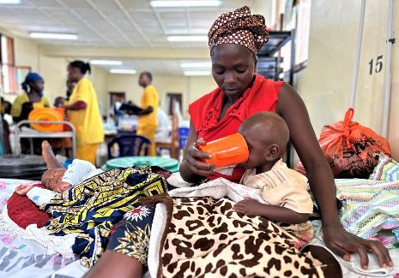 | “This is the first time one of my children is suffering from malnutrition”  Riziki, aged 27, lives with her husband and 7 children in Walikale territory, on the border with Masisi. Her son Richard, aged 2, was taken to the inpatient therapeutic nutritional unit of the Nyabiando referral health centre, supported by MSF in the Masisi territory.  "Since he was born, Richard has often been ill with diarrhoea," she explains. "So, I didn't worry. But recently his feet started to swell. My husband is a nurse who works at the health centre near our home. We tried to get him to eat plumpy'nut [a nutritional rehabilitation peanut-based paste] but he couldn't absorb it. Hence the centre referred us here because his case was too complicated.  Riziki walked for 8 hours to reach the Nyabiondo referral health centre, where the medical team diagnosed severe acute malnutrition accompanied by anorexia. "This is the first time one of my children is suffering from malnutrition", she laments. "We usually have food at home. I grow peanuts, beans and rice in my fields, and I produce enough to sell commercially. But Richard can't eat his food properly”.  After four days in hospital, Richard is getting better and is able to absorb the nutritional therapeutic milk prepared by the medical teams. If subsequently, he can absorb the plumpy'nut as the next step, they will be able to go home. He will then be re-admitted to the nutritional programme for outpatient consultations at the Mutongo health centre.
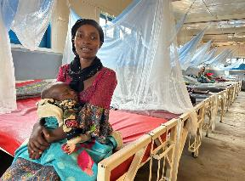 | "What really worried me were his eyes: they were sunken and empty".  Micheline, 23, holds her 10-month-old son Daniel, who was admitted a week ago to the inpatient therapeutic feeding centre at the Mweso general referral hospital, supported by MSF since 2005 in partnership with the Ministry of Health.  With her husband and their two children, Micheline took refuge in the Bushanga site for displaced people, near the village of Mweso, after fleeing the fighting in her village in the Walikale territory. Back home, they were farmers, but with the insecurity, they still can't go home. So, they have to adapt and try to work for other people. But after two years living on this site, the conditions are still disastrous, and even getting worse, with a direct impact on their health.  “We eat badly and hardly at all. It's hard to find work and even when we do, we only eat once a day, with very basic food. Unfortunately, it's only when I've eaten that my body produces enough milk to feed Daniel. Otherwise, he has nothing to eat. When he started vomiting, with diarrhoea and fever, I got worried. But what struck me most were his eyes: they were sunken and empty. So, I rushed to the Bushanga health centre [near the site], where they transferred him here to hospital. They put him in the nutritional programme and gave me the paste [plumpy'nut, a nutritional rehabilitation peanut-based paste]. But Daniel has a lot of trouble eating it. This is the first time one of my children has suffered from malnutrition”.  Despite the nutritional programme, Daniel's health continued to deteriorate. If the daily intake of peanut paste is not respected and not accompanied by other foods to form a balanced diet, then the child may fall into severe acute malnutrition, accompanied by complications such as pneumonia. The child must then be transferred to hospital for a more appropriate treatment.  "Today, things are better. Daniel is smiling again, and his eyes have changed. I am happy”. After a week at the hospital, Daniel's health is improving and they will be able to return home, following the nutritional treatment and regular consultations through the nutritional programme set up by MSF at the Bushanga health centre.

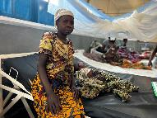 | "This is not the first time one of my children is suffering from malnutrition".  Marianna, 30, comes from a village 6 hours' walk from the Mweso general referral hospital. Her son Irasubisa, 12 months old, was admitted to the intensive care unit of the inpatient therapeutic feeding centre for severe acute malnutrition, accompanied by pneumonia.  "This isn't the first time one of my children has suffered from malnutrition, so when he started having a lot of diarrhoea, vomiting and high fevers, I got really worried. But it was when I saw his eyes that I knew it was serious, so I rushed to the Birambizo health centre". Marianna had 9 children, 5 of whom unfortunately died from malnutrition.  "I grow in the fields when I have the strength, because with my children and the various pregnancies, it's difficult, especially as I'm alone to take care of my children".
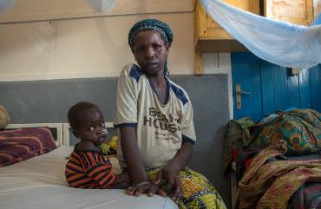 | "My first child fell ill, then the second"  Feza, 34, took refuge in the forest with her husband and their two children after fleeing fighting between armed groups near their village. Her two children, of 3 and 1 years old, are currently admitted to the intensive care unit of the inpatient therapeutic feeding centre at the Mweso general referral hospital for severe acute malnutrition with complications.  "My first one fell ill, then the second. So, I got out of the forest and walked here to the hospital". The two children were admitted to the intensive care unit as a matter of urgency because their malnutrition was accompanied by severe sepsis. The youngest, Mosee, was diagnosed with digestive sepsis, which can be treated with medication. But Fourraz, the oldest, was admitted with severe sepsis of the face known as Noma, which requires surgery. The two main factors behind this infection are mostly link to the living conditions and a weakened health - in Fourraz's case, malnutrition weakened her immune system, making her more vulnerable to diseases and infections.  "This is the first time my children are suffering from malnutrition. In my village, I used to see malnourished children, but my husband and I managed to find work in the neighbours' fields. I mainly grew sweet potatoes.  But since we fled, we have nothing, no clothes, no food. There's no nothing in the forest, so we try to go back to the village during the day when we can to get something to eat, but if there are armed men, we can't get there. At best, we get there 2 days a week".  "Since we have been at the hospital, the children's health has improved. But when we get out of here, what am I going to do? We'll go back to the forest and there won't be any food - so we might end up coming back here”.

