An audiophile dream come true
The Sennheiser brand opens Audiophile Experience Centre in Tullamore, Ireland

Marlow, UK, September 21st, 2023 – Sennheiser audiophile headphones have been manufactured in the company's own factory in Tullamore, Ireland for over 30 years, making it the core of Sennheiser’s audiophile headphone innovation. On September 27th, the brand will open the doors to its inner sanctum for the first time, offering guided tours through the state-of-the-art facility that is home to many audiophile staples including the prestigious HE 1.

The new Sennheiser Audiophile Experience Centre will also offer an extensive audio "tasting" of the various headphones and earphones made on-site. Audiophiles all over the world will have the chance to win the trip of a lifetime to the campus via competitions on the Sennheiser social media channels and Reddit.

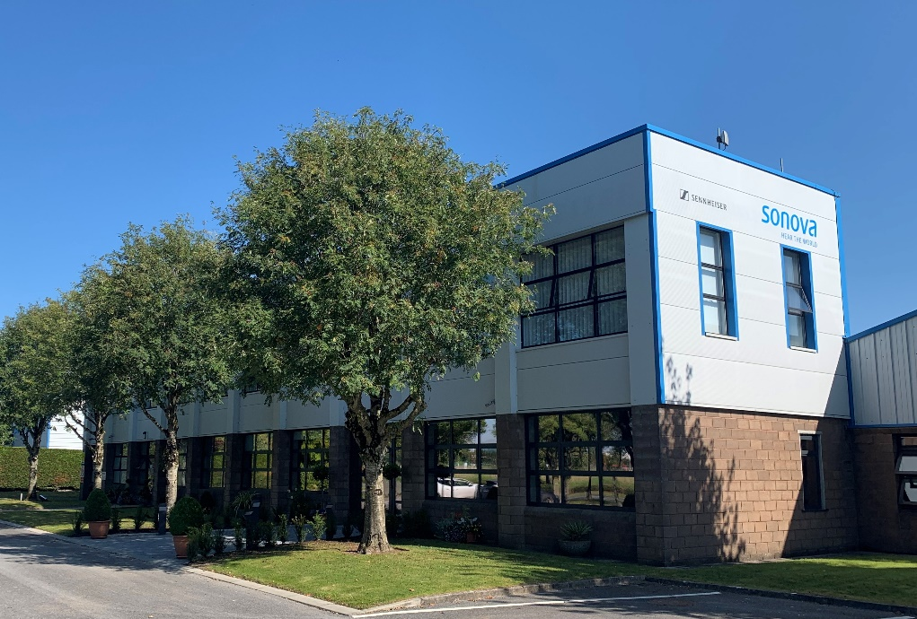

“It all comes together in Tullamore: from the assembly of transducers right through to the packaging of the finished headphones, visitors can experience the full journey our audiophile headphones take,” says Jermo Köhnke, Sennheiser Audiophile Product Manager. “We are extremely proud to open the Audiophile Experience Centre and let them experience audiophile innovation firsthand.”

Tullamore – where the audiophile heart beats
Since 1991 the Sennheiser Tullamore plant has been at the core of audiophile innovation. It has long been the main facility for manufacturing the transducers used in many of the brand’s audiophile products. It’s also where the acclaimed HD 600 series headphones have been manufactured for over two decades. In 2022, the Sennheiser brand took the decision to unite the transducer manufacture and headset assembly in Tullamore under one roof—a rarity in the headphone industry. This not only improves transducer matching; it also enhances the overall quality and innovation that customers know and love from Sennheiser.

“Audiophile assembly is not easy”, says Pat Fulton, Sennheiser Tullamore Plant Manager. “It takes a lot of time and requires extreme precision and attention to detail as well as a lot of human interaction and passion. All of that can be experienced here in Tullamore – and our team is proud to share that with our future visitors from all over the world.”

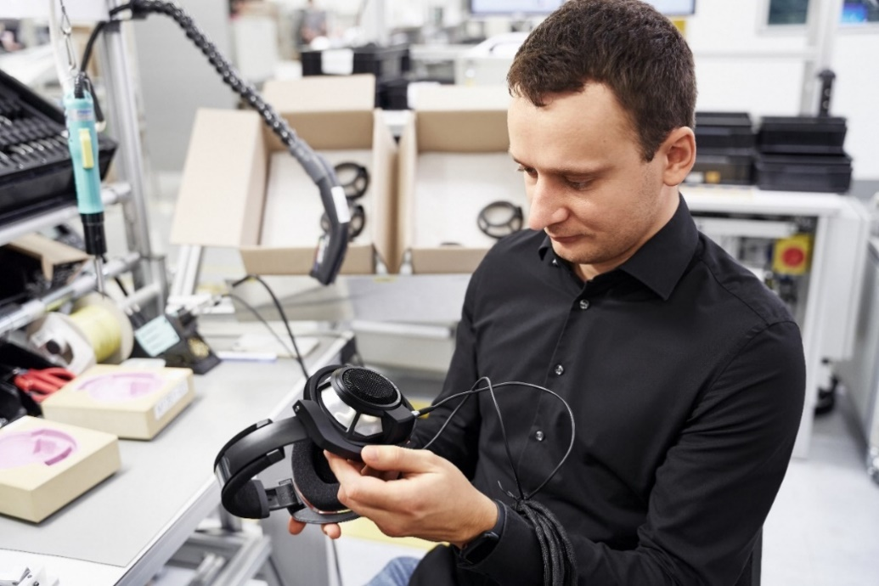

Regarded as one of the leading audiophile headphone brands, Sennheiser has been eagerly preparing for visitors to experience the magic and passion with which these products are made. During the guided tour, guests will not only see how the transducers and headphones are assembled; each will get hands-on experience building one of their own, complete with insights from key members of the Tullamore team. No audiophile tour would be complete without an up-close look at the assembly of the legendary HE 1, complemented by hands-on listening sessions in the factory’s dedicated hi-fi room.

Take a journey to the Future of Audio
In the coming months, the Sennheiser brand will offer members of the audiophile community the chance to win ‘golden tickets’, with which they will receive an all-inclusive Tullamore factory tour. To ensure an intimate and personalised experience within a live, dynamic production environment, Audiophile Experience Centre tours are currently on an invite-only basis. Additional details will follow later in 2023 via the Sennheiser social media channels and Reddit.

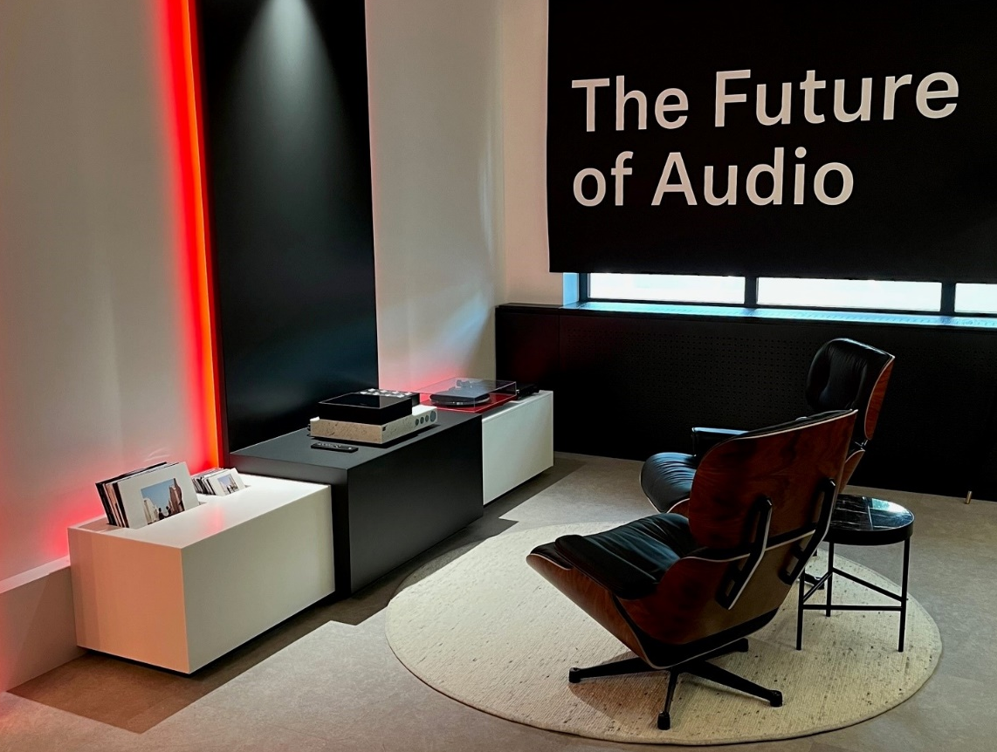

About the Sennheiser brand
We live and breathe audio. We are driven by the passion to create audio solutions that make a difference. Building the future of audio and bringing remarkable sound experiences to our customers – this is what the Sennheiser brand has represented for more than 75 years. While professional audio solutions such as microphones, meeting solutions, streaming technologies and monitoring systems are part of the business of Sennheiser electronic GmbH & Co. KG, the business with consumer devices such as headphones, soundbars and speech-enhanced hearables is operated by Sonova Holding AG under the license of Sennheiser.

Press contact
Sonova Consumer Hearing GmbH
Paul Hughes
Head of PR and Influencers, Sennheiser Headphone and Soundbars
T +49 (0) 162 2921 861
paul.hughes@sonova.com

