

Biuro prasowe better. gaming agency
bettergamingagency.prowly.com

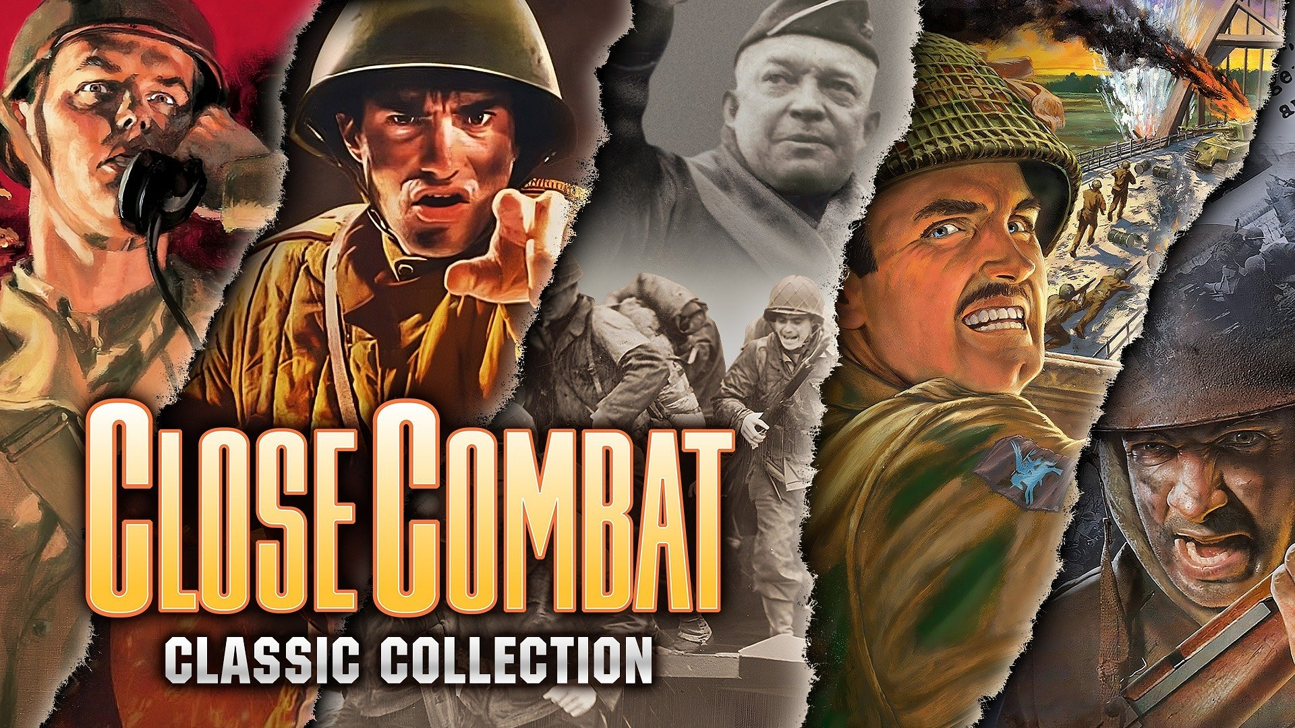

Legendary strategies are back! The five original Close Combat games and the Warlords series are now available on Steam

While media regularly share news about games disappearing from digital distribution, publishers like SNEG ensure that as many iconic titles as possible are easily accessible to players. The Warlords series and the five original Close Combat games, for the first time, are available on Steam. Generations of players grew up with these titles, and now access to them is easier than ever before.

Today, eight classics fully optimized to the requirements of modern computers and operating systems make their debut on Steam, while the first installment of the Close Combat series premieres in digital distribution as a separate and fully functional title. The publisher has also made every effort to eliminate technical issues, with changes based on fan and community feedback.

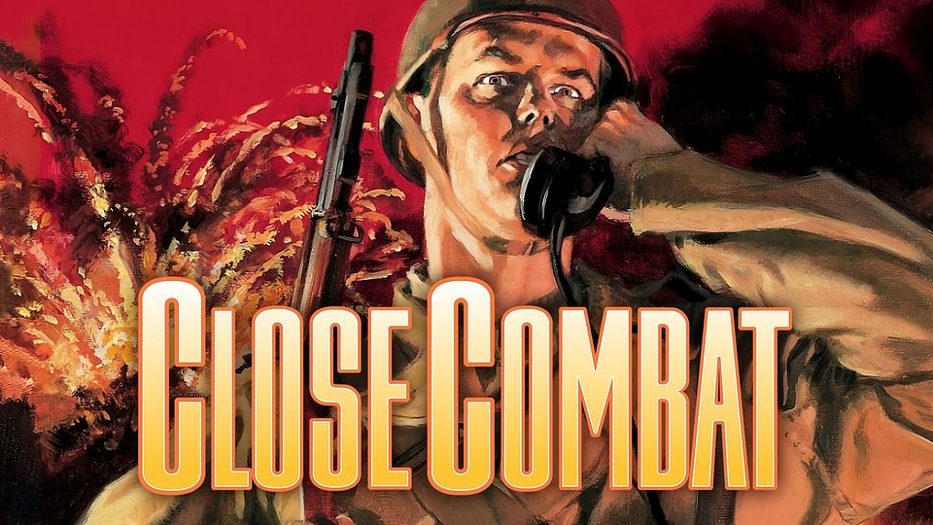

The Close Combat series immerses players into the time of World War II, where they will encounter challenges across various sides of the conflict. In these games players command troops in diverse historical campaigns, engaging in intense battles across a variety of terrains and scenarios. The first installment hit the market in 1996, surprising players with a combination of strategic gameplay, great graphics, animation, and sound effects. Fans of military strategy games fell in love with attention to detail, historical accuracy, and challenging gameplay, which made these games unique from other titles available at the time. Starting from today, players will once again be able to engage in battle in the five original games from this series developed by Atomic Games that started it all.

● Close Combat – defeat the enemy in this classic, nonstop World War II battle action. Lead your men through the terror, fatigue, and hell of war to victory. Only you can bring them back alive! For the first time in history, Close Combat is available digitally as a standalone, fully functional game. [TRAILER]

● Close Combat 2: A Bridge Too Far – take control of five strategic bridges in the most dramatic battle of World War II. From war-room strategy to gritty trench combat, battlefields come to life as you command Allied or Axis powers. It's a fight where every second counts. [TRAILER]

● Close Combat 3: The Russian Front – command a fire brigade of soldiers on the Russian Front in this real-time strategy game set in World War II. Play as either the Soviets or Germans, orchestrating squad attacks, defenses, and survival over four grueling years of the grandest and bloodiest war the world has ever seen. [TRAILER]

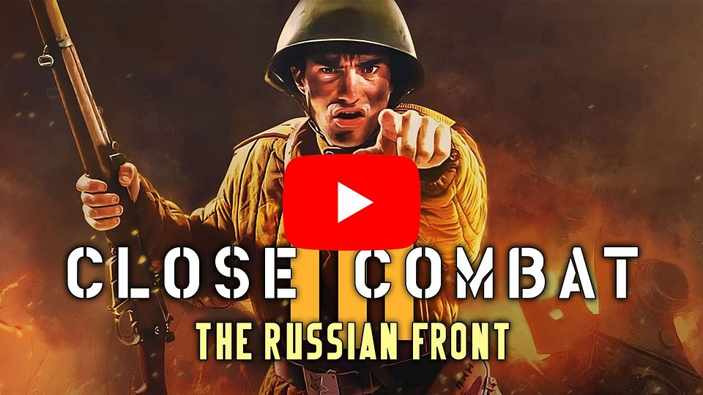
https://www.youtube.com/watch?v=baourUCQvRI&ab_channel=SNEG

● Close Combat 4: The Battle of the Bulge – sneak attacks, stalwart defenders, spies, and saboteurs are among the exciting surprises lurking on both sides of the battle. Whether you command American or German troops, you decide when and where they will be deployed. Launch air attacks against the enemy, but keep your eyes on the skies; random weather patterns can wreak havoc on your offensives from above. [TRAILER]

● Close Combat 5: Invasion: Normandy - Utah Beach to Cherbourg – WWII realism is brought back to the beaches of Northern France. Relive the campaign that gave the Allies a foothold on the doorstep of Fortress Europe. From Utah Beach to Cherbourg, Invasion: Normandy gives you strategic and tactical control of Allied or Axis forces in the pivotal battles that determined the fate of Europe. [TRAILER]

Players who prefer battles in fantasy worlds can immerse themselves in three games from the Warlords series, developed by Strategic Studies Group. The first installment of Warlords was released in 1990, setting trends for the entire genre, thanks to its depth of strategy, immersive world-building, and engaging gameplay mechanics. As media mentioned at that time, Warlords game has everything to offer the strategy gamer who has a taste for a bit of the fantasy genre. To experience these, players can now reach for:

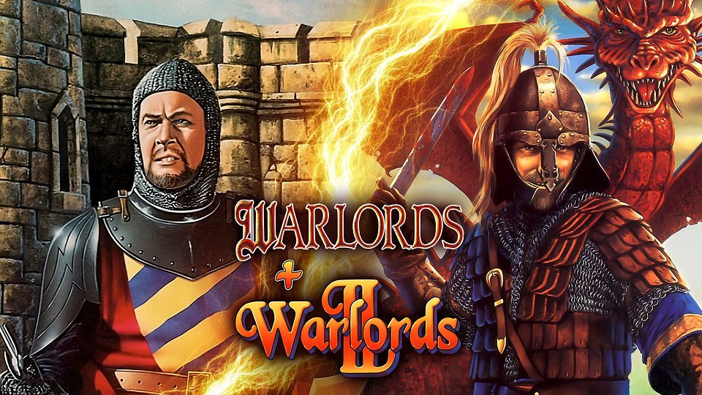

● Warlords I + II – compilation of two great award-winning games. Both bring different worlds to conquer, mighty armies to fight, and enemies to vanquish. Brave heroes, quests, diplomacy and magic are all employed to overwhelm your rivals and dominate the world! [TRAILER]

● Warlords III: Darklords Rising – Enter a rich fantasy world of medieval warfare teeming with rage, revenge and bravery. This epic game of strategy and conquest now delivers a vastly larger world and deeper strategic gameplay that expands beyond the scope and depth of the original Warlords III: Reign of Heroes. Five epic campaigns and massive strategic battles serve as proving grounds that challenge the mettle of even the greatest Heroes and Warlords. [TRAILER]

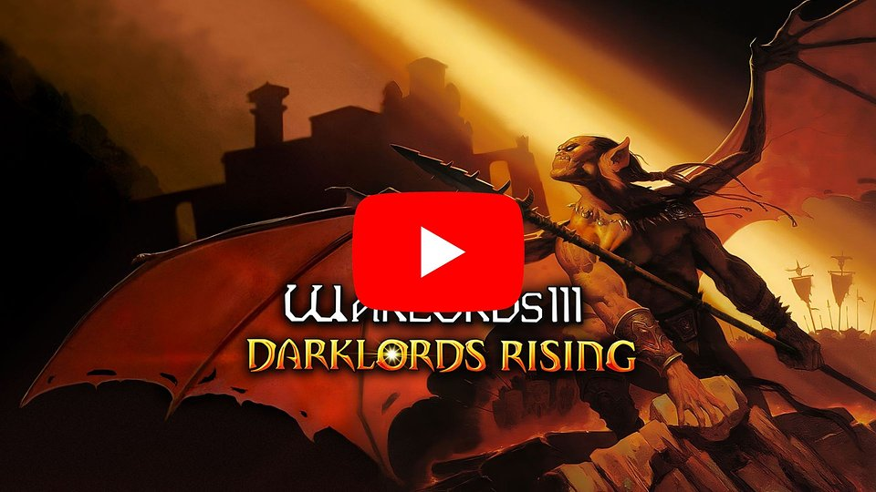
https://youtu.be/NLDfWS7q_SI

"We're committed to preserving classic games and ensuring they're easily accessible. The Close Combat and Warlords series were hugely popular in the 90s, influencing many later hits. Their presence on Steam offers a chance to revisit or discover this part of video game history."

– says Artem Shchuiko, co-founder of SNEG.

"One of Slitherine's founding values is also to preserve the history and tradition of computer wargames, as we are first and foremost enthusiasts of wargaming. Thanks to Sneg's efforts, both veteran players of these titles and those who want to try them for the first time in their lives will have the opportunity to do so with a version that is as updated and functional as possible on modern PCs, while at the same time not altering the original experience."

– Marco Minoli, Director of Publishing Slitherine

All of the above games are now available for purchase on Steam - separately for 5.99 USD each or in promotional bundles. During the launch week, players can look forward to some great deals with discounts up to almost 50%.

The full press kit is available here.

About SNEG:
SNEG is a boutique publisher focused on reviving old gaming gems. We have an admiration for classics and a desire to bring back more interactive entertainment from all eras of the video gaming culture.

About Slitherine:
The Slitherine Group is the world’s leading producer and publisher of digital strategy and wargames. Under the Slitherine (www.slitherine.com) and Matrix Games (www.matrixgames.com) brands it has published literally hundreds of games, with many award-winning titles in its portfolio and spanning all digital platforms, from home consoles to smartphones and tablets. Slitherine also works with a wide array of key licensing partners, such as NBC Universal®, Games Workshop®, Sony Pictures, BBC, Osprey, and many others. For more information contact Slitherine press office – press@slitherine.co.uk

