Sennheiser at InfoComm 2019
The meeting experience perfected: TeamConnect Ceiling 2 – New Control Cockpit software version available

Wedemark/Orlando, FL, May 30, 2019 – At InfoComm 2019 (June 12-14, Orange County Convention Center, booth 5561), Sennheiser will highlight its business and education solutions portfolio, with a focus on its new TeamConnect Ceiling 2 (TCC2) microphone array. Sennheiser will offer live booth demonstrations of TeamConnect Ceiling 2, which uses its patented automatic, dynamic beamforming technology to deliver the ultimate virtual meeting experience.

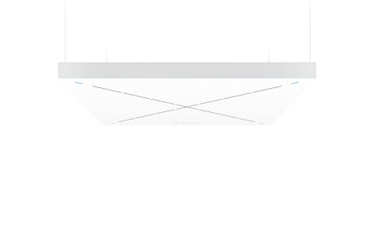 | Sennheiser’s TeamConnect Ceiling 2, on active display at InfoComm 2019, is a conferencing solution that employs automatic, adaptive beamforming technology

The advantages of flexible beamforming
TeamConnect Ceiling 2, which has been shipping since April, is Sennheiser’s flagship A/V conferencing solution and employs its unique flexible beamforming technology to follow the active speaker wherever he or she moves in the room. Unlike ceiling microphones with static beamforming technology that work with predefined speaking zones, TCC2 reliably captures the speaker no matter where they are in the room. Also, there is no need to alter the set-up when the number of participants changes or when a different seating arrangement is chosen: Due to its single, flexible beam technology, TeamConnect Ceiling 2 is as versatile as you need it to be and caters to any type of meeting without further adjustments. TCC2 can be used together with existing analogue conference systems, or integrated into fully digital systems, and can also be controlled and monitored over the network. TCC2 supports Power over Ethernet (PoE), Sennheiser Control Cockpit, Dante Domain Manager and provides an open media protocol for third-party control platforms such as Crestron.

Sennheiser Control Cockpit 3.1.0 out now
The audio specialist will also be demonstrating the latest version of its Sennheiser Control Cockpit software at Infocomm 2019. This offers an intuitive, easy way to set up and manage TeamConnect Ceiling 2 along with SpeechLine Digital Wireless systems, which are also on display at InfoComm. The powerful software is accessible in web browsers on any smartphone, tablet or notebook. It offers a continuous, global dashboard overview of all network-enabled Sennheiser devices, while greatly simplifying adjusting settings for individual or multiple devices.

In addition to various workflow improvements, highlights of version 3.1.0 include out-of-range detection for wireless microphones and the possibility to select exclusion zones for TeamConnect Ceiling 2. When activated, out-of-range activation will notify the system administrator via e-mail and/or text when a wireless microphone leaves the range of the receiver.

Sennheiser Control Cockpit is an ideal application for controlling and monitoring company or campus-wide installations. Version 3.1.0 is available now | 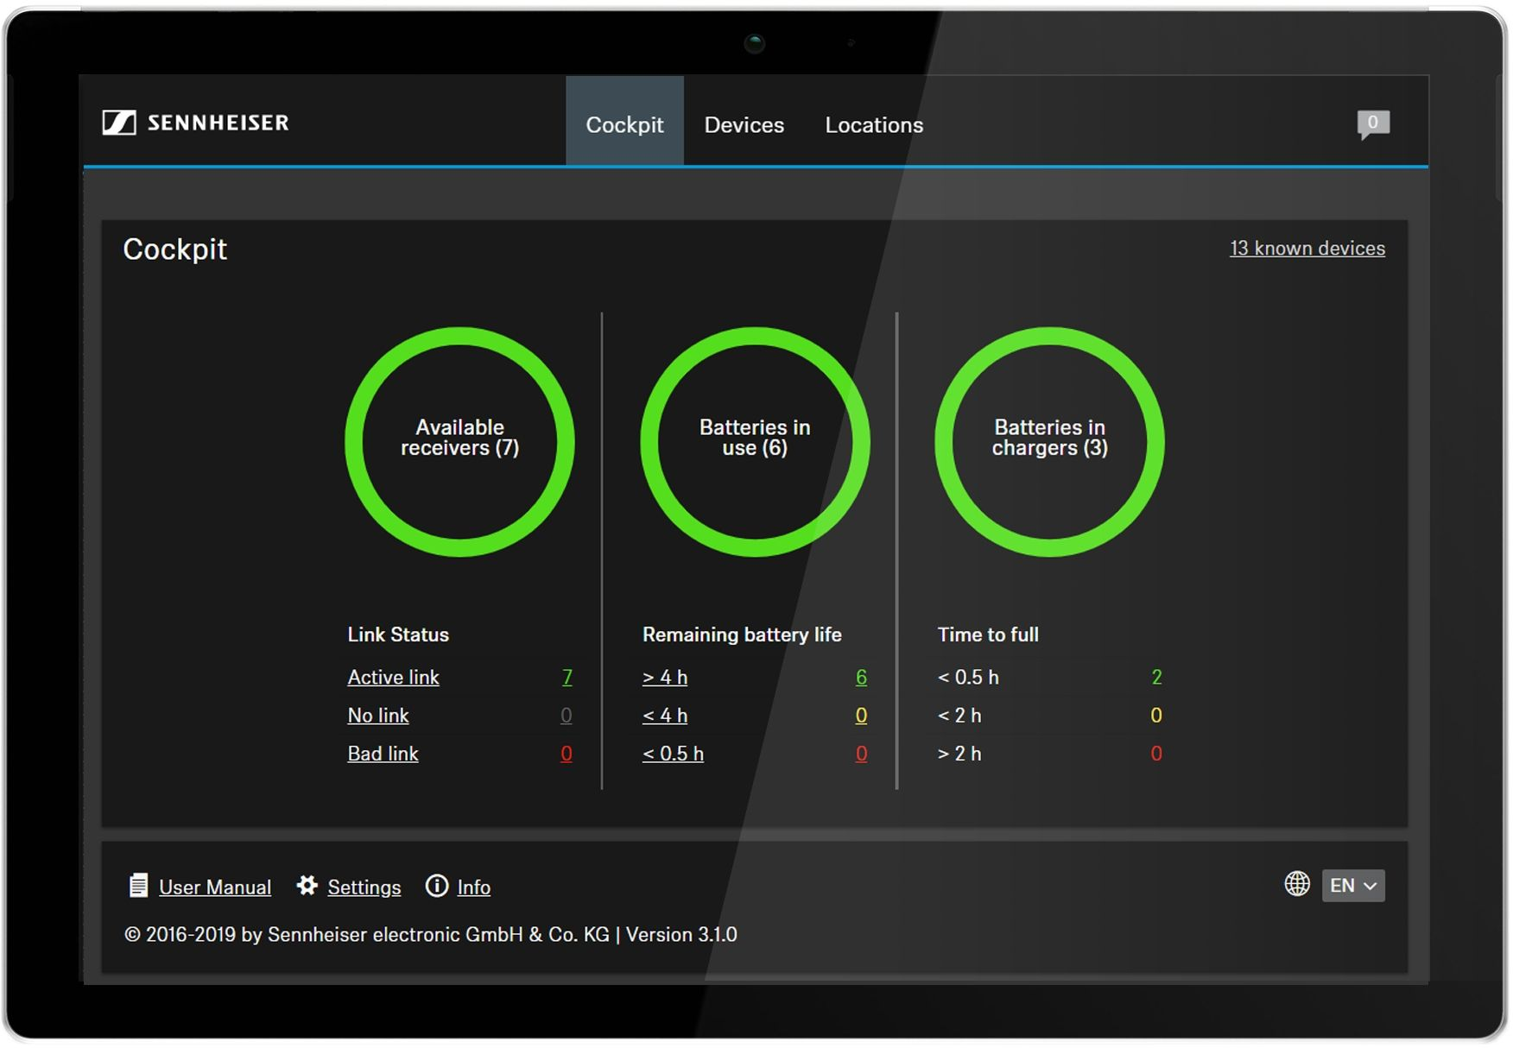

For TeamConnect Ceiling 2, Sennheiser Control Cockpit version 3.1.0 offers the possibility to define vertical exclusion zones in order to minimize noise from projectors or air-conditioning units. The free software can be downloaded at www.sennheiser.com/control-cockpit-software.

SpeechLine Digital Wireless and MobileConnect
Created specifically for speech applications in corporate and educational environments such as universities, Sennheiser’s SpeechLine Digital Wireless microphone line provides highest level of speech intelligibility and concise sound quality. A completely scalable system that is perfect for company/campus-wide installations, SpeechLine Digital Wireless delivers unmatched sound quality and flexible configuration options.

The Sennheiser SpeechLine Wireless Series provides specialist tools for speech applications | 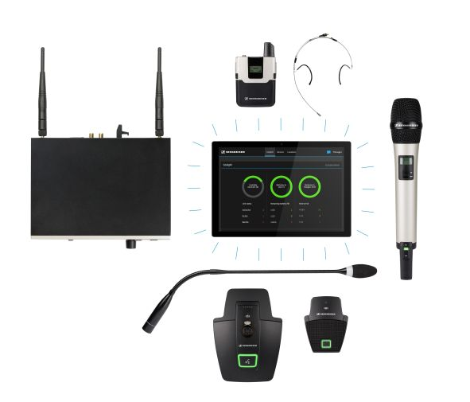

Sennheiser will also be displaying MobileConnect, its WiFi-based system for accessible hearing. The system is ideal for applications in universities and employs a BYOD philosophy so students can connect using their own device to participate in lectures with personalized audio that ensures greater intelligibility. MobileConnect also supports applications for use in theatre, opera and musical environments.

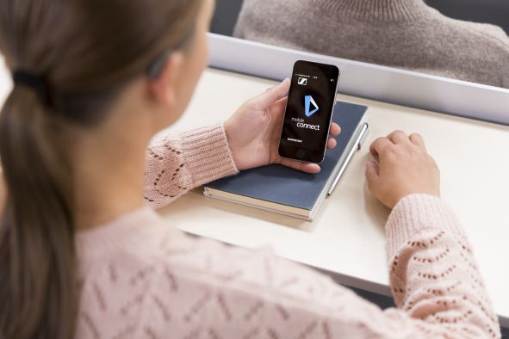 | Mobile Connect provides personalized audio – not only in education environments

To learn more about Sennheiser’s presence at InfoComm 2019, please visit https://en-us.sennheiser.com/infocomm.

About Sennheiser
Shaping the future of audio and creating unique sound experiences for customers – this aim unites Sennheiser employees and partners worldwide. Founded in 1945, Sennheiser is one of the world’s leading manufacturers of headphones, microphones and wireless transmission systems. With 21 sales subsidiaries and long-established trading partners, the company is active in more than 50 countries and operates its own production facilities in Germany, Ireland, Romania and the USA. Since 2013, Sennheiser has been managed by Daniel Sennheiser and Dr. Andreas Sennheiser, the third generation of the family to run the company. In 2017, the Sennheiser Group generated turnover totaling €667.7 million. www.sennheiser.com

Local press contacts
Sarah James Victoria Chernih
sarahj@gasolinemedia.com.com victoria.chernih@sennheiser.com
+44 1483 223333 +44 7881 091687

