Wijchen, October 2019

Latest and largest Nooteboom 4+6 low-loader provides a load capacity of more than
100 tonnes in Germany

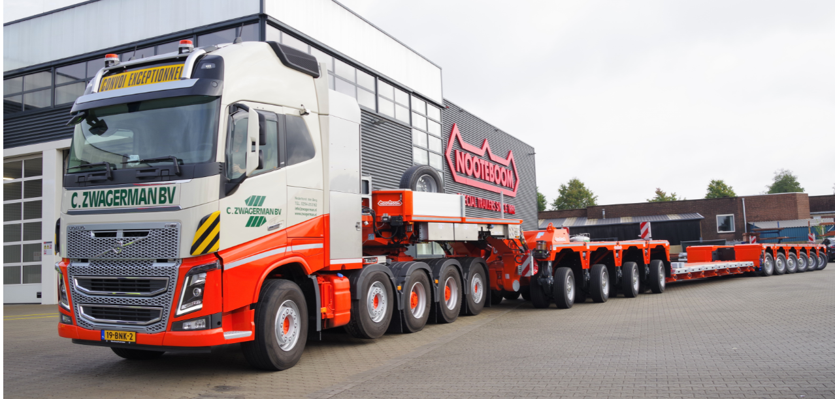
Photo caption 1: With the development of the IC Interdolly Compact with 4-axle lines, Nooteboom has introduced the largest low-loader combination with a load capacity of more than 100 tonnes at 80 km/h.

Nooteboom has further expanded their EURO-PX low-loader programme. The latest addition is the 4-axle IC Interdolly Compact which, combined with 6 steered pendle axle lines at the rear, is now the largest low-loader combination in the Nooteboom EURO-PX low-loader programme. The first 4+6 low-loader combination, type EURO-147-46(ICP), is going to C. Zwagerman Transport from Nederhorst den Berg (NL). This combination has been optimised for the German regulations: an axle load of 12 tonnes at 80km/h, so that loads of 100 tonnes can be transported efficiently in and to Germany.

Photo caption 2: The latest EURO-147-46(ICP) low-loader combination with a load capacity of 100 tonnes has been optimised for the German regulations.

Optimised for German exemptions
Cor Zwagerman, director/owner of C. Zwagerman Transport: “The cranes and machinery that we transport are getting heavier all the time. This new low-loader is the largest that Nooteboom has ever put on the road. With a German exemption the load capacity is just over 100 tonnes and this enables us to enter a new segment of the market. This Nooteboom 4+6 low-loader has several advantages for us. In order to adapt the low-loader, as far as possible, to comply with the German regulations for exemptions, the axle distance has been increased to 1.51 m instead of the usual 1.36 m. In practice this means that due to this larger axle distance, which minimises the load on bridges and viaducts, the exemptions in the various federal states of Germany are easier to obtain. Another advantage is the close coupling system which makes it easy for us to convert the trailer into a 10-axle semi low-loader. In this configuration the load capacity increases to around 110 tonnes and the steering of the Interdolly can easily be adjusted to this shorter configuration. The relationship between Nooteboom and Zwagerman goes back more than 50 years and this gave us enough confidence to award the order to Nooteboom.”

Photo caption 3: Director and owner Cor Zwagerman: “This latest Nooteboom 4+6 low-loader has several important advantages for us.”

Universally exchangeable
Cor Zwagerman: “By choosing the 4+6 low-loader of Nooteboom, all the components – such as the gooseneck, Interdolly, load floor and axle assembly – are universally exchangeable with our 3+5 EURO-PX Nooteboom low-loader. This means we can put no less than 14 different configurations on the road and for us this is an economical and efficient alternative to modular trailers, which are complex and more expensive.”
When purchasing the latest 4+6 Zwagerman opted for a flat, shallow, 2750mm wide extendible floor as well as a narrow spine floor for the transport of large tracked vehicles. This spine floor also comes with mattresses to extend the load floor’s width, in a high or low position. The Interdolly with 4 axle lines is optionally equipped with a hydraulic landing leg which makes it even easier to couple/uncouple the load floor and the Interdolly. The gooseneck of the low-loader can be used on a 4-axle or 5-axle tractor.

Simple operation
Driver Paul van Wijk: “In our company several drivers must be able to operate a low-loader. This is no problem because the Nooteboom trailers are simple and intuitive to operate, especially in comparison with modular trailers and their complex operation. I drove the first Nooteboom low-loader with an Interdolly ten years ago. At first I did not see the advantage. In those days we had been working with a Jeepdolly for years. Initially I thought the smaller steering angle of the 1st generation Interdolly would be a disadvantage. But in practice this was not a problem and the new Interdolly now has a steering angle of up to 70 degrees. This makes the combination much more manoeuvrable than before and reversing is much easier than with a Jeepdolly.”
Photo caption 4: Driver Paul van Wijk: “Nooteboom low-loaders are easy to operate, especially in comparison with a modular trailer.”

About C. Zwagerman Transport
For many people the name Zwagerman brings back memories of plodding FTF’s, Nooteboom low-loaders and long crane booms over the cab. Cor Zwagerman: “I started work in my father’s company when I was 16 years old. In those days we had a fleet of 150 hire cranes and about ten heavy tractors and low-loaders to transport all those cranes. We solved any technical problems ourselves and in doing so I picked up a lot of technical knowledge. In 1994 I started out in the heavy transport business myself. Initially with one single truck, but I was soon able to expand the fleet. Our company specialises in the transport and assembly of cranes in Europe. We carry out these activities for construction companies, crane hire companies, dealers and all the major suppliers of new cranes. C. Zwagerman Transport is a proper family business: my son Martin is co-owner.

+++++

Note to the editor (not for publication): Digital photographs in high resolution are attached and free for publication.

