Sennheiser successfully closes fiscal year 2021
The family-owned company achieved sales of 636.3 million euros in 2021 and recorded significant growth

Wedemark, September 6, 2022 – The Sennheiser Group successfully closes the 2021 financial year. Overall, the family-owned company generated sales of 636.3 million euros and earnings before interest and taxes (EBIT) of 31.6 million euros. Sennheiser was thus able to record sales growth of 62.8 million euros – in a year that continued to be influenced by the effects of the global pandemic and through the repositioning of the company. After more than 50 years, the Sennheiser Group will from 2022 once again focus entirely on the professional audio business.
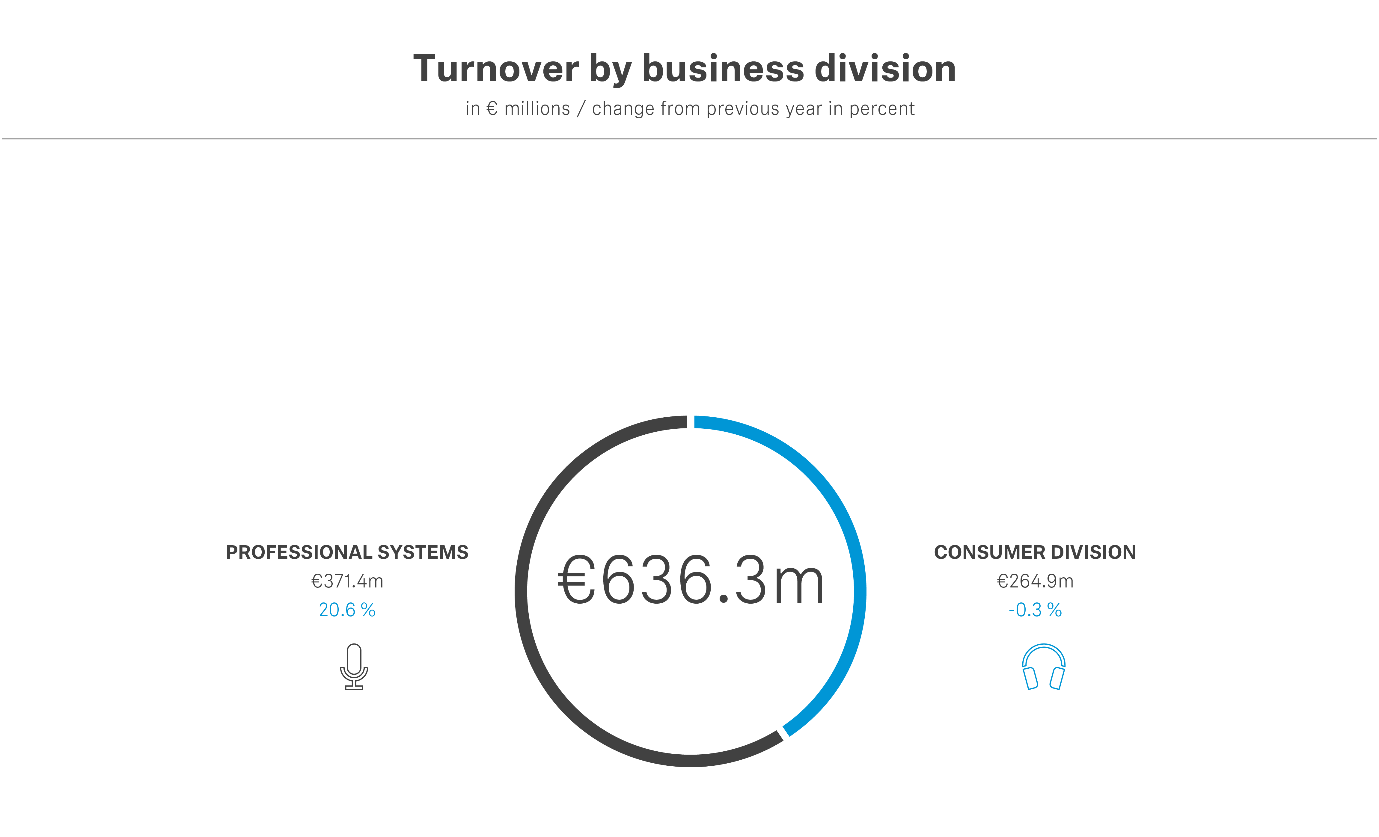
“We can look back on a very good financial year and, at the same time, have laid all the foundations for a successful future as a professional audio company,” said co-CEO Daniel Sennheiser. “Although the event industry initially remained influenced by uncertainty at the beginning of the year, it was important for us to move confidently into the future,” added co-CEO Andreas Sennheiser.
The Sennheiser Group generated sales of €636.3 million and earnings before interest and taxes (EBIT) of €31.6 million in 2021. This already includes preparatory expenses for the sale of the Consumer business.
With the Pro Audio, Business Communications and Neumann business units, the Professional division achieved sales of €371.4 million, representing growth of 20.6 percent compared to the previous year. Growth was driven by the upswing in the event and music industry, the strong growth in business with Neumann’s studio products, and increased demand for professional meeting solutions due to newly emerging formats of hybrid working and learning in the Business Communications area. The Consumer Electronics division achieved sales of 264.9 million euros, only slightly below the previous year’s level.

Turnover by region
The Sennheiser Group’s turnover growth was reflected in all regions. From a global perspective, EMEA remained the market with the largest sales at €279.7 million in 2021; growth here compared to the previous year was 0.4 percent. In the APAC region, sales amounted to €166.0 million, representing growth of 14.8 percent. The Americas region generated a total of 190.6 million euros; the largest increase in turnover was achieved here with 26.8 percent.
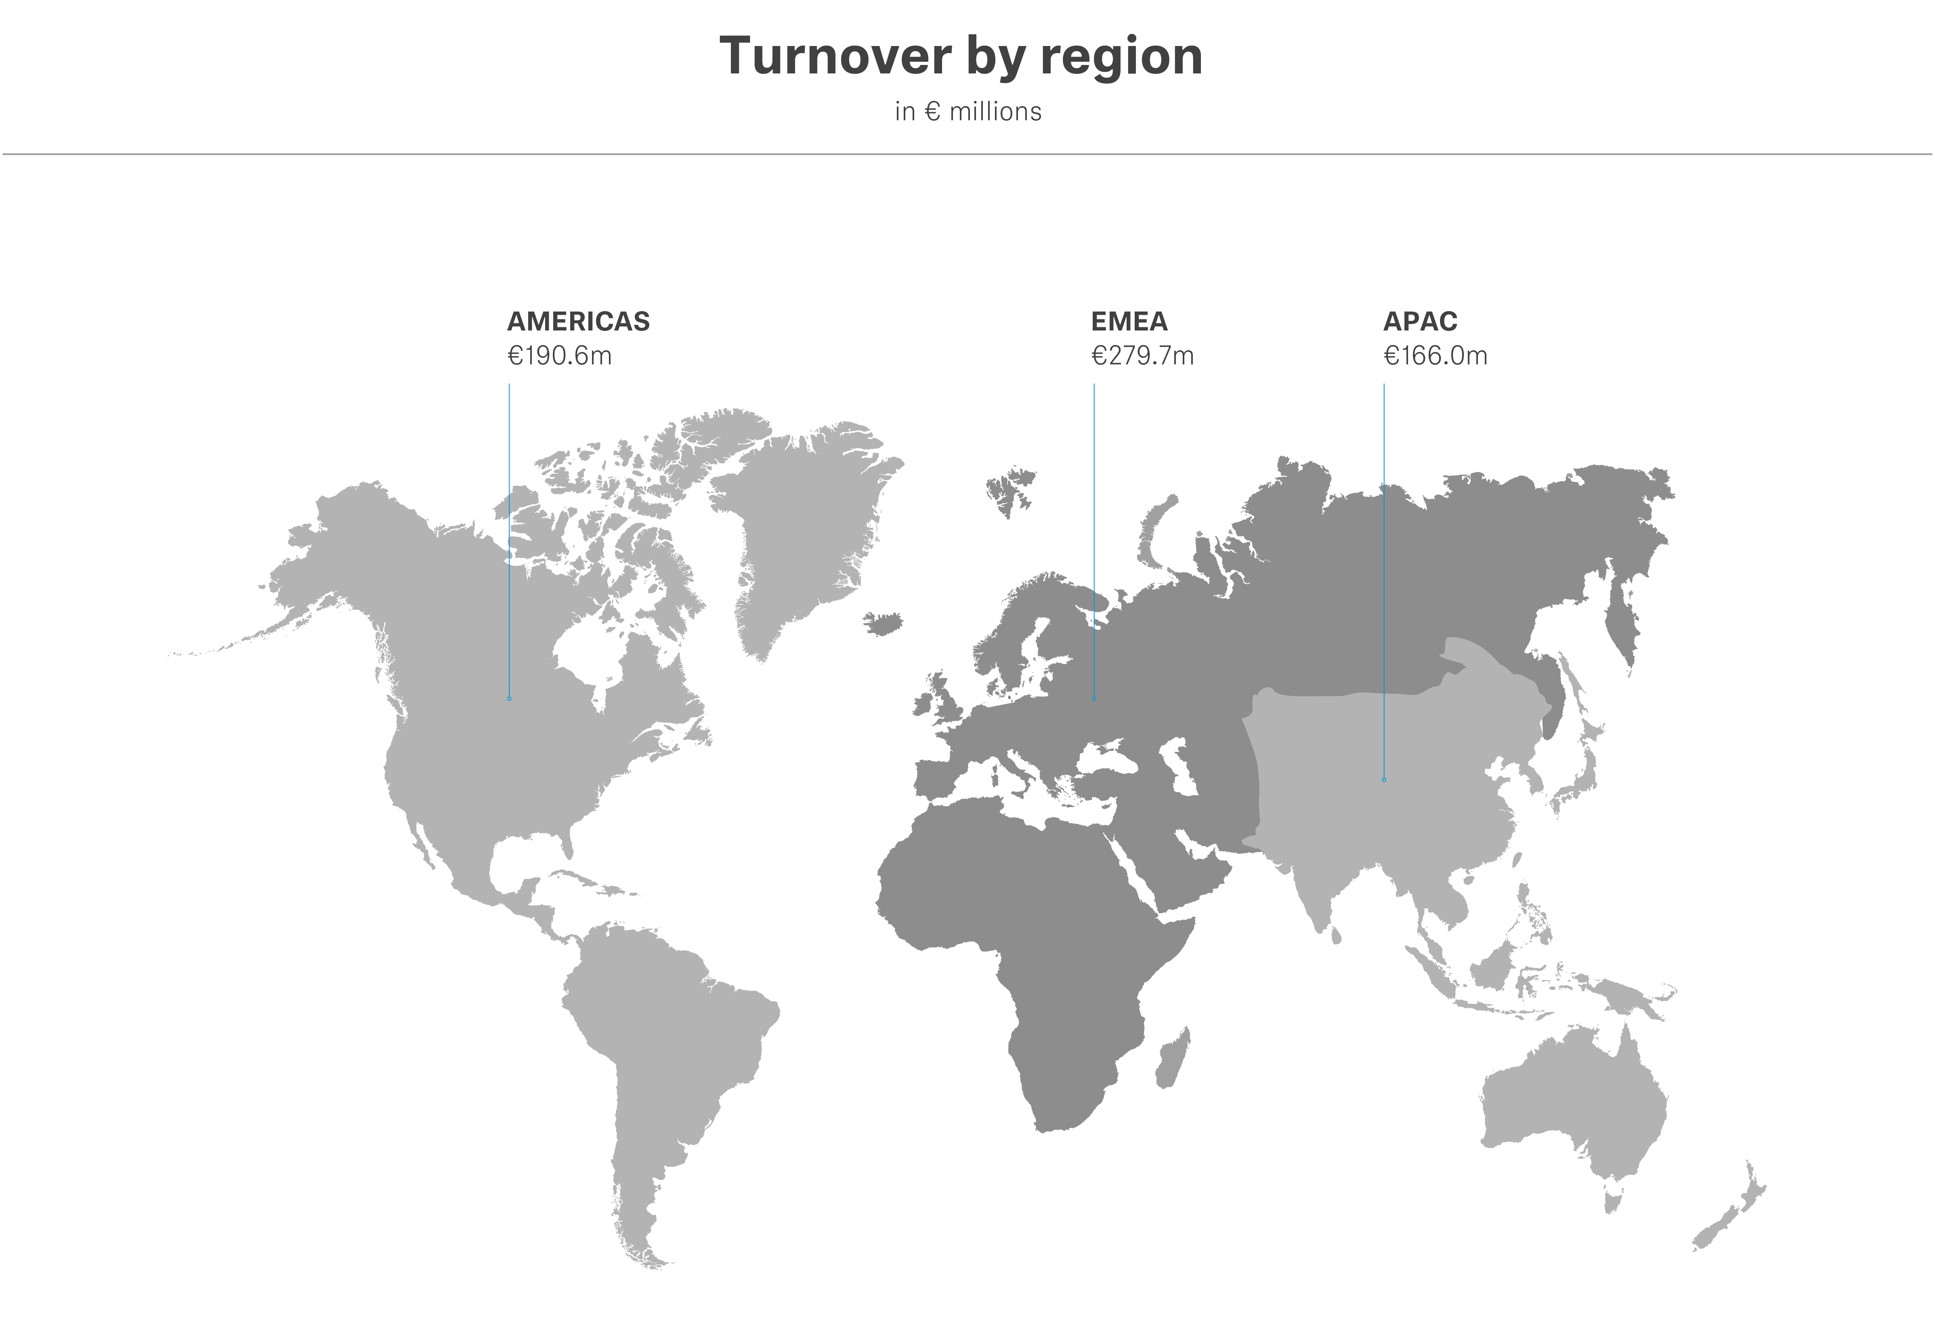
Sustainable growth under own steam
With its approximately 1,970 employees in the three business units Pro Audio, Business Communications and Neumann, Sennheiser intends to grow sustainably on its own and further expand its strong position as a provider of professional audio solutions. Co-CEO Daniel Sennheiser explained: “We will invest, for example, in innovative technical solutions and new distribution channels. These are the best prerequisites for continued success in the future.” Sennheiser already invested significantly in fiscal year 2021: 49.4 million euros went into the development of new products and technologies. This corresponds to 7.8 percent of total revenue.
After more than 50 years, the company is once again focusing entirely on its professional business. Effective March 1, 2022, Sennheiser’s Consumer business has been fully transferred to Sonova AG. Together, the two companies will operate under the Sennheiser brand umbrella and provide Sennheiser customers with premium audio solutions.
“The year 2021 has shown that this company and the entire Sennheiser team are capable of achieving incredible things,” said Andreas Sennheiser, co-CEO, summing up the extraordinary year: “To restructure the group, to carve out a business segment, to redevelop strategies for all areas and, in parallel, to realize an extremely successful and growing business, is an incredible achievement by all employees.”

Supply chain challenges and geopolitical developments
Like many companies, the Sennheiser Group is confronted with challenges in the supply chains as well as geopolitical developments. These include the limited availability of chips worldwide as well as the effects of Russia’s war of aggression on Ukraine. “The regionalization of supply chains has already begun; and this will also have an impact on our business,” summarized Andreas Sennheiser. “We are therefore continuously aligning ourselves with the ever-changing framework conditions and developing our business processes – especially our supply chain – accordingly.

“At Sennheiser, large parts of the value chain have always been in our own hands. This gives us greater influence over important areas of the value chain and therefore also reliability for our customers,” added Daniel Sennheiser. The Sennheiser Group is currently investing significantly in the production facilities at its headquarters in Wedemark, Germany, as well as in the expansion of the plant in Braşov, Romania. This not only enables the audio specialist to respond more flexibly to market requirements but is also an important part of the company’s growth strategy.

Future in the Professional Business
In the Business Communications business area, Sennheiser will greatly expand its portfolio of audio solutions for universities and corporate meeting rooms in the coming years. The goal is to be present with Sennheiser products in the majority of the world’s lecture halls and meeting rooms and to offer customers solutions that are not only audibly better and easier to use, but in particular address the challenges of hybrid working and learning.

In the Pro Audio segment, the audio specialist plans to continue impressing its customers in the live and broadcast business with reliable audio solutions and first-class sound quality. Complementary software solutions for optimal workflows are to expand the range. In particular, Sennheiser sees growth opportunities in the fast-growing markets for semi-professional applications, such as audio-for-video.

Neumann enjoyed especially great success in 2021 and, with its legendary products, is one of the world’s best-known brands for studio-quality audio solutions. This business area is to be expanded in the future with a strong focus on digital workflows and enhanced software and service solutions. One example of investment in this area is Neumann’s collaboration with the Swiss company Merging Technologies, which has been part of the Sennheiser Group since July 1, 2022.

About the Sennheiser Group
Building the future of audio and creating unique sound experiences for our customers – this is the aspiration that unites the employees of the Sennheiser Group worldwide. The independent family-owned company Sennheiser was founded in 1945. Today, it is managed in the third generation by Dr. Andreas Sennheiser and Daniel Sennheiser, and is one of the leading manufacturers in the field of professional audio technology. Within the Sennheiser Group are Georg Neumann GmbH (Berlin, Germany), manufacturer of studio-grade audio equipment; Dear Reality GmbH (Düsseldorf, Germany), known for its binaural, Ambisonics, and multichannel encoders with realistic room virtualization; and Merging Technologies SA (Puidoux, Switzerland), specialist in high-resolution digital audio recording systems.
sennheiser.com | neumann.com | dear-reality.com | merging.com

Press Contact
Sennheiser electronic GmbH & Co. KG
Mareike Oer
Head of Corporate Communications
T +49 (0)5130 600-1719
mareike.oer@sennheiser.com

