Everyday wireless audio companions
Sennheiser introduces affordable CX 350BT and CX 150BT wireless earphones for everyday listening pleasure

Sydney/Las Vegas, January 6, 2020 – Life moves fast, but with Sennheiser’s new CX 350BT and CX 150BT earphones it’s easy to keep pace. Showcased during CES 2020 in Las Vegas (January 7-10), the audio specialist’s new in-ear wireless models are ideal companions for enjoying music on the go. With Sennheiser sound quality, a long-lasting 10-hour battery life and portable designs, the CX 350BT and CX 150BT have been created to accompany listeners anywhere. Additionally, the CX 350BT features a dedicated voice assistant button for fast access to Siri or Google Assistant.

When it comes to listening pleasure, the latest earphones in Sennheiser’s wireless range deliver: Support for audio codecs SBC and AAC ensure a high-quality audio experience, while the CX 350BT additionally features AptX™ and AptX™ Low Latency support. On compatible devices, AptX™ Low Latency keeps sound in perfect sync with onscreen action – ideal when enjoying movies or gaming. The CX 350BT and CX 150BT earphones are also Bluetooth 5.0 compatible to deliver fast and reliable connectivity and, thanks to multi-pairing, can be connected with two devices simultaneously.

With Sennheiser sound quality, a 10-hour battery life and portable designs, the CX 350BT and CX 150BT have been created to accompany listeners anywhere.

No matter how fast life moves, the CX 350BT and CX 150BT can be counted on to keep pace thanks to their 10-hour battery life and fast, convenient USB-C charging. Their sleek, compact design has also been built to ensure comfort and durability. Four different sizes of ear tips make it easy to achieve a perfect, secure fit and offer excellent noise isolation when on the go. Both models will be available in black and white color variants.

“These new, accessible models in our wireless earphone range help consumers enhance their daily audio experience with better sound, while embracing the freedom of the latest wireless technology, a portable, sleek design and dependable quality. With the new CX350BT and CX 150BT, there really is no excuse not to enjoy better sound every day”, explained Jermo Köhnke, Product Manager at Sennheiser.

The earphones’ intuitive remotes make it easy to control music and phone calls. The CX 350BT additionally features a dedicated voice assistant button for immediate, at-a-touch interaction with Siri or Google Assistant, as well as additional smart features. Via the intuitive equalizer on the Sennheiser Smart Control app, users can customize their sound experience to their exact preference. The app also offers firmware updates and a podcast mode for enhancing speech content.
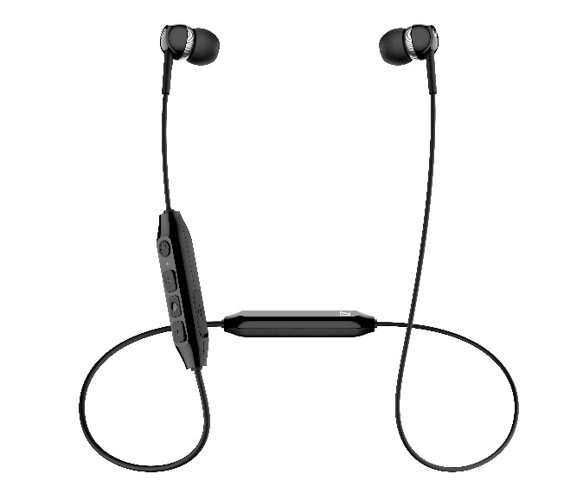

The CX 350BT features a dedicated voice assistant button for immediate, at-a-touch interaction with Siri or Google Assistant.

Priced at AU $109.95 / NZ $119.95 (MSRP), the CX 150BT is available in black from mid-January. A white color variant will be available from February. The CX 350BT earphones are priced at AU $149.95 / NZ $169.95 (MSRP) and will be available in black and white color variants from February.

About Sennheiser
Shaping the future of audio and creating unique sound experiences for customers – this aim unites Sennheiser employees and partners worldwide. Founded in 1945, Sennheiser is one of the world’s leading manufacturers of headphones, loudspeakers, microphones and wireless transmission systems. Since 2013, Sennheiser has been managed by Daniel Sennheiser and Dr. Andreas Sennheiser, the third generation of the family to run the company. In 2018, the Sennheiser Group generated turnover totaling €710.7 million. www.sennheiser.com

Global Press Contact Local Press Contact
Sennheiser electronic GmbH & Co. KG Sennheiser Australia & New Zealand
Jacqueline Gusmag Heather Reid
Communications Manager Consumer Communications Manager
T: +49 (0)5130 600-1540 T: +61 448 119 609
jacqueline.gusmag@sennheiser.com heather.reid@sennheiser.com

