Caverton achieves EASA certification for the Thales Reality H® AW139 simulator and its training center
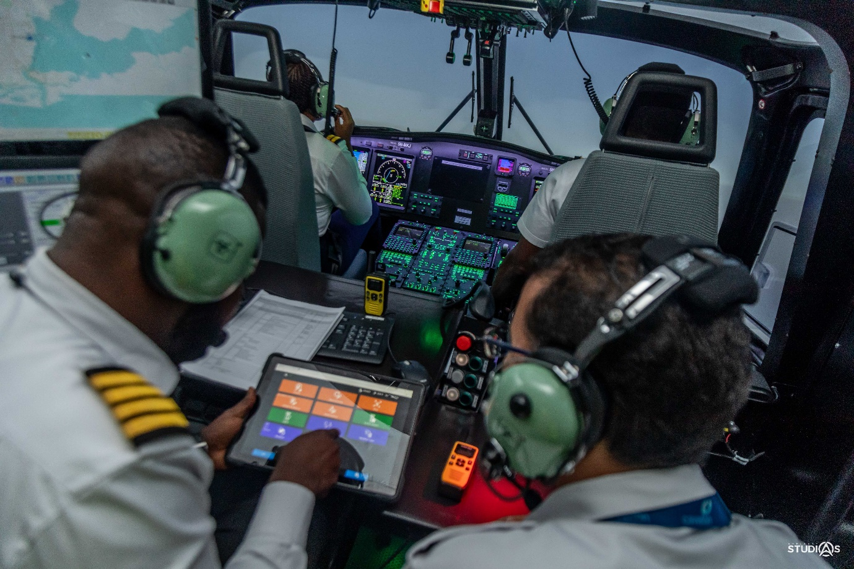©Caverton
Paris – La Défense, November 3, 2021 – Caverton has just been qualified by the European Union Aviation Safety Agency (EASA) as an official full flight simulator operator, using the Thales Level D, Reality H full-flight simulator product for the AW139 helicopter. It is the first Reality H system operational in Africa, and operated by Caverton.
Developed in France, the AW139 Full Flight Simulator offers pilots an immersive experience with extremely faithful reproduction of their operational missions, to train in complete safety for a variety of complex situations (adverse weather conditions, helicopter failures and emergencies), that could occur in the real flight operations. It offers pilots high-level training opportunities with the most comprehensive and versatile equipment available on the market.

Having been approved by EASA, the Caverton Aviation Training Centre, located within the Murtala Muhammed International Airport, Lagos, Nigeria, is now able to commence commercial training operations for AW139 helicopter operators based in the African continent and beyond.

“We are excited to have reached this significant milestone of the qualification of our organisation and the simulator. We selected the Thales Reality H product because of its state-of-the-art features and the fact that we could modify key aspects to suit our operating environment in Africa. With this new training centre now operational, Caverton will provide state-of-the-art training, including initial type rating, recurrent training and proficiency checks, for offshore and onshore missions as well as military and special operations. There could be no better time to experience this pioneering achievement for Caverton. This has opened the door to more flexibility in African aviation overall, and for us, it is a huge achievement.”
Aderemi Makanjuola, Chairman of Caverton Offshore Support Group (COSG)

“Reality H® is ideally suited to the type of missions flown by helicopter pilots today and the special skills they need to develop. It offers high levels of performance and unparalleled realism and flexibility. Thales’s role is to help helicopter operators and pilots prepare for their missions, and with Reality H® we’re proud to provide our customers with the solution that makes this possible.” Peter Hitchcock, Vice President for Thales’s Training & Simulation business.
About Caverton
Caverton Helicopters is a subsidiary of the Caverton Offshore Support Group Plc, which is a fully, integrated offshore support company providing aviation and marine logistics services to businesses operating in the oil and gas industry in Nigeria and across West Africa. Caverton is the largest indigenous aviation logistics support company in Nigeria, with over 18 years experience providing fixed wing and rotary wing services to the oil and gas industry. The company currently operates a mixed fleet of 28 aircraft across multiple locations in Nigeria and West Africa. Since inception, Caverton has successfully operated for major International Oil Companies with a combined contract value of over (US) $2bn. Caverton’s capabilities also extends to the provision of third-party rotary and fixed wing Maintenance, Repair and Overhaul (MRO) services at its facility in Lagos. The company is also an NCAA Approved Training Organisation (ATO) and provides ground and flight training courses.
About Thales
Thales (Euronext Paris: HO) is a global high technology leader investing in digital and “deep tech” innovations –connectivity, big data, artificial intelligence, cybersecurity and quantum technology – to build a future we can all trust, which is vital to the development of our societies. The company provides solutions, services and products that help its customers –businesses, organisations and states – in the defence, aeronautics, space, transportation and digital identity and security markets to fulfil their critical missions, by placing humans at the heart of the decision-making process.
Thales has 81,000 employees in 68 countries. In 2020 the Group generated sales of €17 billion.

PRESS CONTACTS
LIENS WEB
Groupe Thales
Aéronautique civile
Thales Media Relations
Civil & Defence Aerospace
Maria Mellouli
+33 (0)6 89 73 25 47
maria.mellouli@thalesgroup.com
Caverton
Lolade Abiola
+234 (0)703 411 0990 lolade@caverton-helicopters.com

