Merging to unveil Ovation 11 at ISE 2025 in Barcelona

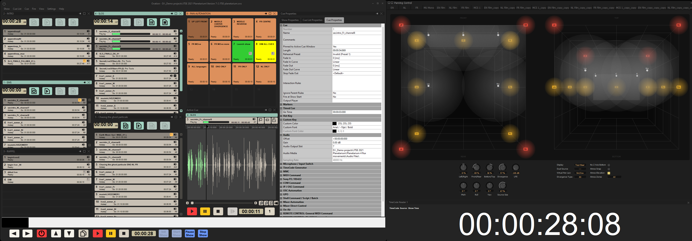

Barcelona, Spain, January 2025 - Merging Technologies is excited to preview Ovation 11 at the highly anticipated ISE Show in Barcelona, running from February 4–7, 2025. The latest evolution of Ovation boasts a bold redesign, enhanced usability, and cutting-edge features that redefine intuitive audio playback and show synchronisation.

A game-changer in professional playout systems, Ovation is the preferred solution for seamless synchronisation and playback of audio content, catering to a wide range of applications. Whether it’s a theatre performance, opera, musical, broadcast with live operators, or a self-contained, automated installation in museums, multizone shopping malls, or immersive experiences, Ovation delivers unmatched reliability.

From grand-scale productions like the Dubai Expo Opening and the Fête des Vignerons (a once-in-25-years spectacle in Switzerland) to theme parks worldwide, Ovation rises to the challenge with redundant, precision timing and advanced synchronisation capabilities. It supports all major formats, including Time Code, MTC, IP, GPIO, (ADM) OSC, and more, while integrating perfectly with the common immersive renderers.

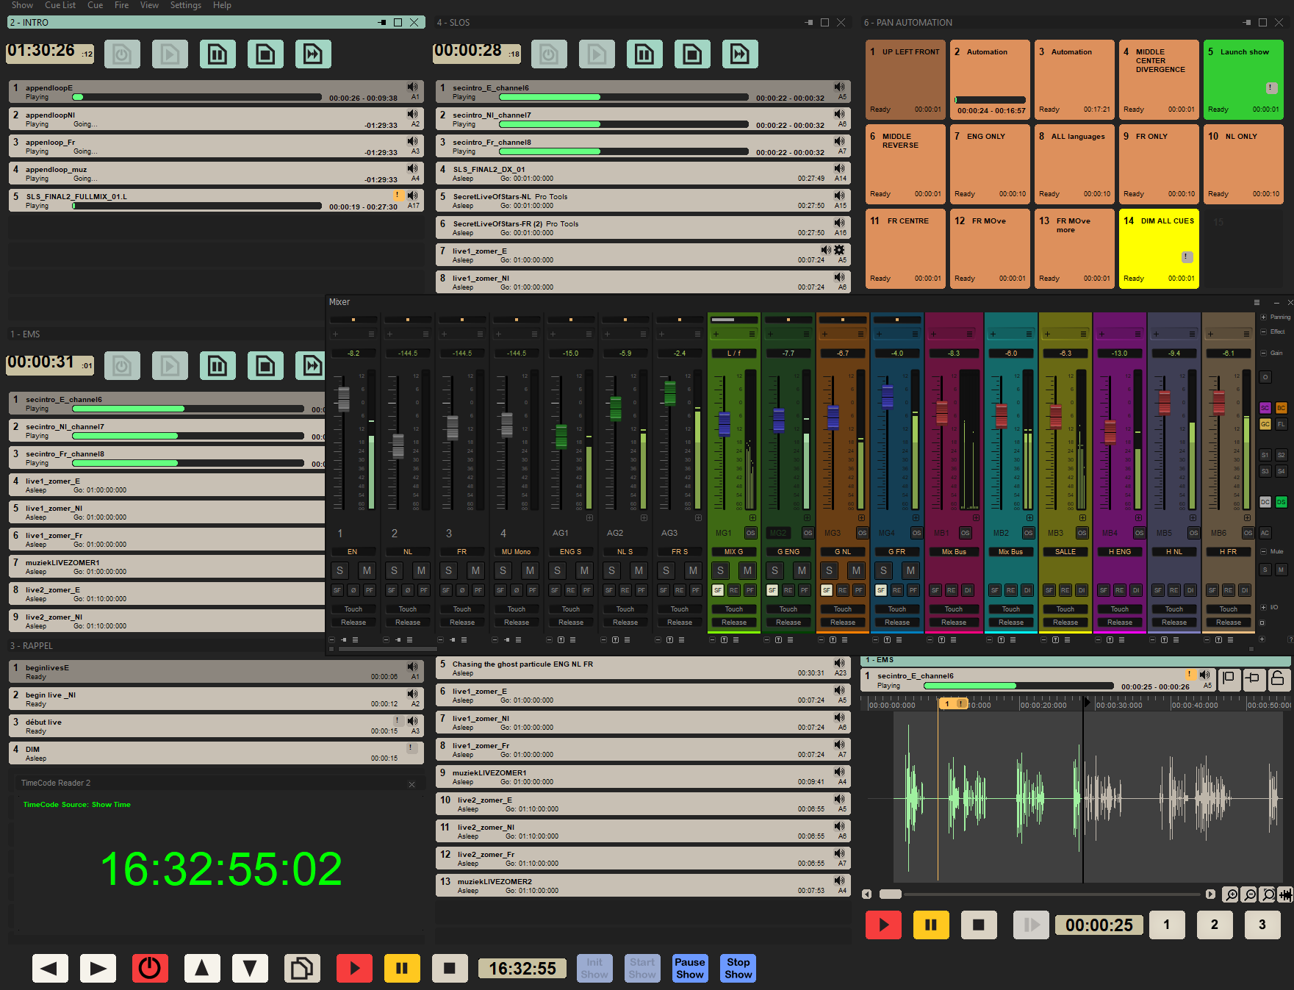
Ovation seamlessly handles professional multitrack audio formats and sample rates without the need for conversion, featuring an integrated mixer and renderer that scales up to immersive audio formats. For those who prefer hardware, Ovation connects effortlessly to external consoles and supports control protocols such as HUI, Eucon, and OASIS (for Lawo and Stagetec). Automation is stored in each CUE independently and can be changed or adapted at any time. Thanks to Pyramix 15 integration, editing and publishing cues have never been faster – enabling on-the-fly adjustments with a single click.

What’s New in Ovation 11?
Ovation 11 delivers a host of exciting updates and enhancements, including:
· Complete UI/UX Overhaul: A sleek, modern dark interface designed for effortless navigation
· Revamped Mixer: Fully customisable configurations – move buses, strips, and aux channels to suit your workflow
· Enhanced Strip & Bus Tools: Expanded sidechain capabilities for unmatched flexibility
· Optimised Merging VS3 Plugins: Redesigned for superior performance
· And More! Numerous under-the-hood improvements and bug fixes for a smoother, more reliable user experience

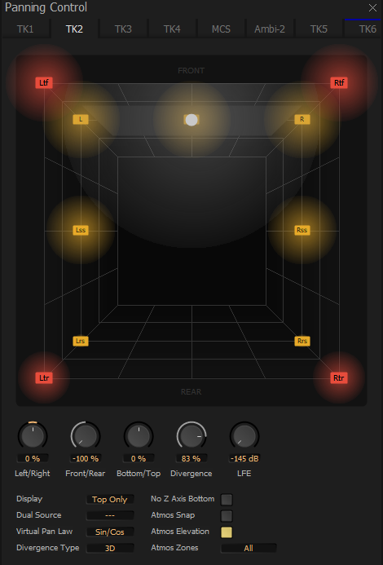
A dedicated team from Merging Technologies, including Maurice Engler (Product Owner - Software Solutions), will be at the ISE Show to demonstrate Ovation 11 and answer your questions.

“It’s with great pride and excitement that we unveil Ovation 11 to the sound engineering and show design community,” says Engler. “This marks the first release since our integration with the Sennheiser Group where Ovation takes center stage. We are confident that Ovation 11 will exceed industry expectations and cement its place as the go-to solution for professional show control.”

Ovation 11 remains a native (ASIO/Windows-based) show controller and playout system compatible with any sound card. It is available in three software tiers (Elements, Pro, and Premium) with an optional Masscore real-time engine, enabling up to 384 low-latency I/O channels with Merging converters or direct integration with RAVENNA/AES67/ST2110.

Ovation 11 will officially launch in Q2 2025 and will be showcased at ISE on the Sennheiser Group booth 3B550.

For images and assets, please click here.

ABOUT MERGING TECHNOLOGIES
Merging Technologies is a Swiss manufacturer with over 30 years of experience in developing groundbreaking, professional Audio and Video products for a wide range of entertainment and media industries. In July 2022, Merging became part of the Sennheiser group and is integrated with Neumann.Berlin. With a dedicated user base in the elite end of the music, film, television, mastering and performances industries, Merging is committed to developing product ranges with unrivalled quality and flexibility, no matter what the application. Merging builds tools for people who want more from their systems, have an inherent need to push boundaries, and believe that quality always comes first.
Press contact:  Emma Davidson  Copper Leaf Media  emma.d@copperleaf.media |  | Contact:  Maurice Engler  Product Owner | Software  Maurice.Engler@merging.com  +41 79 637 94 70

