EMBARGOED UNTIL THURSDAY, OCTOBER 6TH, 2022 AT 11:59AM EDT

New Powered Eurorack Cases and Semi-Modular Synth Accessories from Moog
Moog Music releases an assortment of new accessories for current synth owners and those interested in getting into Eurorack for the first time. Now available at Moog dealers worldwide.

Download Photos Here

Moog Powered Eurorack Cases (60HP & 104HP)
Moog’s new Powered Eurorack Case, available in both 60HP and 104HP formats, invites modular artists to expand their setups and serves as the perfect jumping-off point for anyone interested in constructing their very first Eurorack system.

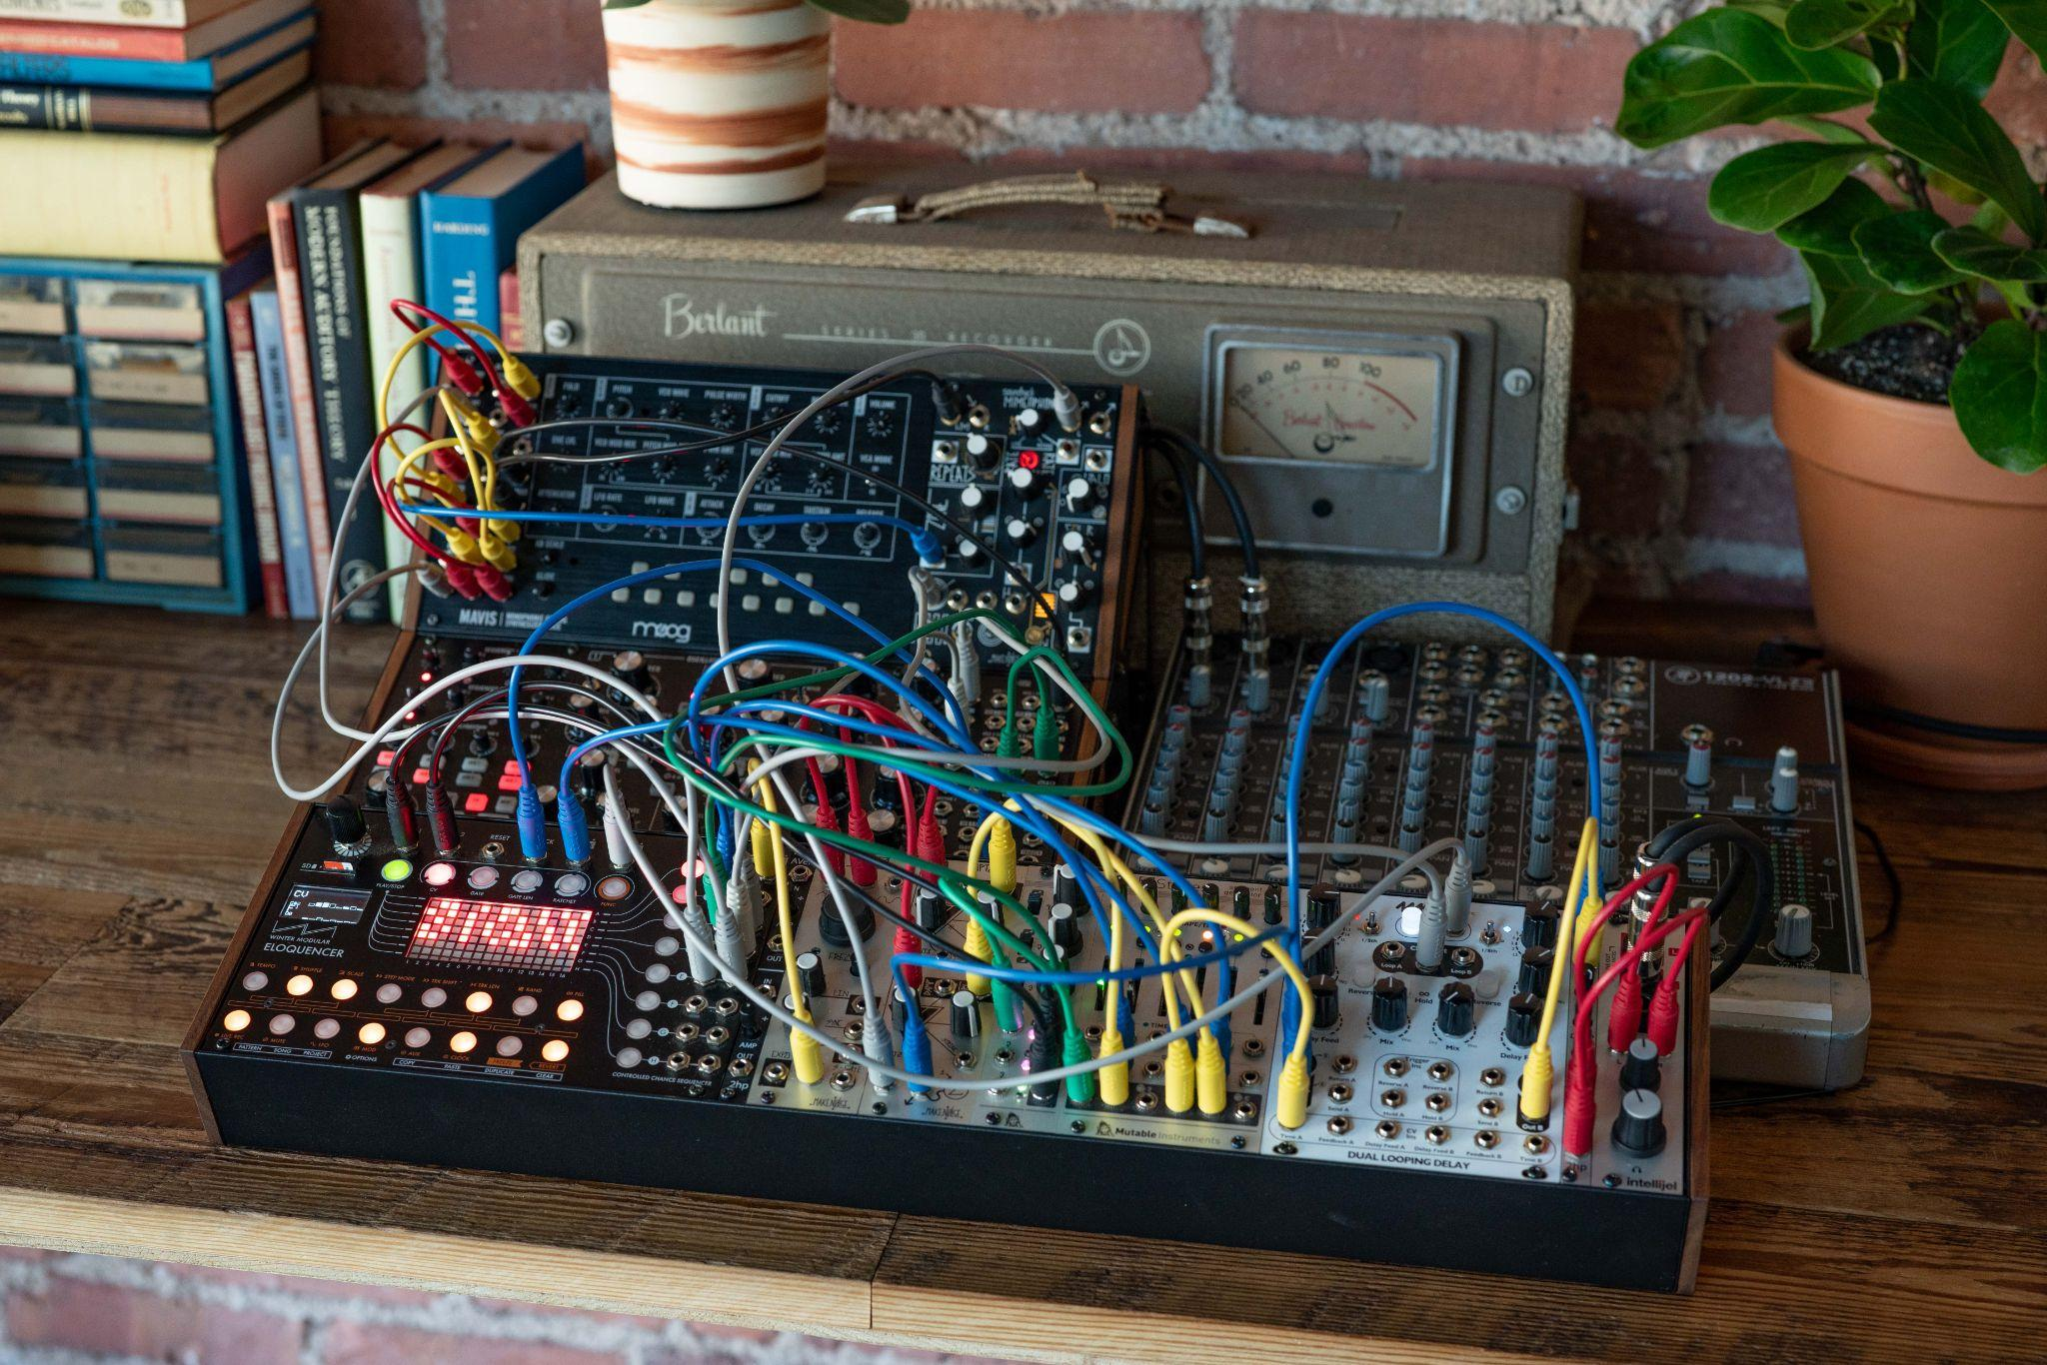

The intuitive plug-and-play unit features 10 Eurorack-compatible 16-pin power connectors and is designed for low-noise performance, high efficiency, and convenient input voltage compatibility. Mount your modules perfectly every time with the included sliding nuts and mounting screws. Once assembled, all modules can be turned on or off as a system using the rear-mounted power on/off button.

Featuring a durable aluminum case with wood sides, the Moog Powered Eurorack Case offers a versatile solution for expanding your setup of Moog’s semi-modular family of synthesizers (Mother-32, DFAM, Subharmonicon, Mavis) and the case’s angled extrusion mounts into Moog 2-Tier, 3-Tier, and 4-Tier Rack Kits. The 60HP case allows for easy expansion of Mavis alongside smaller Eurorack modules, while the 104HP option perfectly fits Mavis plus one Mother-32, DFAM, or Subharmonicon.

Learn more about Moog Powered Eurorack Cases here.

Dust Covers for Matriarch, Grandmother & More
Moog’s latest dust covers are designed specifically to protect Matriarch, Grandmother, two-tier setups, and three-tier setups, made with high-quality materials and features customized for these instruments and configurations.

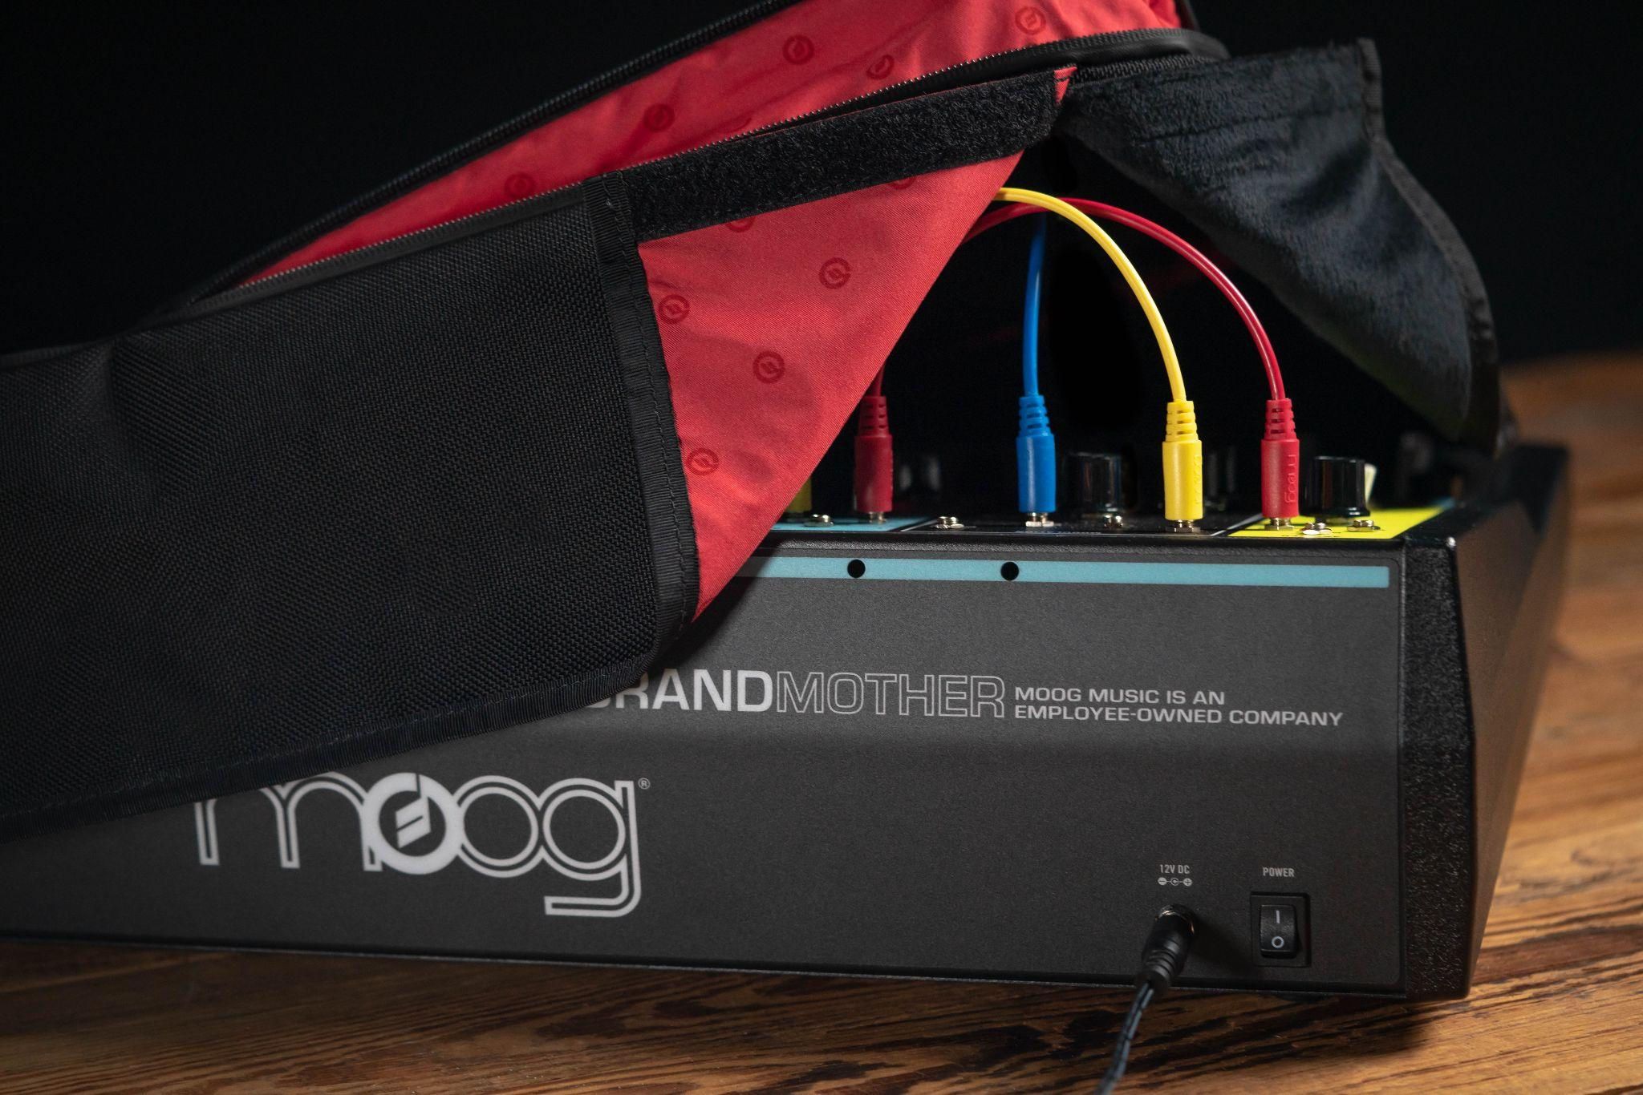

Protective coverings are essential for keeping these coveted semi-modular synths safe when not in use.

Each water-repellant dust cover is made from rugged Ballistic Cordura to safeguard gear from dust, spills, and other studio (and stage) mishaps, while the ultra-soft interior remains gentle against the instrument. This protective covering is custom fit with room to accommodate patch cabling and rear I/O panel access.

Learn more about Moog semi-modular dust covers here.

Available at Dealers Worldwide
Moog Powered Eurorack Cases and dust covers for owners of Moog semi-modular synthesizers are now available through authorized dealers worldwide. To locate a dealer near you, visit our dealer locator or contact our team directly at sales@moogmusic.com.

