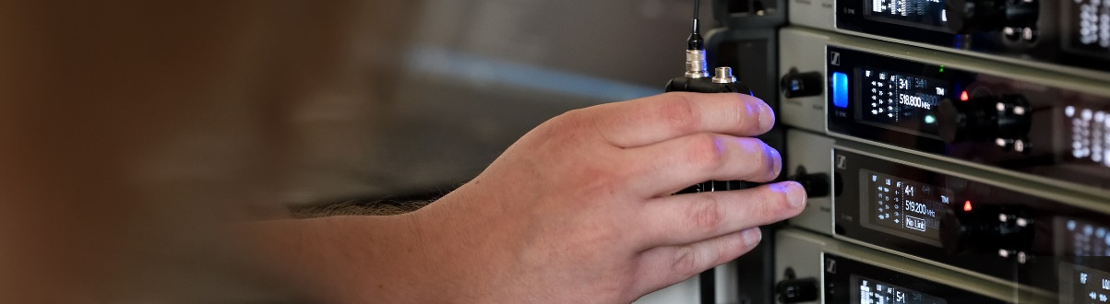Expand your expertise in RF wireless
Join the latest live seminars in Sennheiser’s #DontStopTheEducation series

Sydney/Wedemark, November, 2020 – Brush up your RF wireless knowledge with seven new #DontStopTheEducation seminars. Sennheiser experts Brian Walker, Greg Simon, Jamie Criswell, Thom Salisbury, Jonas Næsby, Vincent Tilgenkamp and Volker Schmitt are looking forward to meeting you in the live seminars and answer your questions.

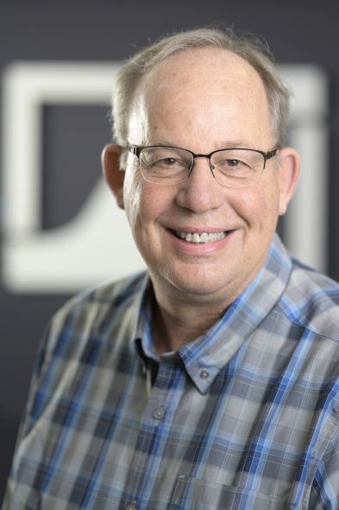 | 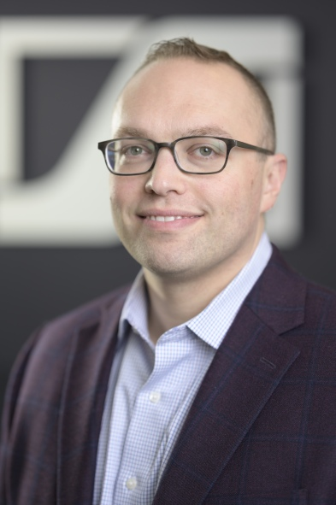 | 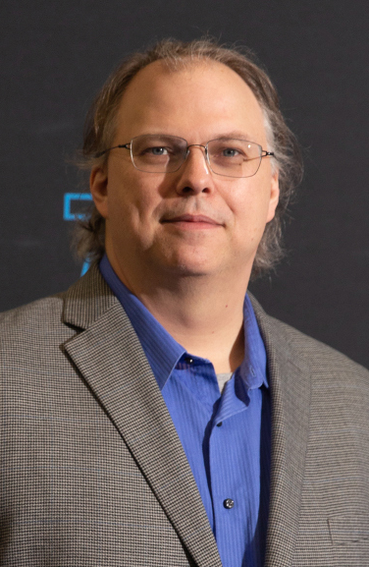 | 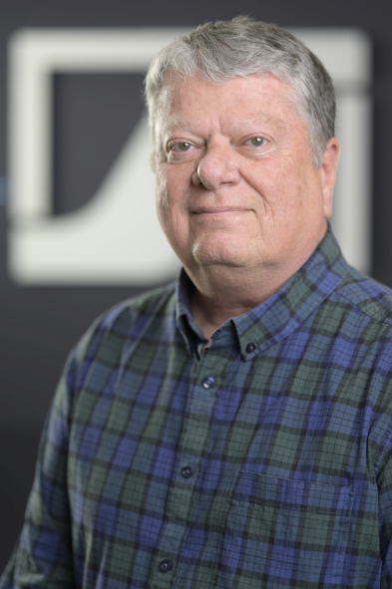
Learn more about RF wireless technology with Sennheiser experts Brian Walker, Greg Simon, Jamie Criswell and Thom Salisbury (from left to right)

Analog wireless
Despite the move to digital, analog wireless transmission remains a reliable, robust, latency-free and economical alternative for wireless microphones. In this seminar, Brian Walker will cover the basics of analog wireless from frequency coordination to power outputs.
Registration is now open for the following course options:
Wednesday, 11 November, 4:00 (AEDT)
Friday, 20 November, 7:00 (AEDT)
Thursday, 3 December, 4:00 (AEDT)
Thursday, 10 December, 7:00 (AEDT)

Professional Digital Wireless Systems
Jamie Criswell will take an in-depth look at the components and advantages of professional digital wireless systems and explain how best to implement a system.
Registration is now open for the following course options:
Thursday, 12 November, 7:00 (AEDT)
Friday, 4 December, 7:00 (AEDT)

Digital 6000 in the Studio
Jamie Criswell will talk about professional digital wireless systems for the broadcast studio and explain how to select and implement the best solution in this environment.
Registration is now open for the following course options:
Wednesday, 18 November, 16:00 (AEDT)
Thursday, 10 December, 16:00 (AEDT)

In-Ear Monitors
In this seminar, Greg Simon will cover the RF theory of wireless in-ear monitoring systems and explain how to set up multi-channel systems. Products covered are evolution wireless IEM G4 and 2000 series IEM systems, AC 41 and AC 3200 active antenna combiners as well as various antennas.
Registration is now open for the following course options:
Thursday, 12 November, 16:00 (AEDT)
Thursday, 19 November, 7:00 (AEDT)
Wednesday, 2 December, 16:00 (AEDT)
Friday, 11 December, 7:00 (AEDT)

WSM Lite
Thom Salisbury will demonstrate how to use the Sennheiser Wireless Systems Manager software to monitor and control your channels of wireless. This seminar will also cover creating virtual channels, labelling, and changing settings.
Registration is now open for the following course options:
Friday, 13 November, 7:00 (AEDT)
Thursday, 19 November, 16:00 (AEDT)
Thursday, 3 December, 7:00 (AEDT)
Wednesday, 9 December, 16:00 (AEDT)

Please also visit https://www.sennheiser.com/seminars for a full, up-to-date list of all upcoming SoundAcademy seminars and register free of charge for a session of your choice.

The high-resolution images of this press release can be downloaded at https://sennheiser-brandzone.com/c/181/BSypvxLf.

About Sennheiser
Founded in 1945, Sennheiser is celebrating its 75th anniversary this year. Shaping the future of audio and creating unique sound experiences for customers – this aim unites Sennheiser employees and partners worldwide. The independent family company, which is managed in the third generation by Dr. Andreas Sennheiser and Daniel Sennheiser, is today one of the world’s leading manufacturers of headphones, loudspeakers, microphones and wireless transmission systems. In 2019, the Sennheiser Group generated turnover totaling €756.7 million. www.sennheiser.com

Local Press Contact

Gabby Wallace
gabby.wallace@groundagency.com
0431 045 932

