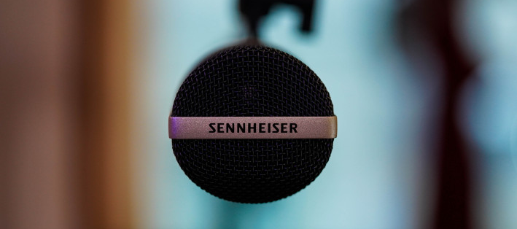Mother’s Day gifts to brighten up their podcasting
What do you buy for the passionate podcaster in the family? It’s time to leave behind clichéd Mother’s Day gifts and get her something she’ll really love from audio specialist Sennheiser

Wedemark, May 2022 – Podcasting is all about sharing stories and ideas with the world – and it has never been easier to get started and find an audience. But don’t let your loved one’s passion and creativity get held back by their gear – thanks to Sennheiser, it’s possible to capture and produce professional results with outstanding sound. Whether she is a first-time podcaster or an expert broadcaster, these gifts from the audio specialist will help make her podcasts stand out.

Incredible studio mics for outstanding sound
Natural sound reproduction and incredible versatility: the MK 4
Easy to handle and excellent value for money, Sennheiser’s MK 4 mic is optimized for voices and acoustic instruments and is an ideal choice for podcasting and voice-overs. It’s just as at home in professional project studios and as it is as a tool for home recordists. This large-diaphragm, true condenser microphone delivers fine resolution and outstanding sound quality with a powerful, warm sound.

- True condenser, large-diaphragm microphone for that typical condenser sound
- Full metal housing with an internally shock-mounted capsule to minimize handling and structure-borne noise
- Uncomplicated to use thanks to cardioid directivity, can take high maximum SPLs
- Low inherent self-noise for pristine audio recordings

Powerful, warm condenser sound – the cardioid MK 4 delivers outstanding audio for your podcast | 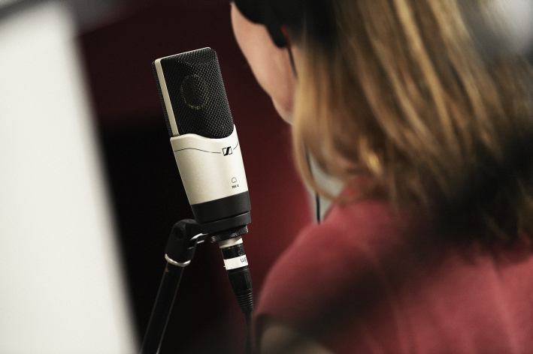

The classic: MD 421-II
For a truly special gift, why not give her a classic microphone that’s much loved by professional radio broadcasters? Sennheiser’s MD 421-II is a legendary cardioid mic with clear sound reproduction, its directivity makes it easy to handle and makes recording high-quality voice recordings a dream.

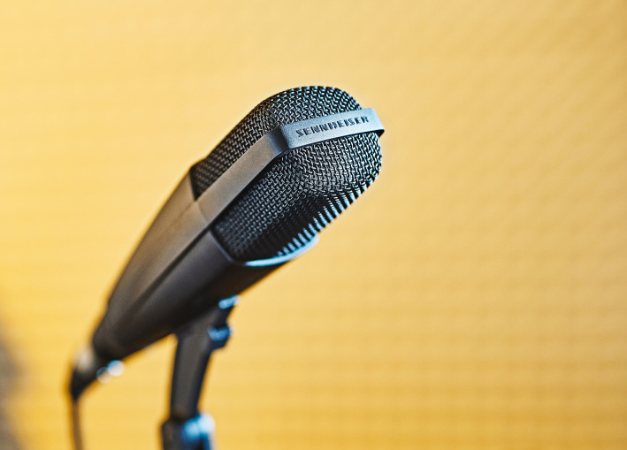 | The MD 421-II is a true studio classic

- Rugged professional microphone
- Clear sound reproduction
- Easy handling due to pronounced directivity
- Five position bass roll-off switch
- Effective feedback rejection

At home in broadcasting and podcasting: The MKH 416 shotgun mic
The MKH 416 is a short shotgun microphone that excels wherever precise voice pick-up from a distance is required. A revered classic that is used extensively in film, radio and television, this microphone has made its way into many podcasting and YouTube studios.

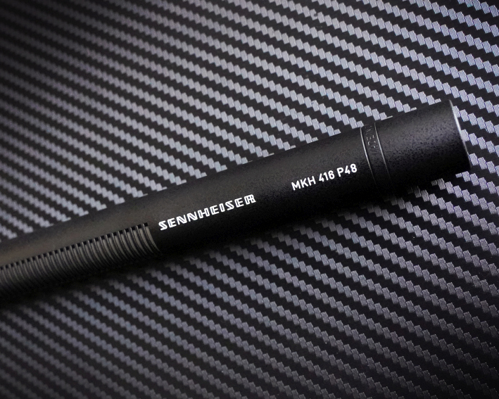 | The MKH 416 is a highly directive shotgun microphone for precise voice pick-up – and a firm favourite with many podcasters and voice-over artists

- Superb all-round microphone with excellent directivity
- High consonant articulation and feedback rejection
- Rugged and suitable for adverse climatic conditions
- Very low inherent self-noise and high sensitivity to capture all the nuances

Headphones for the podcasting studio
Experience powerful studio sound with the HD 200 PRO
Sennheiser’s HD 200 PRO headphones are the perfect companion for monitoring - providing powerful studio sound anywhere. They offer detailed sound with significantly reduced ambient noise, making it easier to concentrate on the task at hand. Rugged, durable and exceptionally dynamic, they make every creative task a pleasure and have been designed for comfort over long periods of use.

Your companion for powerful studio sound: the HD 200 PRO | 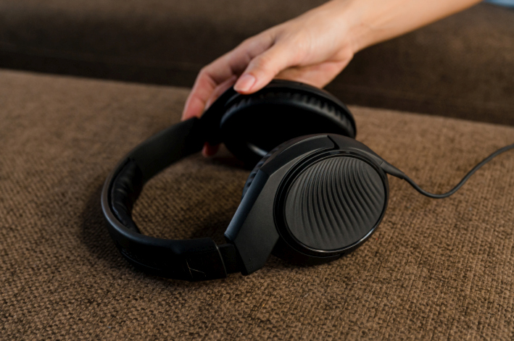

- Closed, around-ear headphone design to reduce ambient noise
- Sennheiser’s proprietary transducers deliver an outstanding stereo sound reproduction with powerful, punchy bass
- The soft ear cushions and the ergonomic design provide enhanced fit and comfort
- Robust 2.0m singled-sided cable, 6.3 mm (1/4”) stereo jack adaptor included

Created for the Pros: the HD 280 PRO
An accurate representation of audio is key when mixing or mastering work. When you give the HD 280 PRO, you’re giving them this professional edge. Eloquent lows, a distinct midrange and clear-cut highs are what define the HD 280 PRO, making them the perfect companion for podcasters. The HD 280 PRO boast an extremely robust, collapsible design with swiveling ear cups and excellent noise isolation.

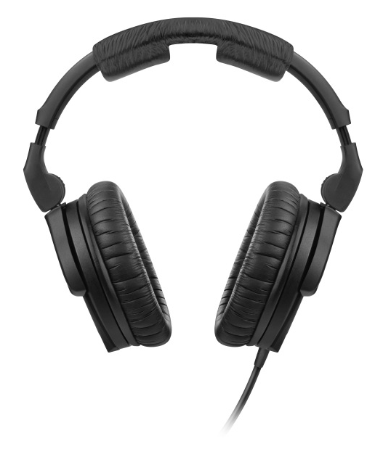 | Give a professional edge with the HD 280 PRO monitoring headphones

- Closed-back monitoring headphones with high attenuation of ambient noise
- Accurate, linear sound reproduction - hear it all with the ultimate precision
- Soft earpads for a comfortable fit
- Folding and rotating earcups for space-saving transport
- Tough, single-sided cable

Meticulously natural sound: HD 300 PRO headphones
The HD 300 PRO is an ideal gift for the podcaster who appreciates every nuance - and who will really appreciate these very special monitoring headphones. They deliver a linear frequency response – not interpreting sound but ensuring neutral transparency with a remarkable, three-dimensional quality. This natural, delicate sound reproduction is the key to ensuring good decisions when mixing audio. The HD 300 PRO represent a smart combination of wearing comfort and ambient noise attenuation. Their circumaural, viscoelastic earpads can barely be felt even after several hours, while the closed ear cup design makes it possible to work with full precision and attention even in loud environments.

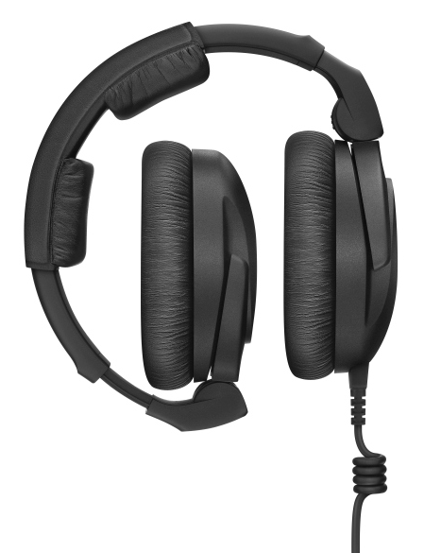 | They fold for easy transport: The HD 300 PRO headphones combine ruggedness with detailed, natural audio reproduction

- Closed-back monitoring headphones that offer accurate and linear sound reproduction with highest resolution
- Comfortable padding allows for extended use in long sessions
- Superior ambient noise attenuation in loud environments
- Perfect companion for your daily work due to long lasting materials and exchangeable cable

Be confident mixing your audio session
Puts you in an ideal mix room: dearVR MIX
When she wants the audio for her podcast to be perfect, this plugin is a great gift: Using advanced spatial audio technology, dearVR MIX turns any pair of studio headphones into a world-class stereo mix room with carefully designed acoustics. This incredible software helps her to confidently mix any recorded content.

The dearVR MIX plugin turns any pair of studio headphones into a world-class mixing environment | 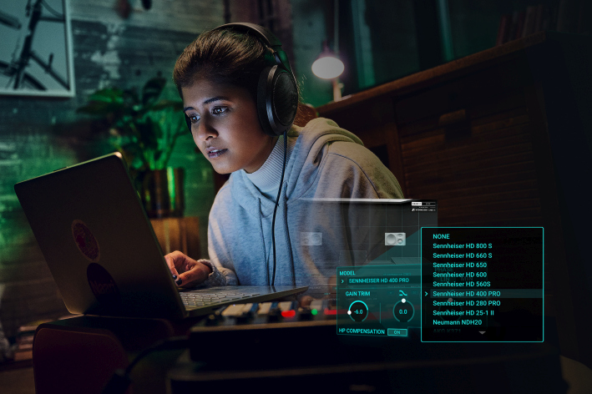

- Stereo headphone mixing plugin (AAX/VST3/AU) suited to all professional studio headphones
- Spatial Headphone Compensation supporting 46 models
- Total reliability judging position, width, reverb & low-end
- Three adjustable virtual world-class reference mix rooms with four mono & stereo loudspeaker positions
- Six additional non-studio listening environments

(Ends)

The images accompanying this press release and additional product images can be downloaded here.

Pricing information
MK 4: EUR 299 MSRP
MD 421-II: EUR 399 MSRP
MKH 416: EUR 999 MSRP
HD 200 PRO: EUR 69 MSRP
HD 280 PRO: EUR 99 MSRP
HD 300 PRO: EUR 199 MSRP
dearVR MIX: EUR 89 (without VAT)

About the Sennheiser brand
We live and breathe audio. We are driven by the passion to create audio solutions that make a difference. Building the future of audio and bringing remarkable sound experiences to our customers – this is what the Sennheiser brand has represented for more than 75 years. While professional audio solutions such as microphones, meeting solutions, streaming technologies and monitoring systems are part of the business of Sennheiser electronic GmbH & Co. KG, the business with consumer devices such as headphones, soundbars and speech-enhanced hearables is operated by Sonova Holding AG under the license of Sennheiser.

www.sennheiser.com
www.sennheiser-hearing.com

Global Pro Audio Press Contact

Stephanie Schmidt
Stephanie.schmidt@sennheiser.com
+49 (5130) 600 – 1275

