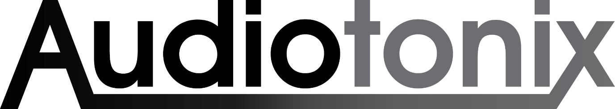

Landmark Investment For Audiotonix
Secures Future Expansion For Technology Leader In Professional Audio

Chessington, UK, April 23rd, 2024 – Audiotonix, a global market leader in professional audio mixing consoles, production software, and ancillary solutions, is pleased to announce it has reached an agreement for a next stage investment from PAI Partners, a pre-eminent private equity firm.

The new investment follows a successful partnership with global investment house Ardian that has seen Audiotonix further enhance its significant presence in live events, professional audio creation, commercial installation, TV and film production, and broadcast markets. Ardian will maintain a minority stake in Audiotonix via re-investment as part of this transaction.

“I would like to thank Ardian for the confidence and their solid support of Audiotonix, and all our brands since their investment in March 2020” states James Gordon, Audiotonix CEO. “Ardian invested alongside us just as the global Covid lockdowns began, and from our first meeting they were aligned in making sure all our brands emerged in a stronger position than before, but with the same teams and brand values fully supported. They allowed us to continue our large investment into R&D and supported our desire to add the right brands to our portfolio.”

On this new investment, James is clear on the choice of partner. “We have spent the last 12 months selecting the right team to partner alongside us in our next chapter, and I am happy to say the PAI team were a perfect cultural fit from our very first meeting. They come to us with a global reach and passion for music and technology that is a natural fit for our pro audio brands today and tomorrow.”

Colm O’Sullivan and Neil McIlroy, both Partners at PAI, said: “We are delighted to partner with James Gordon and the exceptional Audiotonix management team, alongside Ardian, in this next chapter of growth. Audiotonix is well placed to benefit from positive structural tailwinds in the experience economy and diverse professional audio environments – whether in live entertainment, installed professional audio, music or sports. We look forward to working with the team as the group continues to deliver market-leading, professional products, defining audio experiences worldwide.”

Formed in 2014 with leading pro audio brands Allen & Heath, Calrec and DiGiCo, Audiotonix has fast-tracked expansion of its business and portfolio with a series of acquisitions in the pro audio entertainment space, starting with leading US importer and distributor Group One Ltd, prestige studio console brand Solid State Logic and immersive sound pioneers, KLANG:technologies.

Ardian invested in 2020 and, the following year, Audiotonix further expanded its operations with the acquisition of TV and film location sound and RF wireless specialists Sound Devices. A year later, the company finalised the addition of Slate Digital, a market leader in audio processing and instrument plug-ins software and microphone modelling.

2023 saw multiple acquisitions across the group. US-based pro audio console and music production software manufacturer Harrison joined Solid State Logic, followed by the acquisition of sonible, one of the world’s leading developers of assistive artificial intelligence (A.I.) based processing solutions for professional audio. Finally in October, DiGiCo announced the acquisition of Fourier Audio, a UK-based live sound software developer and manufacturer, strengthening the group’s investment in live sound innovation.

Media contact:
Audiotonix: Martin Bennett
Tel: +44 1372 845600
Email: martin.bennett@audiotonix.com

About Audiotonix
Audiotonix is a global market leader in the design, engineering and manufacture of professional audio mixing consoles, production software, and ancillary products. With pioneering solutions from premium audio brands Allen & Heath, Calrec, DiGiCo, DiGiGrid, Fourier Audio, Harrison, KLANG:technologies, Slate Digital, Solid State Logic, sonible and Sound Devices, our products are used extensively in live sound, broadcast, theatre production, installations, house of worship, TV and film production, music creation, and recording studios.
www.audiotonix.com

About PAI Partners
PAI Partners is a pre-eminent private equity firm investing in market-leading companies across the globe. The Firm has c. €27 billion of assets under management and, since 1994, has completed over 100 investments in 12 countries and realised more than €24 billion in proceeds from 60 exits. PAI has built an outstanding track record through partnering with ambitious management teams where its unique perspective, unrivalled sector experience, and long-term vision enable companies to pursue their full potential – and push beyond. Learn more about the PAI story, the team and their approach at: www.paipartners.com

About Ardian
Ardian is a world-leading private investment house, managing or advising $164bn of assets on behalf of more than 1,600 clients globally. Our broad expertise, spanning Private Equity, Real Assets and Credit, enables us to offer a wide range of investment opportunities and respond flexibly to our clients’ differing needs. Through Ardian Customized Solutions we create bespoke portfolios that allow institutional clients to specify the precise mix of assets they require and to gain access to funds managed by leading third-party sponsors. Private Wealth Solutions offers dedicated services and access solutions for private banks, family offices and private institutional investors worldwide. Ardian’s main shareholding group is its employees and we place great emphasis on developing its people and fostering a collaborative culture based on collective intelligence. Our 1,050+ employees, spread across 19 offices in Europe, the Americas, Asia and Middle East are strongly committed to the principles of Responsible Investment and are determined to make finance a force for good in society. Our goal is to deliver excellent investment performance combined with high ethical standards and social responsibility. At Ardian we invest all of ourselves in building companies that last.
www.ardian.com

