Uskomaton äänimaailma kaiken kokoisille näytöille

RS 275 TV -kuulokkeet tarjoavat langatonta viihdettä ja monipuolisia mukautusmahdollisuuksia. Niiden mukana toimitettava BTA1 TV -lähetin tuo tehokkaat Auracast™-ominaisuudet kaikkiin kuunteluympäristöihin.



Sennheiser-brändi julkistaa tänään RS 275 TV Headphones -kuulokepaketin, äänenlaadun voimannäytteen, joka on suunniteltu elokuvista, sarjoista ja urheilusta nauttimiseen täysin langattomasti ja ilman häiriöitä. Yksinkertaisten säätimien sekä monipuolisten liitäntä- ja mukautusmahdollisuuksien ansiosta paketti tuo maailmanluokan langattoman viihteen kaikkien ulottuville.

Lisää alla englanniksi.

Comprised of the ultralight HDR 275 TV Headphones and the compact, companion BTA1 digital transmitter, the RS 275 bundle promises heart-stopping full-range sound at a volume that is always perfect. Featuring Auracast™ transmission technology powered by the LC3 Bluetooth® codec, the RS 275 system offers ultra-low latency synchronization of sound and picture and up to 50 meters of range. Every HDR 275 can also connect to other Auracast or Bluetooth Classic-enabled devices like tablets and smartphones for app-based streaming content when listening in the kitchen, bedroom, or even the classroom. With a plethora of audio inputs, intelligent multi-source switching and multipoint capability, the system complements any modern entertainment setup.

“As screens continue to get thinner, their speakers have to follow, making it harder than ever to enjoy full-range sound without disturbing others.” said Irene Strueber, Senior Product Manager, “The RS 275 TV Headphones unlock total listening privacy and impressive clarity, whether your TV's built-in speakers are underwhelming you—or overpowering everyone else”
More power on demand
Made with simplicity in mind, the RS 275 can be set up just minutes after unboxing. Optionally, users can further enrich their experience with the free Sennheiser Smart Control Plus App (Android, iOS). The app brings additional personalization of features like transparency mode, left-right balance, hearing profiles, device-type audio modes, finding lost headphones and more. Speaking of clarity, the headphones feature the brand’s acclaimed in-house acoustics, tuned for vocal intelligibility and engaging bass response. The system includes several easy-to-use tools for enhancing dialogue and immersion—all at a volume that won’t wake light sleepers or neighbors.

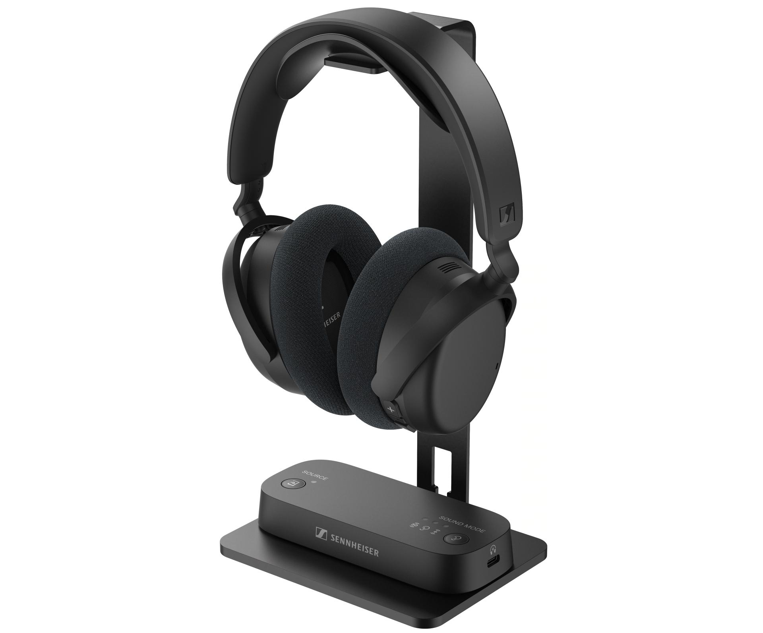

Pictured: The RS 275 TV Headphones bundle—HDR 275 headphones and BTA1 transmitter

Comfort and convenience | TV Headphones
The HDR 275 TV Headphones were made for marathon binging. Engineered to be surprisingly lightweight, they offer a featherlight feel comparable to an everyday remote control. Their supple cushions keep ears cool with a breathable and luxurious fabric for a tailor-made fit that practically disappears on the head. Large, textured buttons offer confident, tactile control of up to 106 dB of volume, power, and even incoming calls. A single charge provides up to 50 hours of listening, and topping up from the transmitter’s USB Type C port or an existing household charger keeps options flexible. Both the ear cushions and battery are user-replaceable to ensure a long operating life as the center of your multimedia setup, while a sturdy metal headphone stand keeps any configuration tidy.

“It was important to make the setup and user experience simple so customers could get to listening immediately. In addition to the headphones being pre-linked to the transmitter out of the box, everything you need to connect is conveniently color-coded.” added Strueber, “And for those that want to truly make the audio experience their own, the Smart Control Plus app goes even deeper with intuitive personalization from the smartphone already in their pocket.”

When connected to the Smart Control Plus app, the headphones can adopt presets or user-defined equalizer settings, bass boost, and other hearing enhancement tools. The wearer can emphasize clarity or warmth, for example, and apply their preference to the HDR 275’s overall character. There is even a selectable noise suppression mode to reduce hiss and static while consolidating the signal to mono—perfect for classic movies and shows.

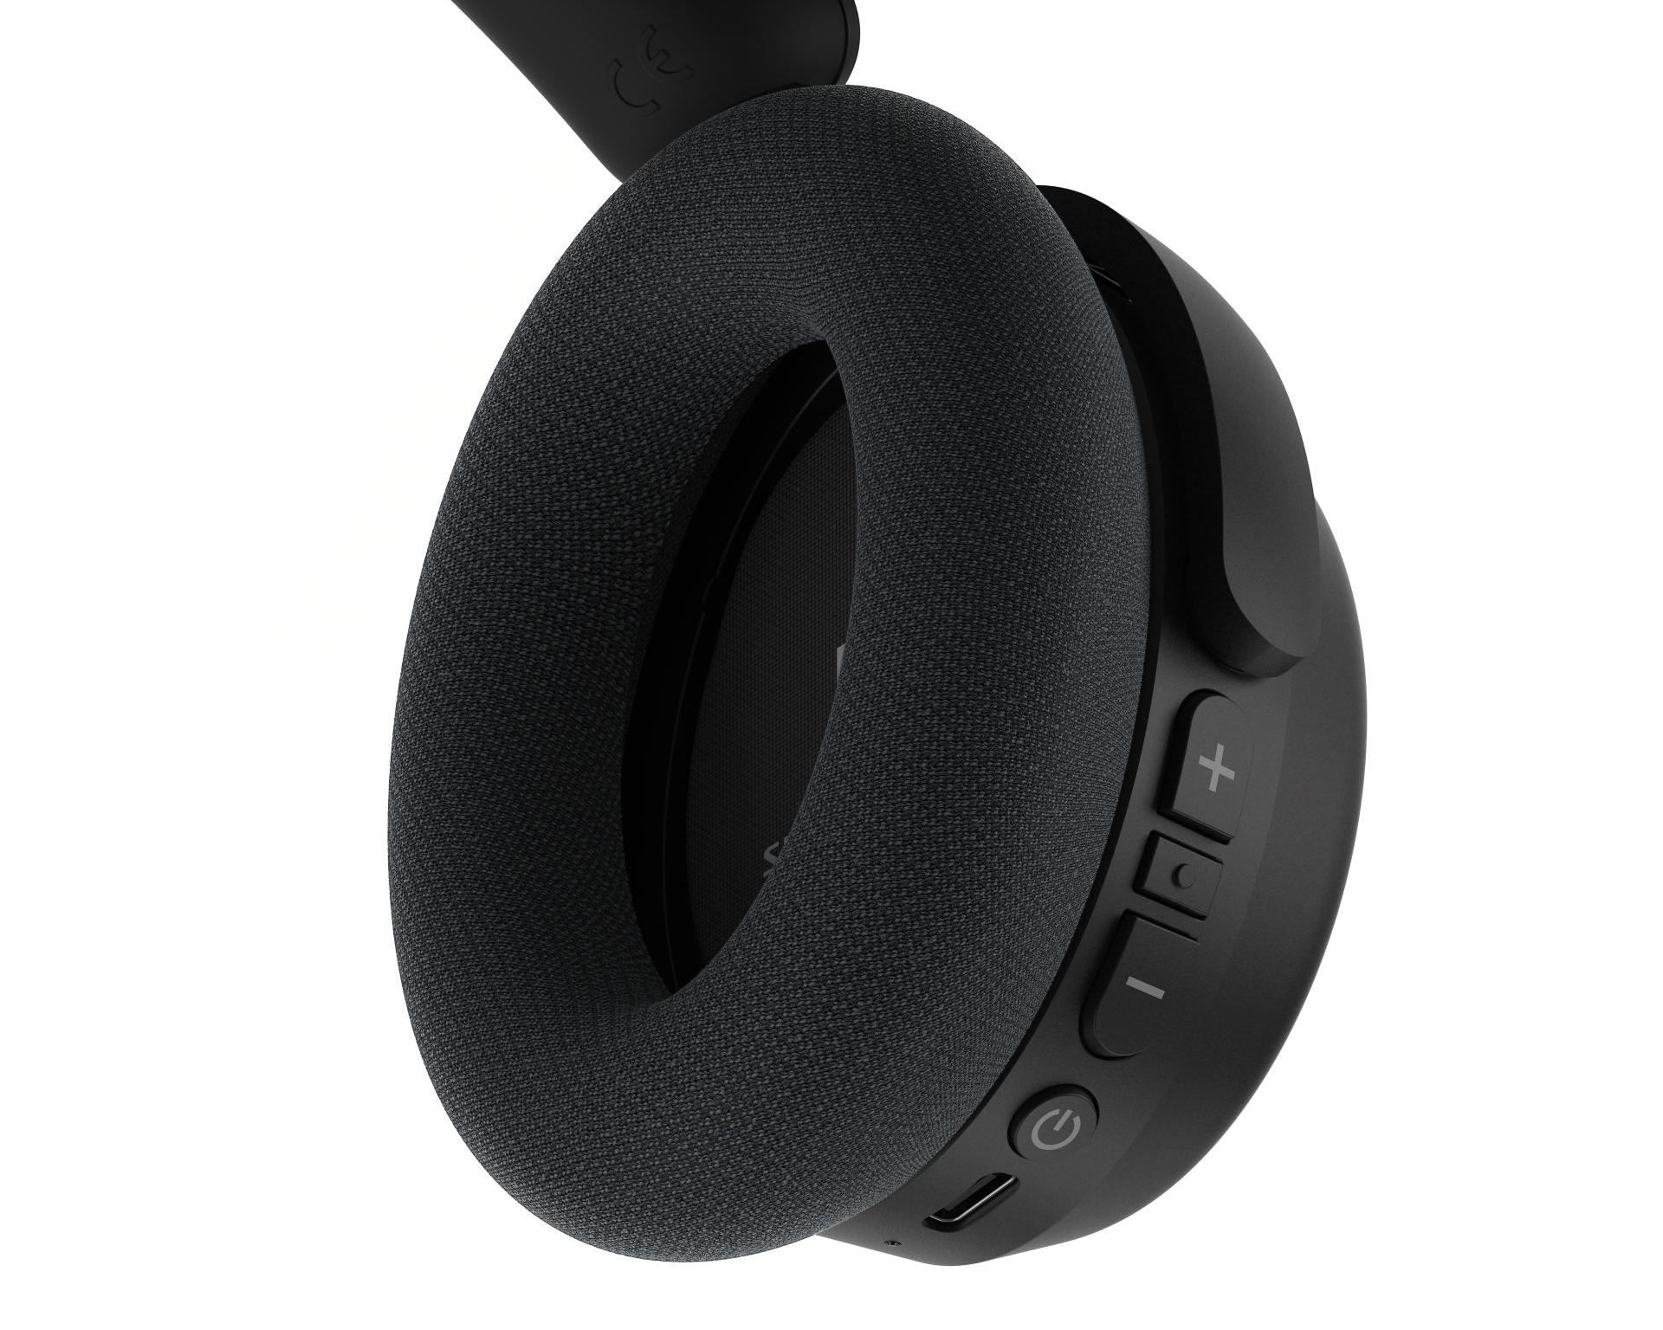
Pictured: Ultralight HDR 275 headphones with tactile controls and luxurious earpads

Sending our best | TV Transmitter
The included BTA1 TV Transmitter uses Auracast exclusively, blanketing any entertainment space with a wireless signal for devices like headphones, earbuds, hearing aids, and loudspeakers using open standard Auracast. This compact hub brings a host of input options and expanded audio enhancement capabilities for easy integration into virtually any setup. Top buttons provide manual switching of inputs and sound modes, including virtual surround sound and enhanced speech clarity when using TV or HDMI ARC sources. Of course, users can also use additional BTA1 features via the smartphone app. This allows configuration of auto-input switching and video delay compensation, while presiding over Auracast settings like broadcast name, password protection, and hearing aid modes.

A combination Optical and 3.5mm input interfaces the BTA1 with TVs, stereo systems, laptops, game consoles and more. The HDMI ARC input expands the possibilities to TVs and A/V receivers using the port to output sound from built-in apps or services. The BTA1 is powered from a nearby device’s USB Type A port, and passes power through to a USB Type C port for headphone charging. The low-profile design fits perfectly on the included headphone stand, or placed discreetly near the sound source.

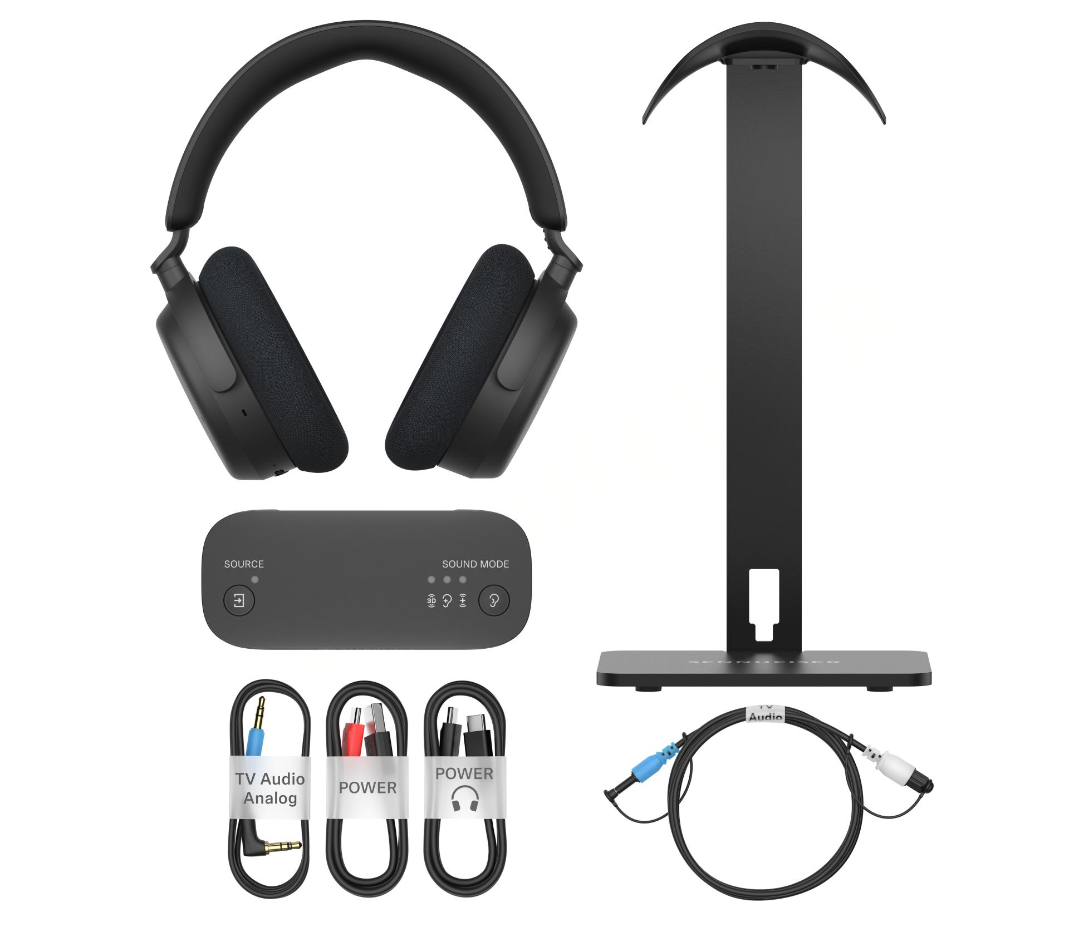
Pictured: The RS 275 TV Headphones bundle

Availability
The RS 275 TV Headphones bundle will be available for pre-order on February 3rd, 2026 at an MSRP of EUR 249.90 from authorized dealers and from sennheiser-hearing.com. Simultaneously, the BTA1 TV Transmitter will be available for standalone purchase at an MSRP of EUR 129.90. This system will also be available without a headphone stand as a retail exclusive, sold as the RS 255 TV Headphones.

The Bluetooth® word mark and logos are registered trademarks owned by Bluetooth SIG, Inc. The Auracast™ word mark and logos are trademarks owned by Bluetooth SIG, Inc. Any use of such marks by Sonova Consumer Hearing GmbH is under license.

About the Sennheiser Brand – 80 Years of Building the Future of Audio
We live and breathe audio. We are driven by the passion to create audio solutions that make a difference. This passion has taken us from the world’s greatest stages to the quietest listening rooms – and made Sennheiser the name behind audio that doesn’t just sound good: It feels true. In 2025, the Sennheiser brand celebrates its 80th anniversary. Since 1945, we have stood for building the future of audio and bringing remarkable sound experiences to our customers. While professional audio solutions such as microphones, meeting solutions, streaming technologies and monitoring systems are part of the business of Sennheiser electronic SE & Co. KG, the business with consumer devices such as headphones, soundbars and speech-enhanced hearables is operated by Sonova Holding AG under the license of Sennheiser.

www.sennheiser.com
www.sennheiser-hearing.com

About Sonova Consumer Hearing
Sonova Consumer Hearing offers premium headphones and hearables – primarily in the true wireless segment – as well as audiophile headphones, hearing solutions and soundbars under the Sennheiser brand. The business is part of the Sonova Group, a global leader in innovative hearing care solutions with headquarters in Switzerland and more than 17,000 employees worldwide.

Press contact
Burson Finland Oy (previously Hill and Knowlton)
sennheiser.finland@hkstrategies.com

