The Next Generation: Hogarth WW Opens State-of-the-Art Advertising Studio Designed by WSDG

World-renowned acoustic-architectural firm unveils latest customized content creation studio

Mexico City, Mexico, September 18, 2019 — Global acoustic consulting and audio-visual integration firm WSDG has announced the completion of a state-of-the-art recording complex for international advertising firm Hogarth WW in Mexico City, Mexico. The new facility will focus on sound design and voice-over recording for Hogarth’s extensive global client base which includes Ford, Gucci, British Airways, Heinz, and Greenpeace. The facility is the latest in a series of content creation studios designed by WSDG specifically for advertising and social media purposes – including Pepsi Content Creation Studios, JSM and Betelgeuse in New York City, Swing Music in Buenos Aires, and PhilippeMortiz in Switzerland – and is outfitted with top-of-the-line data networking technology to ensure its high-speed connectivity between Hogarth WW’s global offices.

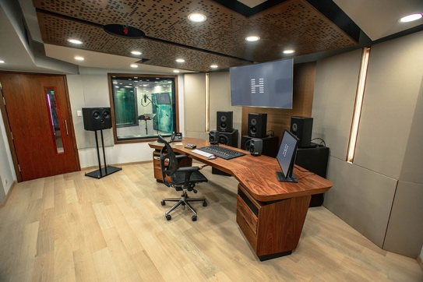
Although WSDG’s design expertise was honed in artist-driven professional recording studios it has recently found itself creating complexes such as this for a wide range of corporate and commercial production clients increasing demands for high quality audio, driven by the growing podcasting and audio content industries. “The standards for audio content in advertising have risen dramatically in the last few years,” explained WSDG Partner/Art Director Silvia Molho, who designed the interior of the new complex. “Although working studios of all kinds have been WSDG’s bread-and-butter throughout our history, we are experiencing an increase in demand for facilities that specifically meet the needs of professional advertising.”

WSDG began its relationship with Hogarth Mexico City when they redesigned the firm’s original studio in 2014. Hogarth WW Audio Lead Victor Machado had worked in a WSDG-designed studio ten years prior and was impressed with its aesthetics and its functionality. “It was an incredible place to work,” said. “I knew then that when we had the opportunity to commission a new studio for Hogarth Mexico City that they would be our designers of choice.” After the successful redesign, the firm was retained for the new facility which would be specially designed to accommodate Hogarth WW’s rapidly expanding needs.

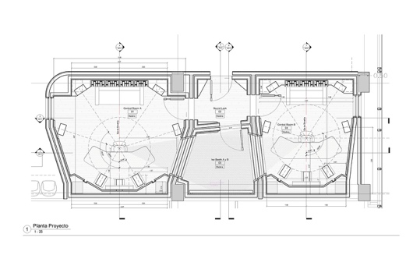
The new complex was designed from the ground up to be a state-of-the-art facility with dual control rooms and an acoustically flawless live room for the company’s voice-over projects and audio advertising work. The complex was specifically designed to work in tandem remotely with Hogarth WW’s offices around the world. “Hogarth WW has production teams on almost every continent, so ensuring that they would be able to communicate and collaborate effectively is key to the success of this facility,” explained Molho. “We were very pleased to have been selected to create this sophisticated new production facility for them.”

WSDG’s project managers and integrators installed Dante networking protocols throughout the studio, enabling it to be linked in real-time to Hogarth WW’s 40 other broadcast production offices and greatly facilitates instant global collaboration “Our Mexico office works with global brands and is a mainstay in Hogarth’s international broadcast production process,” Machado explained. “It was critical that our new studios provide extremely high-end connectivity between all of our international creative teams. Our choice of Avid MTRX is an invaluable element to our integration with the Dante protocol network output.”

Now operating at full capacity, the new studio sets a new standard for advertising-focused content production studios worldwide. “Hogarth WW’s clients have extremely high standards for content quality,” said Sergio Molho, WSDG Partner/Director of Business Development. “Given that, we are confident that this studio complex will meet their production needs for many years to come.”

For more information about WSDG, please visit: http://www.wsdg.com/

ABOUT WSDG, LLC
For 50 years, acoustic consulting and A/V integration firm WSDG has been designing media production facilities worldwide, over 3000, and counting. Projects range from Jimi Hendrix’s Electric Lady Studio and Jazz At Lincoln Center in New York, to broadcast facilities for The Food Network, CBS and WNET, over twenty teaching studios for The Art Institutes, and corporate clients such as Sony, IBM and Novartis. Recent credits include Jungle City in New York, The Church Studio, in London, private studios for Green Day, Jay-Z, Bruce Springsteen, Alicia Keys and Academy Award-nominated film composer Carter Burwell. WSDG has collaborated with such noted architects as Frank Gehry, Philippe Stark, Rafael Viñoly, Santiago Calatrava, Grimshaw, and Norman Foster. An eleven-time winner of the prestigious pro audio NAMM TEC Award for outstanding achievement in Acoustics/Facility Design, WSDG maintains U.S. offices in New York, Washington, DC, San Francisco and Miami and global offices in Barcelona, Basel, Berlin, Belo Horizonte, Buenos Aires, Guangzhou, Mexico City and Mumbai.

Contact:
Steve Bailey
Hummingbird Media, Inc.
+1 (508) 596-9321
steve@hummingbirdmedia.com

Jeff Touzeau
Hummingbird Media, Inc.
+1 (914) 602-2913
jeff@hummingbirdmedia.com

