

Biuro prasowe better. gaming agency
bettergamingagency.prowly.com

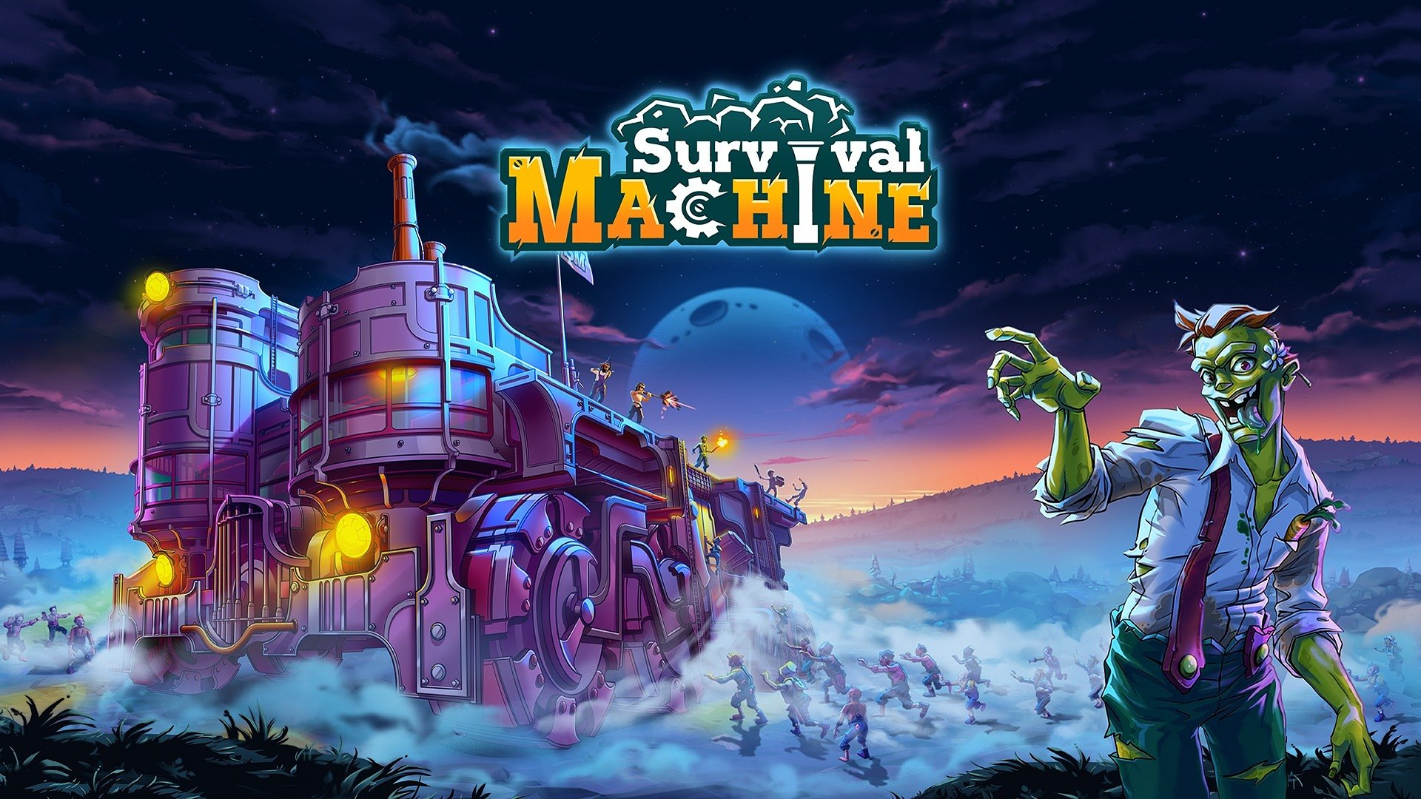

Drive-thru apocalypse! Survival Machine rolls into Steam Early Access

All aboard! A wild odyssey is about to begin! The horde is nipping at our heels, but we’re thrilled to announce that Survival Machine has just hit the open roads of Early Access. The developers at Grapes Pickers and publisher Games Operators invite you on a cooperative adventure full of exploration, challenges, and good fun in a charming low-poly style – proving that not every zombie game has to be dark and grim.

Early Access is just the beginning! Survival Machine will keep evolving with the support of the community, and the developers are counting on players to join them as bold explorers in a post-apocalyptic but still colorful world full of mysteries, treasures, and challenges.

Survival Machine - launch trailer

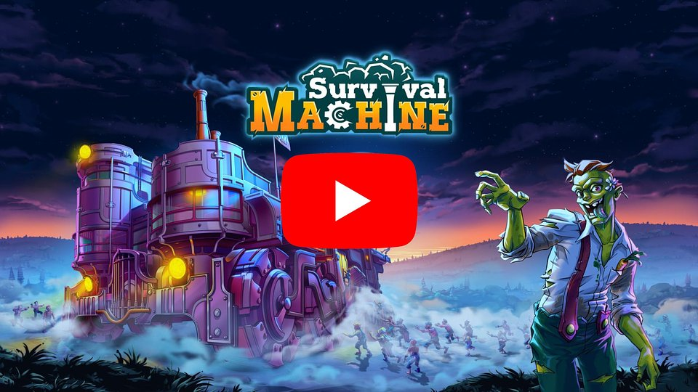
https://www.youtube.com/watch?v=fl9Vf_MTQ3Q

Welcome to a world teeming with eternally hungry – yet strangely lovable – zombies! A place where every hill hides a new discovery, every step brings a fresh challenge, and your only hope for survival is the Machine – your mighty, mobile fortress and lifeline amid the chaos. Get ready to build, fight, explore, and protect what’s yours – solo or with up to three friends!

The pace of Survival Machine is set by the day and night cycle. Daylight is your chance to explore the Frontier biome, gather resources, and upgrade your Machine. It’s also the perfect time to solve puzzles crafted by the dev team and discover intriguing, hidden locations scattered across the map. Night is a whole different beast. During the nights when zombies launch an attack on the Machine, it's best to stay on guard! Let’s hope those spike traps and artillery you put were worth the investment, because the horde is coming, and your only real backup is your team!

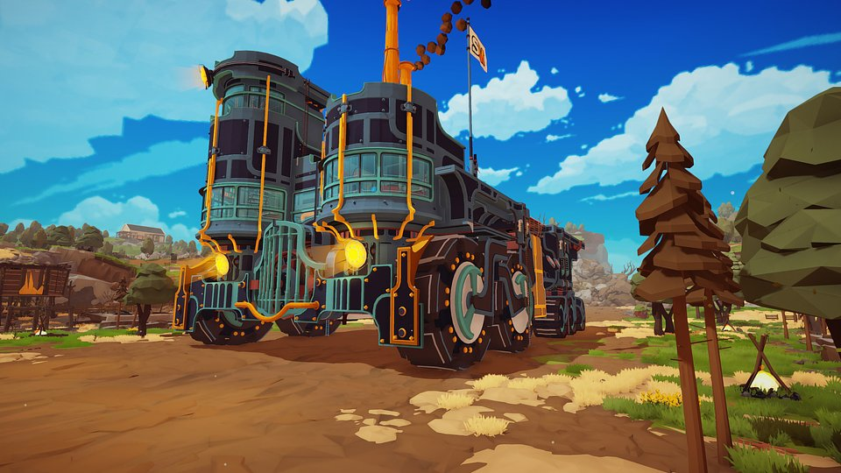

Early Access is the perfect time to jump on your mobile Machine – whether you ride solo or team up with your fellow Survivors. Experience a unique blend of survival mechanics, humorous adventure, base building and defense. Will you play smart and keep the Machine running? Its end means the end of the game!
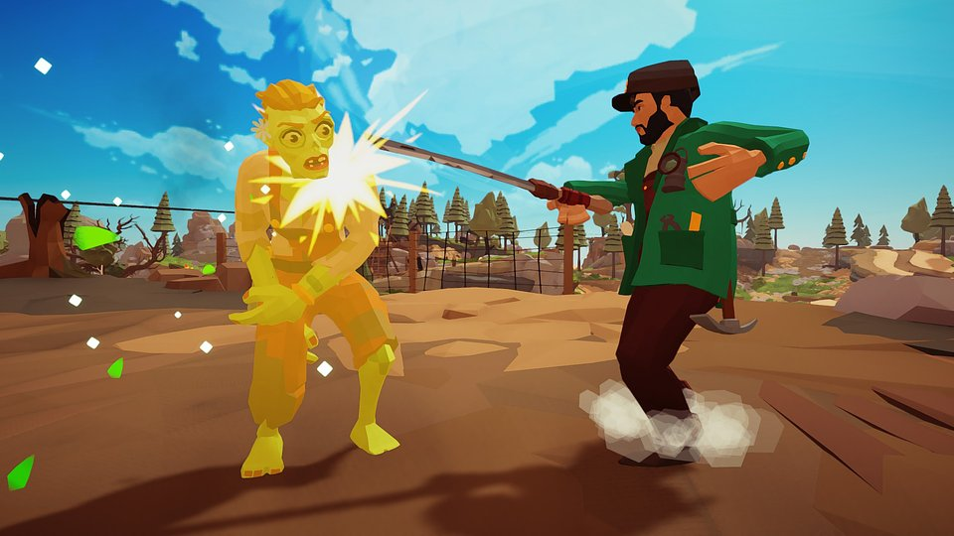

Here’s what’s waiting for you in Survival Machine’s Early Access version:

🧠 4-player co-op– share tasks and work together! With various gameplay modes, every survival player will find something to do! But keep an eye on the most chaotic squadmate!

🧠 Fortress, but make it to-go – gather supplies, upgrade the defense systems, and treat your Machine like your first car, with love and care - you won’t get another one! The ever-evolving Machine is your best option for survival!

🧠 Survival nomads - your Machine moves for a reason! There is a whole world out there to explore! Outside the Machine - glide and parkour to discover mysteries, solve puzzles and complete challenges!

🧠 Traps, turrets and all sorts of lovely tools – your Machine won’t defend itself, but with the right add-ons, it just might become an unstoppable force! (Pro tip: the cannon works just fine!) So get those gathered resources and change them into Machine’s fortifications and upgrades!

🧠 Day like any other, night like your worst nightmare – don’t be fooled. Zombies might try to bust a killing dance move or two during the day, but when the night comes, they’re here not to party… unless you challenge them to a dance-off. Moonwalk, boogie, freeze - it’s time to show your best moveset!

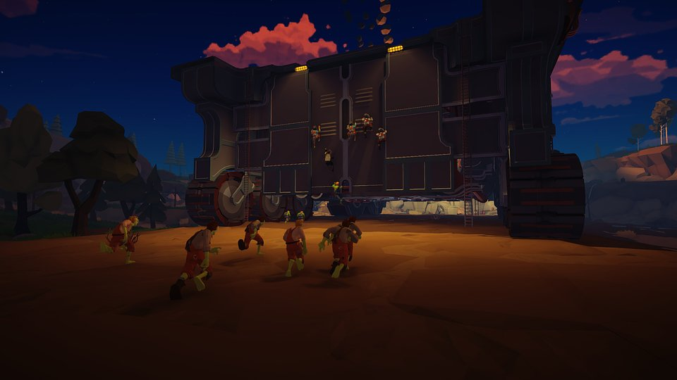

Survival Machine is now available in Early Access on Steam! The devs plan to expand and improve the game based on community feedback, so fire up your engines and see how long you can survive! You can follow the development progress on Facebook, TikTok, X, and YouTube, and join the community on Discord.

Press materials are available HERE.

About Games Operators:

Games Operators is a publisher that invests in, supports, and promotes unique and innovative video games. Known for titles like 911 Operator and Infection Free Zone, they work closely with developers from concept to release, helping deliver standout gameplay experiences. http://www.gameops.pl

