BASSBOSS DJ18S PROFUNDO POWERED SUBWOOFER PROVIDES INTENSE DEEP BASS FROM A MOBILE-OPTIMIZED CABINET

Lightweight design is ideal for DJs and small club installations

Austin, TX, February 8, 2017 — Powered loudspeaker manufacturer BASSBOSS has announced the release of its DJ18S Powered Subwoofer, a compact, deep-bass sub that weighs only 110 lbs and delivers output that’s 3dB down at 27Hz. Perfect for mobile users who need deep, rich bass from a smaller cabinet, the DJ18S offers enough bottom-octave output to replace two similarly sized or similarly priced subwoofers.
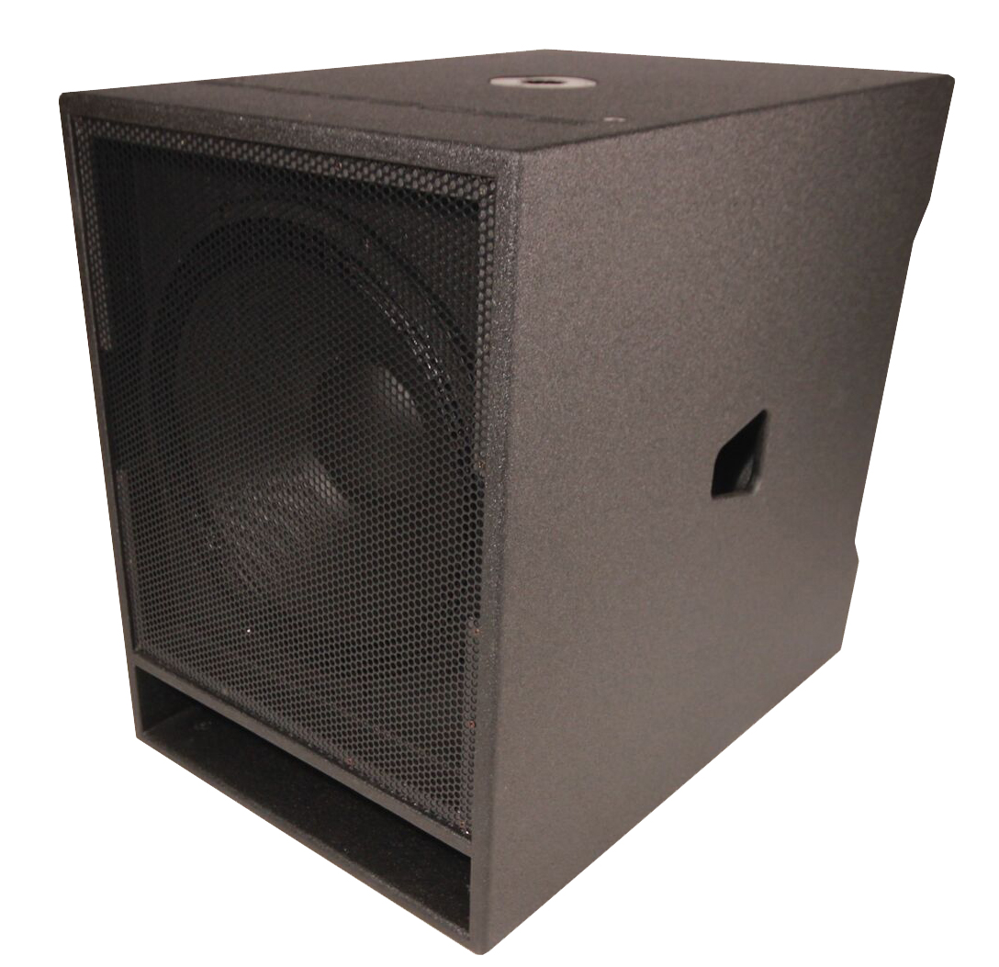
“The DJ18S subwoofer’s compact size and excellent output-to-price ratio is perfect for gigging DJs or venue owners with limited space,” said Lian Amber, CEO of BASSBOSS. “Thanks to its extraordinary capabilities, you really can do more with less. The DJ18S is a powerful, easily portable system that offers extremely deep bass and superior sound quality for a very reasonable price, with plug and play simplicity, integrated DSP, a reliable self-powered system and a compact and lightweight design.”

Power-Packed
The DJ18S is self-powered and includes a USA-made 2400W RMS amplifier. That’s not peak power, but 2400W of continuous output, ensuring that the amp isn’t the limiting factor in the output of low frequencies. Providing abundant power effectively eliminates the possibility of the amplifier overheating and shutting off. It also essentially eliminates clipping as a cause of driver failure, making the DJ18S a solidly reliable subwoofer with much more deep bass output than competing subs.
The long-excursion 18” woofer has a 4” copper voice coil for superior power handling and a Neodymium magnet structure for high sensitivity, which makes the DJ18S lighter and louder.

Total Control
“The ‘secret sauce’ of the DJ18S is in the proprietary processing of the integrated, comprehensive DSP,” says BASSBOSS Designer David Lee. “Although no equalization is required for the DJ18S to achieve its stated frequency response, it includes a comprehensive DSP. The processing consists of high-pass and low-pass filters as well as multiple protection systems and limiters to control all manners of driver overload, including thermal, excursion and clipping. The protection systems effectively prevent the overheating of the voice coil and minimize long-term thermal compression while having virtually no effect on the transient response and peak output of the loudspeaker. The processing ensures seamless integration with all BASSBOSS Powered Subwoofers, Tops and MicroMains. No external processing is required to achieve premium performance.”

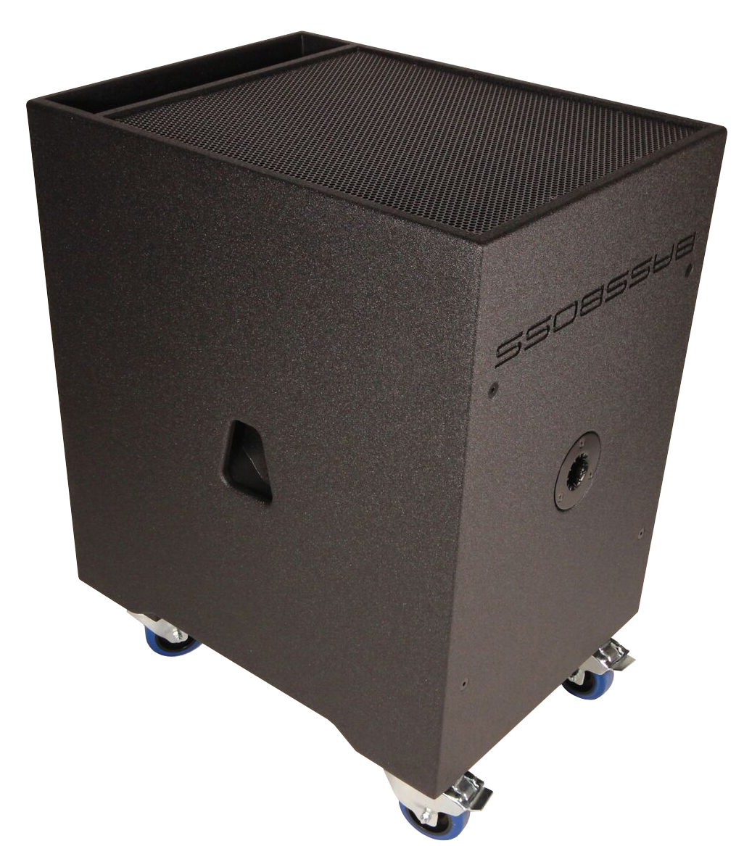
Solid Construction
Rugged 18mm Baltic Birch plywood ensures a solid structure and a long lifespan for the DJ18S. All BASSBOSS cabinets are made in the USA and carry a 6-year warranty. Stainless steel bolts are used to secure the drivers, amplifier and pole sockets. A perforated steel grill protects the waterproofed woofer cone and a black polyurea coating seals the wood from the elements and wayward refreshments.

Accessories for the Mobile DJ
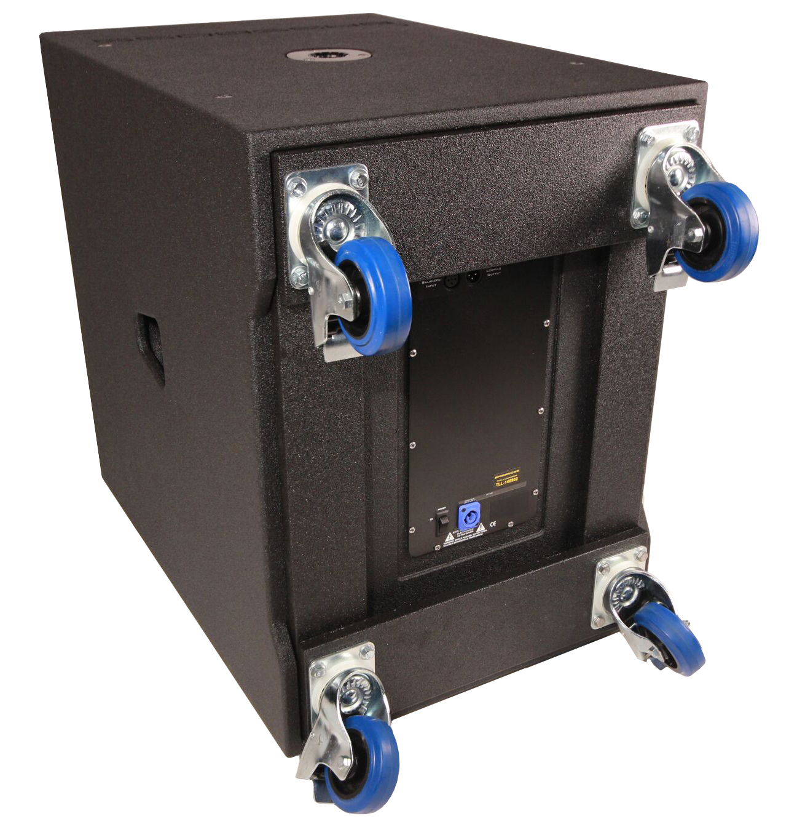
With the custom fit wheel cart, the DJ18S can be easily rolled in and out of venues, speeding load-in, and making the dreaded late-night load-out a breeze. Custom fitted covers protect the DJ18S for years of like-new appearance.

To learn more about BASSBOSS and the DJ18S, visit www.bassboss.com

About BASSBOSS
BASSBOSS creates premium, ultra high-fidelity sound systems for the professional consumer, live sound and systems integration markets. The company was founded on the design and engineering expertise of David Lee, a pioneer in subwoofer design whose work has transformed the audio systems for hundreds of venues across North America. BASSBOSS systems are easily integrated, compact and power-efficient. Each cabinet is highly optimized with dedicated, comprehensive amplification and processing. For more information on BASSBOSS, please visit www.bassboss.com

Press contact:
Jeff Touzeau
Public Relations
Hummingbird Media, Inc.
(914) 602-2913
jeff@hummingbirdmedia.com

