MARÍA TERESA CAZALLA

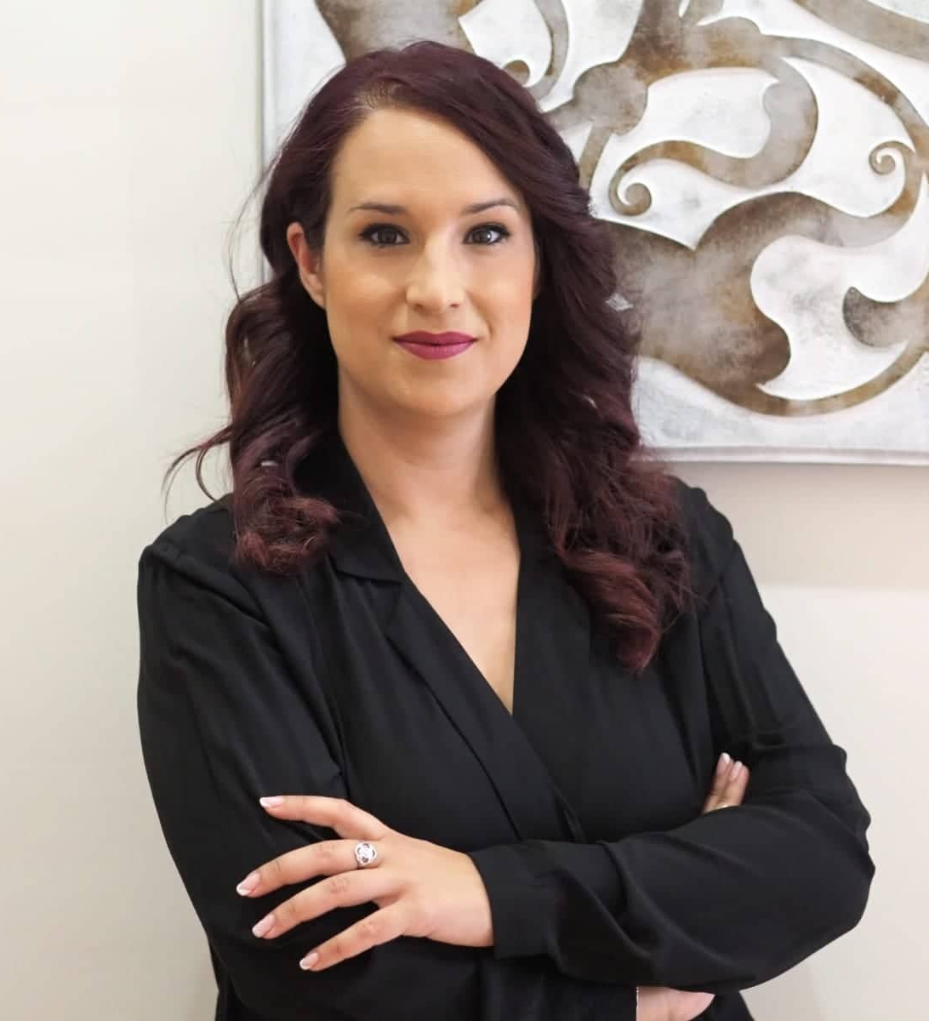
María Teresa Cazalla always knew she wanted to be a hairdresser and at 16 she began her intense learning thanks to her determination. She understands the sector from a position of closeness and extroversion, but also motivation and struggles to achieve her dreams. She develops her profession from different spheres: training, developing creative collections, entering professional competitions and managing her salon, reconciling all with her personal life. She is a generous partner who selflessly tries to help anyone who asks, whether if it is for concrete inquiries or tutorials.
Since her beginnings, she has constantly received training, and she has studied Hairdressing for ladies and gentlemen and taken courses in Perfecting hairdressing, Perfecting updos, Beauty, Make-up, and fashion, trends, color... and she even has a Master in colorimetry.

During her twenty-year career she has received different recognitions and achievements:

• Tijeras de Oro Awards (2018), in the Urban Look Awards of Andalucía Belleza. This contest distinguishes the best Hairdressing, Best Makeup, and the Best Styling, and awards the Golden Scissors to the professional who excels in the three categories.
• Nomination for the Andalusian Hairdresser of the Year award from the Picasso Awards (2019).
• Finalist in two of the three categories to which she aspired in the Trends Hair awards in Granada, with a women's collection and her first avant-garde collection.
• Finalist in the Picasso Awards with the "Aura" collection, in the Andalusian Hairdresser of the Year category and winner of the Press Award (2021), given by the professional hairdressing magazine "C&C Magazine Planetlook".

Besides, she is a member of APES, the Association of Hairdressers of Seville and a national ambassador and technician for the brand Genus.

