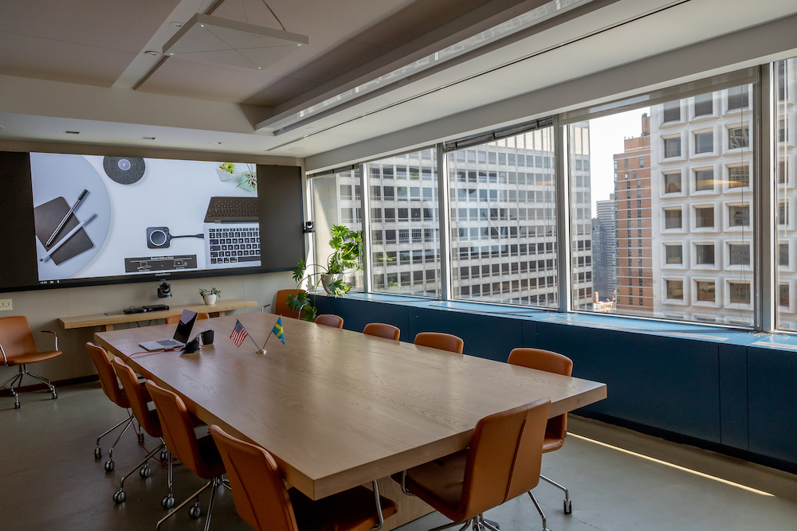

Barco, QSC and Sennheiser Collaborate to Deliver World-Class A/V Demo Facility Within Swedish-American Chamber of Commerce’s ‘Gateway’
An innovation hub for companies looking to extend their success in the U.S., Gateway provides dynamic events, business matchmaking and top-tier technology to its members

New York City, September 29, 2021 – On the 29th floor of 900 Third Avenue, in the very heart of Manhattan, is Gateway — a state of the art co-working and innovation hub. As part of the Swedish-American Chamber of Commerce (SACCNY) — the oldest international chamber of commerce in the United States — Gateway’s mission is to help Scandinavian companies gain a strategic foothold and become more successful in the U.S. market. Recently, top communication technology brands Sennheiser, Barco and QSC all collaborated to help deliver a fully integrated, world class conferencing and equipment demonstration environment within Gateway’s 20,000 square feet facility.
Gateway opened its doors in January of 2019 as a ‘landing’ and ‘launchpad’ for Scandinavian businesses, providing members everything they need to help accelerate their success — whether it be business matchmaking, service-oriented partnerships, administrative set up, desk and event space, and a myriad of other offerings. The Gateway conferencing and technology demonstration center — which features advanced videoconferencing-oriented solutions from Sennheiser, Barco and QSC among other brands — was implemented during 2020 and was completed in March of 2021.

Anna Throne-Holst was appointed as SACCNY’s President in 2017, following life as a public servant — including running on the Democratic ticket for congress in the 2016 election and serving as a Town Supervisor on Long Island: “In my public life, much of my work was supporting small business,” she says. “So, when I was offered the opportunity with SACCNY, I jumped on it, with the goal of creating a model chamber, offering both services and support to the innovation and start-up sectors, while facilitating important synergies with the long-time, large corporate members. Now, Gateway is a co-working, meeting, and innovation platform mostly geared to Swedish start-ups and corporates, but open to other companies as well.”

The opening of Gateway coincided with a move to SACCNY’s current location, which afforded more office space and room to grow: “We needed to be there for our members, and the move meant we could create a myriad of working and event-based spaces for these entrepreneurs and innovators,” Throne-Holst adds.
SACCNY boasts an impressive membership; a bona-fide ‘who’s who’ in Scandinavian innovation that includes large and mid-sized companies in a variety of sectors. It also serves as a knowledge and networking ‘incubator’ for start-ups looking to make their mark in a dynamic market that craves new ideas and fresh insights. The collaboration among Sennheiser, Barco and QSC came about as Throne-Holst began exploring a technology upgrade: “I wanted to create a state-of-the-art meeting space,” she recalls.
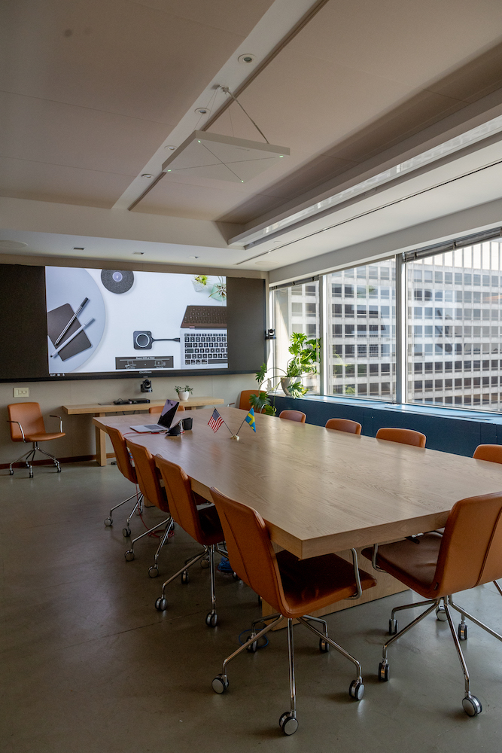 | The ‘showcase’ room within the 20,000 square foot facility is ‘Room with a View’, which provides seating and videoconferencing space for up to 12 people.
A ‘Room with a View’
Throne-Holst’s idea was a winner all around: for members, it meant access to world-class conferencing technology in a beautiful working environment, right in the heart of Manhattan. For Sennheiser, Barco, QSC and a handful of other companies, it meant an ideal technology showcase to demonstrate the quality, functionality, and efficiency of ground-breaking products. To move the project forward, she engaged long-time technology evangelist Greg Harper, president of Harpervision Associates, VP of infrastructure for Shorelight Education and technology advisor for several highly regarded companies and financial institutions. Harper embraced the idea, and subsequently pitched it to Sennheiser, Barco and QSC. “For us, it was a no-brainer,” Throne-Holst says. “Greg loved what we were doing up here and we all became friends.”
The ‘showcase’ room within the 20,000 square foot facility is ‘Room with a View’, which provides seating and videoconferencing space for up to 12 people. It features a Sennheiser TeamConnect Ceiling 2 (TCC2) microphone, which incorporates beamforming technology; this enables the microphone to ‘follow the speaker.’ The TCC2 is connected to a QSC Q-SYS™ Core 110f, which serves as a 'room controller', supporting up to 256 channels of networked audio and multiple instances of VoIP. "The Core 110f is connected to three cameras which use auto-tracking,” explains Harper. “So we are getting the data from the Sennheiser TCC2 microphone, and using that data to switch the cameras based on who is speaking.”

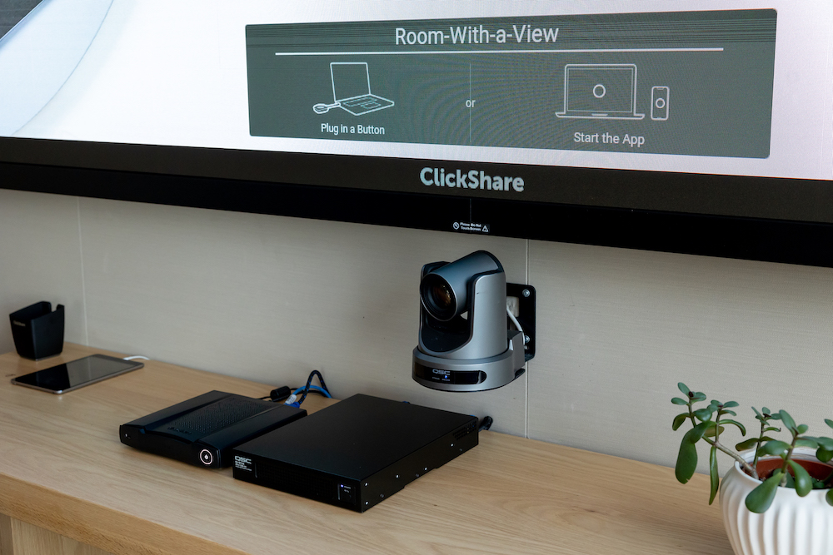 | Barco's ClickShare Conference enables wireless universal sharing of information from the user’s own device across presentation platforms.
Immersive, Agnostic and User-Friendly Conferencing AV
Aside from the fact that there are no microphones on the conference room table, one of the first thing people notice when walking into the Room with a View conference space is the bright 14’ Barco X 1.2 LED video wall, which is being driven by a Barco E2 Gen 2, which handles all the processing and offers flexible layouts. Barco's ClickShare technology allows for seamless, engaging wireless conferencing in Gateway’s meeting rooms. In ‘Room with a View’, ClickShare Conference enables truly agnostic BYOM (Bring Your Own Meeting) capabilities, allowing users easy access to the advanced AV present in the room.

“We have a QSC touch panel, so guests can come in there and say, ‘I want to do a Teams meeting’ or 'I want to do a Zoom meeting'. Or they can just bring in their own laptop with preferred VC solution,” says Harper. Since ClickShare is installed and ubiquitous throughout the space, users can connect and present wirelessly — no matter where they are located on the 29th floor. Meantime, the inbound audio in Room with a View is reproduced through two pairs of QSC speakers — two in the front and two in the rear.

While Room with a View offers breathtaking views of New York City, the bountiful glass and hardwood floors and a hard ceiling presented several acoustic challenges. Thankfully, the Sennheiser TCC2 helped mitigate undesirable sound reflections since the microphone is designed to pick up the subject rather than the room itself. “We tried several different microphones in there and as soon as we used the TCC2, it just sounded better,” says Harper.

"I am very familiar with acoustics and how things sound, and I think this is among the best ceiling microphones out there," he continues. "Sennheiser has a unique capability of sounding really good while giving me very accurate positioning control, with the ability of creating exclusion zones.” By creating 'exclusion zones', users of TCC2 can eliminate sounds coming from HVAC systems, or other noise sources.

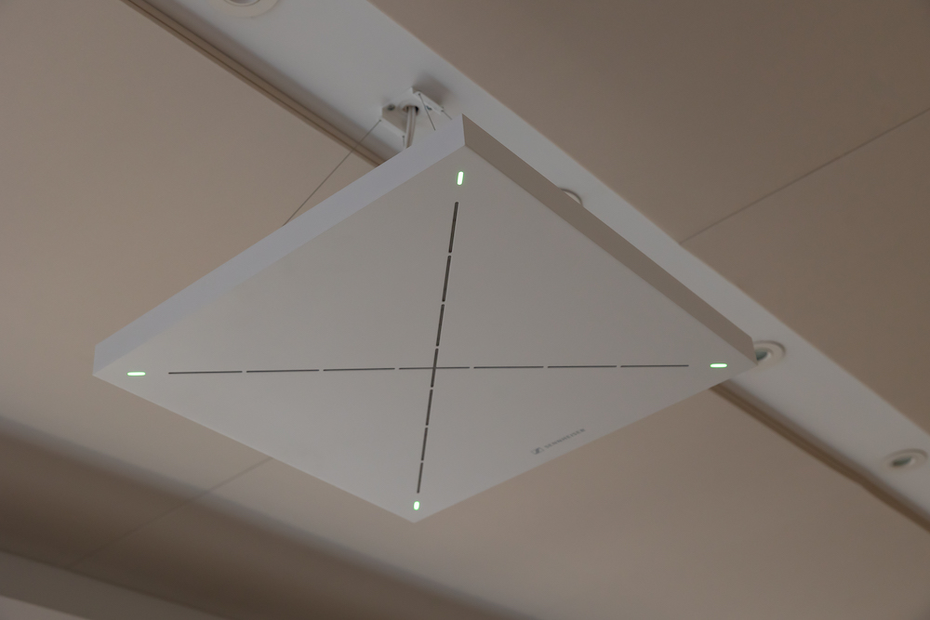 | Sennheiser’s TCC2 microphone, pictured here in the Room with a View, helped mitigate undesirable sound reflections since the microphone is designed to pick up the subject rather than the room itself.

The Board Room
The Board Room is one of Gateway’s larger rooms, providing seating for 18 people. The space is accented with several tables measuring roughly 5’ square, which can be moved around to accommodate different types of meetings, such as seminars or smaller events. It also features a Barco 16’ UniSee video wall with multiple LCD panels, which delivers a uniform degree of brightness and color throughout, as well as two Sennheiser TCC2s. Once again, everything is connected to a QSC Core 110f processor, which serves as the primary technology interface, and Barco's ClickShare Conference enables wireless universal sharing of information from the user’s own device across presentation platforms.

In the Board Room, the Sennheiser TCC2s are used to drive a 1 Beyond Autotracker system, which has seven built-in cameras and is able to track and switch cameras based on the location of the audio source. “The Sennheiser TCC2 has XYZ data coming out of it that is very accurate, so it can actually detect whether someone is standing or sitting," explains Harper. "Once this data is extrapolated, the system can automatically direct the camera where it needs to go among hundreds of possible locations.” In the Board Room, there are two cameras on the left side of the room facing the right side, two cameras on the right side facing the left side, and three cameras at the center pointed at the end tables, the head of the table and a ‘default’ wide shot.

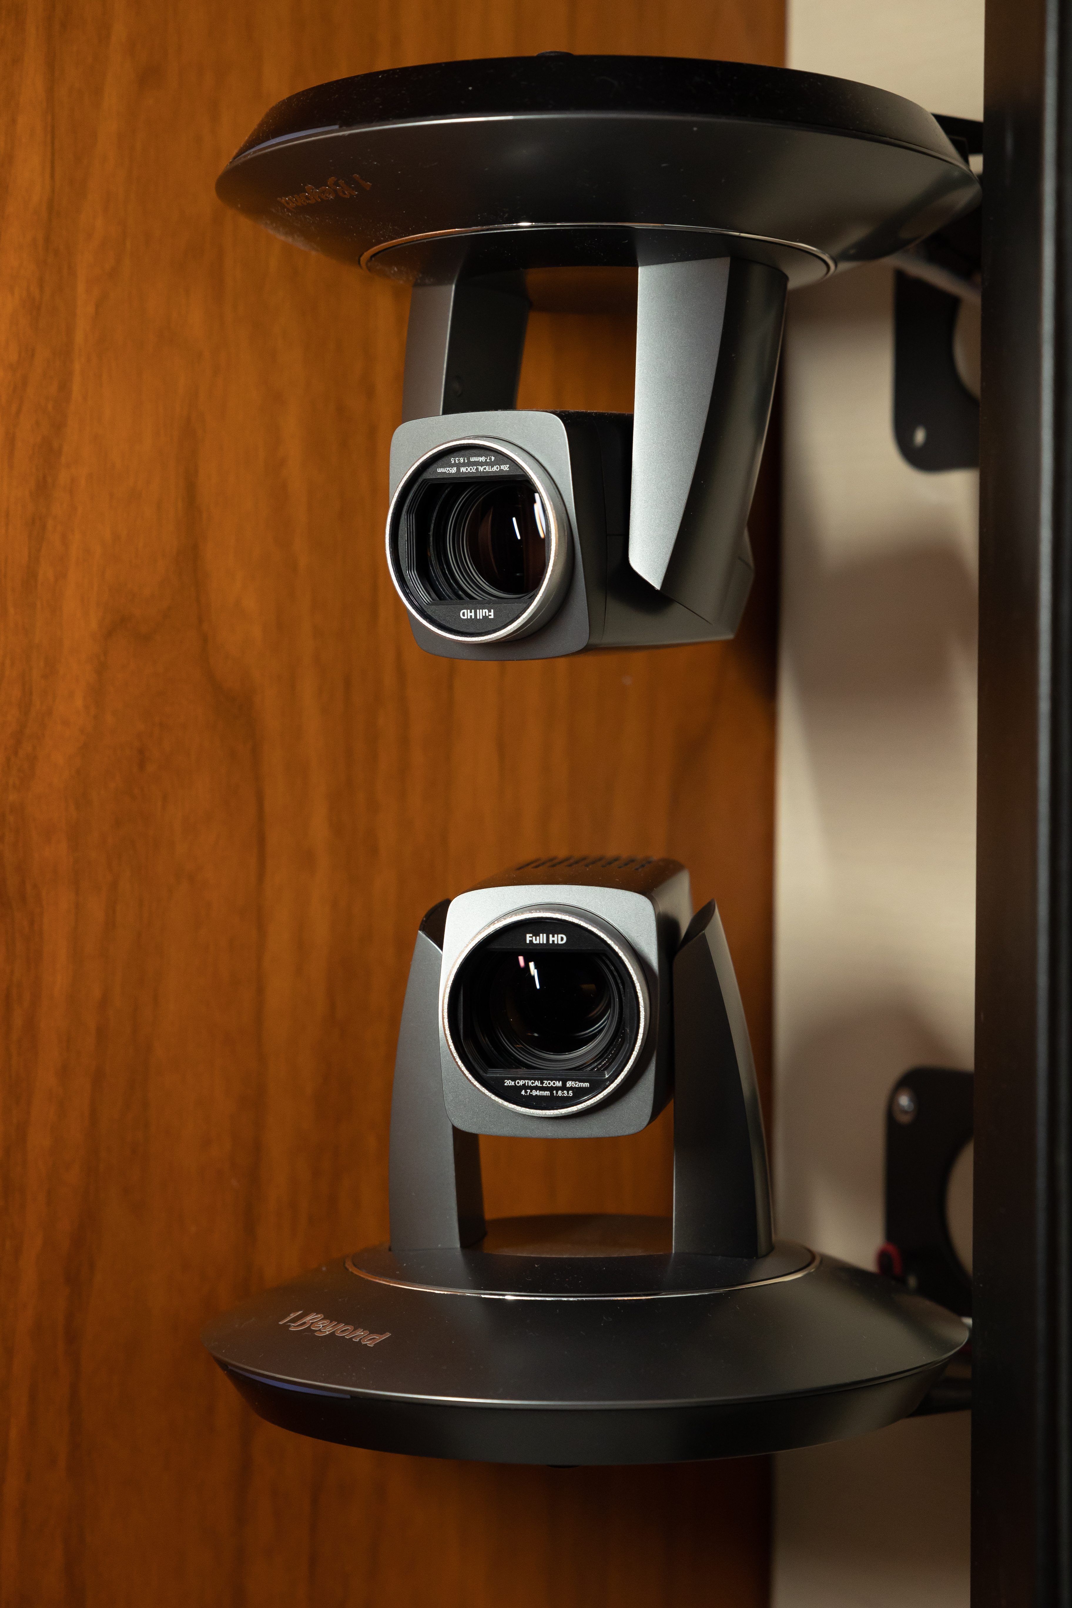 | In the Board Room, Sennheiser TeamConnect Ceiling 2s are used to drive a 1 Beyond Autotracker system, which has seven built-in cameras. There are two 1 Beyond cameras on the left side of the room facing the right side, two on the right side facing the left side, and three at the center pointed at the end tables, the head of the table and a ‘default’ wide shot.
Adjacent spaces
Another smaller space in the facility is the media lab, a retrofitted storage room that has been outfitted with a similar combination of technology: the Sennheiser TCC2 and QSC cameras connected to a QSC Core 110f processor, and several video screens.

Finally, the Event Room features seating for 60, or 100 people standing. While the Event Room was not able to be used for many months due to the pandemic, Gateway is eager to resume its in-person events and programming. "During the pandemic, we had to re-think how we do our events," says Anna Throne-Holst. “And part of what we thought about was, ‘How do we do digital meetings in a way that really functions? This led to a webinar series we called ‘Checking the Pulse’ with corporate metrics, where we touch on an array of different things. The next series we are going to do is on investment tools: IPOs, M&As, and more.”

“Our collaboration with Barco, QSC and the SACCNY really demonstrates the power of combining our respective best-of-breed communications technologies,” comments Charlie Jones, Global Business Development Manager of Sennheiser. ”In this case, our TCC2 ceiling microphone was able to deliver both audio clarity and intelligibility while working within a highly reflective, acoustically challenging environment. Moreover, the seamless interoperability of our TCC2, Barco’s LED Walls and QSC’s processing has resulted in a world-class video conferencing solution for SACCNY and its members.”

“This unique cooperation demonstrates the breadth which Barco can offer in high-end meeting rooms with the best in both collaboration and visualization. We’re excited to offer SACCNY true, engaging meeting experiences with BYOM in an outstanding audio environment and with the best-in-class control & tracking cameras.” says David Fitzgerald, VP Global Alliances at Barco.

Augmenting live events with world class videoconferencing
Now that Throne-Holst has a robust, state of the art videoconferencing capability in place, she is anxious to augment this capability with in-person events — which before the pandemic, were held approximately 2-3 times per week.

Greg Harper says that while the technology in Gateway is truly state of the art, it is most effective when it is 'invisible'. "Executives don't want to have to think about the technology — they want a videoconferencing experience to be as authentic as possible." Part of the beauty of Gateway is that the videoconferencing technology works with just about any device. "Our set up is truly BYOD — this is extremely powerful, and you don’t get that in many places," Harper concludes. "And you are taking advantage of this beautiful Barco LED wall, Sennheiser microphones and QSC speakers. You get the whole package: high-quality audio, stunning visual communication, lots of control, remote capability — what else could you want?"
###
About Barco
Barco designs technology to enable bright outcomes around the world. Seeing beyond the image, we develop visualization and collaboration solutions to help you work together, share insights, and wow audiences. Our focus is on three core markets: Enterprise (from meeting, classroom and control rooms to corporate spaces), Healthcare (from the radiology department to the operating room), and Entertainment (from movie theaters to live events and attractions). In 2020, we realized sales of 770 million euro. We have a global team of 3,300 employees, whose passion for technology is captured in 461 granted patents. For more information, visit us on www.barco.com.

About QSC
Founded over five decades ago, QSC is a globally-recognized leader in the design, engineering and manufacture of award-winning high-performance loudspeakers, digital mixers, power amplifiers, audio processors, digital cinema solutions, and the Q-SYS™ software-based audio, video and control ecosystem. Offering reliable, scalable and flexible solutions for professional installed, portable, production, corporate and cinema applications, QSC puts customers first with its highly-acclaimed sales, service, and support networks worldwide. www.qsc.com.

About Sennheiser
Shaping the future of audio and creating unique sound experiences for customers – this aim unites Sennheiser employees and partners worldwide. The independent family company, which is managed in the third generation by Dr. Andreas Sennheiser and Daniel Sennheiser, is today one of the world’s leading manufacturers of headphones, loudspeakers, microphones and wireless transmission systems. In 2020, the Sennheiser Group generated turnover totaling €573.5 million. www.sennheiser.com

Local Press Contact

Daniella Kohan
Daniella.Kohan@sennheiser.com
+1 (860) 598 – 7514

