Dear Reality becomes part of the Sennheiser Group
Sennheiser acquires a majority stake in the VR/AR audio software company

Wedemark/Sydney, 12 July 2019 – Audio specialist Sennheiser has taken a majority shareholding in Dear Reality GmbH on 1 July 2019. The expert in spatial audio algorithms and VR/AR audio software will continue to operate as a separate company based in Düsseldorf; customers will be able to rely on existing dearVR products and can look forward to joint VR/AR workflows by Sennheiser and Dear Reality. Uwe Cremering, responsible for AMBEO Immersive Audio at Sennheiser, will support the company as a third CEO alongside founders Achim Fell and Christian Sander.

The CEOs of Dear Reality GmbH (from left to right): Uwe Cremering, Achim Fell and Christian Sander | 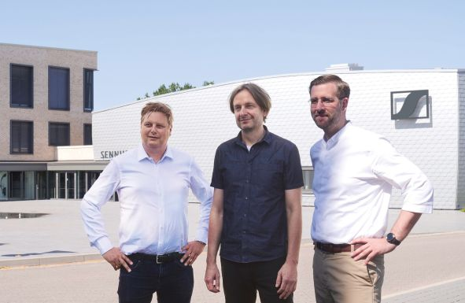

“For us, 3D audio is the future. With AMBEO, Sennheiser is active in all areas of immersive audio production, from the initial recording to mixing and processing and, finally, reproduction,” said co-CEO Dr. Andreas Sennheiser. “Audio software is an important building block in this production chain, especially as regards VR/AR applications.”

Co-CEO Daniel Sennheiser explained: “We are pleased to have gained additional highly qualified software experts and further 3D audio products with the acquisition of Dear Reality. At the same time, leveraging the strength of the Sennheiser brand and its global distribution network will give Dear Reality a larger scope of action.”

“We have been working closely with Sennheiser as an investor and partner for the past one and a half years, and are excited to now become a part of the Sennheiser family,” added Dear Reality founders Achim Fell and Christian Sander. “3D audio software has an ever-increasing importance in audio production. Together, we will expand our innovative, professional end-to-end workflows – and develop new ones.”

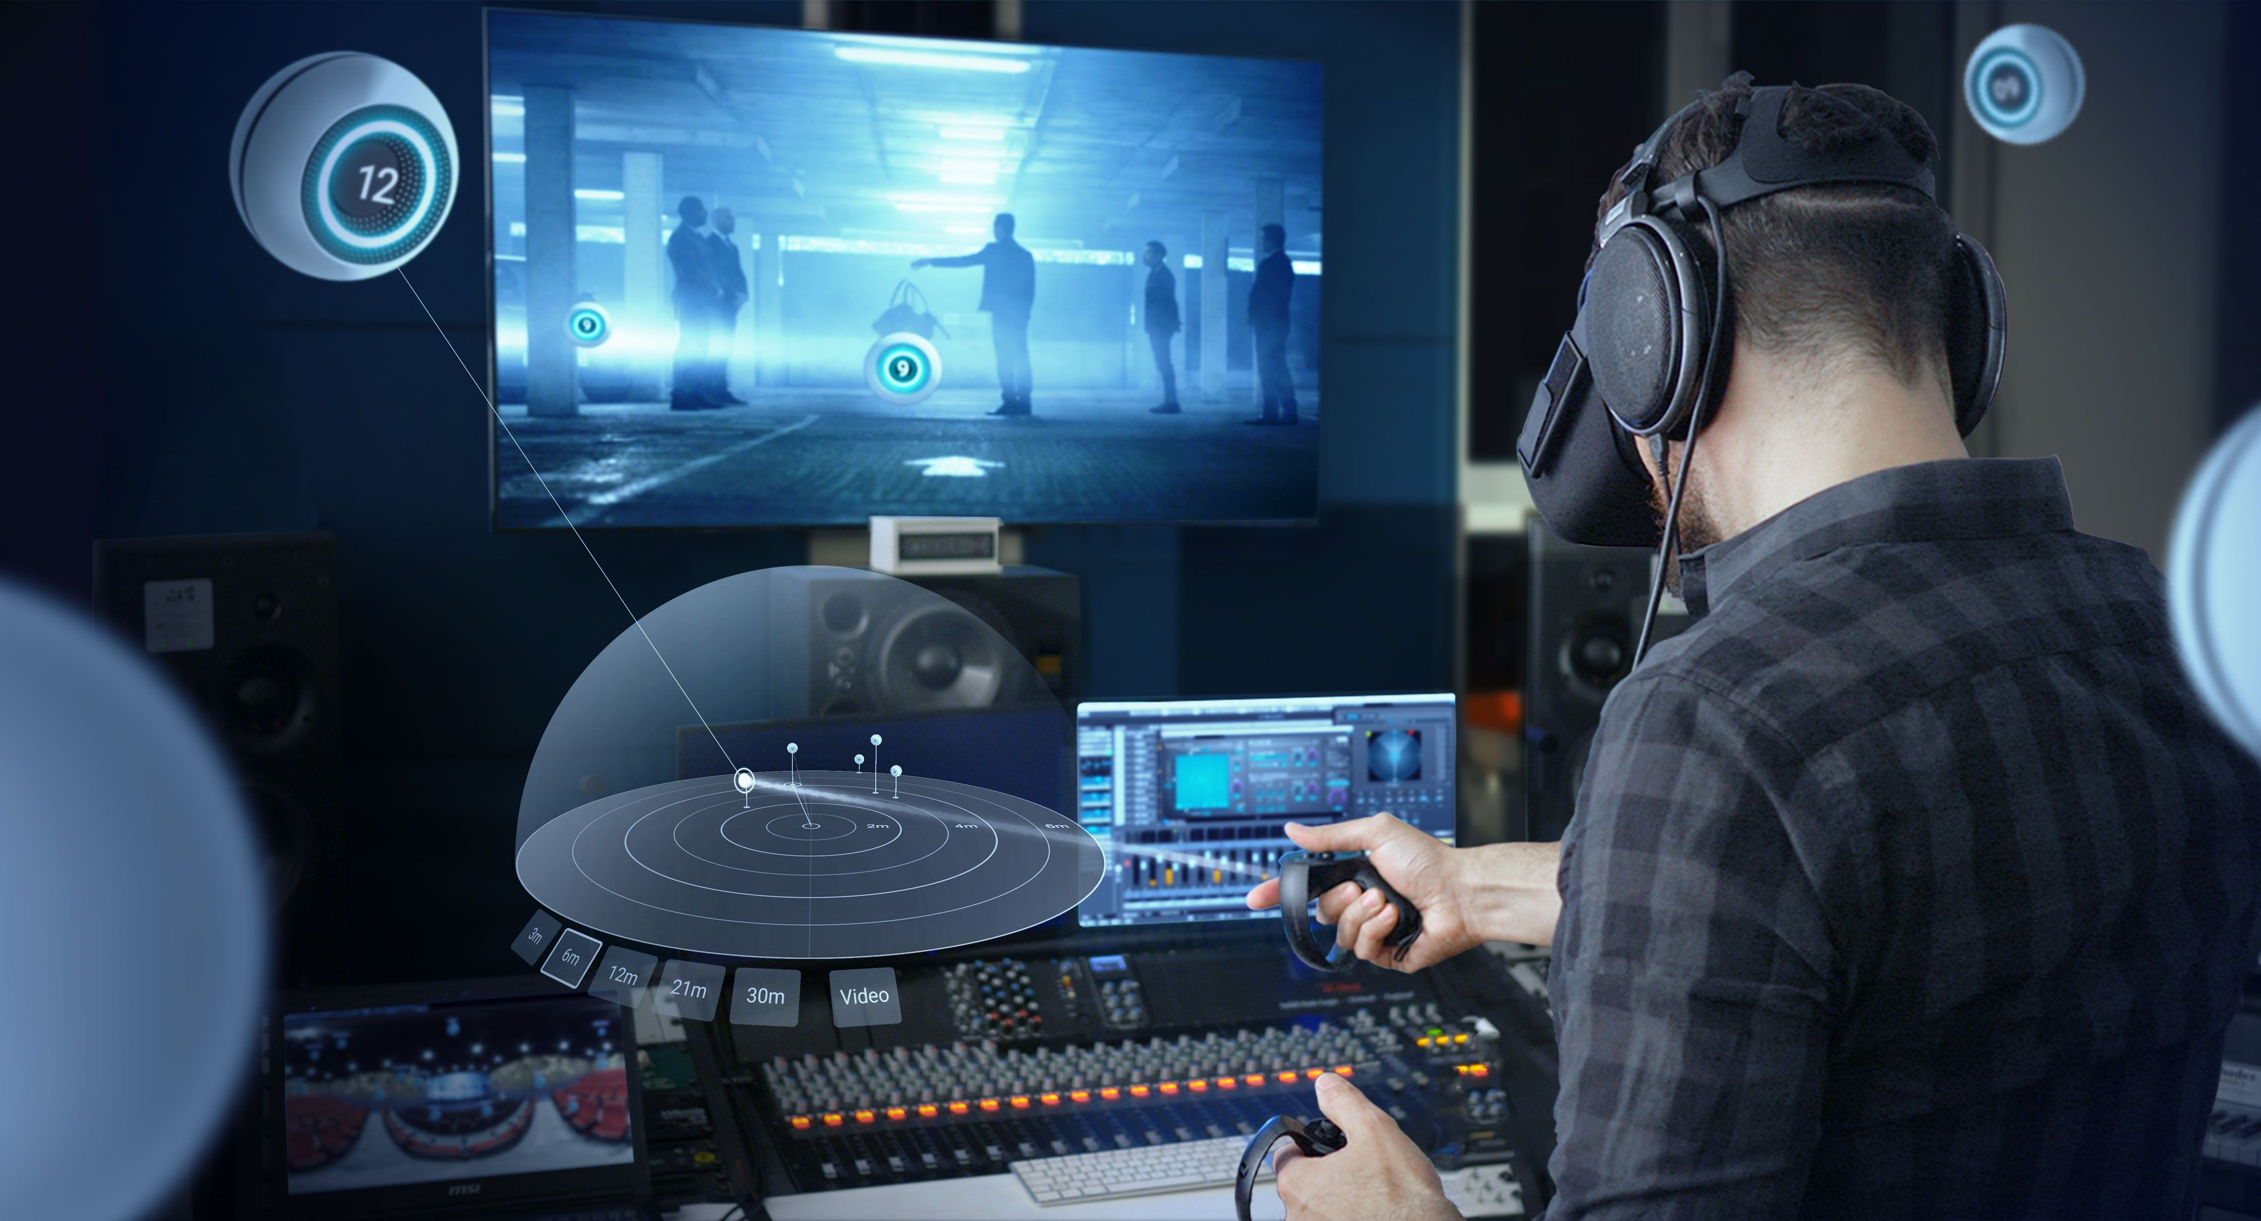 | dearVR SPATIAL CONNECT enables sound engineers to immersively mix VR in VR

Dear Reality is a leading company in the field of immersive audio controllers, well-known for its dearVR PRO binaural, Ambisonics and multichannel encoder with totally realistic room virtualisation. The company’s products are used the world over by sound engineers, sound designers, broadcasters and musicians. The latest Dear Reality software is dearVR SPATIAL CONNECT for immersively mixing VR content in VR, for example with the Nuendo 10 DAW.

https://www.dearvr.com

About Sennheiser
Shaping the future of audio and creating unique sound experiences for customers – this aim unites Sennheiser employees and partners worldwide. Founded in 1945, Sennheiser is one of the world’s leading manufacturers of headphones, loudspeakers, microphones and wireless transmission systems. Since 2013, Sennheiser has been managed by Daniel Sennheiser and Dr. Andreas Sennheiser, the third generation of the family to run the company. In 2018, the Sennheiser Group generated turnover totaling €710.7 million. www.sennheiser.com

Global PR Contacts Local PR Contact

Mareike Oer Heather Reid
mareike.oer@sennheiser.com heather.reid@sennheiser.com
+49 (5130) 600 – 1719 +61 448 119 609

Stephanie Schmidt
stephanie.schmidt@sennheiser.com
+49 (5130) 600 – 1275

