For more information, please contact Marta de Paco
On +34 670 780 664 or email press@comunicahair.com

Important:
These images are only available for editorial content.
Credits must be included.
Notification of their publication is expected.

KATI SUOKAS
WEAVE OF DAWN Collection
FINLAND

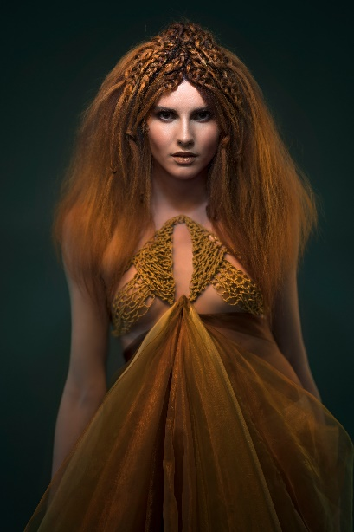
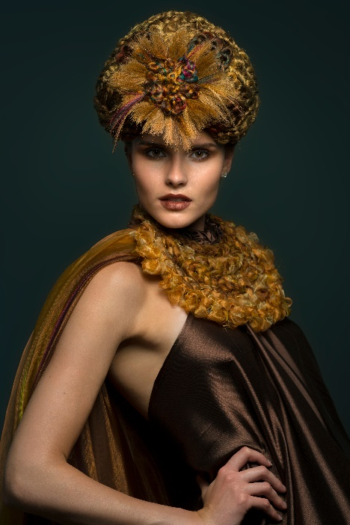
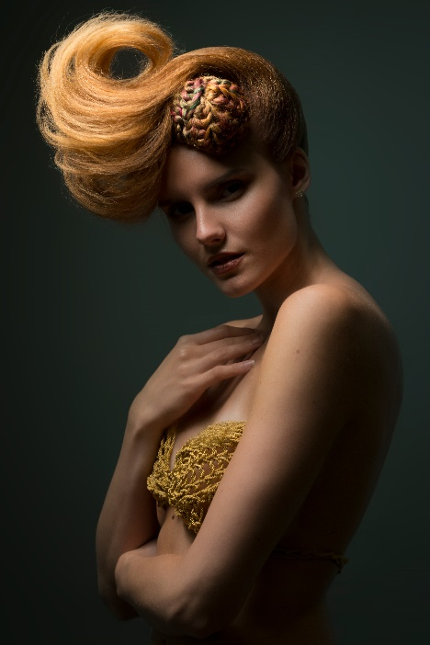

Hair: Kati Suokas – Glohair @kati.kampaaja
Photography: Mikko Karekivi @tikrumikko
MUA: Tiina Lamberg @studiotiinalamberg
Styling: Kati Suokas @kati.kampaaja
Model: Milla Grönstrand @milla.gronstrand
Products: Glohair - glohair.fi

KATI SUOKAS
WEAVE OF DAWN Collection
FINLAND

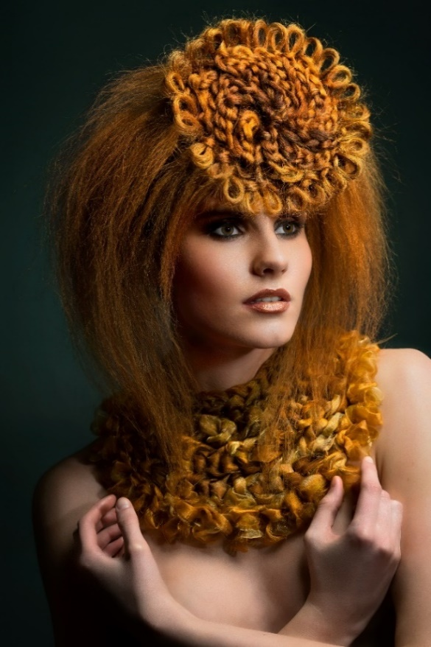

Finnish hairdresser Kati Suokas created "Weave of Dawn" based on household crochet. During one summer, in her cabin in the woods, her children wove for school homework. Meanwhile, the sun was filtering through the pines and covering them with a warm bronze hue. In that bucolic moment, the inspiration for this collection was born. The hairdresser has not only woven the hair, but she has also designed and sewn the garments herself. The result transforms hair into a headdress and at the same time a complement, acquiring a new, precious, and delicate identity, but full of personality. The artisanal, the modest act of weaving, rises to a new dimension, the artistic. And this is thanks to the result and the fact that each look is unique and unrepeatable. It is the bearer of ancient knowledge that is completely renewed and contemporary.

