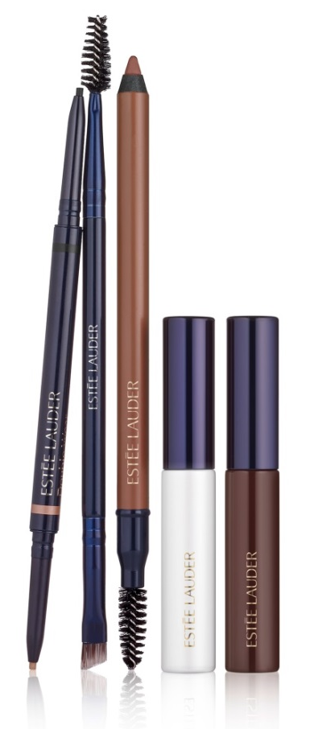

BROW NOW

A full service brow collection of breakthrough and
quick transformational tools and techniques for the best brows now

Eyebrows are one of the most important features of a face. A well-defined brow brings balance and proportion, creating a refreshed, polished and youthful look – it’s the foundation of a flawless face. Whether a beginner or a pro, perfect brows are possible. Introducing, Estée Lauder Brow Now – from shaping and taming to tinting and lifting, Estée Lauder becomes the go-to eyebrow destination for the fast and simple brow transformation. Featuring an assortment of intuitive and innovative brow products in expertly selected shades, Estée Lauder Brow Now has all the tools needed to create a uniquely perfect, tailored arch every day.

FILL & GROOM

- NEW Brow Defining Pencil
The innovative 2-in-1 gel pencil that tints and sets brows in just one stroke. This unique gel-gliding texture helps style and set brows while natural-looking pigments fill in thin, patchy spots for a quick and simple fix. Extreme 12-hour wear formula is water, humidity and sweat resistant, creating perfect brows for any environment. Available in 5 NEW shades: Blonde, Soft Brown, Rich Brown, Black Brown and Black.

Application Tip: Fill in brows with brow pencil using short, hair-like strokes. For a natural look, start with a light touch and build color to desired fullness and intensity. Brush brows in place with the spooly.

Suggested Retail Price: € 23,80
Available from October 19th, 2015 at Estée Lauder retailers and on www.esteelauder.be.

- NEW Double Brow Brush
The new brow essential. This dual-ended brow tool features an angled cut brush to precisely fill and define brows, while the opposite end features a brush for effortless and even blending. The result – a natural, polished finish for the perfect arch.

Application Tip: Starting with the arch of brow, apply brow product and blend towards the tail. Fill in the inner part of the brow with the remaining product on the brush. Use the spooly end to smooth and blend color.

Suggested Retail Price: € 23,80
Available from October 19th, 2015 exclusively at Estée Lauder counters at the Galeria INNO and on www.esteelauder.be.

SET & STYLE

- NEW Volumizing Brow Tint
From tinting to taming, this lightweight fiber-filled gel tint formula lasts up to 12 hours. A unique blend of fibers fill in patchy, uneven spots and builds easily for fuller, natural-looking brows in a few quick and simple steps. The specially designed, micro tapered brush builds and shapes with precision and combs through to blend effortlessly, while the water resistant, smudge and transfer proof formula keeps brows in place all day. Available in 5 NEW shades: Blond, Soft Brown, Rich Brown, Black Brown, Black.

Application Tip: Using short pressing motions, stroke brush tip along brow to define shape. Comb through to blend and smooth hair into place. For emergency hair touch-up between color appointments, apply to dry hair by simply picking up the strand of hair and brush on in an upward motion. Let set for a minute and repeat if desired. Wash hair to remove.

Suggested Retail Price: € 23,80
Available from October 19th, 2015 exclusively at Estée Lauder counters at the Galeria INNO and on www.esteelauder.be.

- NEW Stay-in-Place Brow Gel
The finishing touch to every brow. This brush-on clear gel features a mini-mascara brush designed to tame, shape and set brows in seconds. The non-flaking formula in a universal clear shade can be used alone or on top of another favorite eyebrow product so brows always look tamed, polished and in place.

Application Tip: Brush brows into place using short, upward strokes.

Suggested Retail Price: € 23,80
Available from October 19th, 2015 exclusively at Estée Lauder counters at the Galeria INNO and on www.esteelauder.be.

All Estée Lauder Brow Now Collection products are ophthalmologist and dermatologist tested.

For more information or to request images or samples, please contact:
Dominique Nellens
DOWNLOAD HI RES VISUALS
FROM THIS LINK:
ESTEELAUDER.PREZLY.COM
(no password required)
PR Manager Estée Lauder Benelux
T +32 2 716 85 76
M +32 474 55 25 39

