CX PLUS TRUE WIRELESS: SUPERIOR SOUND. NO COMPROMISE.
Sennheiser’s new earphones deliver premium sound with Active Noise Cancellation all day long

Marlow, UK, September 14, 2021 – When it comes to true wireless listening, superior sound and great wearing comfort are essential. Sennheiser’s new CX Plus True Wireless earphones deliver on both fronts and more, offering a thrilling, high-quality listening experience with Active Noise Cancellation, effortless smart interaction, and a sleek design for supremely comfortable all-day enjoyment.

The new CX Plus True Wireless earphones provide superior sound at an accessible price point. The clarity of the German-engineered TrueResponse transducer delivers an acoustic system bringing audiophile technology to everyday listening. Developed for the audio specialist’s premium earphones, this bespoke acoustic system delivers high-fidelity stereo sound with deep basses, natural mids and clear, detailed treble.

The Active Noise Cancellation function ensures that listeners won't miss a beat, allowing them to experience clarity, detail and thrilling bass without distractions – even in noisier environments. Meanwhile, the Transparent Hearing feature makes it easy to focus on external sounds without the need to remove the earbuds. This feature is particularly useful in letting outside sound in, so users are more aware of their surroundings.

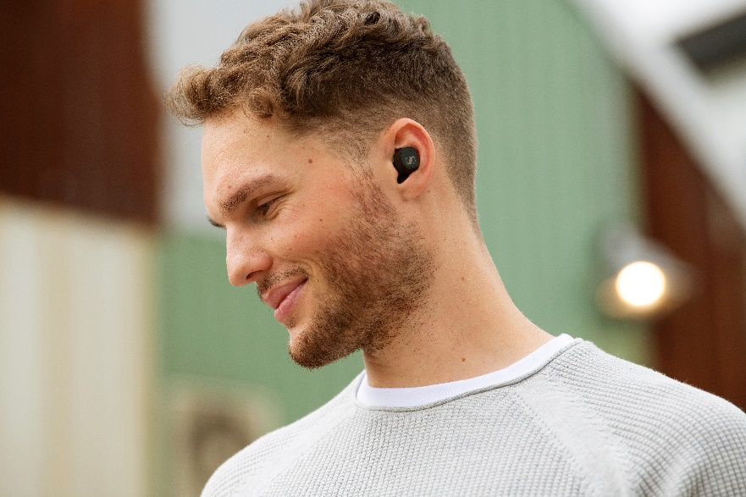 | The CX Plus True Wireless expands Sennheiser’s True Wireless portfolio by offering a superior listening experience with Active Noise Cancellation at an accessible price point

“Hot on the heels of the sleek CX True Wireless, we are now bringing an even more exceptional consumer earphone offering to the market,” says Frank Foppe, Product Manager at Sennheiser. “With audiophile-grade technology and added features like Active Noise Cancellation and Transparent Hearing, the CX Plus True Wireless provide a high-fidelity listening experience that’ll last the whole day.”

Everyday life, simplified
Thanks to the customisable touch controls, every interaction with the CX Plus True Wireless is effortless. Users can tailor bespoke commands to ensure that controlling audio, calls and accessing voice assistants is convenient and intuitive. Each earbud is equipped with a pair of dual mics to optimise speech for calls and voice assistant access to ensure crystal clear voice pick-up. The independent earbud use allows the right and left earbuds to be used individually or as a pair.
Another intelligent feature, Smart Pause, has been developed with the fast pace of modern life in mind. It automatically pauses audio when the earbuds are taken out and instantly resumes playback when replaced. The earbuds also automatically power up when removed from their charging case and switch off when put away, so they are ready when you need them. The CX Plus True Wireless offer the latest connectivity options for a high-tech listening experience: Bluetooth 5.2 compatibility and SBC, AAC, aptX and aptX Adaptive codec support for high resolution, low latency audio that syncs perfectly with video content. Bluetooth connections can be easily managed via the Sennheiser Smart Control app, while the built-in EQ delivers a personalised audio experience and a thumping Bass Boost preset.
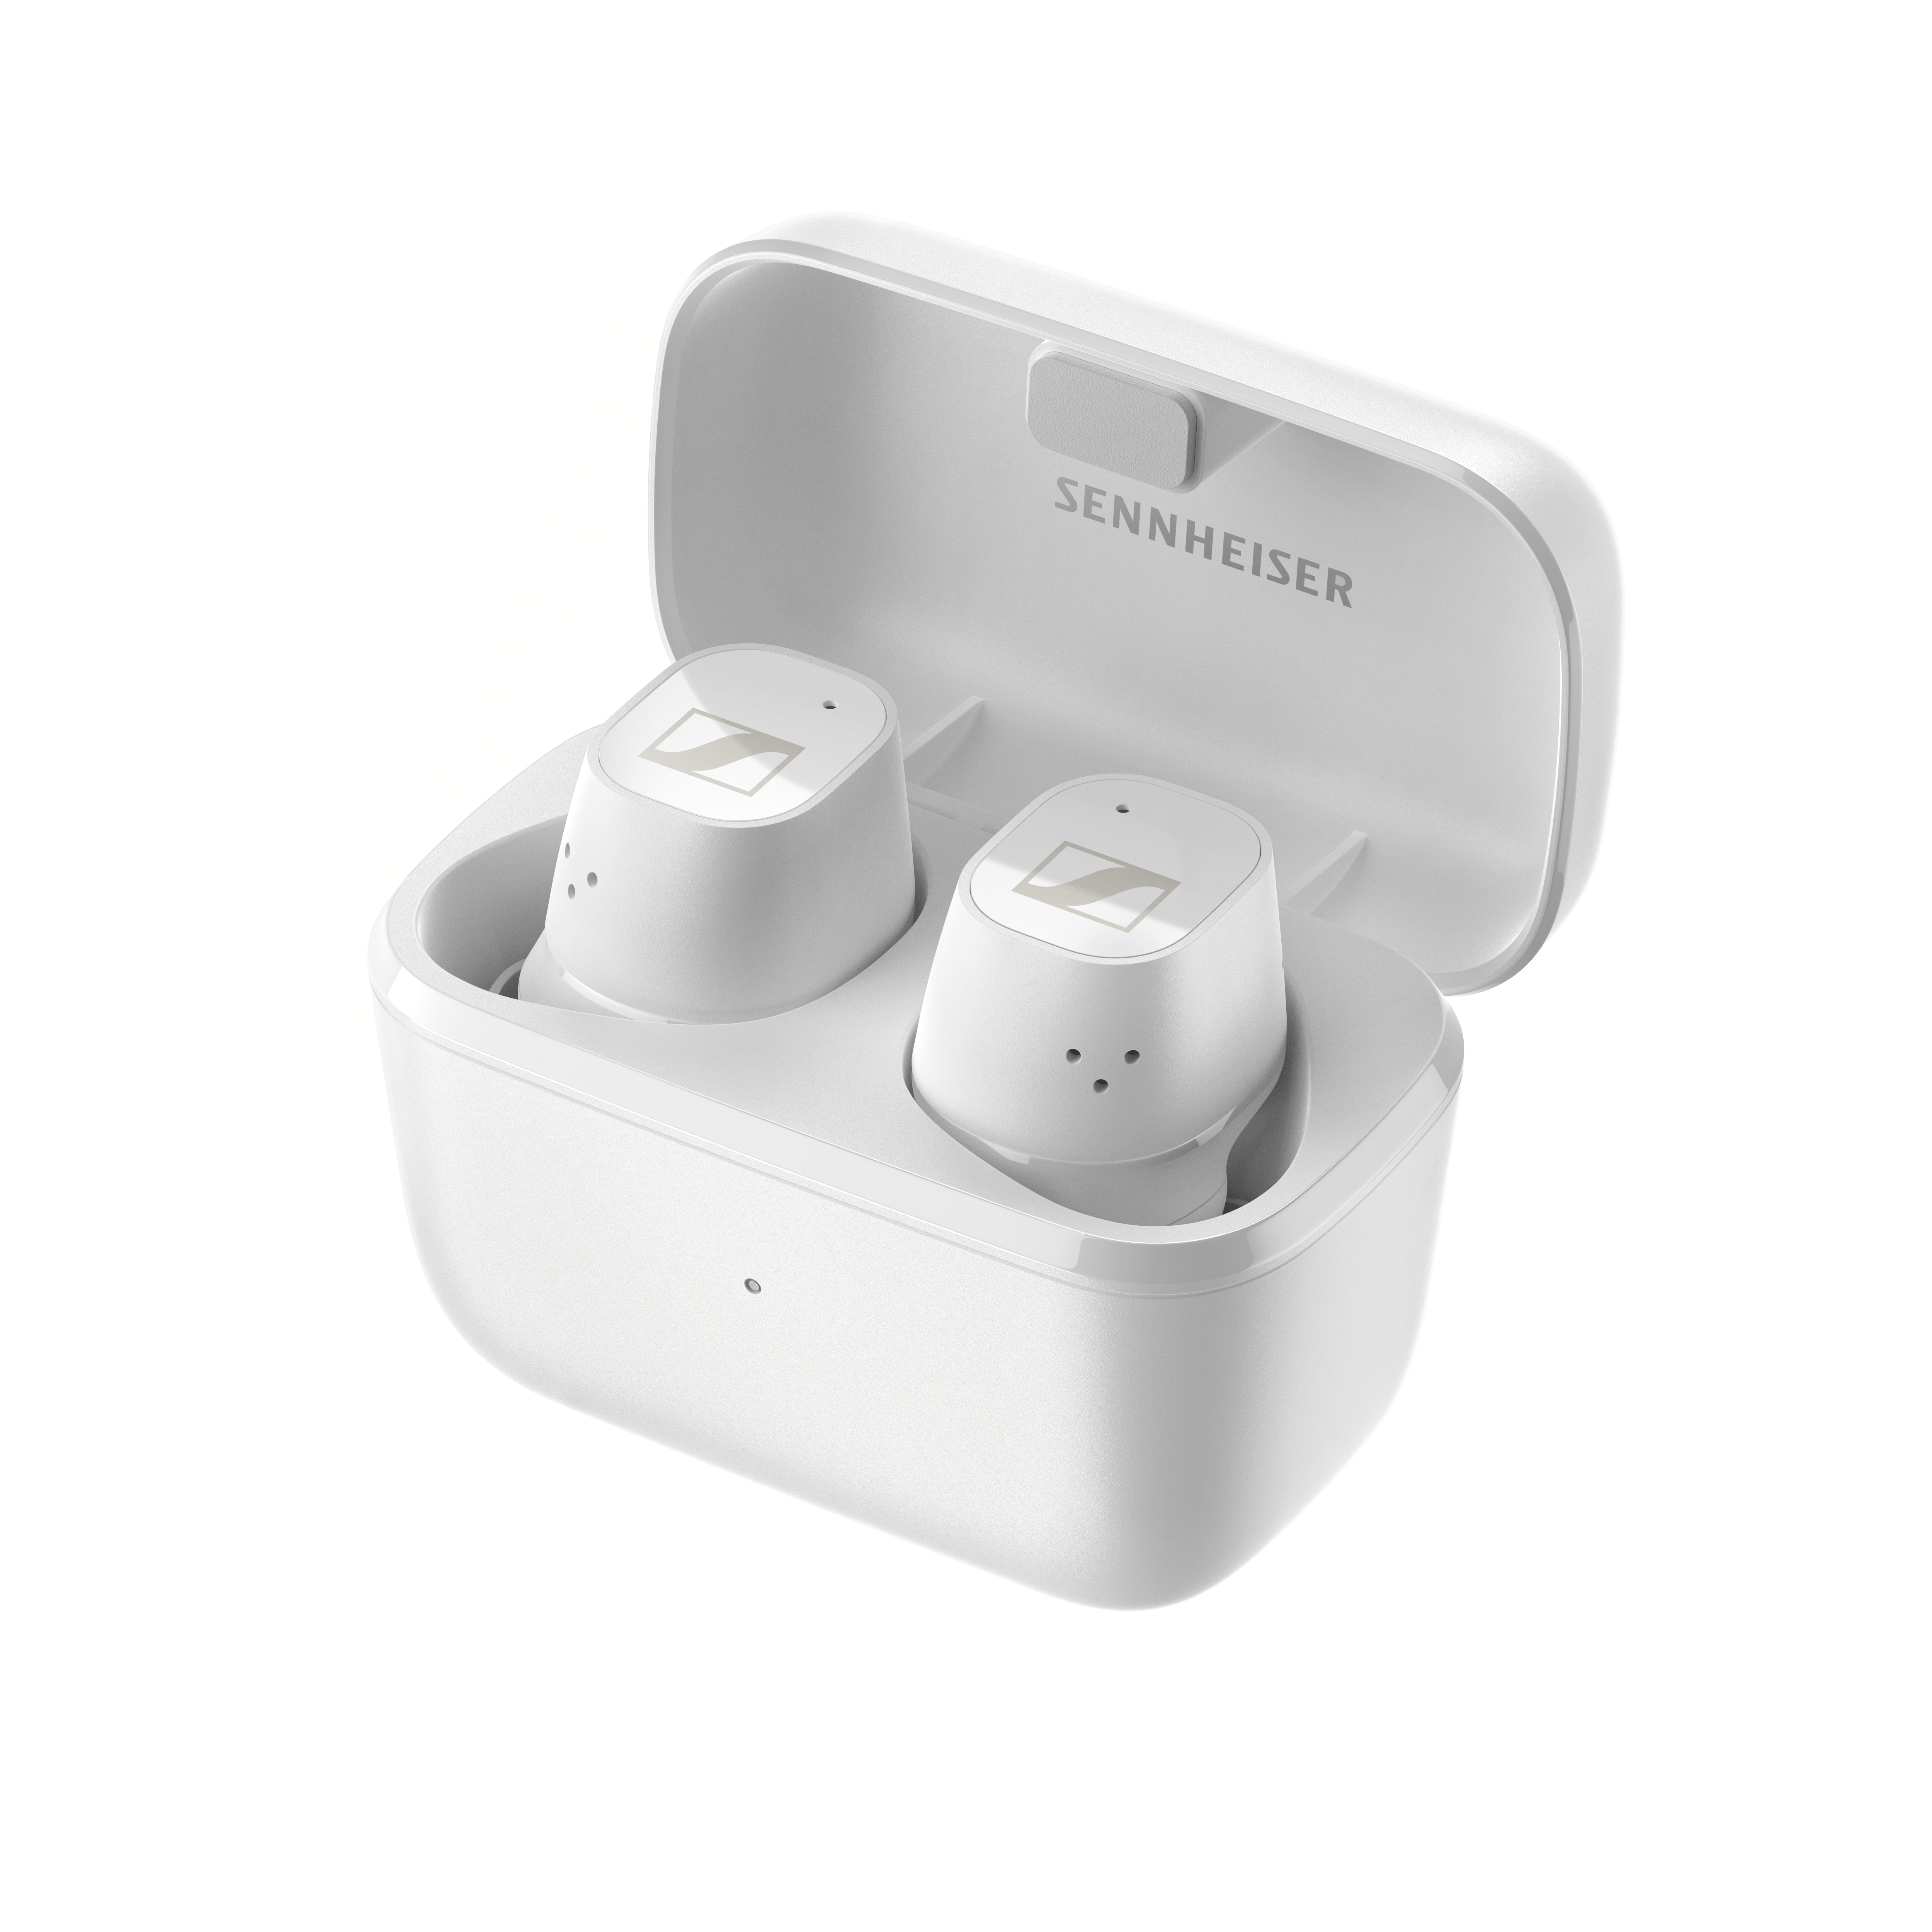 | The CX Plus True Wireless offer customisable touch controls and up to 24 hours playback time with on the go charging
Designed for all-day enjoyment
All of Sennheiser’s True Wireless earbuds have been developed in line with the latest ergonomic research, and the sleek, smaller design of the CX Plus True Wireless guarantees comfortable all-day enjoyment. The compact earbuds securely fit into the ear to stay firmly in place when listening on the move. Optimal comfort is assured thanks to a selection of four different sized silicon ear adapters, which add further passive noise isolation to complement the earbuds’ ANC.

With IPX4 rated splash resistance, listeners can enjoy the CX Plus True Wireless wherever they go. The CX Plus True Wireless are ready to keep pace with a long-lasting battery and portable charging case, providing an impressive 24 hours of playback time.

The CX Plus True Wireless will be available in black or white from 28th September for £129 / €159.90 EUR (RRP).

ABOUT SENNHEISER
Shaping the future of audio and creating unique sound experiences for customers – this aim
unites Sennheiser employees and partners worldwide. The independent family company,
which is managed in the third generation by Dr. Andreas Sennheiser and Daniel Sennheiser, is
today one of the world’s leading manufacturers of headphones, loudspeakers, microphones
and wireless transmission systems. In 2020, the Sennheiser Group generated turnover totaling
€573.5 million. www.sennheiser.com

Global Press Contact
Sennheiser electronic GmbH & Co. KG
Maik Robbe
Communications Manager EMEA
T +44 (0) 7393 462484
maik.robbe@sennheiser.com

Emily Ackland
Harvard
T +44 7393 758442
emily.ackland@harvard.co.uk

