THE DEPENDABLE TV-VIEWING COMPANION
Introduces the Sennheiser RS 120-W – for entertainment with outstanding sound
Old Lyme, CT, August 16, 2022 – Sennheiser's TV listening portfolio is being enhanced with a powerful addition. The RS 120-W wireless on-ear headphones offer no less than three different sound modes for a customized listening experience, working with advanced LE audio transmission for crystal-clear and undistorted sound powered by Bluetooth®. In combination with the usual long-lasting battery life and an improved design for optimal comfort while wearing, the new Sennheiser headphones serve as the ideal foundation for binge-worthy TV sessions.

"High-quality sound and an engaging televisual experience are essential for the Sennheiser brand," said Irene Strüber, Sennheiser Product Manager TV Listening. "The new RS 120-W is designed to make the sound experience even more individual and versatile. Users can tailor their sound settings according to their preferences, whether they like more bass or speech clarity. A pair of headphones should not be limited to one type of entertainment. That's exactly the philosophy we're putting into practice with the RS 120-W."
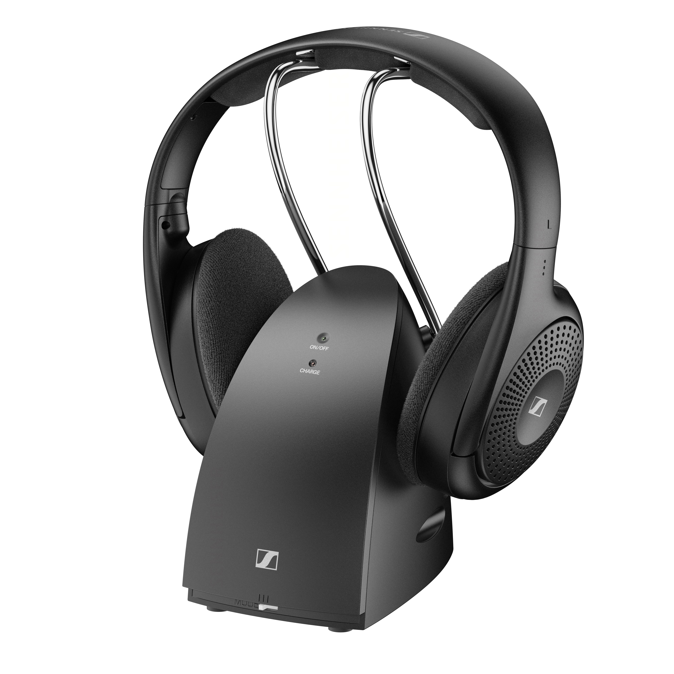

Designed for high-quality entertainment
Depending on the preferred type of entertainment, users can choose between ‘Speech’, ‘Music’ and ‘Neutral’ sound modes to adjust the soundscape to their respective requirements. To ensure a detailed, balanced, and undistorted sound, the RS 120-W uses advanced LE audio, which enables audio streaming via Bluetooth® Low Energy transmission technology. LE audio includes a new high-quality LC3 audio codec. This technology not only convinces listeners through its delivery of crystal-clear audio, but also offers a very low latency, which guarantees immersive entertainment sessions.

Meanwhile, the enhanced design of the RS 120-W makes controls even more intuitive. For example, users can now adjust the volume independently of the TV by using the control on the headphones’ ear cup. The comfortable on-ear design with light ear pads and a soft headband pressure contributes to the RS 120-W's all-day wearing comfort, making it ideal for extended periods of TV viewing.

Enjoying the sound of Sennheiser together
With a battery life up to 20 hours and wireless transmission in a range of 60 meters, the RS 120-W also provides the technical foundation for unlimited entertainment sessions. As usual, the transmitter included in the scope of delivery serves as a charging station and transmission center in one. Meanwhile, the new ‘Broadcast Mode’ feature can pair the transmitter with multiple sets of headphones, so that the breathtaking sound can be enjoyed by several people at the same time. Those who like it loud can increase the volume up to 100 dB, without having a negative impact on their surroundings.

Pricing and availability
The Sennheiser RS 120-W will be available in EMEA for pre order on 16 August and for sale on 30 August with an MSRP of $129.95 USD/ $179.95 CAD. It will be available in North America from October, and in other countries from Q1, 2023.

About the Sennheiser brand
We live and breathe audio. We are driven by the passion to create audio solutions that make a difference. Building the future of audio and bringing remarkable sound experiences to our customers – this is what the Sennheiser brand has represented for more than 75 years. While professional audio solutions such as microphones, meeting solutions, streaming technologies and monitoring systems are part of the business of Sennheiser electronic GmbH & Co. KG, the business with consumer devices such as headphones, soundbars and speech-enhanced hearables is operated by Sonova Holding AG under the license of Sennheiser.

www.sennheiser.com
www.sennheiser-hearing.com

Press contact
Sonova Consumer Hearing GmbH
Paul Hughes
Head of PR and Influencers
Sennheiser Headphones & Soundbars
T +49 (0) 162 2921 861
paul.hughes@sennheiser-ce.com

