**How a Rising RF Star is Rewriting the Rules of Live Audio on Cyndi Lauper’s Farewell Tour  
  
*Shannon Fitzpatrick Reimagines Workflow and Gear Requirements with Sennheiser Spectera***

**Wedemark, Germany – Sept 24, 2025** **- In the high-stakes world of live music where technical precision is paramount, radio frequency (RF) coordinator Shannon Fitzpatrick has quickly become one of the industry's rising stars. For Cyndi Lauper’s “Girls Just Want to Have Fun Farewell Tour,” Fitzpatrick is not only navigating the complex RF challenges of a multi-city tour, she’s revolutionizing her workflow by leveraging cutting-edge technology from Sennheiser — the new Spectera system, which is paving the future of wireless audio.**

Fitzpatrick’s path to the soundstage wasn’t a conventional one. Her passion for music began with a stint in a Led Zeppelin cover band and an internship at a recording studio where she could often be found doing the mundane: cleaning studios and fetching coffee. But it was a gig setting up drums for a live show that sparked her true calling. “I began to wonder why I was sitting in a studio when I had found a part of the industry that felt like a substantially better fit. And it was much, *much* cooler,” Fitzpatrick recalls.

She transitioned from studio work to live production, learning the ropes on the road. Navigating an industry that is quite often male-dominated, Fitzpatrick says her success came from a simple philosophy: self-advocacy. “In this industry, you most certainly have to be an advocate for yourself,” she says. “If you want to learn something, you have to just tell people you want to learn it and do it. My motto is: throw me in the fire, I’m ready!” Fitzpatrick has carried this mentality with her as she’s continued her career working with legendary acts like Journey and with a recent tour with Halsey.

Fitzpatrick's ascent continued through high-profile tours, from a one-truck tour with Elvis Costello to a massive undertaking for the “Game of Thrones in the Round” show that involved a 29-truck spectacle. Despite the scale, the core challenges of live audio remained constant. On previous tours, she struggled with intermodulation issues, dropouts, and the sheer amount of gear required. Her daily workflow was a meticulous and time-consuming process of manually walking the stage with multiple receiver packs to test for coverage, a task she describes as both inefficient and stressful.

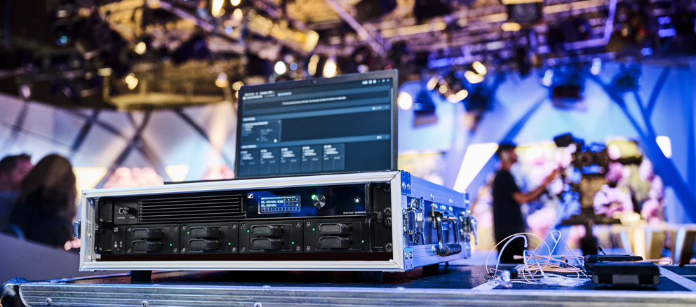

*As the world’s first wideband, bidirectional, digital wireless ecosystem, Spectera is not only solving the technical challenges of RF coordination but also elevating the artistic experience for everyone on stage.*

For Cyndi Lauper’s tour, Fitzpatrick began integrating Sennheiser’s Spectera, the world’s first wideband, bidirectional digital wireless ecosystem, providing audio professionals with unparalleled capability and flexibility. The results have been revolutionary, directly solving the challenges she previously faced. A single, compact Spectera base station replaced an entire rack of equipment, including the antenna combiners and complex cabling. “It's so eye-opening to be able to completely reimagine the process. I no longer have to lug around the antenna combiner and all the other heavy gear,” she explains. “Thanks to Spectera, my job has become so much simpler!”

This system, which began shipping earlier this year, is the first to incorporate the newly FCC-approved WMAS framework, placing Fitzpatrick among the earliest adopters. Her involvement reflects a forward-looking approach and a clear commitment to advancing audio technology. By embracing this emerging standard at such an early stage, Fitzpatrick demonstrates the kind of initiative and technical leadership that continues to shape the future of audio.

The system's wideband technology allows for frequencies to be placed even the most complex environments without interference. “I placed it over a much higher noise floor than would ever work for a traditional system and did not have one single issue,” Fitzpatrick says of a challenging venue in Boston. Spectera also saves her an immense amount of time.

Spectera's single pack testing feature has also saved her countless hours. Instead of walking the stage with multiple packs on various frequencies, Fitzpatrick can now use just one pack to verify coverage for the entire system. She described the relief of this new process: “I’m going to walk this one pack on this one frequency. And I don't have to sit there and sync each pack. All I need to do is change the battery, turn it on, walk it, and I've walked like all the packs with one, which is incredible. I love that part. I’m saving 30 minutes a day, which can be spent on more critical tasks.” In a touring production of this scale where the crew only has limited hours each day before a show to set up and test the equipment, each minute is crucial.

The impact of the Spectera system is evident not just in the ease of use for Fitzpatrick but in the performance of Lauper’s entire onstage band, as the musicians have noticed a significant improvement in the clarity and quality of their mixes. The backup singers were the first to switch and immediately praised the system's clean sound and low noise floor, describing it as “night and day” compared to their previous setup.

Other musicians noted the difference as well, such as the band’s bassist. Fitzpatrick shared his feedback, “He mentioned that the way he can now hear feels like there's more space for everything. He said that he doesn’t need to have everything super loud, because he can actually pick out what's happening. Our percussionist felt the same way — she can finally hear and feels like everything has its place now. I’m thrilled that they are loving this solution!”

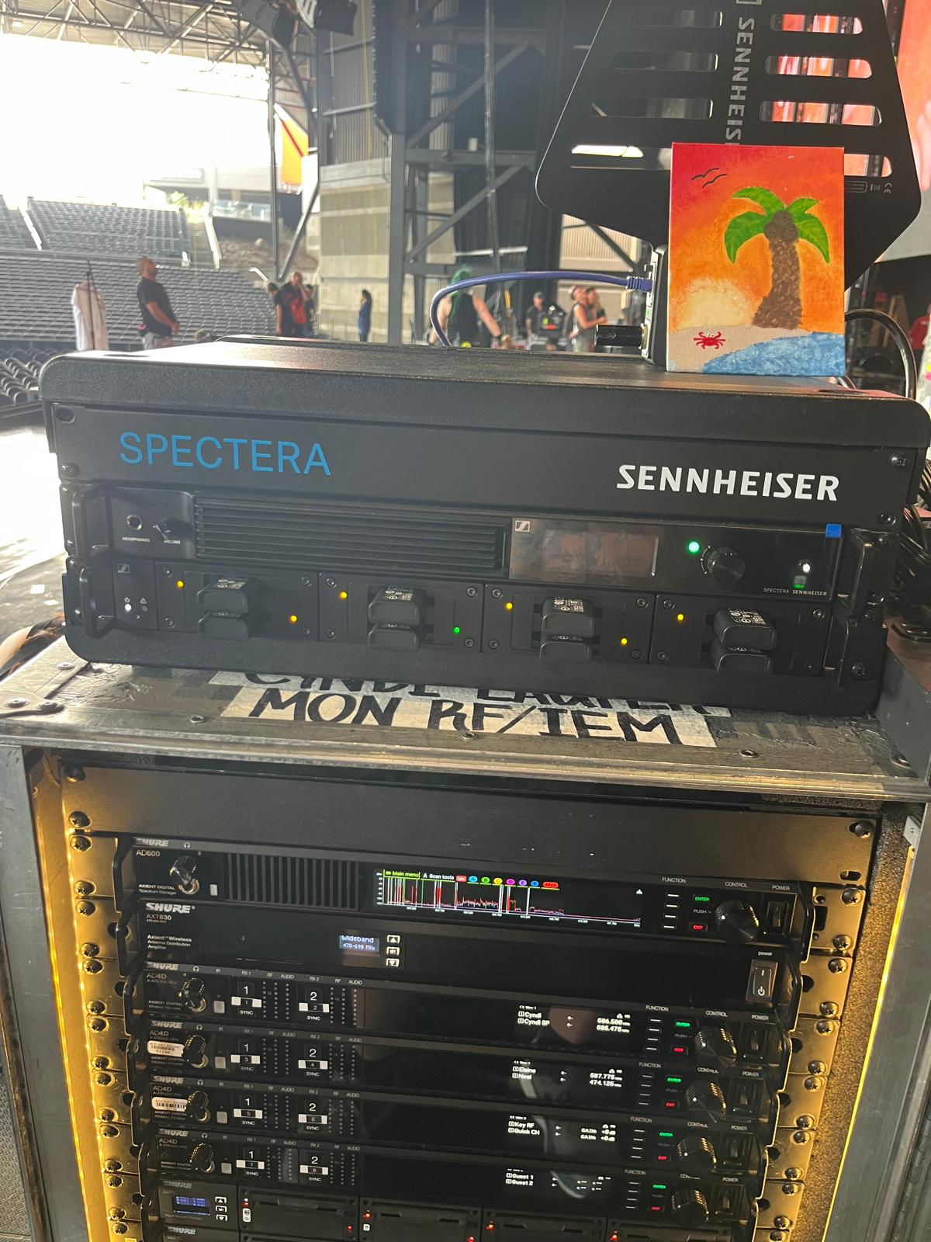

*With Spectera, Shannon Fitzpatrick is proving that with the right technology and an unwavering drive, magic can be created for touring productions. Image Credit: Jonny Brook, Systems Engineer*

By providing a reliable and clear audio signal, Spectera has not only solved the technical challenges of RF coordination but has also elevated the artistic experience for everyone on stage. Ultimately, Fitzpatrick believes the key for engineers is to trust the equipment. When asked for advice for others, she says simply: “Just do it. Don't be scared of it.”

With a passion for creating a memorably mesmerizing experience for her audiences, Shannon Fitzpatrick is proving that with the right technology and an unwavering drive, magic can be created. “My favorite part about what I do is creating an atmosphere for people to escape to. I feel like that’s what we do, we offer a little bit of magic that can’t always be explained. I simply love what I do — and I love what Spectera does as well.”

For more information about Sennheiser and its solutions, visit [www.sennheiser.com](http://www.sennheiser.com/).

###

**About the Sennheiser Group**

We live and breathe audio. We are driven by the passion to create audio solutions that make a difference. In 2025, the Sennheiser Group celebrates its 80th anniversary. Since 1945, we stand for building the future of audio and bringing remarkable sound experiences to our customers.

Today, the Sennheiser Group is one of the leading manufacturers in the field of professional audio technology. With our brands Sennheiser, Neumann, AMBEO and Merging, we offer a comprehensive range of solutions that is fully tailored to the needs of our customers. As independent family-owned company Sennheiser is led in the third generation by Co-CEOs Dr. Andreas Sennheiser and Daniel Sennheiser. [www.sennheiser.com](https://dundeehillsgroup.sharepoint.com/DHG%20SharePoint/DHG%20-%20Agencies/InGear/Sennheiser/Press%20Releases/250924%20-%20Lauper%20tour/www.sennheiser.com)

**Local Press Contacts:**

Daniella Kohan

[daniella.kohan@sennheiser.com](mailto:daniella.kohan@sennheiser.com)

+1 (860) 227-2235

Peter Schuyler

Peter@ingearpr.com

+1 (917) 496-8970