Step into new worlds of Sound at CES 2019
Sennheiser presents Augmented Audio experience, new MOMENTUM True Wireless and upcoming AMBEO Soundbar

Wedemark, December 21, 2018 – At CES 2019, held in Las Vegas from January 8 to 11, Sennheiser will be providing visitors with the unique opportunity to explore the world of Augmented Audio and craft their very own AMBEO AR experience. Additionally, listening sessions with the much anticipated AMBEO Soundbar at the Sennheiser booth will reveal how the audio specialist is bringing its innovations in immersive 3D sound to the home. Visitors to CES can also get hands on with the new MOMENTUM True Wireless earphones.

“CES has evolved beyond being a showcase for the products of today - it provides a window into the future. There is real desire to see and experience tomorrow’s worlds and with the products and the AMBEO AR experience at the Sennheiser booth, we can literally let visitors step into the future of audio,” commented Pete Ogley, Chief Operating Officer Consumer Division at Sennheiser.

AMBEO AR Experience - explore the world of Augmented Audio
Truly immersive sound is essential to create a compelling Augmented Reality journey. This idea is embodied by an interactive CES experience that combines Sennheiser’s AMBEO AR One headphones, developed for spatial computing creators and developers, and Magic Leap’s One headset. Utilizing the AMBEO Augmented Audio Lab, a dedicated app, CES visitors can explore the world of Augmented Audio and craft their very own AR experience.

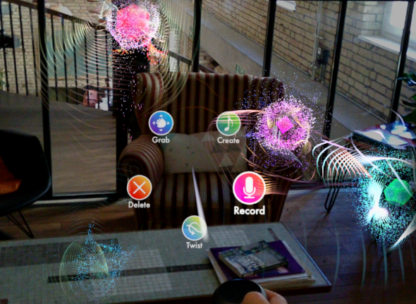

Visitors to the Sennheiser booth at CES can craft their very own AR experience.

With the AMBEO AR One and its Transparent Hearing feature, users can seamlessly blend real-world sounds with virtual audio and play around with sound using the companion app and the Magic Leap One. Sounds are visualized as balls of colorful, pulsing energy which users can capture, grab, position, loop and interact with. In the context of creating augmented and mixed reality applications, this platform empowers developers to bring immersive augmented audio soundscapes to the next generation of spatial computing productions.

A 5.1.4 home entertainment experience in a single device – the new AMBEO Soundbar
In another stunning showcase of the AMBEO 3D audio program, Sennheiser will present the forthcoming AMBEO Soundbar, a prototype of which was unveiled at CES 2018. In 2019, visitors to the show can discover the finished product which offers a remarkably spatial sonic experience with immersive 5.1.4 sound and deep bass in a single all-in-one device.

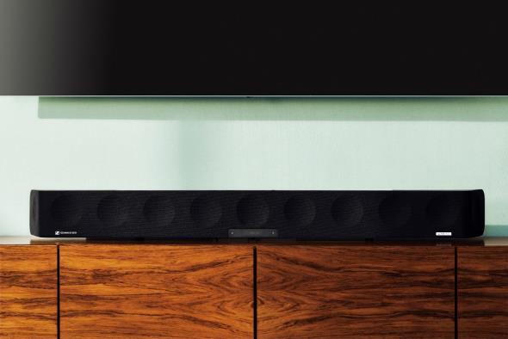

The forthcoming AMBEO Soundbar offers a remarkably spatial sonic experience with immersive 5.1.4 sound and deep bass in a single all-in-one device.

MOMENTUM True Wireless - The new standard for true wireless audio
Visitors to the Sennheiser booth can also get hands on with another exciting new product - the MOMENTUM True Wireless, which is making its CES debut.
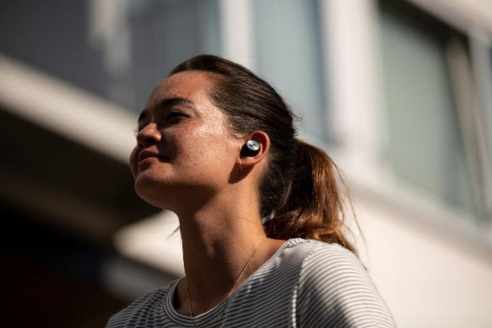

Sennheiser’s MOMENTUM True Wireless earphones set new standards in true wireless audio.

The latest addition to the iconic MOMENTUM range of headphones, these Bluetooth earphones set new standards in true wireless audio, thanks to Sennheiser’s audiophile 7mm dynamic drivers. The MOMENTUM True Wireless offers direct voice access to Apple Siri or Google Assistant. Meanwhile, the earphones’ Transparent Hearing feature makes it possible to hear sound from the outside environment to increase situational awareness, or to participate in conversations without removing the ear buds.

Visit Sennheiser in South Hall 1 at booth 20200.

About Sennheiser
Shaping the future of audio and creating unique sound experiences for customers – this aim unites Sennheiser employees and partners worldwide. Founded in 1945, Sennheiser is one of the world’s leading manufacturers of headphones, microphones and wireless transmission systems. With 21 sales subsidiaries and long-established trading partners, the company is active in more than 50 countries and operates its own production facilities in Germany, Ireland, Romania and the USA. Since 2013, Sennheiser has been managed by Daniel Sennheiser and Dr. Andreas Sennheiser, the third generation of the family to run the company. In 2017, the Sennheiser Group generated turnover totaling €667.7 million. www.sennheiser.com

Global Press Contact
Sennheiser electronic GmbH & Co. KG
Jacqueline Gusmag
Public Relations Manager Consumer
T: +49 (0)5130 600-1540
jacqueline.gusmag@sennheiser.com

