CREATE YOUR OWN HOLIDAY SOUNDTRACK
Sennheiser’s Holiday Gift Guide

Sydney, Australia, October 6 2021 – When December 23rd comes rolling around, everyone swears that they will go shopping for Christmas presents earlier the next year. While Mariah Carey is, once again, belting from every radio around the world, singing about what she wants for Christmas, you’re left wondering what your loved ones would want. To ensure Sennheiser can’t be accused of not offering any help in this regard, we’ve put together some ideas for a little inspiration – just in time for you to catch some Black Friday deals.

Discover even the subtlest details in popular Christmas songs with the IE 900, dive into a cinematic winter wonderland with the AMBEO Soundbar, or protect yourself from listening to "Last Christmas" for the hundredth time with the new CX Plus True Wireless' Active Noise Cancellation and create your own holiday soundtrack.

SOUND-PRIORITISING EARBUDS FOR A TRULY WIRELESS CHRISTMAS

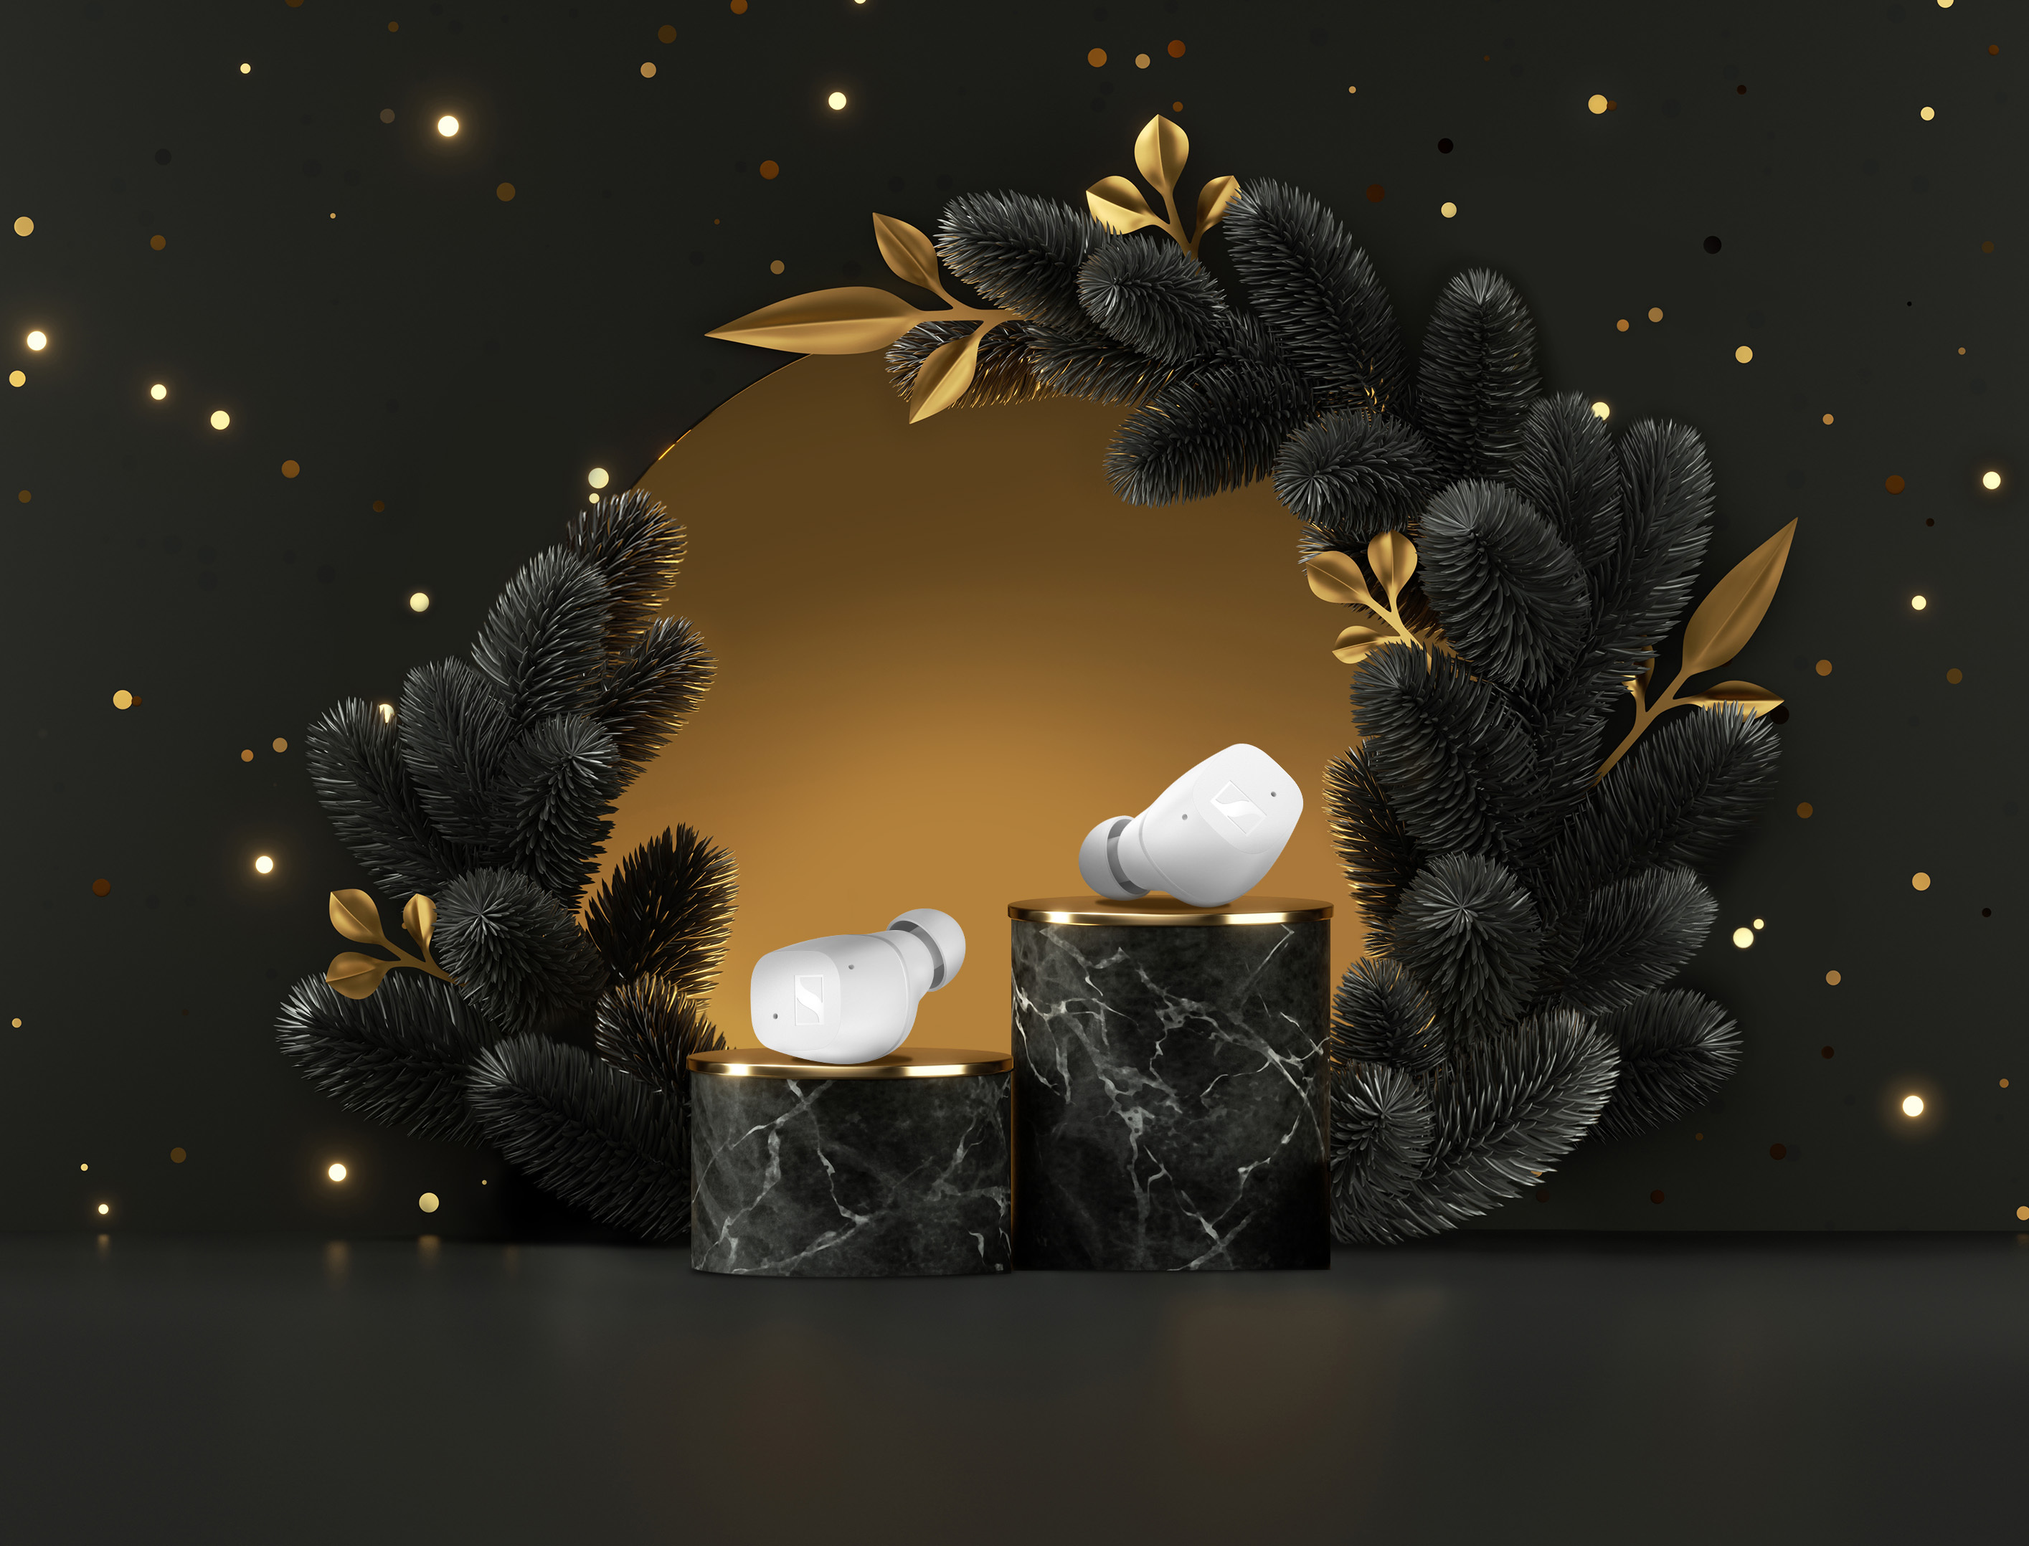
CX TRUE WIRELESS
+ The bespoke TrueResponse transducer delivers crystal-clear sound
+ Personalised sound thanks to Bass Boost and the Built-In Equaliser
+ Passive Noise Cancellation for undisturbed listening pleasure
+ 9-hour battery life (+18 hours with the case) for the long way home for Christmas
+ Available in black or white
$199.95 AUD / $219.99 NZD

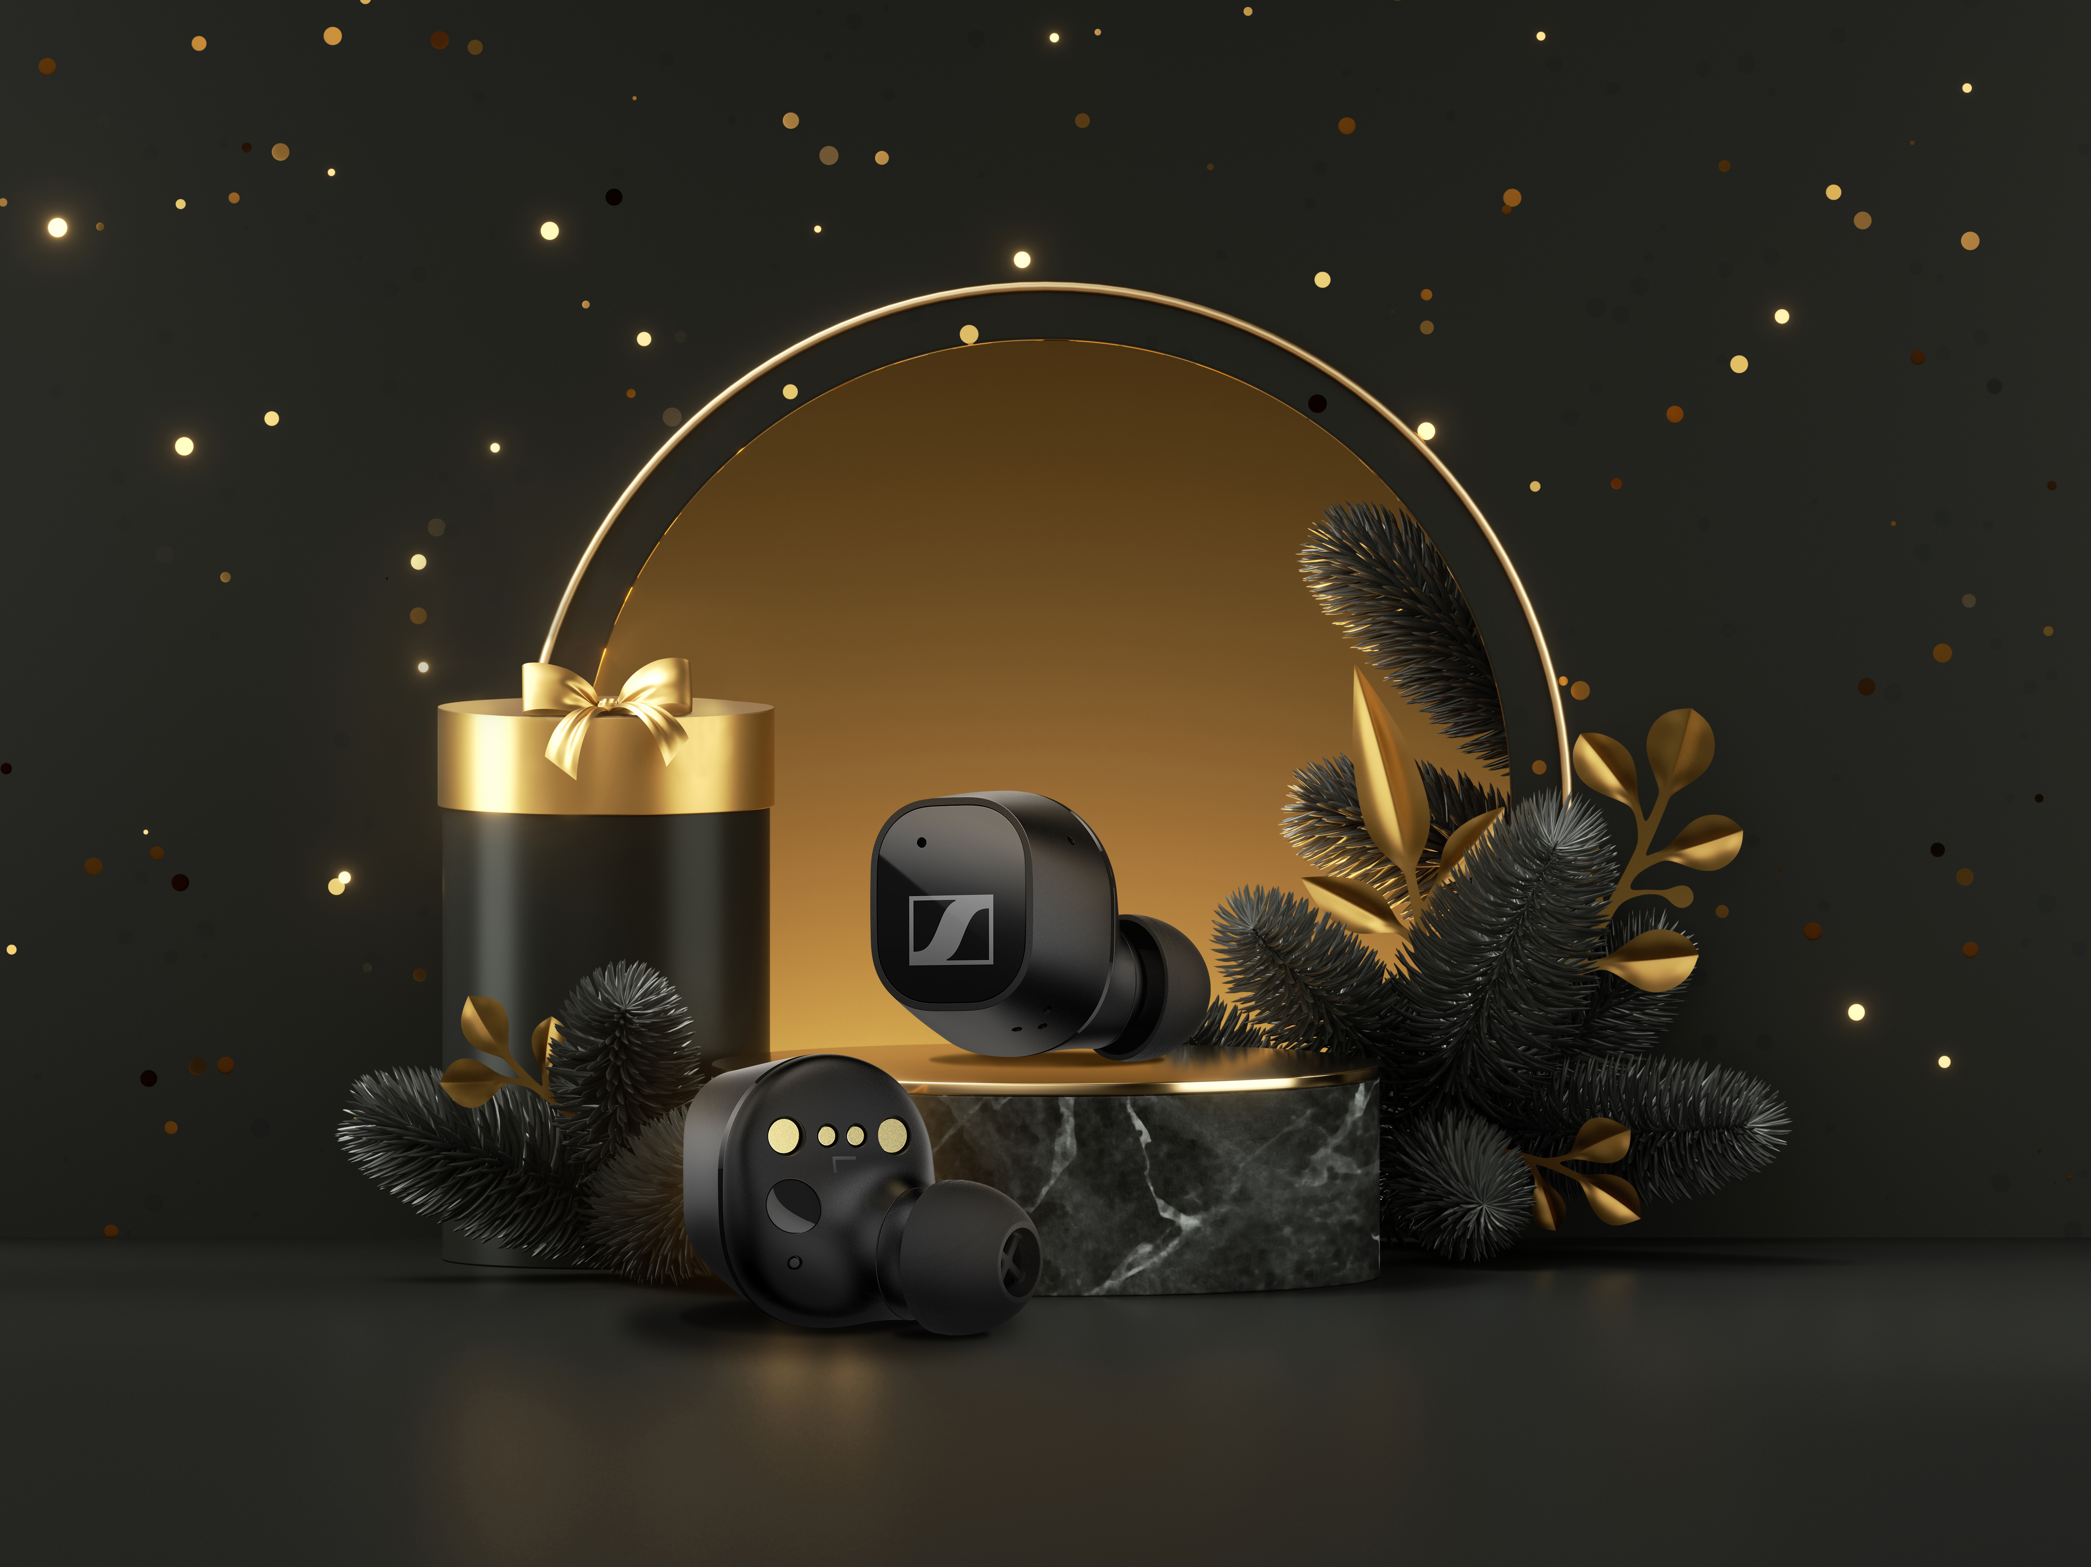
CX PLUS TRUE WIRELESS
+ Crystal-clear sound thanks to Sennheiser’s TrueResponse transducer
+ Active Noise Cancellation and Transparent Hearing to blend out or let in the holiday buzz
+ Effortless smart interaction and a sleek design for all-day enjoyment
+ 8-hour battery life (+16 hours with the case)
+ Available in black or white
$259.95 AUD / $274.95 NZD

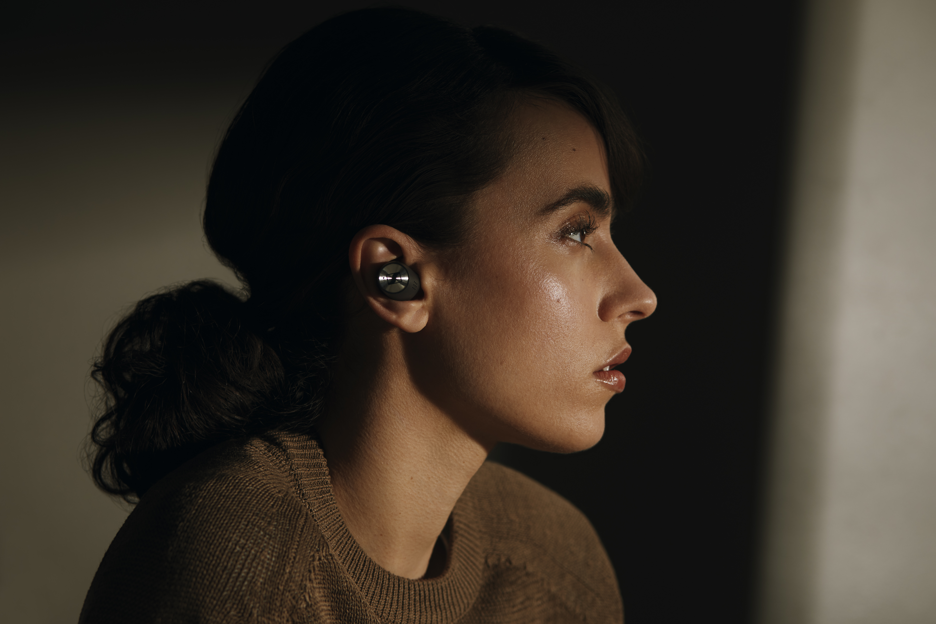
MOMENTUM TRUE WIRELESS 2
+ Crystal-clear sound thanks to Sennheiser’s TrueResponse transducer
+ Active Noise Cancellation and Transparent Hearing to blend out or let in the holiday buzz
+ Customisable touch controls
+ Exquisite craftsmanship
+ 7-hour battery life (+21 hours with the case)
+ Available in black or white
$499.95 AUD / $549.99 NZD

THE ANALYST AND THE PERFORMER: THE DIFFERENT ROUTES TO OVER-EAR PERFECTION

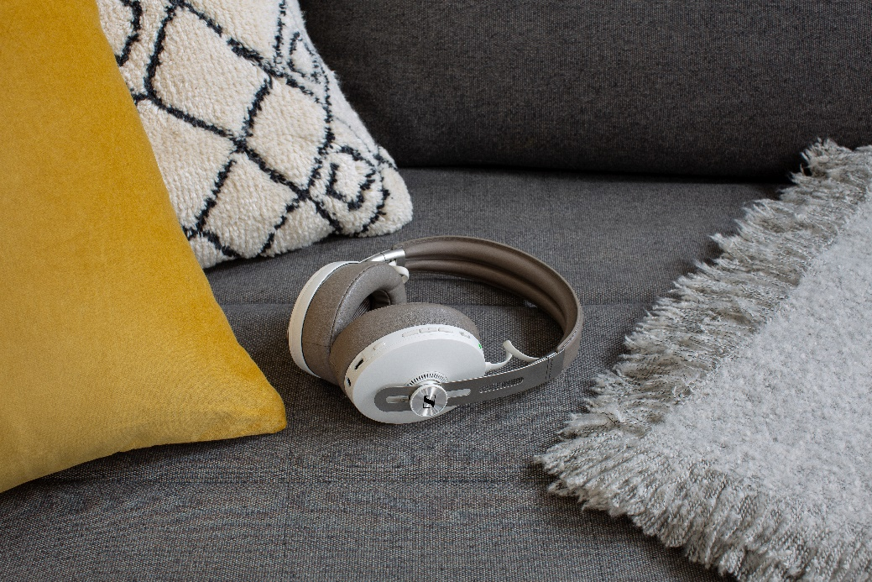
MOMENTUM WIRELESS
+ Outstanding sound performance
+ Three ANC modes and Transparent Hearing function
+ Auto On/Off and Smart Pause
+ Luxurious design with soft leather on the earpads and headband
+ 17-hour battery life
+ Six months of free access
to TIDAL HiFi
+ Available in black or sandy white
$599.95 AUD / $649.99 NZD (currently on sale for $459.95 AUD $599.99 NZD)

A NEW BENCHMARK IN PORTABLE AUDIO

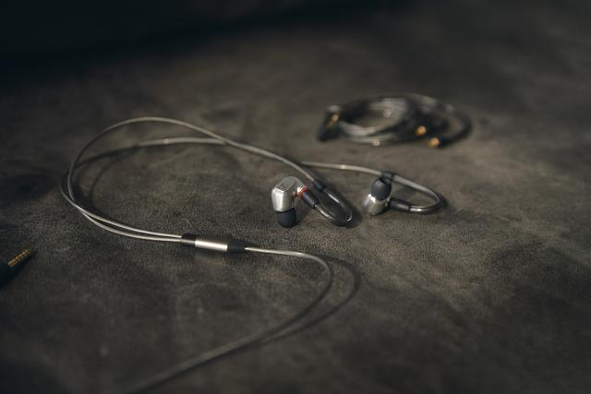
IE 900 / IE 300
+ Reveal music’s finest details
+ New level of clarity thanks to X3R technology with the IE 900
+ (Hand-) assembled at Sennheiser’s headquarters
+ Excellent comfort thanks to individually adjustable ear hooks and a choice of silicone and
memory foam ear adapters
$2,099.95 AUD / $2,199.99 NZD
$479.95 NZD / $509.99 NZD

RAISING THE BAR FOR HOME ENTERTAINMENT

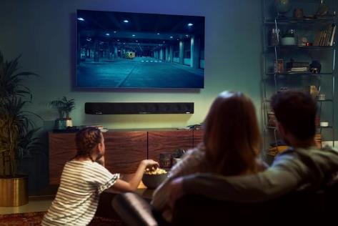
AMBEO SOUNDBAR
+ 3D soundbar that creates immersive sound and powerful bass without a subwoofer
+ Automated room calibration tailors the sound to the room – placing the listener at the centre of the action
+ Supports 3D audio formats, such as
Dolby Atmos, MPEG-H, and DTS:X, to
ensure that Christmas is, in fact, “all
around you” when watching classics
like Love Actually
+ Features Upmix Technology to
recreate stereo and 5.1 content in 3D
$3,999.95 AUD / $4,299.99 NZD

ABOUT SENNHEISER
Shaping the future of audio and creating unique sound experiences for customers – this aim unites Sennheiser employees and partners worldwide. The independent family company, which is managed in the third generation by Dr. Andreas Sennheiser and Daniel Sennheiser, is today one of the world’s leading manufacturers of headphones, loudspeakers, microphones and wireless transmission systems. In 2020, the Sennheiser Group generated turnover totaling €573.5 million. www.sennheiser.com

Press Contacts

Gabby Wallace
gabby.wallace@groundagency.com
+61 431 045 932

Caitlin Todd
caitlin.todd@groundagency.com
+61 410 781 849

Daniella Kohan
daniella.kohan@sennheiser.com
+1 (860) 598 7514

