RME Celebrates 25th Anniversary with Fireface UCX II USB Audio Interface
The Fireface UCX II is the successor of the iconic Fireface UCX

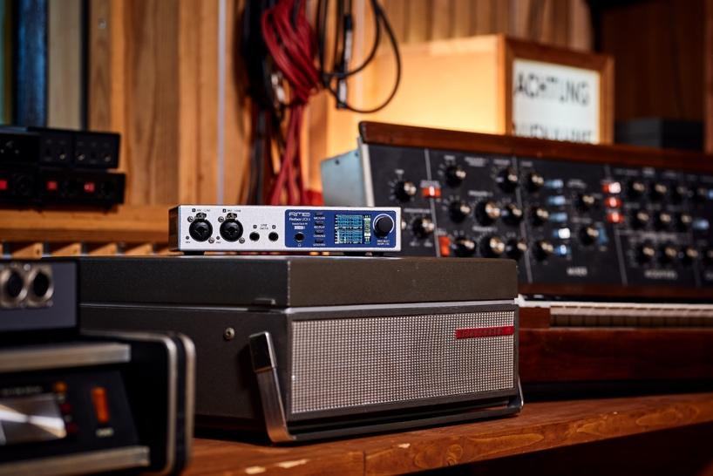
Fort Lauderdale, June 3, 2021 — RME has launched the Fireface UCX II, the successor of the iconic Fireface UCX. Featuring 40 I/O channels as well as a great variety of applications, the Fireface UCX II marks a new standard in the field of professional audio interface solutions with compact half-rack size. Also, in celebration of the company's 25th anniversary, the UCX II represents 25 years of RME innovation in a cutting-edge interface for flexible use in studios and live performances.
25 Years RME
For 25 years, RME has been committed to the principle of flexibility. The more flexible its products and designs, the easier they can be adapted to new requirements. For company founder Matthias Carstens this lies at the heart of RME's success: "The Fireface UCX II makes us proud and enthusiastic as it represents a natural evolution of our product range.”
Boasting up to 20 recording and 20 playback channels, SteadyClock FS, high-performance microphone inputs, built-in parametric EQ, USB direct recording plus full stand-alone functionality, the brand-new Fireface UCX II truly represents the essence of freedom, flexibility, and passion. At present, no existing audio interface offers more connectivity and functionality in a half-rack package.
The Fireface UCX II houses two mic/line preamps in XLR combo configuration on the front panel, along with two digitally controlled line/instrument inputs, followed by a headphone jack, various control buttons, a display, and the main volume knob. At the rear is a set of ten analogue balanced line inputs and outputs, MIDI I/O, ADAT I/O, AES/EBU and SPDIF I/O, USB 2.0 as well as a switchable word clock I/O.
DURec Direct USB Recording
Thanks to the digital DURec (Direct USB Recording) functionality, any input or output of the Fireface UCX II can be recorded directly to a USB storage device. Therefore DURec uses the integrated DSP which provides stand-alone operation without the need for a computer. The fields of potential applications include stand-alone field recordings, live and rehearsal recordings, or playback of live recordings for virtual soundchecks.
Femtoseconds for Clocking
With the SteadyClock FS, the Fireface UCX II features the latest clock and jitter rejection technology from RME. Based on a femtosecond clock, SteadyClock FS reduces the intrinsic jitter when converting from and to analogue over all digital formats to a new all-time low.
TotalMix FX & DigiCheck
The Fireface UCX II comes with the TotalMix FX DSP mixer offering comprehensive routing and monitoring options, as well as the DIGICheck analyzer allowing it to measure and analyze the digital data feed in both directions with maximum precision.
For more on RME, visit rme-usa.com

About Synthax, Incorporated
Synthax Inc. is the exclusive USA distributor for RME digital audio solutions, Digigram broadcast audio systems, Appsys digital audio tools, Ferrofish advanced audio applications, myMix personal monitoring systems and ALVA cableware. We supply a nationwide network of dealers with these products for professional audio, broadcast, music industry, commercial audio, theater, military and government applications. For additional information, visit the company online at http://www.synthax.com.

Media Contacts:
Katie Kailus
Public Relations
Hummingbird Media
+1 (630) 319-5226
katie@hummingbirdmedia.com

Jeff Touzeau
Public Relations
Hummingbird Media
+1 (914) 602 2913
jeff@hummingbirdmedia.com

