AirPop Active+ Face Mask: The World’s First Smart Air Wearable for Active Movement is Now Shipping
Active+ smart face mask with Halo Sensor is available now with companion iOS app

SAN FRANCISCO, CA, MARCH 16, 2021 — Air wearable brand AirPop has announced that their Active+ smart mask with Halo sensor is now available from their online store for $149.99. Designed specifically with movement in mind, the Active+ delivers advanced comfort and superior breathability for high intensity workouts, cycling, running, and other athletic activities. In addition to this, the Halo sensor
actively monitors air quality and user respiratory health stats, providing meaningful feedback regarding breathing and mask performance through the companion app. The app is currently available for iOS and will be available for Android at the end of this month from all supported app stores. For more information, please visit www.AirPopHealth.com.
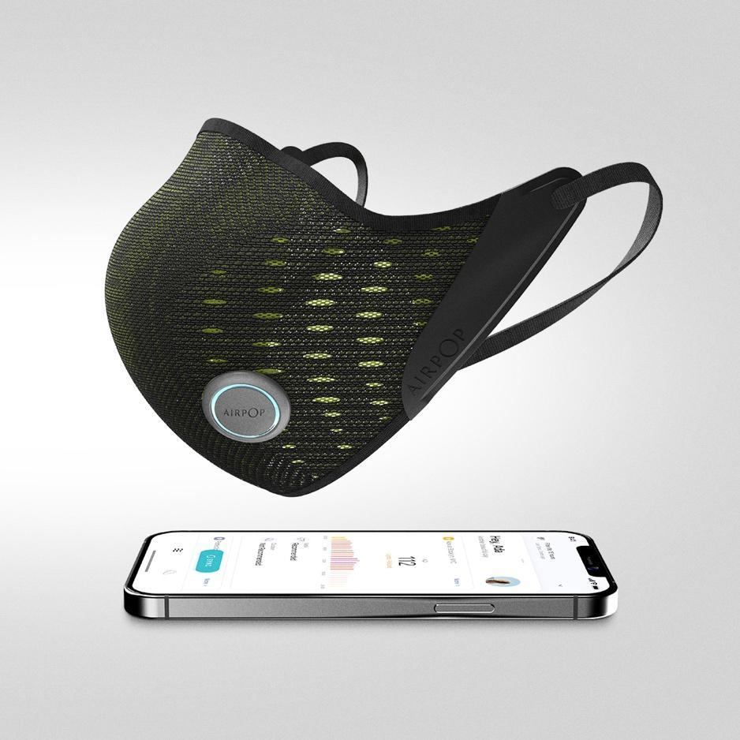

Currently available in Black/Green, the Active+ will also launch in White/Grey and Yellow/Grey in April 2021.

The Future of Mask Technology
Made from a specialized soft knit structure and designed with performance pores to channel airflow from outside in, Active+ expands on AirPop’s precisely fitted physical profile with cutting-edge app support that gives the wearer the ability to actively monitor local air quality and potential health risks, as well as their own respiratory health. The app uses a combination of data collected from the Halo sensor about the wearer’s breathing patterns to give a visual overview of their breathing behavior, cycles, and even the pollutants that the mask has blocked during use. The app’s Active Mode also tracks metrics like breaths per minute, breaths per pace, and more, giving the wearer an accurate picture of their breathing activity during heighted aerobic activity.

In addition to giving the wearer continuous crucial health metrics, the app also will notify the wearer when it’s time to replace AirPop’s snap-in filters, which block >99% PM0.3, including dust, allergens, particulate matter and microbial particles. Each of the four supplied AirPop filters come with a unique QR code that can be scanned, and authenticated, by the AirPop app when it’s installed, ensuring that the proper filters for the mask are being used.

AirPop Active+ Features:
- Proprietary inclusive, contoured mask profile which conforms to a variety of facial structures for the perfect fit every time.
- Easy change snap-in filters to ensure the best possible air quality at all times.
- Halo sensor monitors breathing cycles and behavior, as well as local air quality and potential health risks.
- Android and iOS support.
- Multi-month battery life.
- Durable Airknit soft shell with Aerodome design

ENDS

Press release assets available here

About AirPop
AirPop is the world’s first Air Wearables company. Since 2015, the company has harnessed filtration science and technology to build high-performance products that deliver unrivaled comfort and breathability for millions of people worldwide. AirPop masks deliver superior performance by solving three critical issues: fit, filtration and breathability. The revolutionary mask design includes a patented seal ensuring a secure fit, while the 3D Air Dome increases airflow for better breathability and comfort. Furthermore, AirPop masks combine a 4-layer filter material to create a barrier down to 0.3 microns achieving greater than 99% efficiency in accredited laboratory tests. For more information visit: www.airpophealth.com.

Media Contact

Gemma Stenberg
OLEX Communications
AirPop Media Relations
gemma@olexcommunications.co.uk
+44 7854 813 153

Monica Rohleder
Strax Director of Public Relations
monica.rohleder@strax.com
(847) 606-1973

