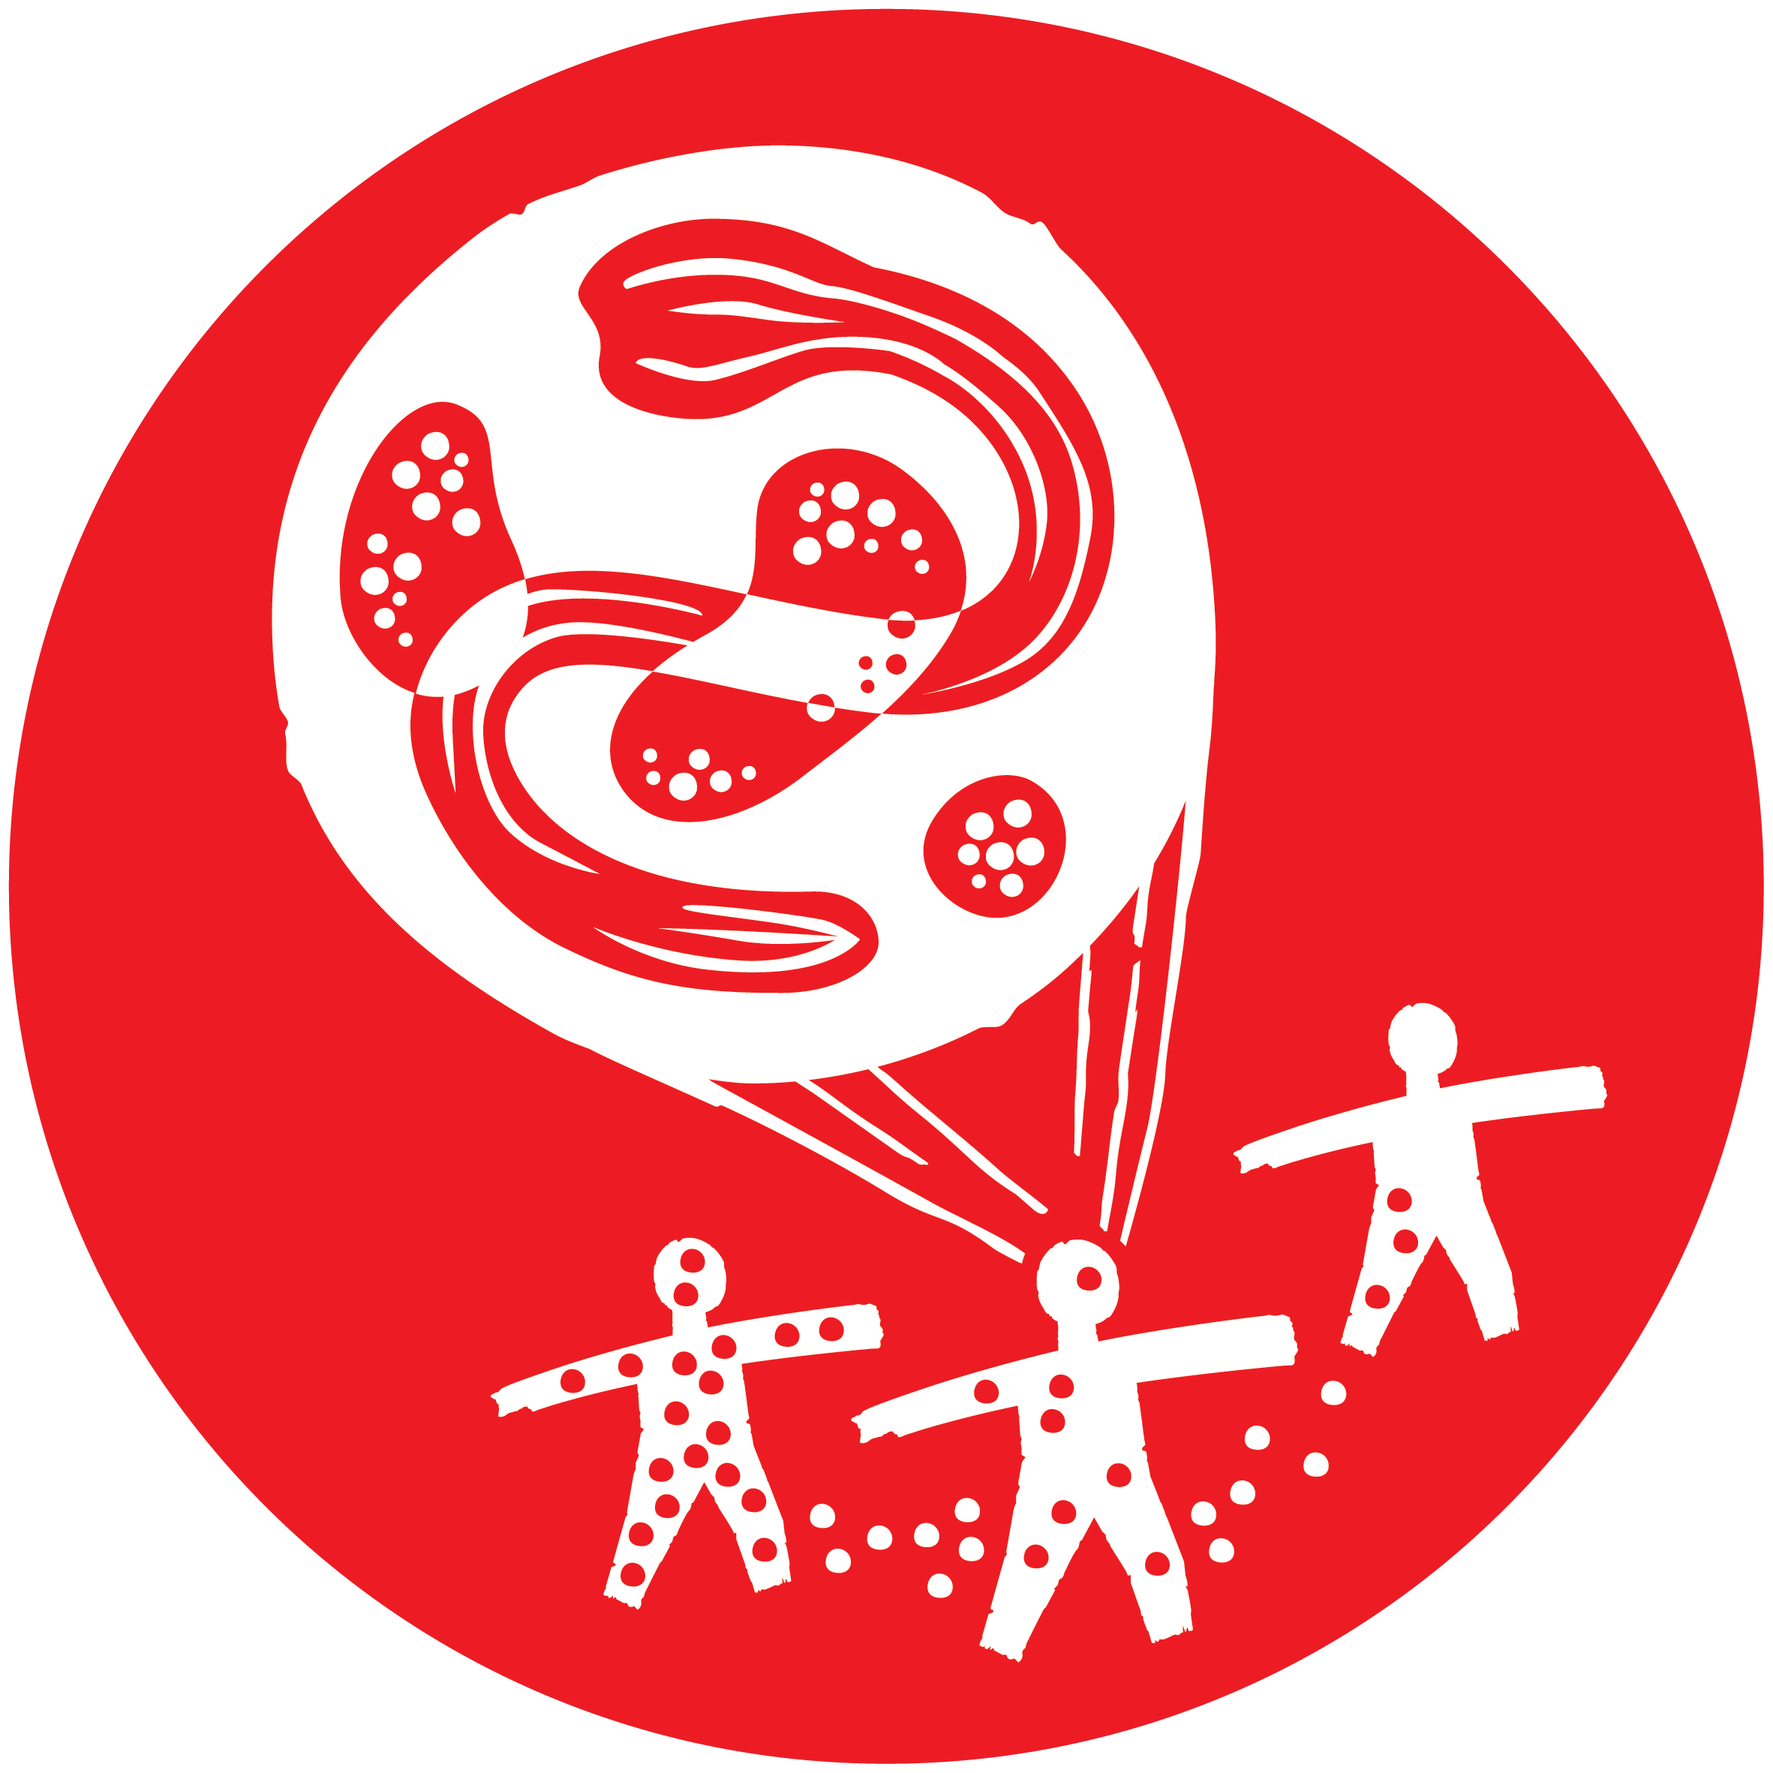  EPIDEMICS | MSF COVID-19 FACT SHEET  South Africa  2020/05/18

BACKGROUND:
Doctors Without Borders (MSF) has continued uninterrupted operations in South Africa since 2000, first pioneering HIV treatment during the dark period of government AIDS denialism. Treating HIV-TB coinfection and drug-resistant forms of TB became additional operational priority in the years following, as well as developing a community based medical and psychological response to meet the needs of victims of sexual violence. Due to the unaddressed needs of asylum seekers and migrants, MSF developed specific programmes to address this and during times of xenophobic violence MSF, teams offered emergency medical humanitarian responses.
In 2018/2019, MSF teams totalling 282 fieldworkers treated 21,000 people for HIV, starting 1,430 people on treatment of TB and treating 550 people for the medical consequences of sexual violence.
MSF’s COVID-19 RESPONSE:
South Africa is the hardest hit African country by the COVID-19 pandemic. To date, 14,355 people have tested positive, 261 have passed away and 6,478 have recovered. A national lock-down is in place restricting regular movements, economic activity and limiting people’s ability to access routine services ranging from immigration services to basic healthcare.
Khayelitsha, Western Cape 75 staff
MSF has been working in Khayelitsha, a densely populated peri-urban area in the Western Cape Province, for the past 20 years to provide medical humanitarian assistance with a specific focus on HIV and TB, including drug-resistance TB.
The Khayelitsha team is currently responding to COVID-19 in partnership with the Department of Health:
- Triage activities include support to contact screening and testing in communities and at health facilities. The team provides ongoing support with screening and patient flow primary health care level.
- Digital, facility-based and community health promotion and prevention activities, including distributing cloth masks, are ongoing.
- MSF teams have made significant contributions to adapting care for people those whose underlying medical conditions put them at heightened risk of COVID-19 (co-morbidity care), especially people living with HIV and TB. Our Specifically, the team supports strategies aimed at eliminating non-essential clinic visits for TB/HIV patients, including assisting with triage/screening and patient flow in clinics, assisting the DoH with a telephonic counselling strategy and conducting routine counselling sessions over the phone, and supporting the delivery of chronic medication from facilities to about 4,500 patient’s homes.
- In collaboration with the DoH, MSF is preparing the set-up of field hospital for the management of moderate COVID-19 patients as an extension of the Khayelitsha district hospital. The hospital will have a capacity of up to 60 beds.

Eshowe, KwaZulu-Natal 80 staff
MSF’s project in Eshowe, a relatively rural district of KwaZulu-Natal, began in 2011 with the aim of bending the HIV epidemic curve in an area with particularly high infection rates. Research in 2019 showed that the project had demonstrated that this objective was possible by increasing the rates of testing, those who tested positive beginning treatment and those starting treatment remaining on treatment and showing a suppressed viral load. The project’s results had surpassed the UNAIDS 90-90-90 goals – 90% of people living with HIV know their status, 94% of those were on antiretroviral treatment and 95% of those had a suppressed viral load.
The Eshowe team is now using lessons from their work on HIV and TB to assist the health department to prepare for and respond to COVID-19.
- Prevention activities include community-based health promotion, focusing on open businesses, welfare grant gatherings and traditional healers’ practices. Water, sanitation and hygiene points established in the town and during welfare grants week.
- Triage activities include help desks in health facilities, where MSF staff do health promotion as well as COVID-19 screening, with people screening positive referred within the facility for testing. We support patient flow in facilities and four MSF nurses are supporting the DoH team with community screening and testing.
- To safeguard TB/HIV patients at this time, 35 medication pick-up points are being set up in communities and a call centre has been established to confirm the addresses of 17,000 people on chronic medication. MSF staff are supporting the pre-packing the medication parcels and we have organized that 27 MDR-TB patients will receive treatment and care at their homes.
- The team is preparing the possible set up of a COVID-19 field hospital of 30 beds to support existing Department of Health hospital capacity in the district.
Tshwane and Johannesburg, Gauteng 35 staff
MSF’s interventions in Gauteng are an extension of the ongoing work of the teams to provide medical and psychosocial support to vulnerable groups, such as migrants.
- In Tshwane, MSF teams are providing a comprehensive package of healthcare services in four shelters for the homeless –including primary healthcare services, mental health services, social services, health promotion and water, sanitation and hygiene services. Mental health, water and sanitation, social work and health promotion are also being provided by MSF to seven other shelters. Health promotion activities include the distribution of cloth masks to all people in the shelters.
- In response to health needs in Johannesburg, an MSF team operates mobile clinic services for vulnerable homeless people accommodated at shelters in the city with bi-weekly visits. Services include screenings for COVID-19 and TB, as well as voluntary HIV testing. Cloth masks are distributed and a health promotion team shares COVID-19 information among shelter residents while supporting other community-based organisations with training.
- MSF nurses and drivers are also supporting the DoH with community-based contact tracing, screening and testing in Tshwane and Johannesburg.

Rustenburg, North West 55 staff
MSF runs a project partnership with the Department of Health providing medical and psychological care for survivors of sexual violence (SGBV). Health promotion and medical services for survivors of SGBV are ongoing during this time and the team has been actively supporting the national SGBV call centre with counselling tools. MSF is also supporting the COVID-19 response through:
- Community health promotion
- Triage activities at facilities, including establishing and staffing screening tents at two community health centres.

