SANTA FE ART INSTITUTE AND “THE ART OF CHANGE:” A NIGHT OF FILM, MUSIC AND ART CELEBRATING CATALYTIC ARTISTS THAT CHANGE THE WORLD
Exclusive screening of Prince documentary “Mr. Nelson: On the North Side” performance by Brian Hardgroove, and support from Sennheiser

Santa Fe, NM, September xx, 2019 — Beneath a serene, star-filled evening sky on September 6th, Santa Fe Art Institute (SFAI) hosted “The Art of Change: A Night of Film, Music and Art Celebrating Catalytic Artists that Change the World.” The evening was a cross disciplinary art experience that featured a mixed media exhibit, an exclusive screening of a new Prince documentary film by Director Kirk Fera, and an intimate performance by Belling The Cat: Brian Hardgroove’s newly minted rock ensemble which also scored music for the film. During the event, a sensational multi-room audio experience was delivered by Sennheiser.

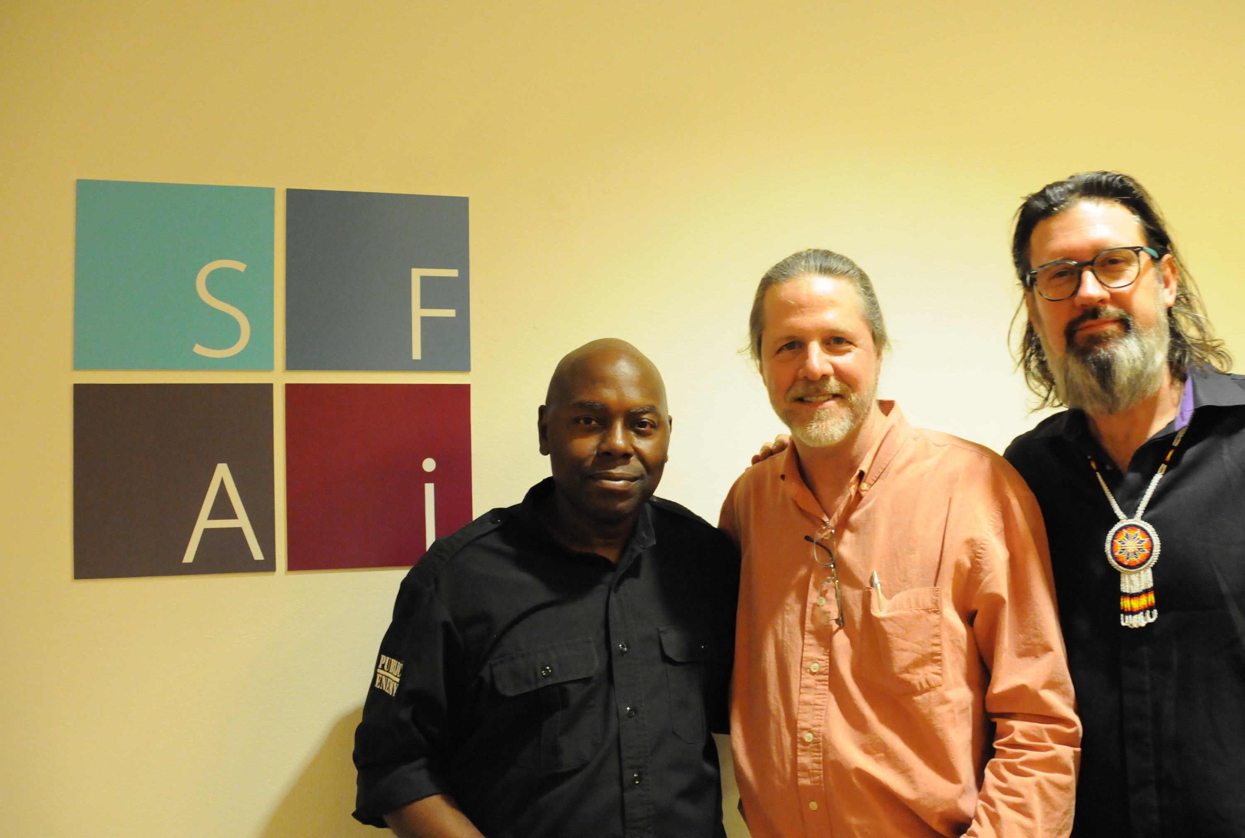 | L-R: Brian Hardgroove of Belling The Cat, David Missall, Development & Engineering, Sennheiser and Kirk Fera, Director of “Mr. Nelson: On the North Side”

The new movie, entitled “Mr. Nelson: On the North Side,” describes how Prince found security, musical opportunities and encouragement while growing up in North Minneapolis at a local community center called The Way. The intimate screening included a thoughtful Q&A with Director Kirk Fera and Brian Hardgroove, moderated by Director Chris Eyre (Smoke Signals and Skins), followed by an outdoor musical performance by Hardgroove’s Belling The Cat.

Wireless system heard ‘round the world
SFAI guests were invited to listen to a custom stereo feed of the performance through a pair of Sennheiser MOMENTUM headphones, while moving freely throughout the facility. This was made possible through a Sennheiser evolution wireless G4 system, which broadcast a stereo mix to 26 different G4 wireless receiver packs which were connected to the headphones. The set-up consisted of a single Sennheiser ew IEM G4 transmitter coupled with an A 5000-CP passive antenna, which then broadcast the stereo signal to 26 IEM G4 stereo receivers.

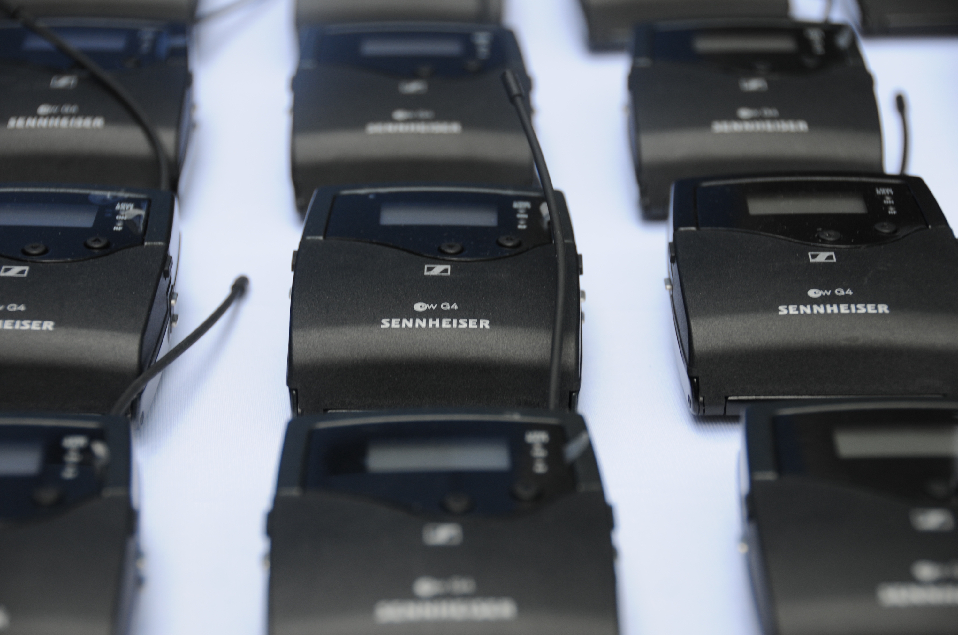 | SFAI guests were invited to listen to a custom wireless feed using Sennheiser evolution wireless G4 systems, which broadcast a mix to 26 G4 wireless receiver packs connected to headphones

Throughout the evening, Sennheiser evolution 900 series microphones graced the stage, ensuring that instrument and vocal performances were captured with detail, fidelity and power. Several Sennheiser e 935 cardioid microphones handled vocal duties, while a 906 super-cardioid was used on guitar amplifiers. The drum kit, played by Hardgroove himself, featured an e 901 on the kick drum, e 904s on the snare and toms, and e 914s on the hi-hat and as overheads.

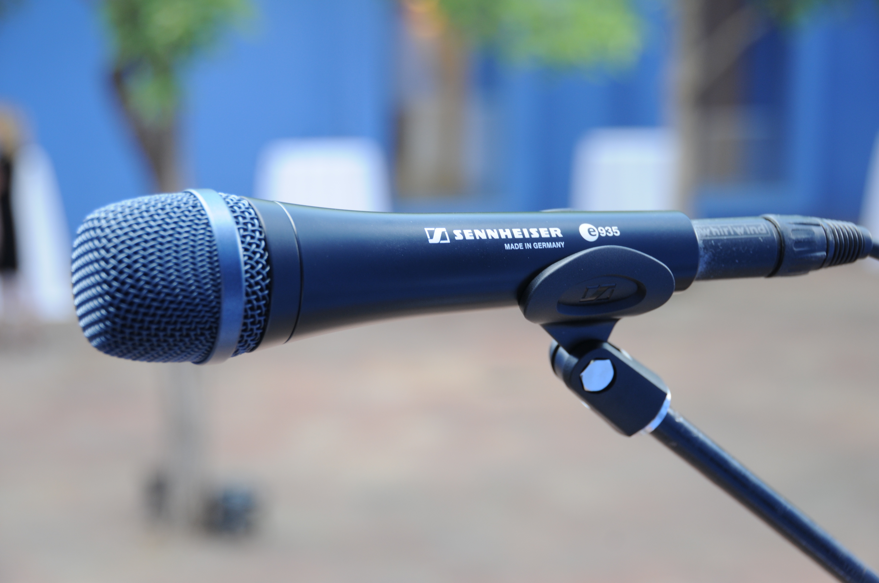 | Several Sennheiser e 935 cardioid microphones handled vocal duties, while an e 906 super-cardioid was used on guitar amplifiers. The drum kit featured an e 901 on the kick drum, e 904s on the snare and toms and e 914s on the hi-hat and overheads

“I love that the Art Institute has been able to partner with a world class musician and producer like Brian Hardgroove, who brings his passion, expertise and perfectionism to Santa Fe,” commented Jamie Blosser, Executive Director of SFAI. “Having Sennheiser products here to accompany our guest experience exemplifies the amazing quality that all artists strive for. We support many local artists, as well as national and international artists, and they are all blown away by what is going on right here in Santa Fe. This work has something of a ripple effect around the world.”

Keeping it in Santa Fe
Hardgroove, a longtime collaborator with Sennheiser, was asked by Director Kirk Fera to score the new film after having worked with him on an earlier film by Fera entitled Find Your Groove. For Hardgroove, it was all about getting the right people in the room and making it happen in an inspiring location: “It was important for me to keep this project in Santa Fe after we agreed to do the score,” he says. “Kirk agreed to this and once we assembled everybody in the room we listened to Kirk’s cues and just let the inspiration run.”

 | Event organizer and Sennheiser advocate Brian Hardgroove of Belling The Cat on drums

“I fell in love with the Santa Fe community itself through Brian, and when we went into the studio, it was genius,” adds Fera. “I would give the band a cue — each one from different time period and varying in length — and these guys nailed it. The music in this film is really special to me, and the creative spirit of everyone coming out together in Santa Fe made the film so much better in the end.”

“We’ve done many projects with Brian over the years — he is a true visionary who has pulled all of this together,” said David Missall, Development & Application Engineering, Sennheiser. “We are very pleased to have contributed to the successful outcome of this event by helping provide a superior audio experience for guests and friends of the SFAI.”

To learn more about SFAI’s events and programming, please visit https://sfai.org.

About Sennheiser

Shaping the future of audio and creating unique sound experiences for customers – this aim unites Sennheiser employees and partners worldwide. Founded in 1945, Sennheiser is one of the world’s leading manufacturers of headphones, loudspeakers, microphones and wireless transmission systems. Since 2013, Sennheiser has been managed by Daniel Sennheiser and Dr. Andreas Sennheiser, the third generation of the family to run the company. In 2018, the Sennheiser Group generated turnover totaling €710.7 million. www.sennheiser.com

Local press contact Global press contact

Jeff Touzeau Stephanie Schmidt
jeff@hummingbirdmedia.com stephanie.schmidt@sennheiser.com
+1 (914) 602-2913 +49 (5130) 600 – 1275

