Adapt & Overcome: Digigram’s IQYOA X/LINK-LE Codec Offers Musicians Professional-Quality Audio While Broadcasting at Home

Digigram’s codec offers satellite radio-quality broadcasts with no dropouts
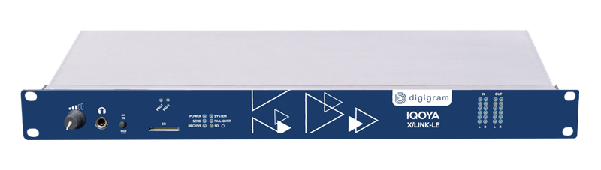
Fort Lauderdale, Florida, April 7, 2020 — As more and more artists are taking to social media to broadcast live performances to their fans, poor audio abounds. Enter Digigram’s IQOYA X/LINK-LE: a 1U rack IP audio codec designed for live remote broadcasting over IP networks, including web radio. With the help of a free web streaming site, such as Caster.fm, and an IQOYA X/LINK codec, an artist can now broadcast live with professional-quality audio, all from their living room. The IQOYA X/LINK-LE bridges a user’s studio gear, virtually turning the internet into their worldwide P.A. system.
“The IQOYA X/LINK is a dedicated hardware solution that does one thing: makes a reliable connection every time with no software burdens,” explained Derek Badala, Director of Sales, Americas for Synthax, Digigram’s U.S. distributor. “The alternative is using your computer with a software codec which requires an audio interface, adding more latency, several variables and signal routing challenges. Connecting a dedicated hardware codec like the X/LINK to a musician’s mixer can free up their computer to be used for their usual live performance tools, such as virtual instruments, playback tracks, virtual processors or any other solution they would need during a typical live gig.”
The IQOYA X/LINK-LE is easily configured to broadcast to a user’s web streaming account. This allows a musician to then share a link from their account with fans so they can listen in to their performance and enjoy satellite-quality audio with no dropouts.
“This is a robust web streaming solution for artists featuring a dedicated box with a dedicated purpose: to turn it on and go live,” Badala said. “Listeners can listen for hours without any clicks, pops or drop-outs — just pristine audio.”

For more information on Synthax, visit: https://www.synthax.com/
For more information on Digigram, visit: https://www.digigram.com/

About Synthax, Incorporated
Synthax Inc. is the exclusive USA distributor for RME digital audio solutions, Digigram broadcast audio systems, Appsys digital audio tools, Ferrofish advanced audio applications, myMix personal monitoring systems and ALVA cableware. We supply a nationwide network of dealers with these products for professional audio, broadcast, music industry, commercial audio, theater, military and government applications. For additional information, visit the company online at http://www.synthax.com.
About Digigram
For over 30 years, Digigram has developed innovative digital systems that make modern broadcasters rapidly evolving operations more efficient, more reliable and more effective. Used by thousands of journalists, broadcasters and industrial users all over the world, Digigram’s sound cards, audio processing software and pioneering IP audio technologies are designed with a consistent attention to quality and reliability. Digigram (DIG) is publicly listed on the NYSE Euronext Paris stock exchange. More information is available at http://www.digigram.com/.

Media Contacts:
Katie Kailus
Public Relations
Hummingbird Media
+1 (630) 319-5226
katie@hummingbirdmedia.com

Jeff Touzeau
Public Relations
Hummingbird Media
+1 (914) 602 2913
jeff@hummingbirdmedia.com

