#Dontstoptheeducation

Join Sennheiser’s Audio for Theatre Round Table No. 2 on April 28

Wedemark, April 23, 2020 – Sennheiser SoundAcademy is pleased to present a second Audio for Theatre Round Table on April 28 at 5 p.m. CEST. Continuing from the last session on theatre sound design, Sennheiser hosts Jamie Criswell, Tim Moore and Andy Egerton will be discussing theatrical audio with panellists Julie Sloan, Maxine Gutierrez, Rory Maguire and Reese Kirsh.

During the 90-minute webinar, Julie Sloan (Tina, Sponge Bob, Charlie and the Chocolate Factory), Maxine Gutierrez (Dear Evan Hansen), Rory Maguire (Only Fools and Horses) and Reese Kirsh (42nd Street, Back to the Future) will discuss their approach to Theatrical Audio and Sound Design and answer questions from the audience. Registration is now open at https://zoom.us/webinar/register/WN_L0yTAw3PS1KR1IgEt6_KTQ.

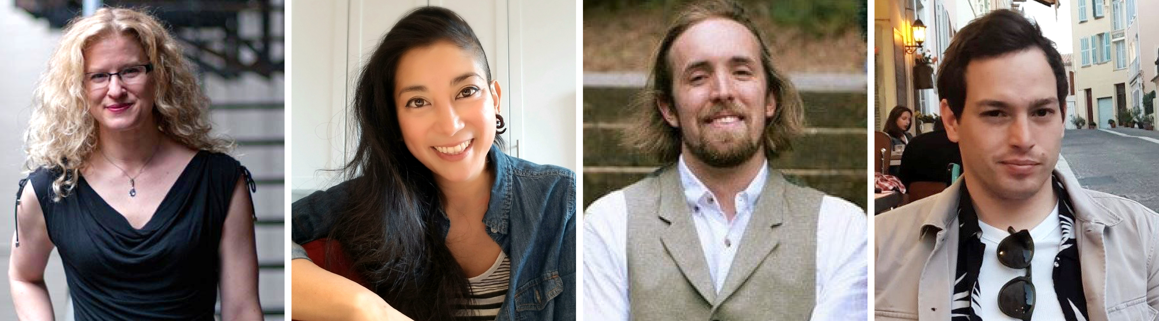
The panellists of the Audio for Theatre Round Table #2: Julie Sloan, Maxine Gutierrez, Rory Maguire and Reese Kirsh (from left to right)

Expand your expertise with more webinars – totally free
In addition to round tables, Sennheiser’s SoundAcademy provides a host of other popular pro audio training webinars and in-depth product discussions. Please visit https://www.sennheiser.com/webinars for a full, up-to-date list and to register free of charge for a SoundAcademy webinar of your choice. The free training sessions are offered at several different times to allow as many people from around the globe to tune in as possible.

For your social media channels

Join Sennheiser’s Audio for Theatre Round Table No. 2 and meet leading sound designers online! #Don’tStopTheEducation

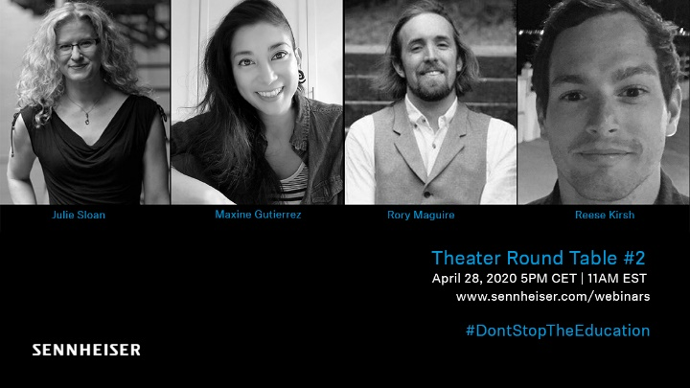 | Live webinar: Julie Sloan, Maxine Gutierrez, Rory Maguire and Reese Kirsh will discuss Audio for Theatre on April 28
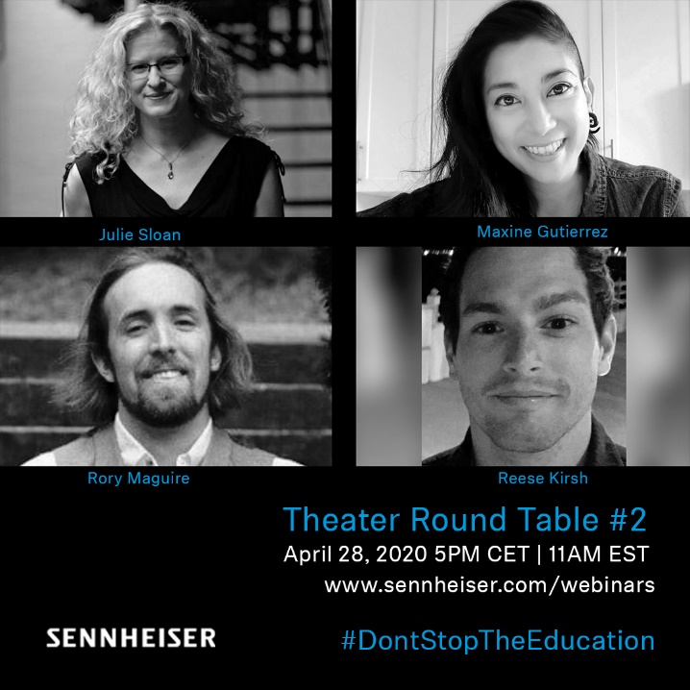 | 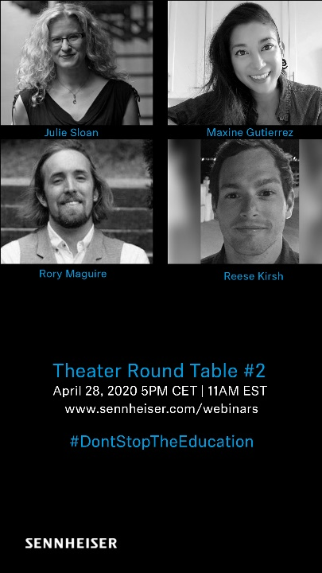

About Sennheiser
Founded in 1945, Sennheiser is celebrating its 75th anniversary this year. Shaping the future of audio and creating unique sound experiences for customers – this aim unites Sennheiser employees and partners worldwide. The independent family company, which is managed in the third generation by Dr. Andreas Sennheiser and Daniel Sennheiser, is today one of the world’s leading manufacturers of headphones, loudspeakers, microphones and wireless transmission systems. In 2018, the Sennheiser Group generated turnover totalling €710.7 million. www.sennheiser.com

Global Press Contact

Stephanie Schmidt
Stephanie.schmidt@sennheiser.com
+49 (5130) 600 – 1275

