In the Neighborhood
Berlin’s Friedrichstadt-Palast and Neumann are co-operating on a technical level

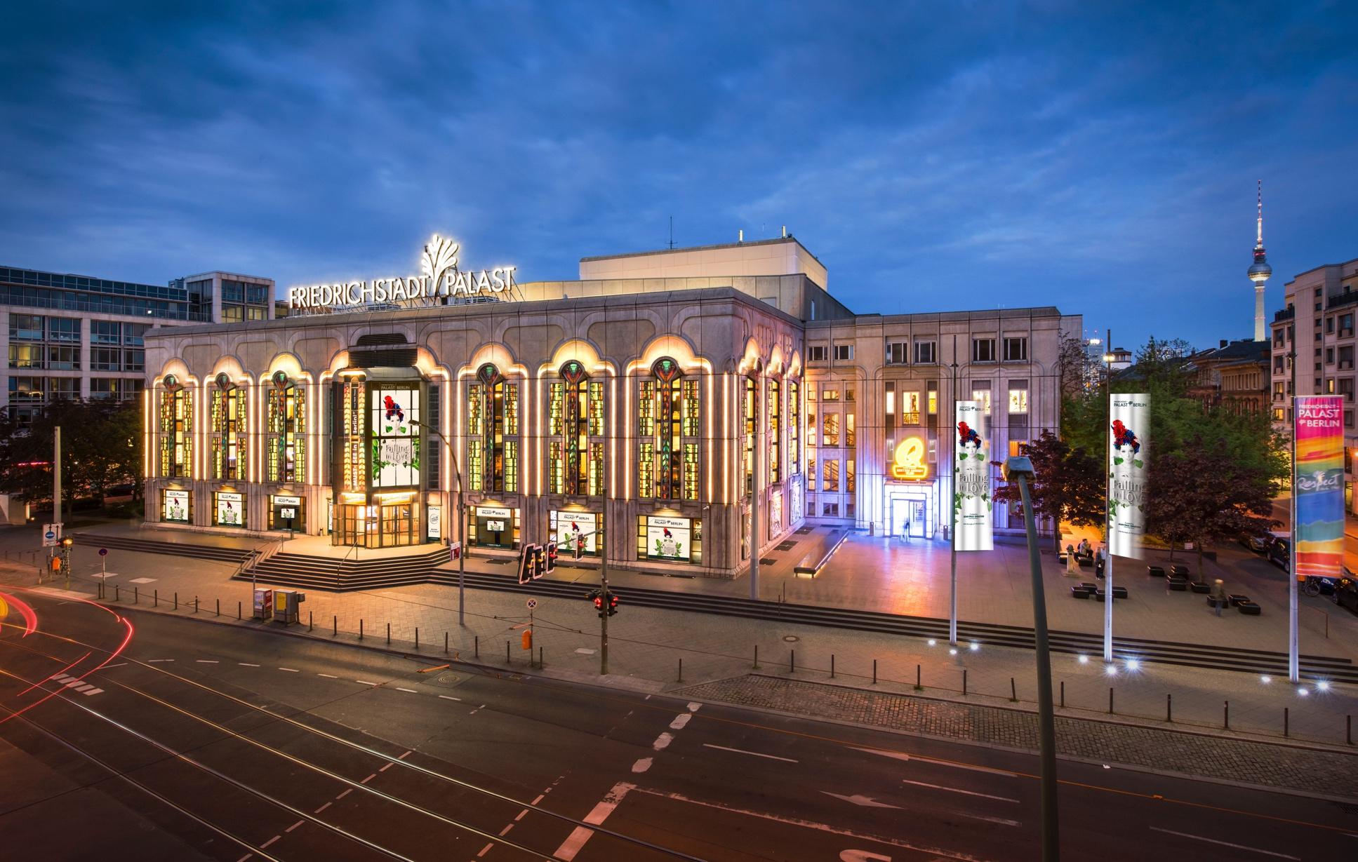
Friedrichstadt-Palast | Photo: Bernd Brundert

The Friedrichstadt-Palast in Berlin is considered the largest theatre stage in the world. Every two years, a completely new, visually stunning Grand Show with singing, live music, dance choreography and breathtaking acrobatics is developed to fill the 2,854-square-metre stage with life. No other theatre in Europe can match this. It takes passionate people on stage and behind the scenes to make a show like this happen. But also a great deal of state-of-the-art technology – which has led to a fruitful collaboration with Neumann.

Berlin, Germany, March 31, 2025 – The Friedrichstadt-Palast is one of those institutions that give Berlin the glamour and glitz of a cosmopolitan city. Indeed, it has done so for over 100 years. The Großes Schauspielhaus opened in 1919 and was renamed Friedrichstadt-Palast in 1947. When the building had to be closed in 1980 because the foundation pillars had sunk, it was decided in the same year to build a new, no less magnificent theatre. Completed in 1984, the new Friedrichstadt-Palast was one of the last prestige buildings of the former GDR. Big Saturday night TV shows were also recorded here, and numerous artists from the West also performed.

Today, the Friedrichstadt-Palast is (once again) a pure revue theatre with spectacular shows that cannot be seen anywhere else. The Grand Shows of the last 10 years have attracted over 700,000 visitors each. And those visitors have been treated to a lot: singing, dancing, acrobatics, accompanied by magnificent stage sets, an extremely elaborate light show and even scents. For two hours, the audience can forget all their worries and immerse themselves in a magical world.

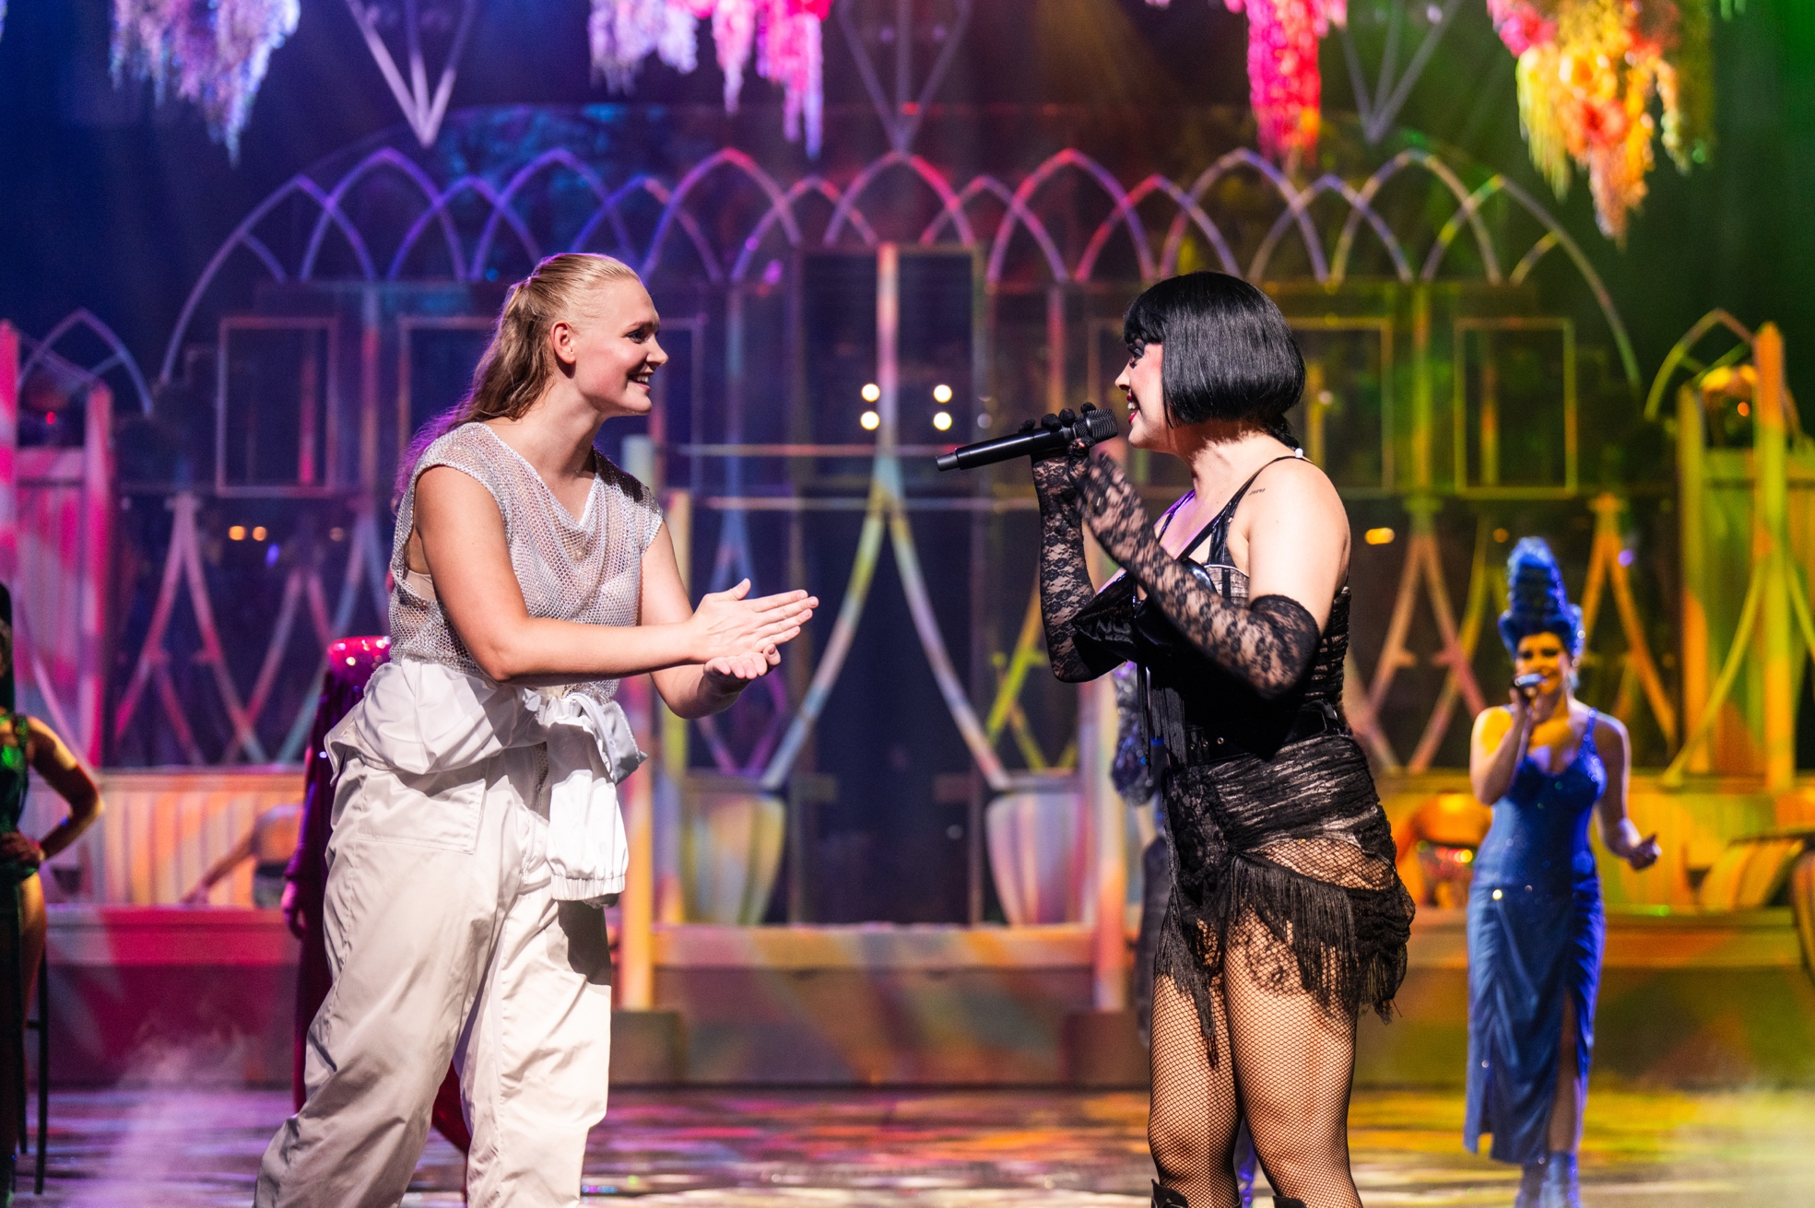
Friedrichstadt-Palast | Photo: Nady El-Tounsy

A Grand Show runs for a period of two years, with up to eight performances per week. Three to five singers take to the stage every evening, supported by ballet dancers and breathtaking artistic performances. Much of this would be unthinkable elsewhere, because the special features of the Friedrichstadt-Palast include not only the huge stage area but also very high ceilings and a well-used airspace that makes aerial acrobatics possible, as well as a huge, extendable water basin. However, the 40-year-old building also presents particular challenges, such as the small stage doors. All the technical equipment and the large-scale backdrops have to be delivered disassembled and then reassembled on site.

The live music is played by a 15-piece band that doesn’t just play in the background but is part of the current Grand Show on a mobile stage. “If you have a band of this size, it would be a shame to hide it. So, we let them perform in various scenes, make them present. To do that, you need the right technical tools. Needless to say, everything is played live,” explains Thomas Herda, Technical Director of the Friedrichstadt-Palast.

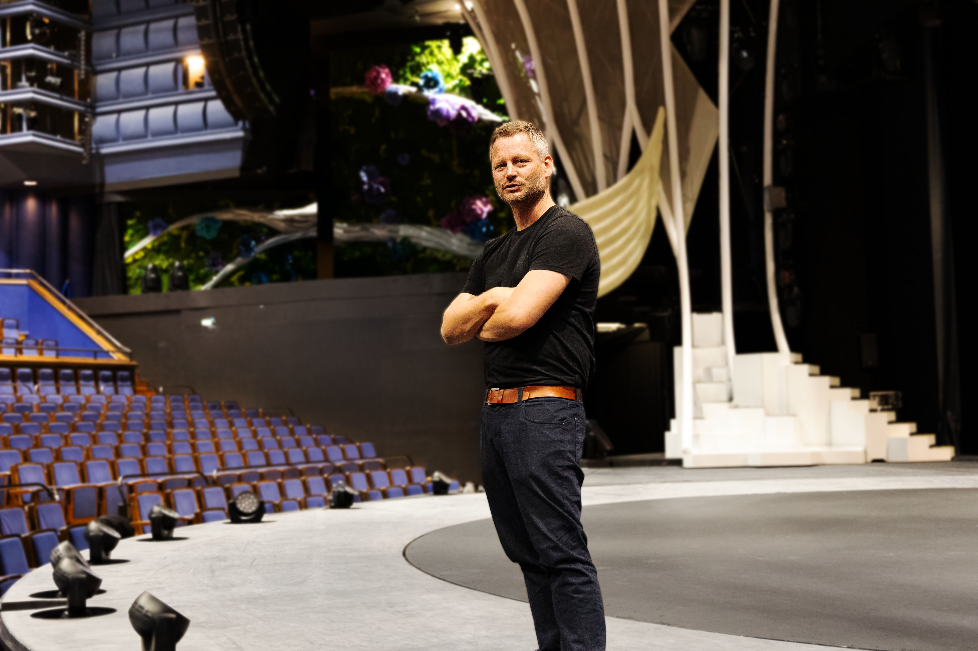
Technical Director Thomas Herda on the stage of the Friedrichstadt-Palast

The Right Tools
These tools include a sophisticated, immersive sound system with over 150 speakers. For the performers, there is an optical tracking system specially developed for the Friedrichstadt-Palast so that the panning moves with them – even when the singer moves around in the auditorium, which holds almost 2,000 seats. The in-ear monitoring system is also immersive. This has been shown to make the musicians feel significantly more relaxed when they hear what is happening as naturally as with their own ears.
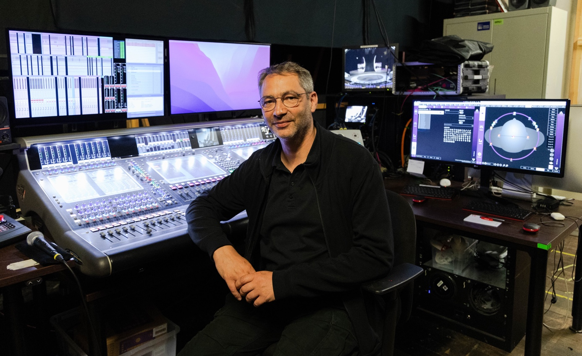
Thomas Milde, Head of Sound, backstage at the monitor station

A technical challenge in terms of feedback and crosstalk is that the actors usually perform on the forestage. “We don't play behind the PA, but always directly in front of it, where the audience is seated. In the past, we sometimes reached the limit where we had to be very careful. With the Neumann KK 105 U capsules, we have significantly more leeway,” reports Thomas Milde, Head of Sound. “We no longer have to turn the music down so much.” The Neumann capsules for the wireless system are also a significant improvement in terms of sound: “Our show is multilingual. Speech intelligibility therefore plays a major role. The technology has to support that, also in terms of dynamics,” comments Thomas Herda. And Thomas Milde adds: “The Neumann KK 105 U capsules are more dynamic than our previous ones, which started limiting very early, even at relatively low volumes. The Neumann KK 105 U can handle a lot more. And we need a lot less EQ processing.”

“We used to have extreme EQ curves on the vocal mics, but with the Neumann KK 105 U this is no longer necessary. The sound that comes across is already natural,” confirms FOH engineer János Linde.
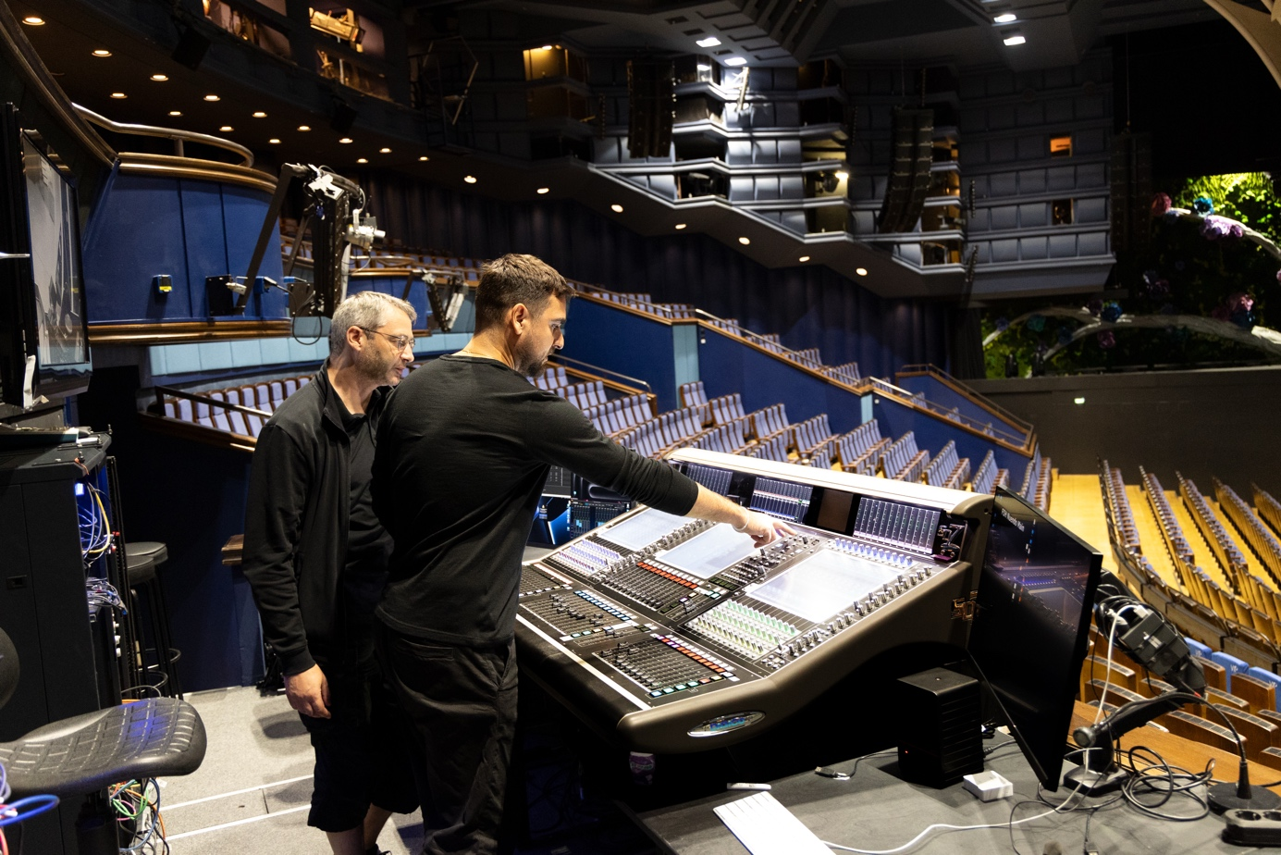
János Linde and Thomas Milde at the FOH mixing desk

The same applies to the Neumann MCM system, which is now used for instrument miking. “We first tested the MCMs with wind instruments. Here we were able to bypass the EQ because they sounded much smoother than the previous clip-on microphones. They no longer had this harsh quality that also hurts the guests in the auditorium. The musicians are also thrilled,” explains Thomas Milde. The situation is similar for the strings: In the past, we needed a dynamic EQ so that the cello still sounded present in quiet passages, but not unpleasant and scratchy when it played loud. With the MCM, that's no longer necessary.

“The sound shouldn't be annoying, and it has to be at the right volume,” Thomas Herda confirms. “It shouldn't be too loud, but it has to convey the emotion. And it has to work for all seats, from the front rows to the very back.”

After the Show is Before the Show
While the current production is still running, the next Grand Show is already being prepared behind the scenes. At the end of the two-year run of the current show, there is only a short four-week period in which the successor show, for which preparations have been underway, will be staged. During this time, the Technical Director and the 85 technicians are working at full stretch. Any delay could disrupt the schedule and result in a loss of revenue.
This makes it all the more important to have technology that you can rely on – and that ultimately conveys the feeling. Therefore, it is a stroke of luck for both sides that the Friedrichstadt-Palast and Neumann have found each other. After all, reliability and emotion are also among the core virtues of Neumann's live sound products. As a result, the new KK 105 U capsule for wireless systems was tested at the Friedrichstadt-Palast before its market launch.

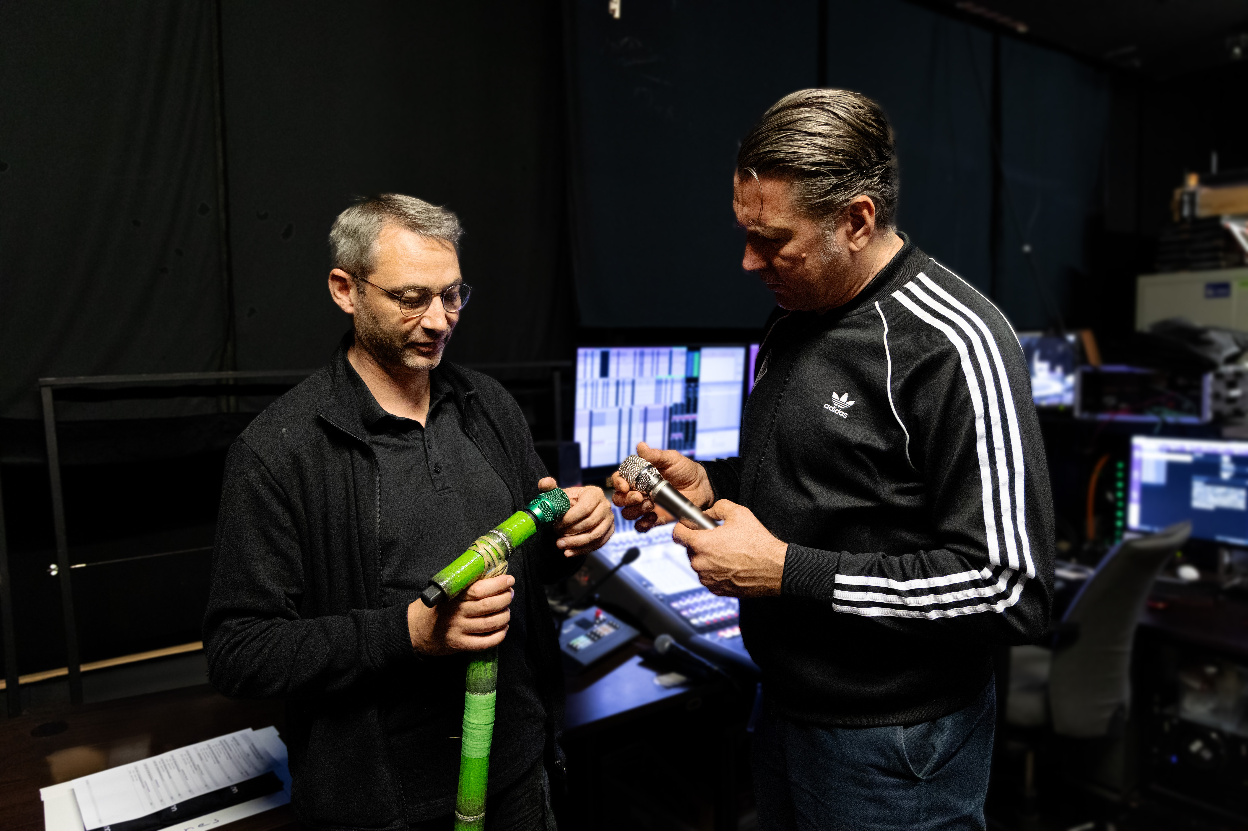
Thomas Milde and Neumann's Relations Manager Boris Kummerer with the KK 105 U in custom finishes

“Neumann and the Friedrichstadt-Palast have a similar history; both have been in Berlin for about 100 years. Neumann builds technology that fits our requirements, for example, microphone capsules with high speech intelligibility and feedback resistance. And their headquarters is just around the corner. This has led to a fruitful collaboration. We went to Neumann and saw that there are engineers there who develop exactly what meets our requirements,” says Thomas Herda.

“We perceive the Neumann capsules as being less sensitive to feedback. This gives our engineers more leeway to bring out the precision of the vocals. With other capsules, we were limited, while the Neumann capsules have this clear punch.”
For Neumann, too, the collaboration with the Friedrichstadt-Palast is a blessing. Only when a product has proven itself in an environment with such high demands can you be sure that it will meet with universal approval. Or, to paraphrase Frank Sinatra: If you can make it there, you'll make it anywhere!

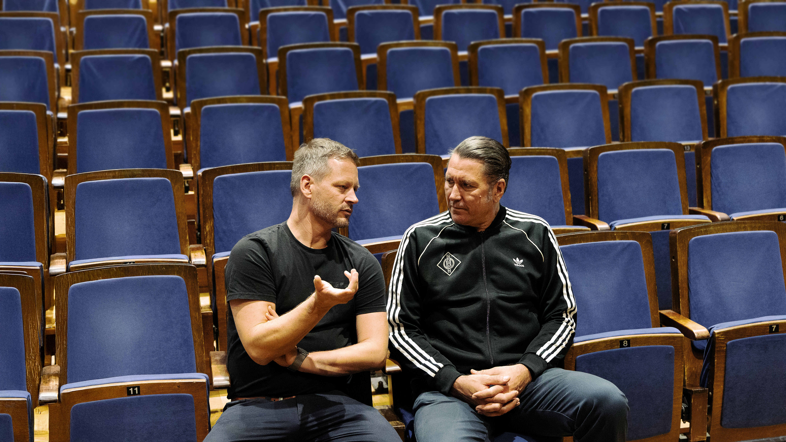
Thomas Herda and Boris Kummerer in the auditorium of the Friedrichstadt-Palast

About Neumann
​Georg Neumann GmbH, known as “Neumann.Berlin”, is one of the world’s leading manufacturers of studio-grade audio equipment and the creator of recording microphone legends such as the U 47, M 49, U 67, and U 87. Founded in 1928, the company has been recognized with numerous international awards for its technological innovations. Since 2010, Neumann.Berlin has expanded its expertise in electro-acoustic transducer design to also include the studio monitor market, building upon the legacy of the legendary loudspeaker innovator Klein + Hummel. The first Neumann studio headphones were introduced in 2019, and since 2022, the company has increased its focus on reference solutions for live audio. With the introduction of the first audio interface MT 48, and its revolutionary converter technology, Neumann now offers all the necessary technologies needed to capture and deliver sound at the highest level. Georg Neumann GmbH has been part of the Sennheiser Group since 1991 and is represented worldwide by the Sennheiser network of subsidiaries and long-standing trading partners. www.neumann.

Stay up to date and follow us on: FACEBOOK I INSTAGRAM I YOUTUBE

Press Contact Neumann:
Dr. Andreas Hau
andreas.hau@neumann.com
T +49 (030) 417724-15

Raphael Tschernuth
raphael.tschernuth@neumann.com
T +49 (030) 417724-67

