Asian Delight: Hong Kong Church Chooses myMix System for its Ability to Customize Personal Mix
The in-ear monitoring system solves audio bleeding and set up delays for Solomon’s Porch — making rehearsals and worship services effortless
Hong Kong, June 20, 2018 — Located in the center of bustling Hong Kong, Solomon’s Porch is a Christian church that each week attracts a large population of young families to its contemporary services in one of the busiest metropolises in the world. With a combined attendance of 400 across three services each Sunday, Solomon’s Porch offers its congregants a contemporary worship experience, complete with a full band which includes acoustic guitar, keyboard, drums, bass, a few singers and sometimes even an electric guitar.

In search of a reliable, customizable, in-ear monitoring system, Nate Chung, associate pastor of worship and youth at Solomon’s Porch, learned about the myMix personal monitoring and mixing system from a fellow church in Singapore.

“I liked that the myMix was an in-ear system,” Chung explained. “It was really important to us to find a system where the monitor mix wouldn’t bleed into the main house speakers. So, we took a recommendation from a larger church in Singapore that was already using the system and installed myMix after moving into our new, current building. And we haven’t looked back since. The myMix allows us to do exactly what we want.”

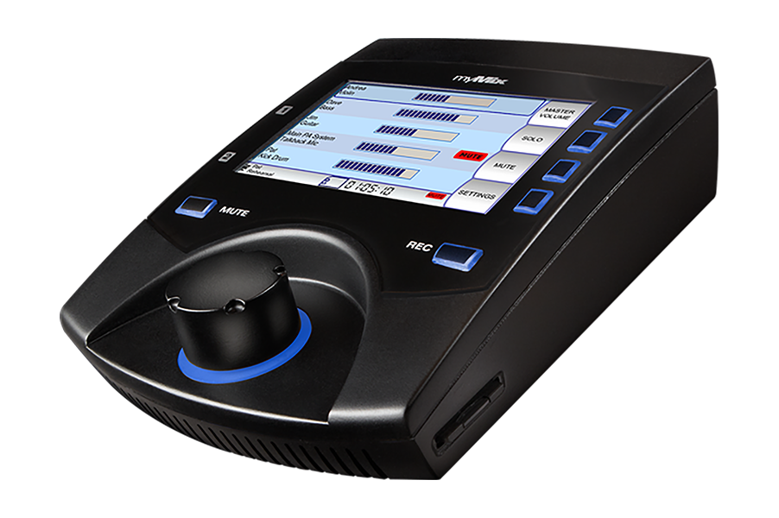
Your Sound, Your Way
For Chung, the customizability offered by the myMix system was a major selling point.

“I like that the interface allows me to adjust things like tone, effects and panning for each channel,” Chung explained. “This is extremely helpful because it makes my personal mix sound even better, plus I can make it sound exactly how I want. This feature of the system was very attractive for us.”

While a tap of the ‘Record’ button will let users record selected audio channels in multi-track, the myMix can also be placed in ‘Play Along’ mode, allowing two local inputs to be mixed with recorded tracks — making rehearsals at Solomon’s Porch a breeze.

“The myMix makes the worship band rehearsals easier because we don’t have to take extra time to adjust our floor monitor mix,” Chung said. “This makes it run much smoother for everyone.”

Quick & Easy Setup
With six units in use each week, Chung has found the myMix’s easy-to-operate functionality a key factor — especially for first-time users. Unlike other interfaces on the market, the myMix feature one single knob, making it simple for anyone to be mixing and recording without delay.

“The myMix is very intuitive,” Chung said. “I can have first-time users up and running within minutes because it’s just that easy to operate.”

For more information, visit mymixaudio.com.

About myMix
Part of the Synthax family, the North American distributor for RME, myMix is a personal monitor mixing and recording system featuring local network inputs and can operate either self-contained or integrated with any analog or digital mixing consoles. Thanks to its ease of use, the myMix is ideal for on-stage performances, studio monitoring as well as installed applications such as houses of worship.

Media Contacts:
Katie Kailus
Public Relations
Hummingbird Media
+1 (630) 319-5226
katie@hummingbirdmedia.com

Jeff Touzeau
Public Relations
Hummingbird Media
+1 (914) 602 2913
jeff@hummingbirdmedia.com

