For immediate distribution

Ferrofish Announces PULSE 16 DX Converter is Now Shipping
Latest PULSE offering provides audio professionals with the same high-quality features as its predecessors,
with the added benefits of Dante connectivity

Fort Lauderdale, Florida, October 25, 2018 — German converter manufacturer Ferrofish has announced that the new Dante-compatible version of its popular PULSE 16 line of converters is now shipping. Available now and priced at $1,999 MAP, the new PULSE 16 DX is a 16-channel, AD/DA, MADI and ADAT converter with Dante compatibility — meeting the needs of audio engineers who require integration and connectivity on a variety of networks.
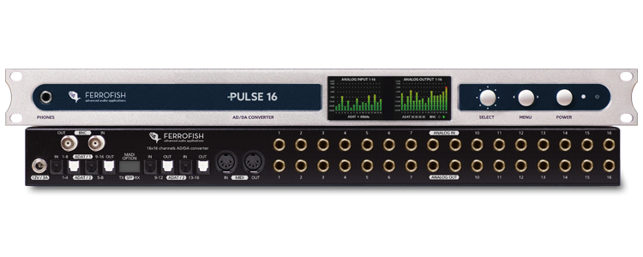
“Dante connectivity is central to many audio engineer’s setups and the PULSE 16 DX is helping Ferrofish stay on the forefront of today’s audio connectivity demands,” said Derek Badala, Director of Sales, Americas for Synthax, distributor of Ferrofish. “The PULSE 16 DX boasts the same top-of-the-line features and pristine audio quality users have come to expect from Ferrofish, with the added benefit of Dante connectivity.”

A Versatile Solution
Like the PULSE 16 MX MADI and ADAT converter, the PULSE 16 DX features 16 fully balanced analog inputs and outputs. Additionally, the PULSE 16 DX offers two RJ45 ports for integration into a Dante audio network. This means that not only all 16 analog inputs and outputs can be integrated into a Dante network, but that the PULSE 16 DX can also be used as a format converter between various digital interfaces.

The PULSE 16 DX features single- or multimode-operation via a SFP module. The BNC connections provide Word Clock I/O and 2 x TFT screens allow for complete control of all levels and settings on the device. The 19-inch, 1 rack unit also boasts input and output gain of all analog channels switchable in 1dB steps.

That Sweet 16 Sound
The PULSE 16 family — which includes the new PULSE 16 DX, PULSE 16 MX and the original PULSE 16 — is relied on by some of the biggest names in recording. Thanks to its Cirrus Logic converter chips, the PULSE 16 operates with an active digital jitter elimination, which compensates shifts or jitters in the audio signal and thus provides audio engineers with the high-quality audio they expect from Ferrofish.

The Ferrofish PULSE 16 DX is now available for $1,999 MAP.

For more information, visit ferrofish.com.

About Ferrofish
Known for its precision-engineered German technology, Ferrofish manufacturers high-quality, innovative advanced audio applications. From its class-leading A16 MK-II and A32 AD/DA converters to its Verto Series of intuitive Dante converters, Ferrofish is known for its premium conversion solutions that are ideal for a wide range of applications. For additional information, visit the company online at http://www.ferrofish.com.

About Synthax, Incorporated
Synthax Inc. is the exclusive USA distributor for RME digital audio solutions, Ferrofish advanced audio applications, myMix audio products, and ALVA cableware. We supply a nationwide network of dealers with these products for professional audio, broadcast, music industry, commercial audio, theater, military and government applications. For additional information, visit the company online at http://www.synthax.com.

Media Contacts:
Katie Kailus
Public Relations
Hummingbird Media
+1 (630) 319-5226
katie@hummingbirdmedia.com

Jeff Touzeau
Public Relations
Hummingbird Media
+1 (914) 602 2913
jeff@hummingbirdmedia.com

