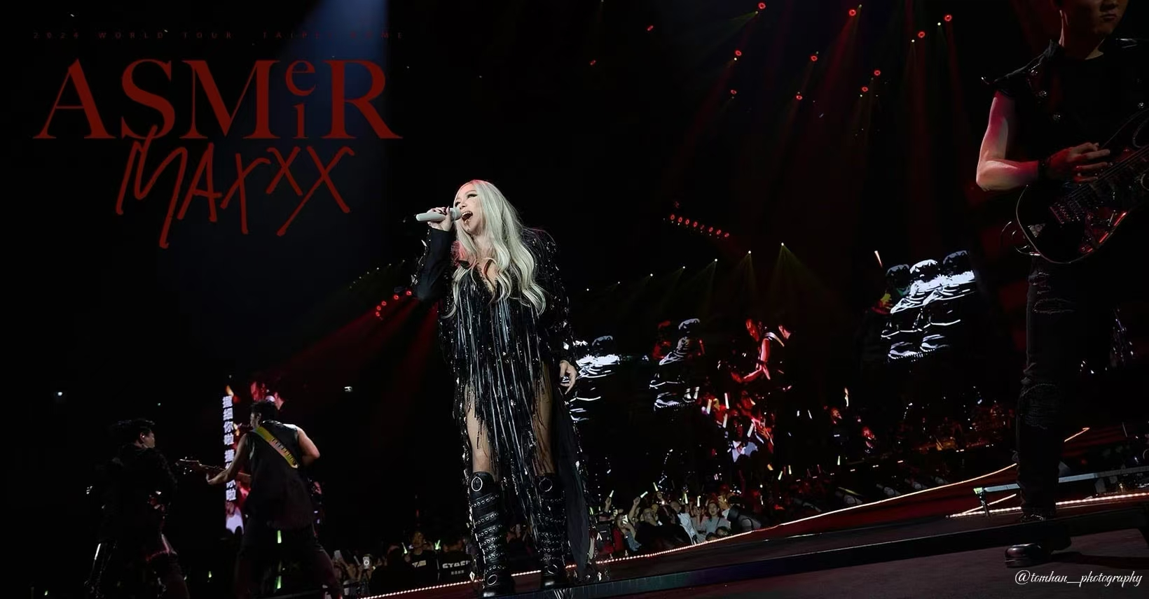

**Neumann’s MCM Powers aMEI ASMR MAX World Tour**

**Beijing, November, 2024 – In the dazzling galaxy of Mandopop stars, aMEI is one of the most brilliant ones. Since her debut, she has achieved worldwide record sales of over 50 million, won countless awards and repeatedly broken the highest sales records for Chinese female singers. In 2024, the aMEI ASMR MAX World Tour kicked off, bringing an immersive sonic experience to audiences globally. Behind the outstanding performances, Neumann’s support is indispensable. The tour’s live band consists of nearly 20 different instruments using Neumann’s Miniature Clip Microphone System (MCM), which not only significantly improves the sound quality, but also lets the audience deeply feel the power of the music.**

The aMEI ASMR MAX World Tour is an upgraded version of the aMEI ASMR World Tour, featuring a top-notch live band with over 20 different instruments, including guitars, bass, drums, electronic keyboards, brass and string instruments, creating a stunning immersive live experience.

With such a large band formation, sound engineers need to maximize signal-to-noise ratio and minimize crosstalk. And of course, the microphones must be sturdy and durable to withstand the challenges of high-intensity touring. The Neumann’s MCM system stands out among clip-on microphones with its excellent studio-grade sound quality, compact design, durability, and reliability.

|  |  |
| --- | --- |
|  | *The aMEI ASMR MAX tour concert adopted 18 sets of MCMs to pick up the sound of various instruments.* |

Chen Qiyao and Hideki Takama were the Monitor Engineer and FOH Engineer respectively for the tour. On the recommendation of Sennheiser’s Artist Relations team’s, Chen and Takama tried Neumann’s MCM and eventually chose MCM to capture the band's sound. Designed specifically for close miking instruments, the MCM has a wide frequency range and a high maximum SPL of up to 153dB, enabling it to handle instruments of all timbres and volumes. Whether it's the passionate thunder of drums or the melodious sound of orchestral instruments, the MCM is able to capture the subtle nuances of each note.

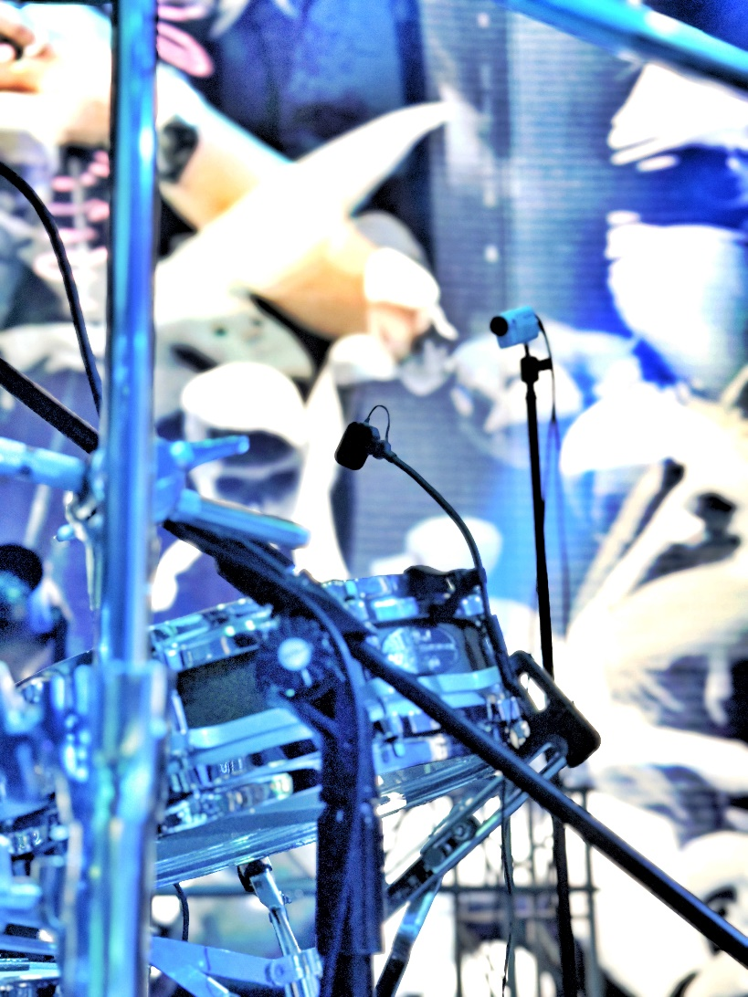"We have equipped a total of 18 MCM sets for string instruments, brass instruments, and drums. The MCM can accurately capture the sound details of various instruments, providing natural, delicate, and distortion-free sound quality. In addition, the MCM system has a wide range of clip accessories, that are highly adaptable to instruments, making the installation process easier, faster, and more reliable.” Takama commented.

*The MCM accurately captures every detail. With a wide range of clips and accessories, it is highly adaptable to different instruments and ensures fast and reliable installation.*

|  |  |
| --- | --- |
|  |   *"Since upgrading to MCM, the problems we had with excessive crosstalk and unstable low frequencies have been well resolved," shared Chen.* |

"On previous tours, we used a bodypack transmitter with a lavalier microphone for instrument pickup but often encountered issues of excessive crosstalk and unstable low frequencies. Since upgrading to MCM, these problems have been well resolved. We also combined the MCM with a bodypack transmitter to create a wireless system. When the musician moves, the sound remains stable and excellent. We have had a better experience in terms of both sound quality and workflow," shared Chen.

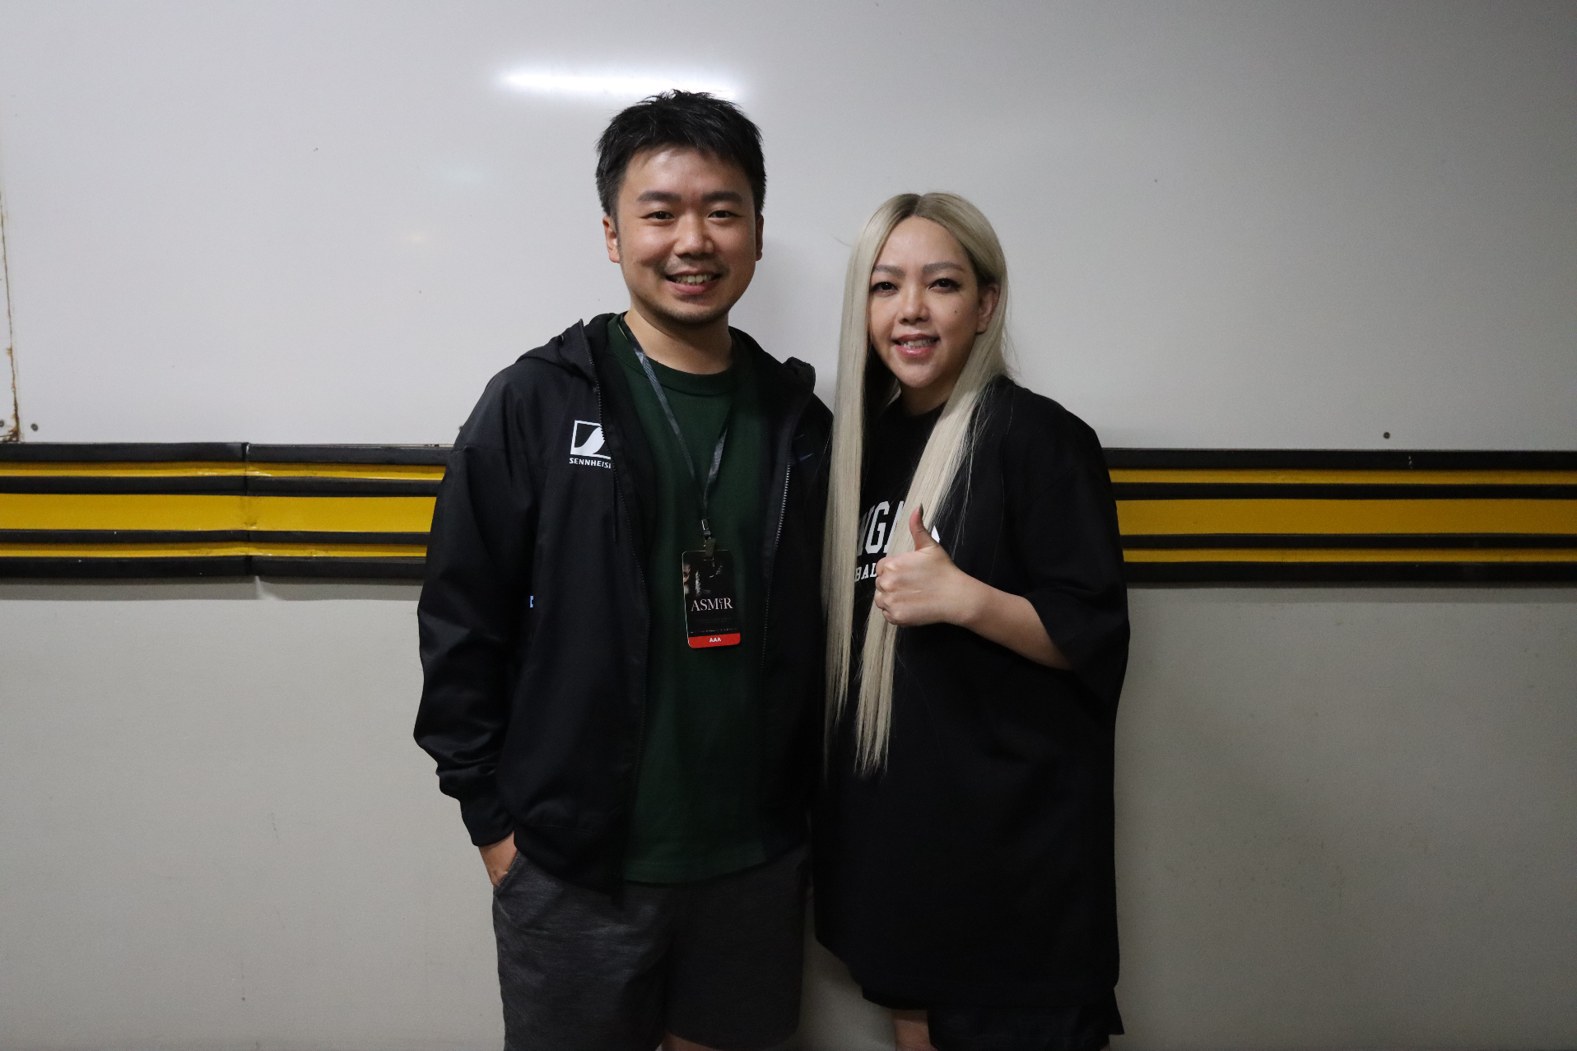

*On the recommendation of Sennheiser’s Artist Relations team, aMEI’s team tried Neumann’s MCM and eventually chose it to capture the band's sound, and was very satisfied with the audio performance.*

"Using MCM uniformly ensures a consistency of timbre, sound quality, and sensitivity. Also, changing the microphone at any time during the tour is very convenient, which takes a lot of pressure off our intense tour work," Chen further added, "MCM is a microphone that is very suitable for touring. Not only do the team's sound engineers and musicians love the MCM, but many industry peers have also highly praised it!"

**About Neumann**

Georg Neumann GmbH, known as “Neumann.Berlin”, is one of the world’s leading manufacturers of studio-grade audio equipment and the creator of recording microphone legends such as the U 47, M 49, U 67, and U 87. Founded in 1928, the company has been recognized with numerous international awards for its technological innovations. Since 2010, Neumann.Berlin has expanded its expertise in electro-acoustic transducer design to also include the studio monitor market, building upon the legacy of the legendary loudspeaker innovator Klein + Hummel. The first Neumann studio headphones were introduced in 2019, and since 2022, the company has increased its focus on reference solutions for live audio. With the introduction of the first audio interface MT 48, and its revolutionary converter technology, Neumann now offers all the necessary technologies needed to capture and deliver sound at the highest level. Georg Neumann GmbH has been part of the Sennheiser Group since 1991 and is represented worldwide by the Sennheiser network of subsidiaries and long-standing trading partners. [www.neumann.com](http://www.neumann.com/)

Stay up to date and follow us on: [FACEBOOK](https://www.facebook.com/neumann/) I [INSTAGRAM](https://www.instagram.com/neumann.berlin/) I [YOUTUBE](https://www.youtube.com/user/GeorgNeumannGmbH)

**Press Contact Neumann:**

Dr. Andreas Hau Raphael Tschernuth

andreas.hau@neumann.com raphael.tschernuth@neumann.com

T +49 (030) 417724-15 T +49 (030) 417724-67