

Biuro prasowe better. gaming agency
bettergamingagency.prowly.com

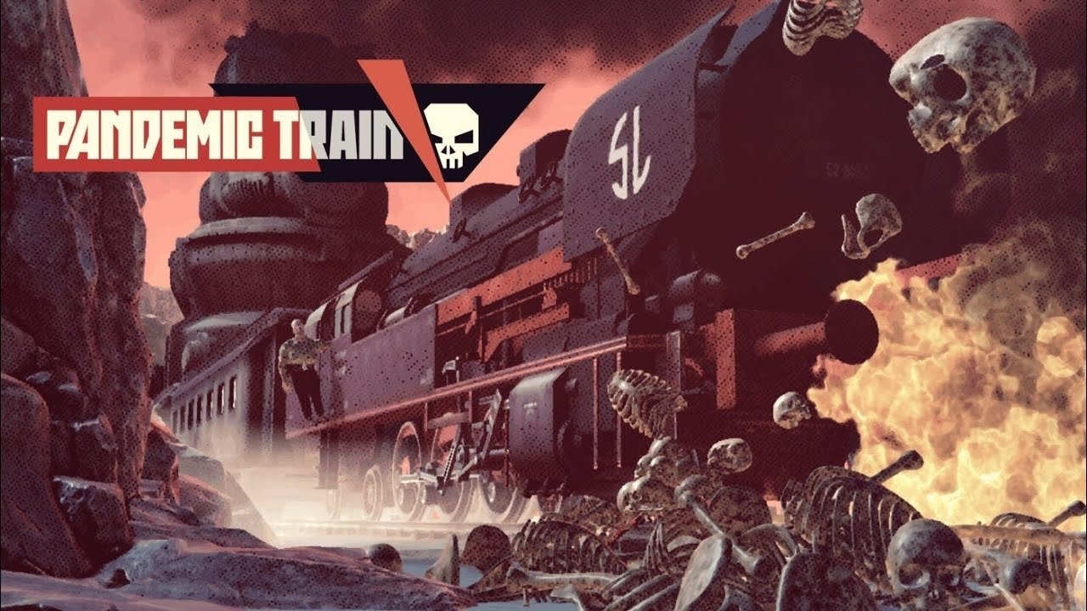

Travel through post-apocalyptic wastelands aboard humanity's last hope. Pandemic Train launches on PC today

Today players will have the opportunity to journey back in time to the 20th century and immerse themselves in an alternative history, post-apocalyptic world of Pandemic Train. The game blends features from survival, roguelike, and action games. The player's primary objective is to find a cure for a virus which devastated the human population.

The disease is spreading at an insane rate, but creating a remedy is possible, and this task will be undertaken by the crew of an extraordinary train. Managing the steam-powered behemoth will be the player's main responsibility. The longer it remains operational, the better the chances of gathering all the necessary resources and people willing to face the deadly threat. Harsh circumstances require the train to be self-sustainable, with workshops, animal farms, gardens, labs, and hospitals set up in the subsequent carriages. In this post-apocalyptic world, even the most basic resources, such as water, are incredibly valuable, so managing the crew and the provisional settlement on rails must be planned carefully.

Pandemic Train - Launch Trailer

Youtube
https://youtube.com/embed/3CrKgkNAZuA

The train cannot remain in motion all the time, and each of the stops means a challenging mission for its crew members. They will have to confront not only cruel bandits, but also monsters born from viral mutation. Nothing works on them better than lead. The commander must secure not only rations, but also the crew's safety and mental well-being.

The Pandemic Train world is brutal, and players must be prepared to make difficult decisions during their journey through virus-infected wastelands. It's impossible to save everyone, but it's important to remember that the mission's goal is to obtain a cure, and the price for achieving this often might be painful. When fighting for a long time, it's crucial to minimize losses, and every commander needs to understand this.

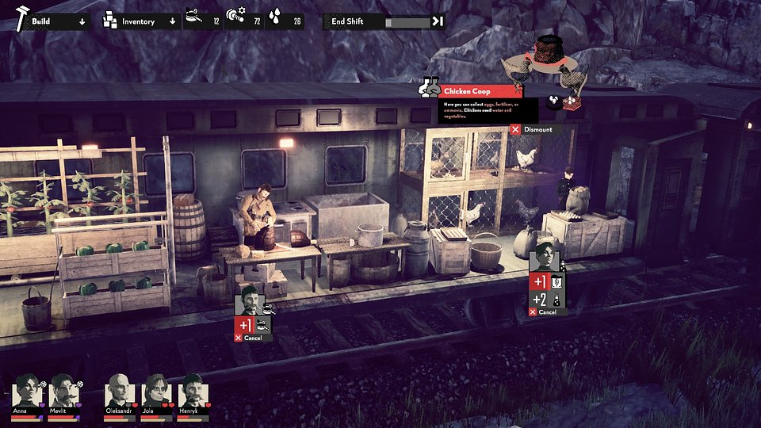

Pandemic Train – key features:

● The post-apocalypse in the 20th century – Pandemic Train shows players an alternative version of events from the last century. In this world, a pandemic nearly devastated humanity. As the commander of an extraordinary train, you'll journey through bleak wastelands infested with bandits and monsters in search of resources to survive and create a cure.

● You won't save everyone – as a commander fighting a deadly plague, you must make decisions that will determine the lives of the crew and passengers. Resources and medicines are limited, so they must be used wisely, remembering that each choice can have a significant impact on the mission's success.

● The self-sufficiency of the rail bastion – death lurks outside, so your goal is to create a self-sustaining train facility. Purify water, craft ammunition from scrap, cultivate food, and raise animals - what goes in the carriages is up to you.

● The burden of responsibility – unexpected events will frequently force you to face the outcomes of your decisions, and these won't be easy. In the fight for the future of humanity, you'll often have to choose the lesser evil.

● What's hidden in the post-apocalyptic wastelands? – exploration of the Pandemic Train world is a crucial gameplay element, because it's the only way to acquire the resources necessary for survival. However, if you don't want to scavenge the wastelands and confront threats manually, you can use the auto-resolve combat button.

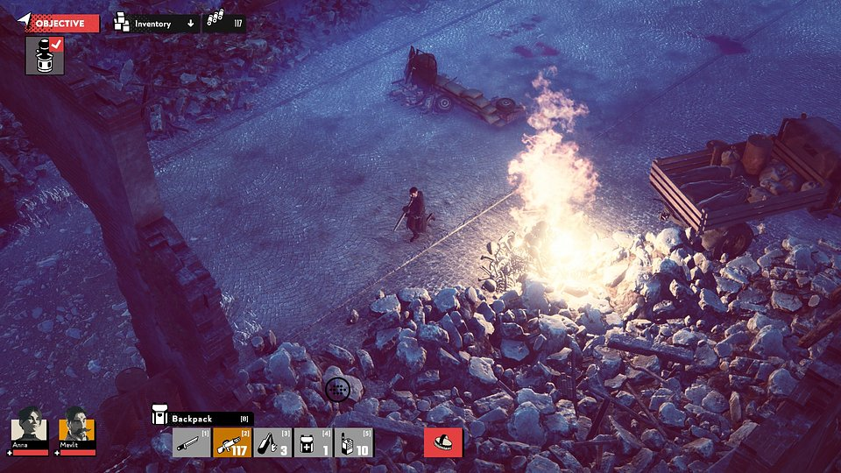

Pandemic Train was developed by Trigger Labs and co-published by Games Operators. The game is available on Steam from October 18th. To stay updated on otherGames Operators projects, follow the publisher's profiles on Twitter and Facebook.

The full press kit is available here.

About Games Operators:Games Operators is a publishing company that invests in, releases, and promotes video games. The company helps develop innovative and unique video games like 911 Operator, Radio Commander, 112 Operator, BE-A Walker, and Transport INC. by getting involved in projects at various levels of progress – from the conceptual phase to nearly-finished products. For more information visit: www.gameops.pl.



Jakub Smolak
PR Specialist at better. gaming agency
jakub.smolak@bettergaming.pro
Twitter

