Press Release

EVOC PRODUCT HIGHLIGHT PREVIEW: SPRING/SUMMER 2021:
One for all - all in one

The new RIDE is EVOC‘s premiere of an all-purpose backpack with full mountain biking capabilities

Thanks to its superior comfort, efficient ventilation and intelligent pocket management, the versatile multitalented EVOC RIDE is not only the ideal backpack for your first mountain biking adventures, but also the perfect companion for any other occasion - be it leisure, city or school. It will go on tour from autumn 2020 in three volumes and six different colourways.
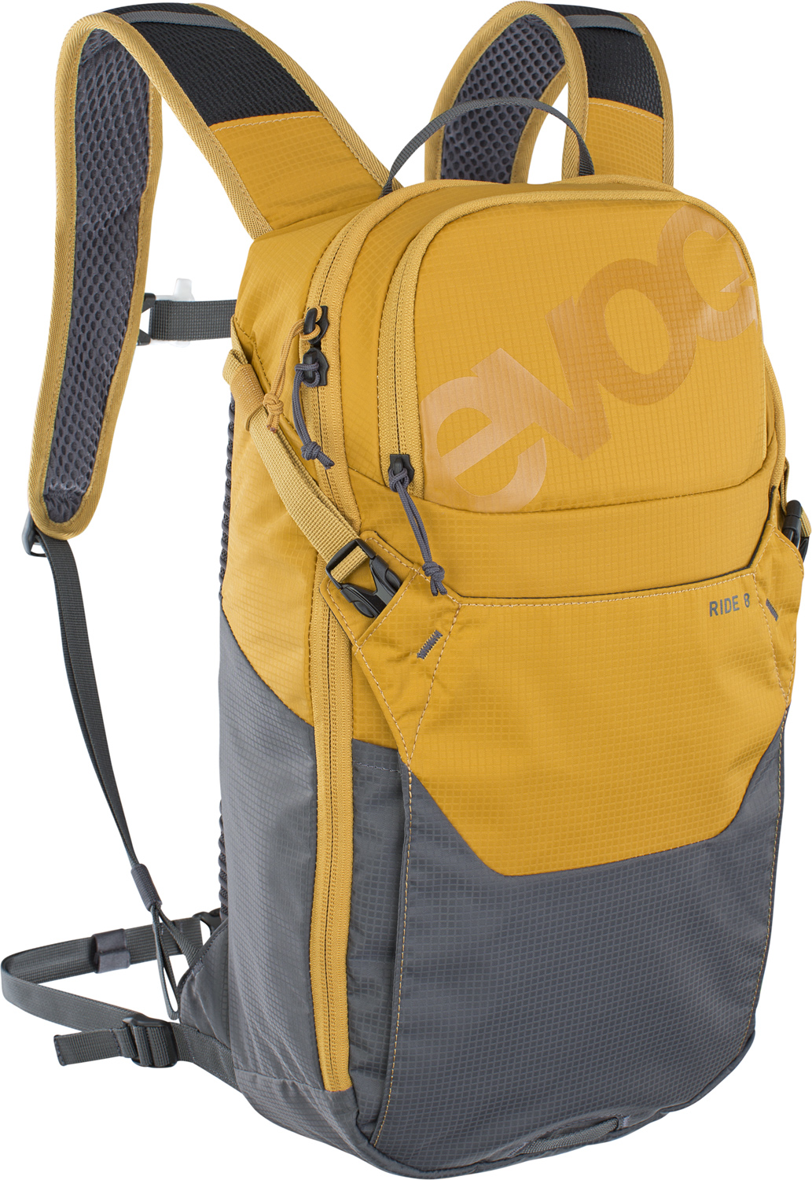
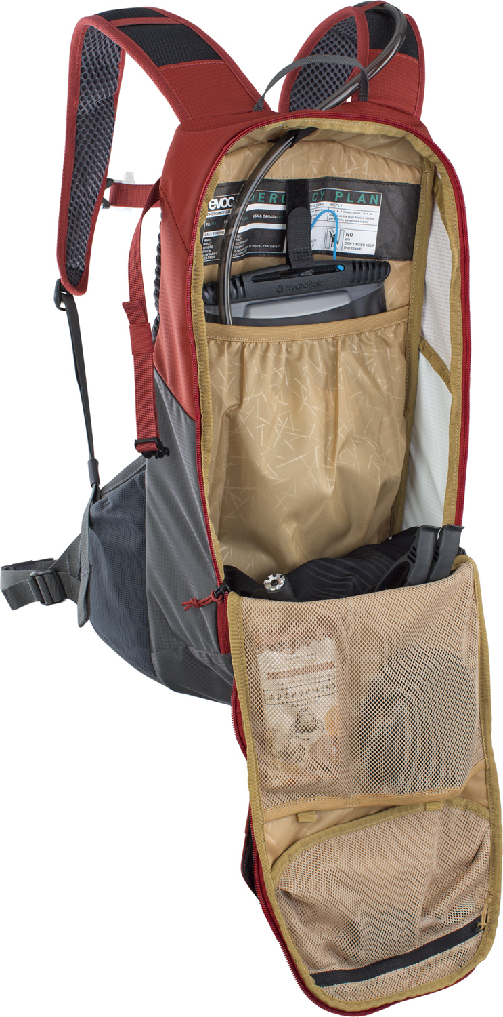
The search for a multifunctional backpack that performs just as well when you are mountain biking as in your everyday life is over. EVOC is offering the perfect solution with the fully equipped, typically stylish, yet affordable RIDE.

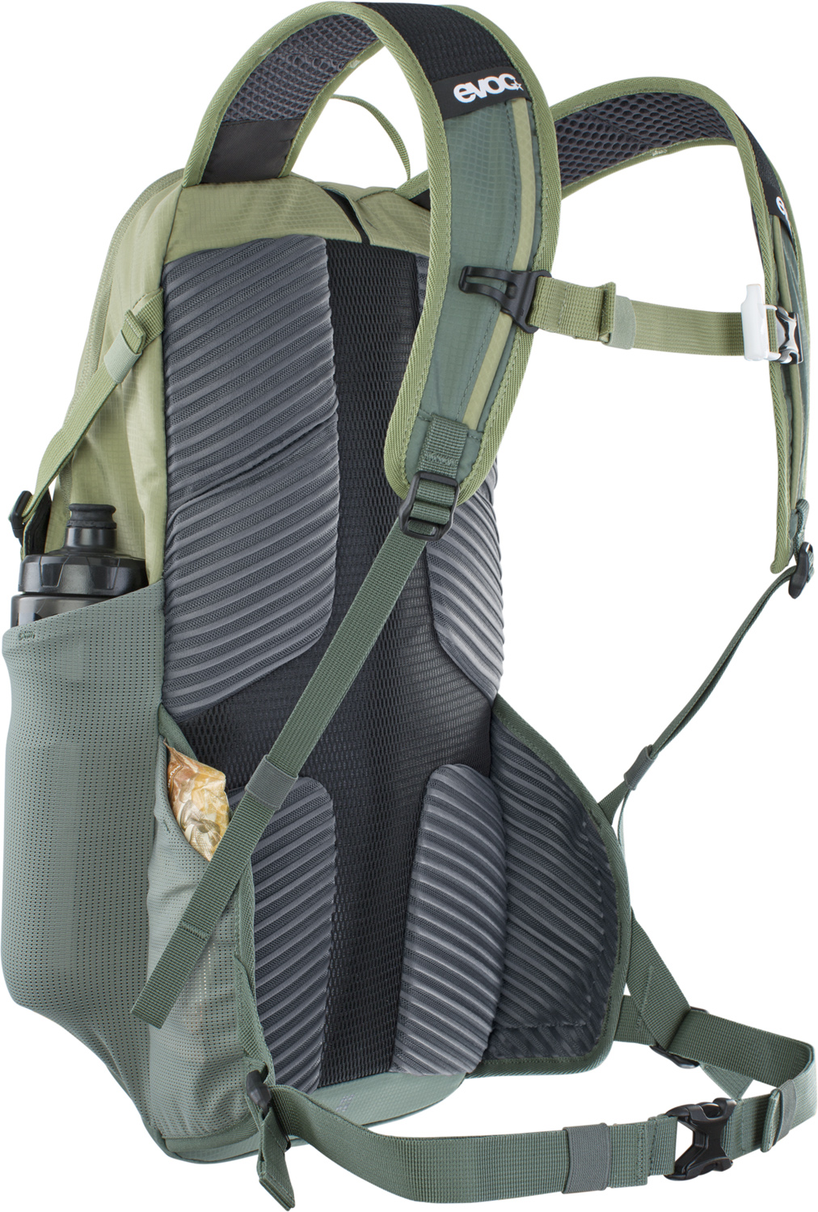
The main compartment of the backpack available in three volumes (8, 12 and 16 litres) can be fully opened. The interior is equipped with a compartment and attachment for a hydration bladder, as well as a sophisticated tool compartment with various mesh and zippered pockets. This makes it easy to organize smaller parts and tools just as easily as your keys, wallet and phone safely.

The extra-wide hip belt ensures perfect carrying comfort and a secure fit for any degree of action. The 12 and 16 litre versions have additional mesh pockets on the belt for anything you need to have quick access to while riding.
The reliable AIR PAD system provides cushioning and also prevents heat build-up with its excellent air circulation through the integrated ventilation channels. The exterior helmet carrier offers variable storage capacity for more than just a helmet.

Additional features:
- Compartment for glasses
- Backlight clip
- Emergency plan
- Height-adjustable chest strap with clip for the hydration system hose
- Integrated signaling whistle in the chest strap

Volumes, weight and sizes:
8 l, 500 g, 24 x 43 x 8 cm
Colours: Black; Loam - Carbon Grey

12 l, 590 g, 24 x 47 x 10 cm
Colours: Carbon Grey - Black; Chili Red - Carbon Grey

16 l, 600 g, 24 x 49 x 14 cm
Colours: Black; Light Olive – Olive

Material: Nylon 100/D, PU coated
Not included: Hydration Bladder
Price: 8l 80.00 €, 12l 90.00€ 16l 100.00€
Available in stores from autumn 2020

#EverythingWillBeAllRIDE
#MyFirstEVOC

Royalty free photos for download in the EVOC Press Room

Date: May 2020
Subject to changes.

Media Contact: Dani Odesser | press@evocsports.com | +49 (0)170 3131812

