Sonarworks Reference 4.3 Adds New Features
Riga, Latvia - 5th June 2019 -- The Latvia-based audio technology company Sonarworks has released the latest update to their award-winning software, Reference 4. Dedicated to improving the experience for both current and new users, the update includes a reworked filter mode as well as usability, latency and onboarding improvements to allow greater ease of use with the software.
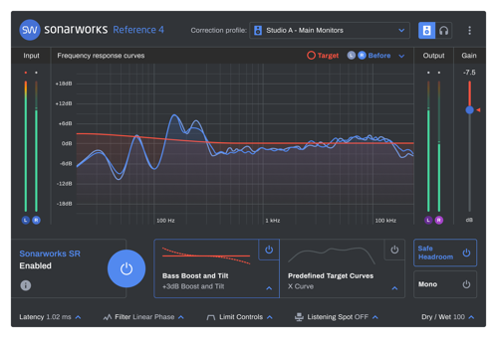
Following the complete revamp of the Systemwide app, the update now includes on-demand headphone profile downloads, which makes for a quicker set-up time and also allows users to download profiles for their individually measured headphones directly into the software. The UI on both macOS and Windows can now be switched to dark mode, a long-requested feature from the night-owls of the Sonarworks community.

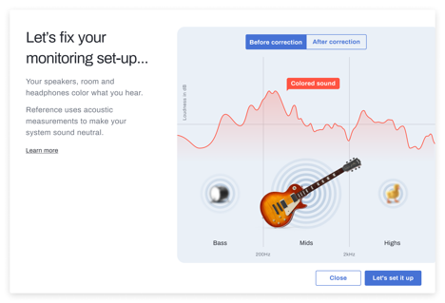
The Reference 4.3 update also introduces a mixed filter mode with a much-needed improvement over the previous “optimum” version. Having worked hard doing internal research and external testing, the new filter serves as a good middle ground to deliver accurate frequency response and sound quality without introducing significant latency.

“For this release, we decided to rewrite Systemwide from ground up with the main aim of improving set-up experience for new users, though we couldn’t help adding some improvements for our existing users as well,” said Viesturs Marnauza, Product Manager of Reference 4.

Striving to support the growing demand and trend for mixing on headphones, the update takes the supported headphone count to 232 with these new models:
- Beyerdynamic Custom Studio
- Beyerdynamic MMX 300
- Direct Sound EXTW37 Pro
- Direct Sound Serenity Plus
- Direct Sound Studio Plus
- Marshall Major III
- Marshall Major III Bluetooth
- Marshall Monitor Bluetooth

The Reference 4.3 update is available free to current users.
Until the 16th of June Reference 4 is available with a -20% discount - EUR/USD 79 for the Reference 4 Headphone Edition, EUR/USD 199 for the Reference 4 Studio Edition and EUR/USD 239 for the Reference 4 Studio Edition with Mic.
The full release notes can be found on the Sonarworks website - https://www.sonarworks.com/blog/product-news/reference-4-3/
For a 21-day free trial, visit www.sonarworks.com/reference

About Sonarworks
Sonarworks began in 2012 when two music lovers met a scientist — a perfect storm of acoustic know-how and passion for good sound soon became the software that's currently transforming sound monitoring. Sonarworks’ flagship professional audio product, Reference 4 software, removes unwanted coloration and delivers the same accurate studio reference sound on all speakers and headphones. The software has since been endorsed by many Grammy-award winning mixing and mastering engineers and has won several industry awards and accolades.

Media Contact:
Steve Bailey
Hummingbird Media
+1 (508) 596-9321
steve@hummingbirdmedia.com
Jeff Touzeau
Hummingbird Media
+1 (914) 602-2913
jeff@hummingbirdmedia.com

