NAMM 2020: RME’s Babyface Pro FS Brings Unparalleled Innovation to Portable Interfaces
Latest upgrade includes SteadyClock FS technology, improved preamps/converters, increased headphone power & a suite of third-party plug-ins
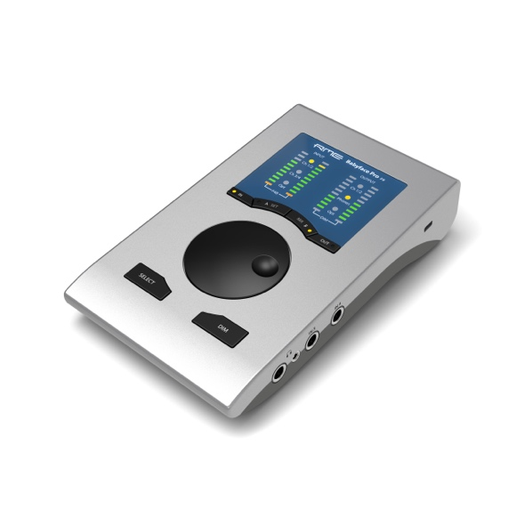
Anaheim, CA – January 6, 2020 – RME, [Booth 14702, ACC North Hall], German manufacturer of premium digital audio solutions, will officially launch the new Babyface Pro FS during the 2020 NAMM Show from January 16–19, 2020.
As the latest addition to the RME family of audio interfaces, the Babyface Pro FS features RME’s proprietary SteadyClock FS technology, bringing self-jitter to new lows and providing recording musicians, studio techs and live recording engineers with the most pristine audio available. This new interface also features a variety of upgrades and benefits, including increased headphone power and a slew of plug-ins from companies like Scuffham Amps, Gig Performer, and Brainworx via the Plugin Alliance.
“We are excited to release the third generation of the Babyface at the 2020 NAMM Show,” said Derek Badala, Director of Sales Americas Synthax, distributor of RME. “Now featuring our industry-leading SteadyClock FS technology, the Babyface Pro FS boasts an ultra high-end audio performance to optimize users’ recordings and mixes. From a strictly hardware point-of-view, RME has improved the mic preamps, AD/DA converters and now included the same headphone circuit as the award-winning ADI-2 Pro series making this one of the most advanced portable audio interfaces on the market.
“The unit will also ship with both a USB 2 and USB C cable, making it easily compatible for users of all computer types,” Badala continued. “On the software side, the Babyface Pro FS includes the following plug-ins: Scuffham Amps S-Gear guitar amp simulator, Gig Performer Brainworx BX Opto, Brianworx BX Masterdesk mastering tools, Pianoteq 6 by Modartt and Blue3 by GG Audio. With all of the hardware and software enhancements, the value to the customer in this portable-but-mighty interface is unprecedented.”
SteadyClock FS Technology
In digital audio, clock frequency is an essential factor as it creates the correlation between the audio bits and the time reference. However, clock frequency is not always as stable as desired. The new Babyface Pro FS offers the full SteadyClock FS circuit for the lowest jitter and highest jitter immunity. Excellent performance in all clock modes and high-quality analog conversion allows users to hear their mix as it is. Digital format conversion in RME products are done without any loss or depredation, and SteadyClock FS ensures a user’s sonic image will never experience degradation. This helps optimize recordings and mixes because the soundstage has more depth and clarity. At the end of the day SteadyClock FS improves converter performance and takes the over-all audio quality to reference class performance.
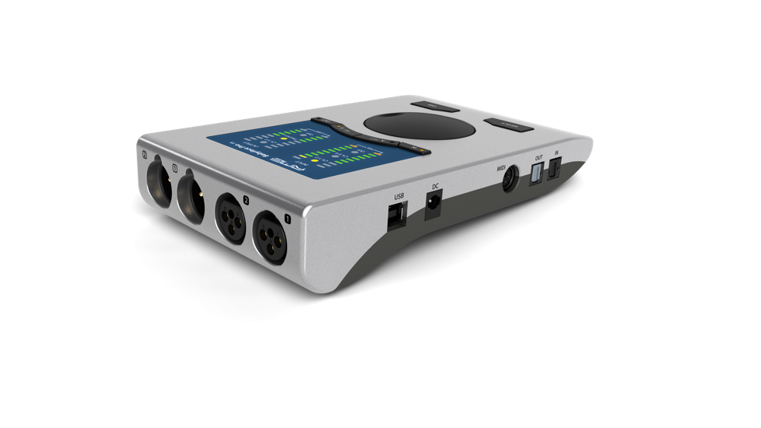
Improved Inputs & Fully Bus-Powered
In addition to the SteadyClock FS technology, the new Babyface Pro FS includes two digitally controlled preamps providing individually switchable 48V phantom power. These improved new circuits feature a gain range of 76 dB, adjustable in steps of 1 dB, including a relay-driven PAD — resulting in exceptional EIN (Equivalent Input Noise) performance as well as line overload protection, and enough gain for even the lowest level microphones.
For the main I/O, RME has designed an XLR socket which integrates seamlessly into the housing and saves space. The comprehensive feature set also includes an optical TOSLINK I/O to be used as either an ADAT port with SMUX support or SPDIF for sessions up to 192 kHz. In combination with an external ADAT converter, the Babyface Pro FS fully supports 12 analog inputs as well as 12 outputs, making it ideal for both live and studio multi-track applications. Users can plug any guitar, line or high impedance into the Babyface Pro FS’s jack inputs 3 and 4 and record on-the-go with no additional hardware required. A MIDI I/O via an included breakout cable completes the package.
Newly Designed Analog/Digital Circuits
Maintaining its position as a leader in superior craftsmanship, the Babyface Pro FS incorporates newly designed analog and digital circuits. A new +19/+4 dBu switch on the bottom of the unit adds a direct way to reduce the output level, thus improving SNR for sensitive active monitors, avoiding distortion/overload and helping to keep TotalMix FX faders near 0 dB instead of high attenuations.
Featured-Packed FS Technology
Further additions to the feature-packed Babyface Pro FS include the same headphone circuits available in RME’s leading ADI-2 Pro Series converter/headphone preamp. The two new headphone outputs, offering TRS and mini-jack sockets in parallel, feature completely separate driver stages to perfectly match low- and high-impedance headphones, guaranteeing pristine sonic results no matter what type of headphone is used. The 3.5-mm TRS phones output power rises to 90 mW. The THD of both headphones’ outputs is improved by up to 10 dB and now uses the same output op-amps as the ADI-2 Pro. Finally, the output impedance of 3.5-mm TRS was lowered from 2 Ohms to 0.1 Ohms.
For mobile users, the new Babyface Pro FS features a K-slot, which can be used with a variety of locking solutions for theft protection. Also, the Babyface Pro FS remains 100% bus-powered for complete mobile operation.
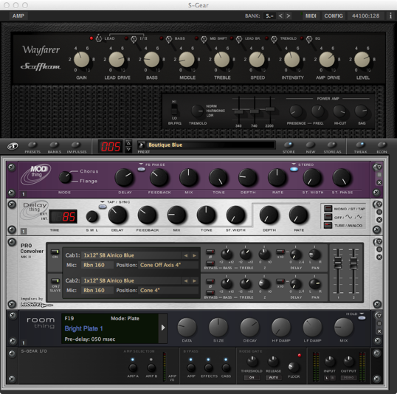
TotalMix FX
Like all RME audio interfaces, the Babyface Pro FS comes complete with RME’s powerful digital real-time mixer TotalMix FX allowing for fully independent routing and mixing of input and playback channels to all physical outputs. TotalMix FX is also equipped with DSP Reverbs, Delays, EQ, and a highly versatile headphone mixing system for tracking and overdubbing. TotalMix FX also allows users to expand their Babyface pro System into a 10 mic input studio easily using the Octamic II or XTC with full digital control of the preamps in TotalMix FX.
Babyface Pro FS - Equipped with Premium Plug-ins
RME teamed with S-Gear, state-of-the-art software guitar amplification by Scuffham Amps, to offer its software free-of-charge (a $129 USD value) with the purchase of an RME Babyface Pro FS audio interface. This promotional bundle will be available from January 1 through March 31, 2020.
Ideal for guitarists of all levels, the bundle provides players with a virtually unlimited variety of sounds and effects in an ultra-portable setup for both home recording and live performance.
Created by former Marshall Amplification product designer Mike Scuffham, S-Gear’s highly regarded, ultra-flexible guitar amplification software can be used as a standalone application or as a plug-in for DAW recording software. Compatible with both PC and Mac, S-Gear employs sophisticated tube amp modeling algorithms to deliver highly authentic guitar amp sounds with a natural feel.
Additionally, Babyface Pro FS users will also have free access to the full, unlimited versions of Plugin Alliance’s Brainworx BX Opto and Brainworx BX Masterdesk plug-ins. Users will also receive trial versions of Pianoteq 6 by Modartt and the Blue 3 Organ by GG Audio.
Rounding out the added offerings, Babyface Pro FS customers will receive a free 14-day, full version of Gig Performer. After which, a special VIP offer applies.
These bundles will only be available to customers in the Americas.
Check out the new Babyface Pro FS and all of RME’s new products at the Synthax’s 2020 NAMM Show booth 14702 in the ACC North Hall, or visit rme-usa.com.

About Synthax, Incorporated
Synthax Inc. is the exclusive USA distributor for RME digital audio solutions, Digigram broadcast audio systems, Appsys digital audio tools, Ferrofish advanced audio applications, myMix personal monitoring systems and ALVA cableware. We supply a nationwide network of dealers with these products for professional audio, broadcast, music industry, commercial audio, theater, military and government applications. For additional information, visit the company online at http://www.synthax.com.

Media Contacts:
Jeff Touzeau
Public Relations
Hummingbird Media
+1 (914) 602 2913
jeff@hummingbirdmedia.com

Katie Kailus
Public Relations
Hummingbird Media
+1 (630) 319-5226
katie@hummingbirdmedia.com

