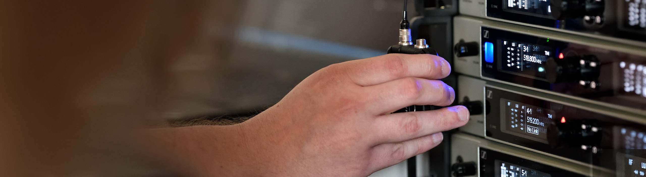

#Dontstoptheeducation

Behind the Console: Women of Sound

Wedemark, May 7, 2020 – On May 12 at 17:00 CEST (15:00 UTC), Sennheiser’s expert round table will see leading women from the pro audio and touring industry join Sennheiser hosts Jessica Dabbs and Tim Moore. Loreen Bohannon, Rachel “MrSoundlady” Ryan, Jess Jacobs, Grace Royse, Jac Nott and Amanda Davis will speak about their roles in the industry and answer questions from the audience. Registrations are now open at https://zoom.us/webinar/register/WN_HM1jq_sSRc69pGRFy7-eCg.

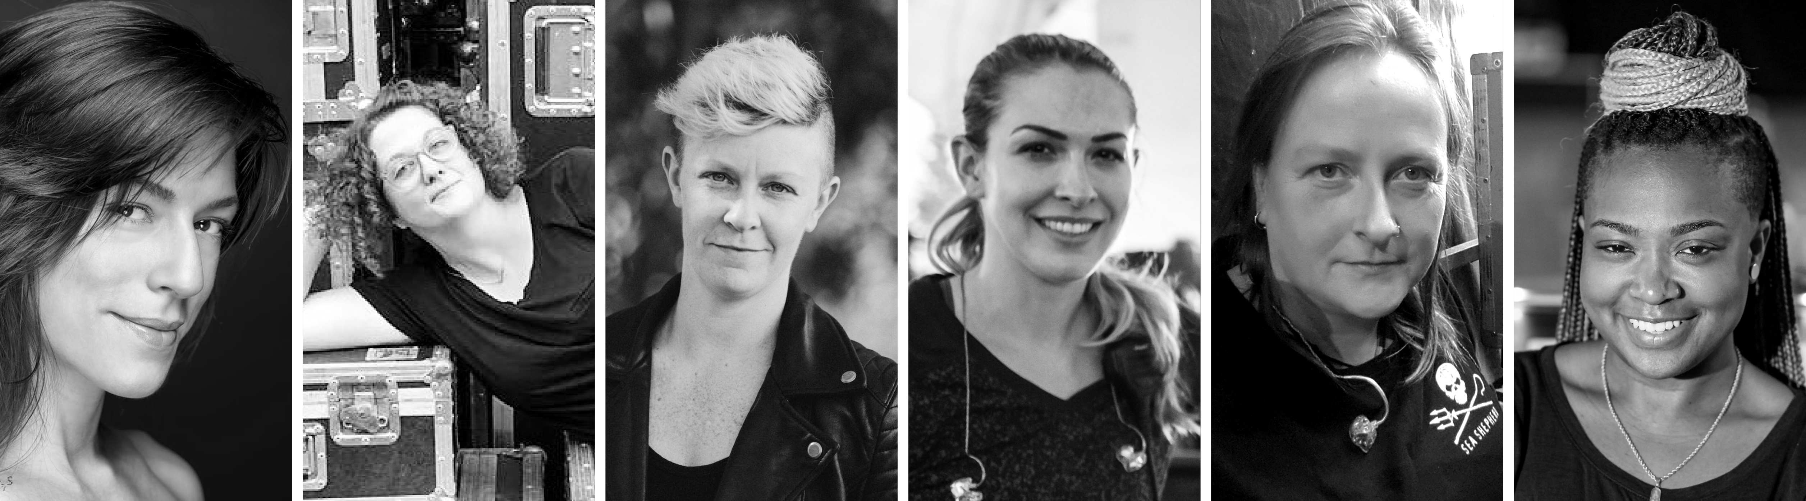
The panellists of “Behind the Console: Women of Sound”: Loreen Bohannon, Rachel “MrSoundlady” Ryan, Jess Jacobs, Grace Royse, Jac Nott and Amanda Davis (from left to right)

Brief notes about the panellists
Loreen Bohannon is a monitor and RF engineer and has worked with Lizzo, Michael Bolton, Plain White T’s, Rusted Root
Rachel “MrSoundlady” Ryan is a front-of-house engineer and tour manager and has worked with Iron & Wine/Calexico (FOH), Brian Fallon (TM/FOH), The Twilight Sad (TM/FOH)
Jess Jacobs is a production manager, front-of-house engineer, monitor engineer and playback engineer who has worked with Ella Mai, Pussy Riot, The Glitch Mob
Grace Royse is a production manager, technical director and A1. Her roster includes the LA Pride Festival, NYC World Pride, Sublime with Rome, Fitz & the Tantrums, Lauryn Hill
Jac Nott, winner of two TPI awards, is a monitor engineer and has worked with The Levellers, KT Tunstall, The Flaming Lips, Gary Neumann
Amanda Davis is a front-of-house engineer and production manager for Janelle Monáe (FOH), Tegan and Sara (FOH/PM), Ella Mai (FOH/PM)

Expand your expertise with more webinars – totally free
In addition to round tables, Sennheiser’s SoundAcademy provides a host of other popular pro audio training webinars and in-depth product discussions. Please visit https://www.sennheiser.com/webinars for a full, up-to-date list and to register free of charge for a SoundAcademy webinar of your choice. The free training sessions are offered at several different times to allow as many people from around the globe to tune in as possible.

For your social media channels

Join leading women from the pro audio and touring industry at Sennheiser’s next round-table discussion on May 12, 17:00 CEST (15:00 UTC). #Don’tStopTheEducation

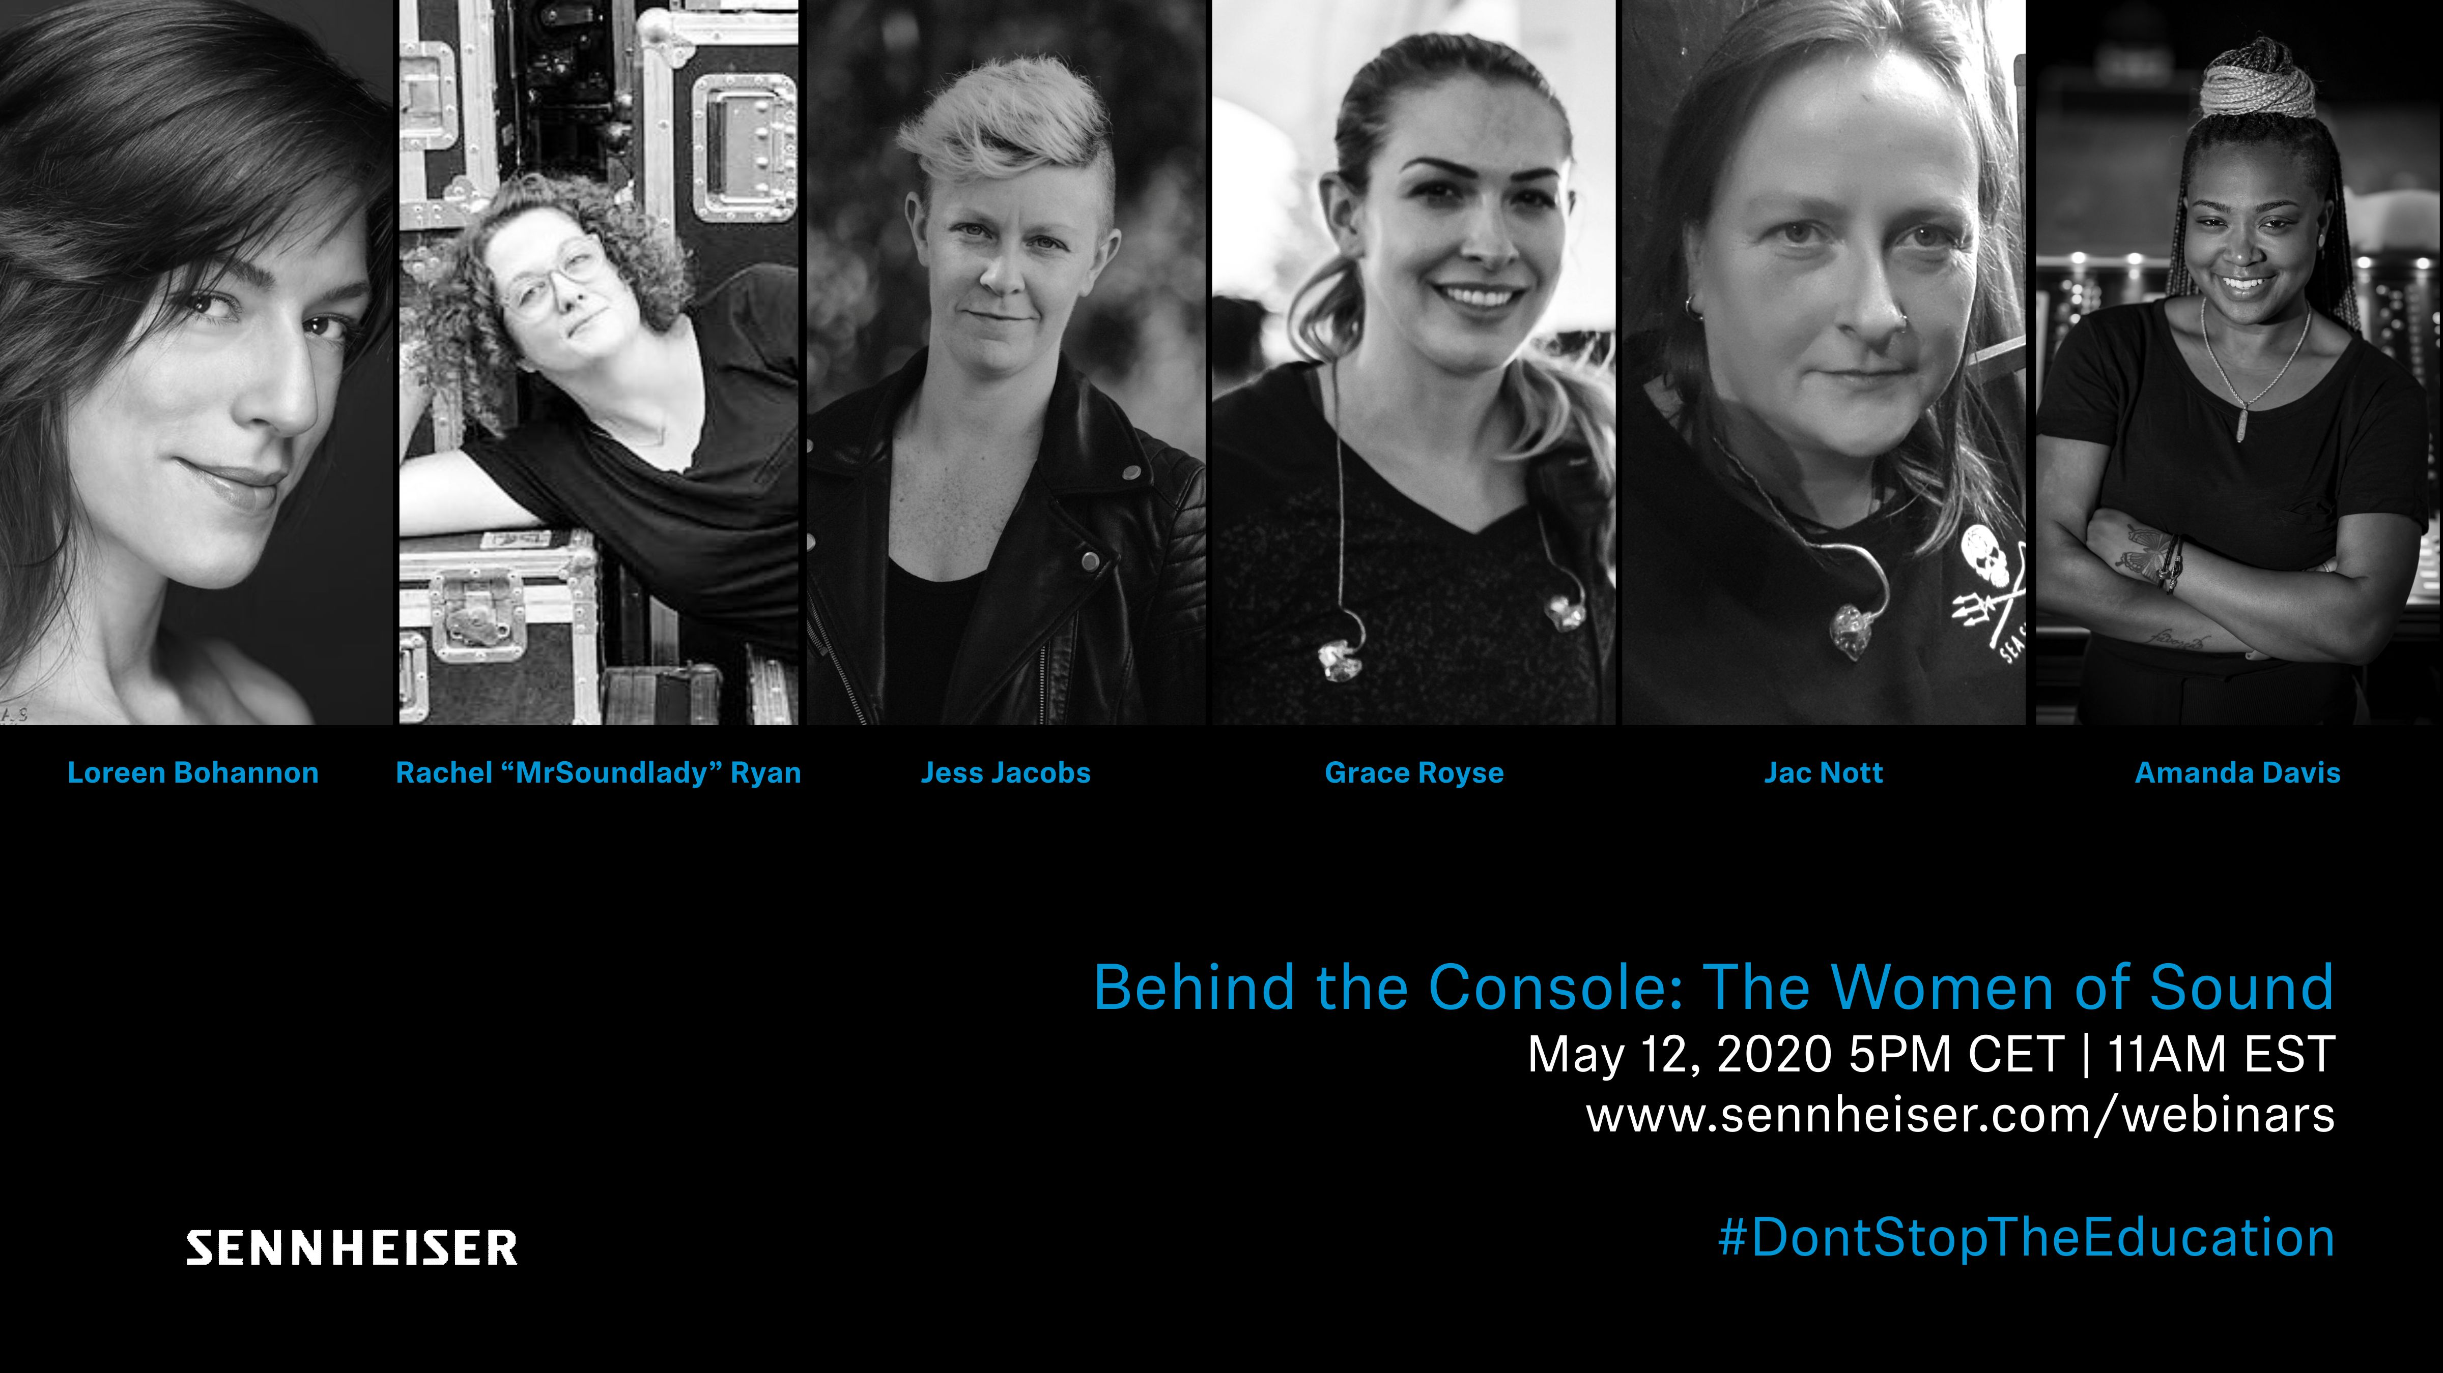 | Behind the Console: Women of Sound: Meet six leading women from the pro audio and touring industry
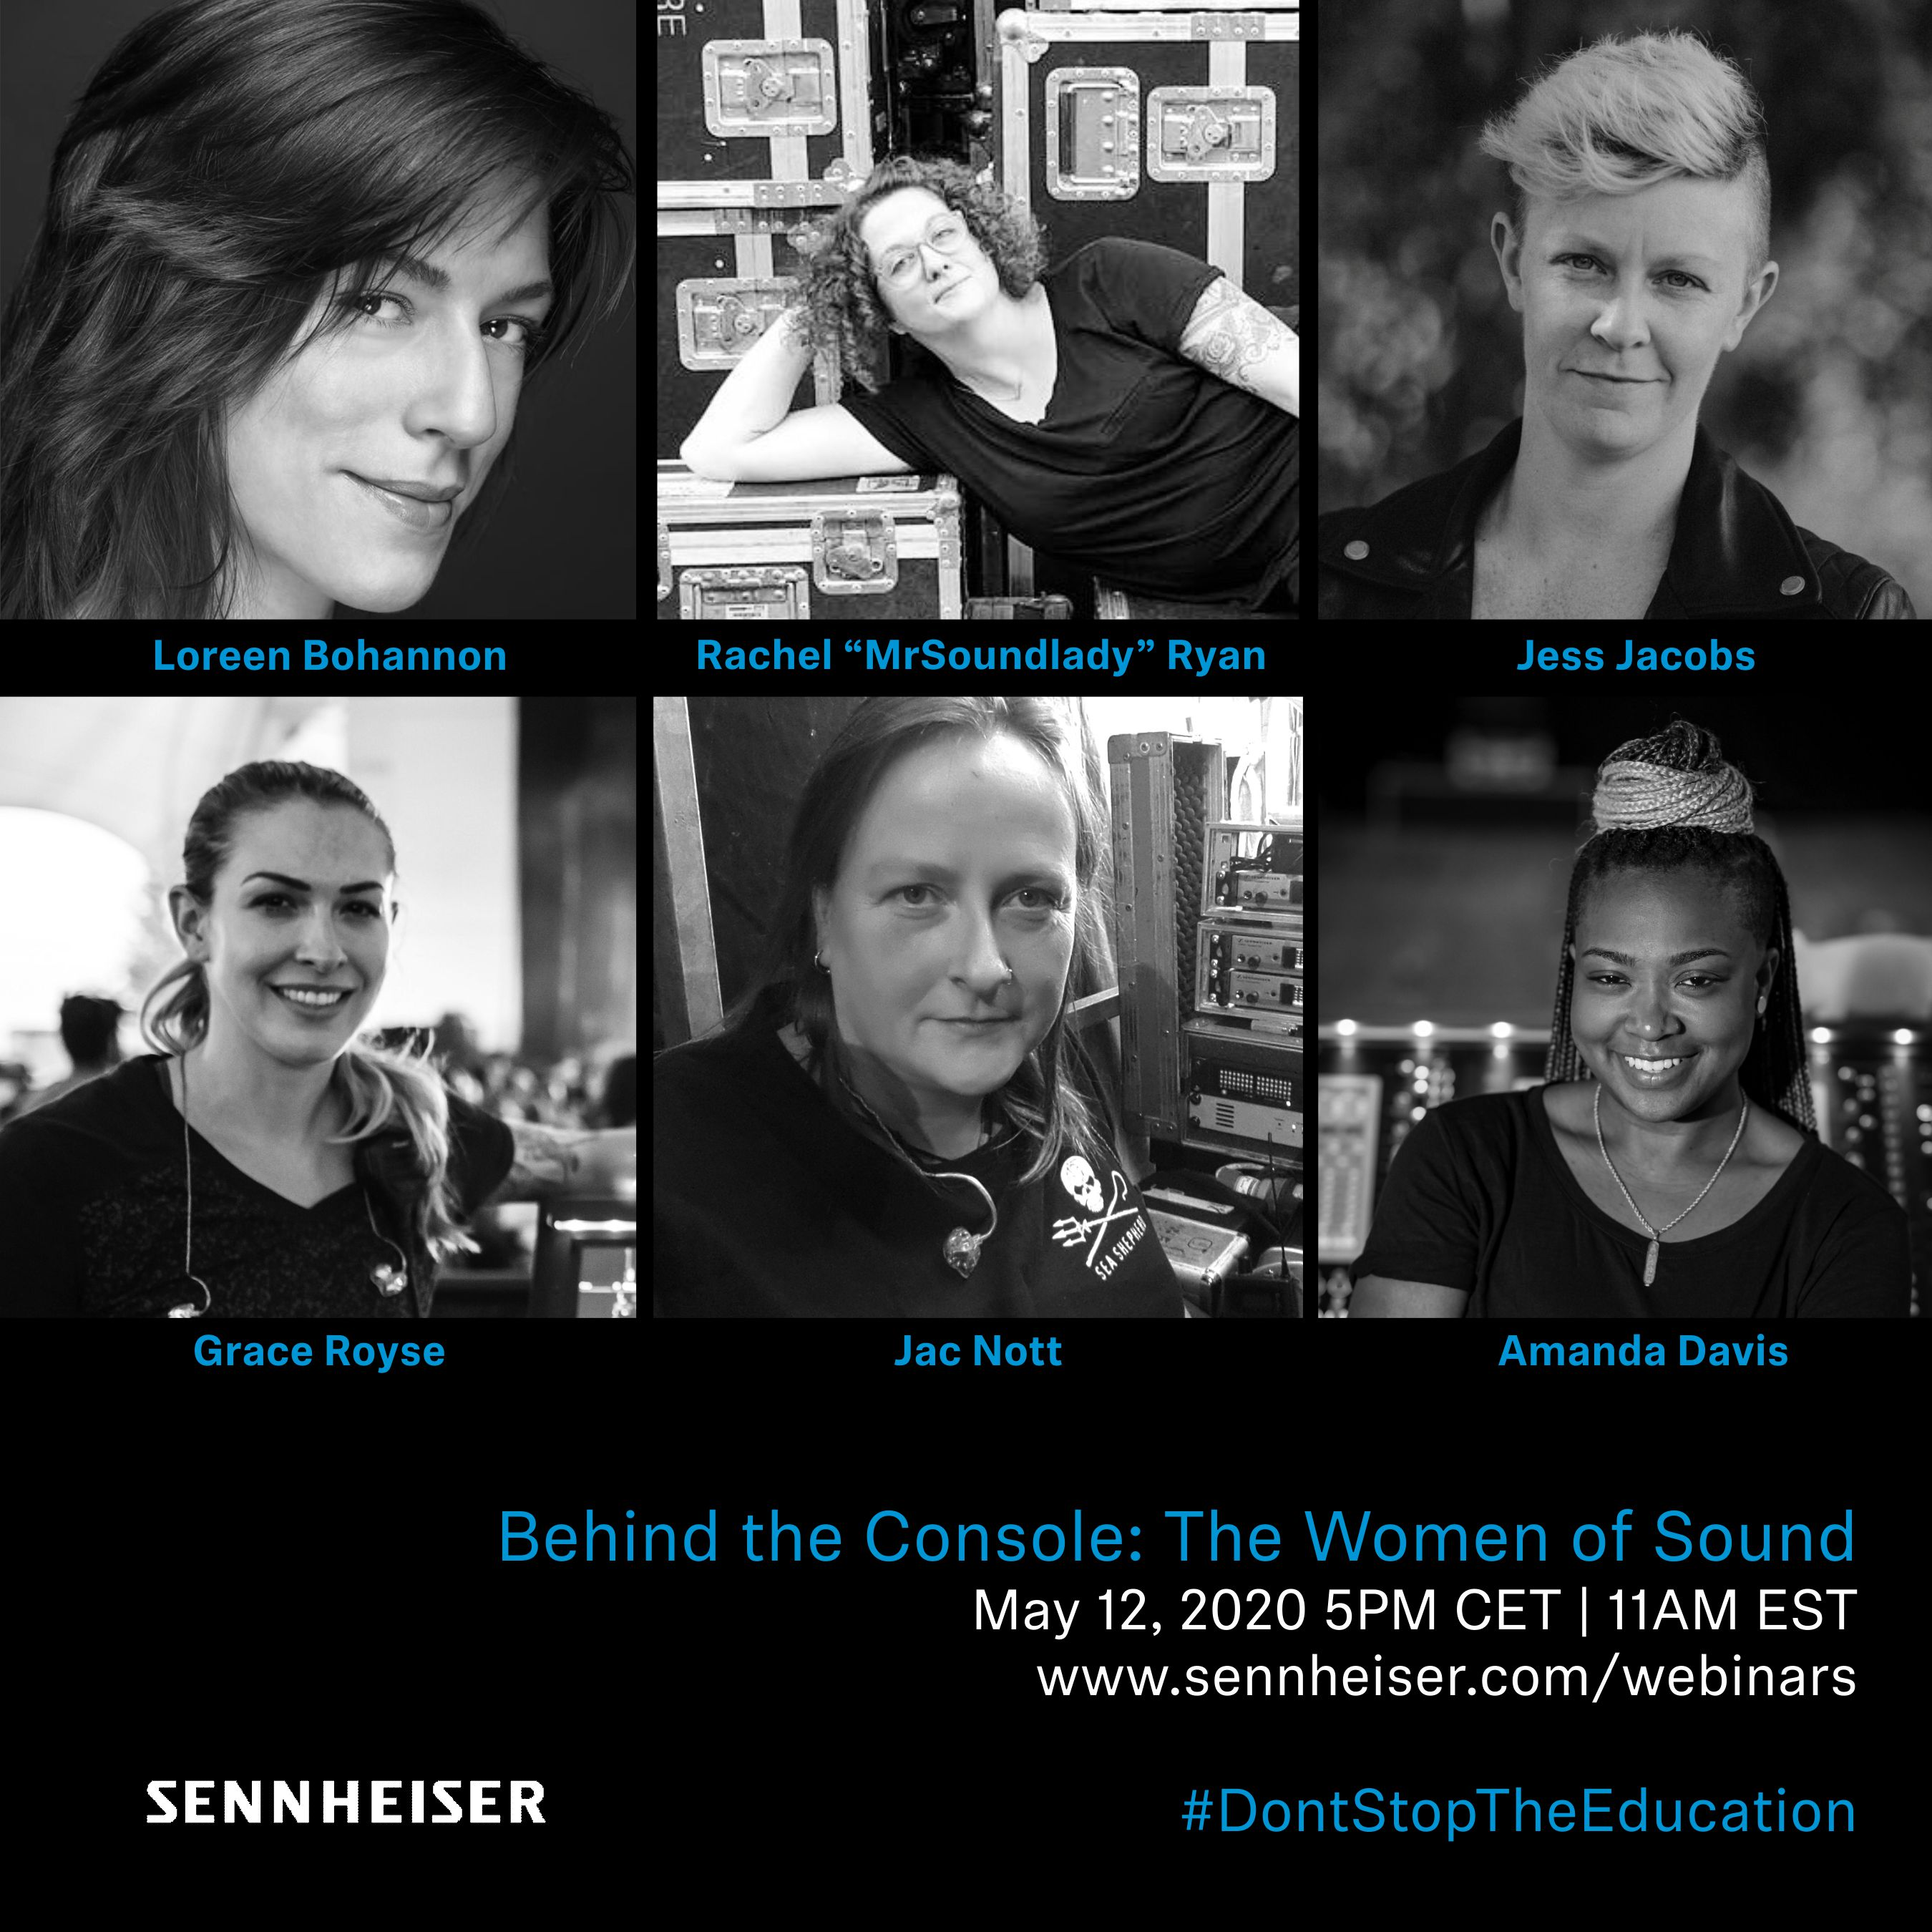 | 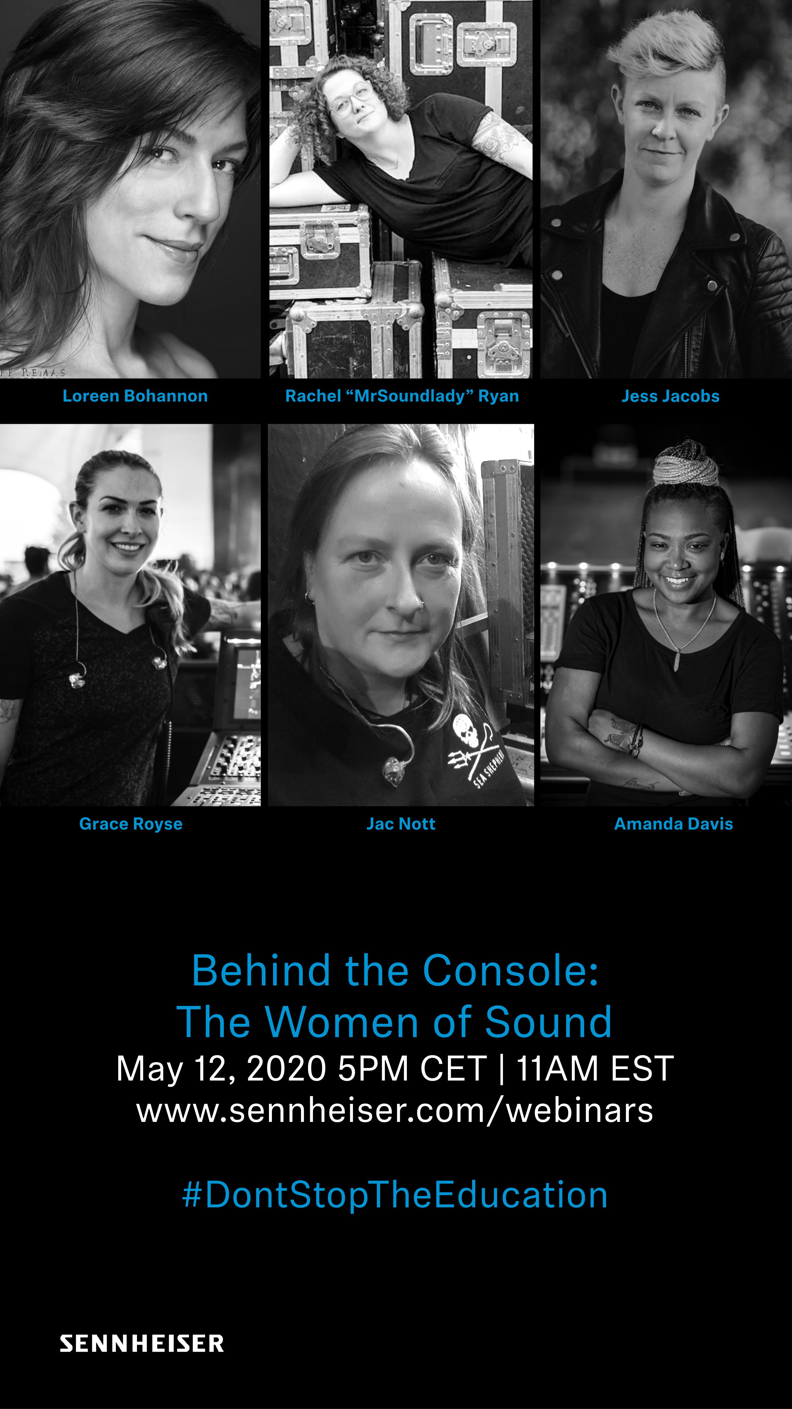

About Sennheiser
Founded in 1945, Sennheiser is celebrating its 75th anniversary this year. Shaping the future of audio and creating unique sound experiences for customers – this aim unites Sennheiser employees and partners worldwide. The independent family company, which is managed in the third generation by Dr. Andreas Sennheiser and Daniel Sennheiser, is today one of the world’s leading manufacturers of headphones, loudspeakers, microphones and wireless transmission systems. In 2018, the Sennheiser Group generated turnover totalling €710.7 million. www.sennheiser.com

Global Press Contact

Stephanie Schmidt
Stephanie.schmidt@sennheiser.com
+49 (5130) 600 – 1275

