NAB 2022: Xytech Launches New Modules, Features with MediaPulse 2022, the First Release Since the Acquisition of ScheduALL

The latest update of MediaPulse features upgrades across the entire platform with a continued focus on the user experience

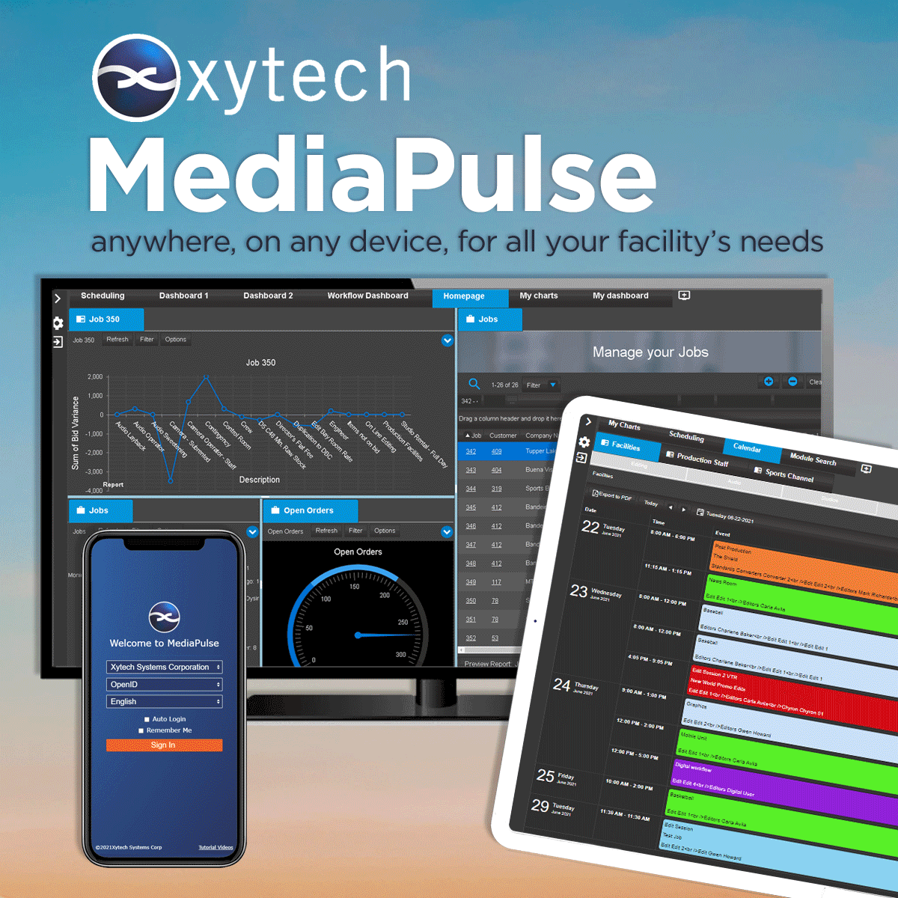
Las Vegas, March 15, 2022 — Xytech, the leader in resource management software for the broadcast, studio, media services and video transmission industries, has announced it will introduce MediaPulse 2022, at its North Hall booth 6314 during the 2022 NAB Show in Las Vegas.

Since the April 2021 acquisition of ScheduALL, Xytech has improved MediaPulse, to innovate the best features of both products, with a focus on the Schedule Book and Transmission modules. Xytech is also introducing the Resource Capacity Management Module, a new Budgeting Module and upgrades to integration toolsets and project budgeting. The overall user interface of MediaPulse continues to transform to accommodate all levels of users.

“We’ve been saying it for a long time, but we cannot wait to get back in front of our clients at NAB this April,” said Greg Dolan, Xytech CCO. “Since we last met face-to-face, we have made significant upgrades to the MediaPulse Managed Cloud, have introduced major updates and new modules to MediaPulse, and have a great upgrade program for ScheduALL customers.”

MediaPulse 2022 – The New Way to Manage Resources
The three areas of concentration for 2022 are transmission, the cloud and resource capacity management to support the changing nature of the business. Resource Capacity Management allows for scenario planning and budgeting as well as automated resource selection. Xytech is leveraging the ScheduALL community and developed new features across the transmission and scheduling modules to make MediaPulse more impactful for its users.

“One of our goals for MediaPulse 2022 is to provide every user exactly the functionality they need, when they need it, on the device of their choosing,” Dolan says. “As we emerge from the COVID-19 pandemic, the need for solutions to operate anywhere is paramount. MediaPulse 2022 delivers on this need.”

MediaPulse is the upgrade path for all ScheduALL customers, and Xytech is excited to show these clients all MediaPulse has to offer. MediaPulse now has conversion routines and feature updates to provide not only a seamless migration but a rich feature footprint on a state-of-the-art platform. For the first time, these clients have a cloud option for their systems with Xytech managing the platform, updates, backups and configuration. The MediaPulse Managed Cloud is highly available platform.

Xytech is exhibiting at the upcoming 2022 NAB Show from April 24–27, 2022. Located in the North Hall booth 6314, Xytech will demonstrate the new features of its leading facilities management software MediaPulse 2022, along with its Dash, a robust solution for smaller companies. Those interested in scheduling an appointment may contact Alexandra Kuipers at akuipers@xytechsystems.com, + 1 (818) 698-4958.

About Xytech
For over 30 years, the world’s premiere media companies have depended on Xytech to run their businesses. MediaPulse is the only end-to-end solution for the complete content lifecycle. MediaPulse provides scheduling, automation, asset management, billing and cost recovery for broadcasters, media services companies and transmission facilities in a scalable platform-independent solution. In April 2021, Xytech acquired the ScheduALL brand of enterprise resource management software for broadcasters and media companies, providing end-users with an even more robust product roadmap and greater global service offerings. For more information, visit xytechsystems.com.

Media Contacts:

Katie Kailus
Public Relations
Hummingbird Media
+1 (630) 319-5226
katie@hummingbirdmedia.com

Jeff Touzeau
Public Relations
Hummingbird Media
+1 (914) 602 2913
jeff@hummingbirdmedia.com

