MEDIA ALERT: Synthax to Hold 2nd Virtual ‘Extravaganza Pro Audio Show’ Featuring Artist Performances, Demos & Live Q&A

To be held Jan. 15, the event will feature Synthax- and artist-lead educational sessions designed to help end-users master their audio experience
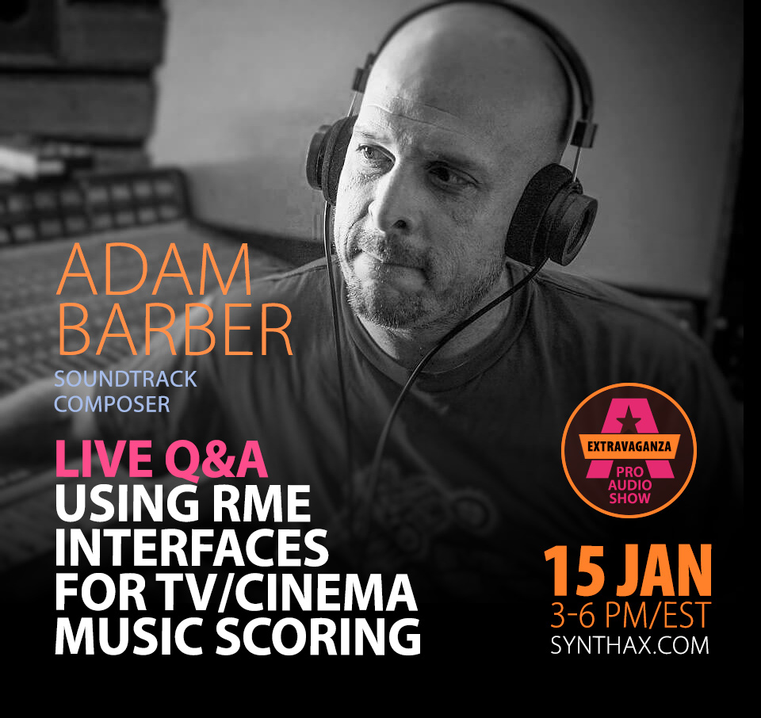
Fort Lauderdale, Florida, January 13, 2021 — Synthax — distributor of RME audio solutions, Ferrofish audio converters, Digigram broadcast and streaming solutions, Appsys digital audio tools, and myMix personal monitor and mixer — has announced its second installment of Extravaganza Pro Audio Show, a free, online event to be livestreamed Friday, January 15 from 3-6pm EST on the official RME Audio YouTube page.
The event will feature product demonstrations, educational webinars, artist performances and a live Q&A with Hollywood composer Adam Barber.
“After the success of our first Extravaganza event in September 2020, we knew we wanted to unite the pro-audio community once again and share best practice tips to help them get the most out of their audio workflow,” said Mathias von Heydekampf, director of Synthax US. “We are excited to announce that this second installment of Extravaganza will be broadcast simultaneously on the official RME Audio YouTube page as well as all Synthax social media accounts so those interested can easily access the stream which will include brand new live performances and valuable how-to sessions.”
Though virtual, event attendees will receive a pristine listening experience for both product demos as well as artist performances thanks to Digigram’s IQOYA Guest which will supply the audio feed for the entire event. IQOYA Guest offers uninterrupted, distortion-free audio connections, delivering a 20Hz to 20,000Hz frequency range, therefore allowing attendees to hear every detail of each product demonstration and artist performance.
Knowledge-Packed Virtual Event
In addition to live performances from guitarist Lari Basillio and Tower of Power’s Roger Smith, the Extravaganza event will feature a live Q&A with Hollywood composer Adam Barber who will break down his audio workflow and how he employs his RME gear to get the most out of his audio setup.
Five-minute transitional how-to videos hosted by Synthax’s Jeff Petersen will walk listeners through various tech support fixes, such as how to fix driver downloading issues, and more.
Additional sessions include how to expand your audio capabilities with MADI, essentials for working with RME’s TotalMix FX routing and mixing software, and composing audio for video games with sound designer Frank Klepacki.
Those interested in attending the free event can log onto the official RME Audio YouTube page at 3pm EST on Friday, Jan. 15th via the following link: https://www.youtube.com/channel/UCLTihxTIiANMhvpCB91h-AA
For more information on Synthax, visit: https://www.synthax.com/
About Synthax, Incorporated
Synthax Inc. is the exclusive USA distributor for RME digital audio solutions, Digigram broadcast audio systems, Appsys digital audio tools, Ferrofish advanced audio applications, myMix personal monitoring systems and ALVA cableware. We supply a nationwide network of dealers with these products for professional audio, broadcast, music industry, commercial audio, theater, military and government applications. For additional information, visit the company online at http://www.synthax.com.

Media Contacts:
Katie Kailus
Public Relations
Hummingbird Media
+1 (630) 319-5226
katie@hummingbirdmedia.com

Jeff Touzeau
Public Relations
Hummingbird Media
+1 (914) 602 2913
jeff@hummingbirdmedia.com

