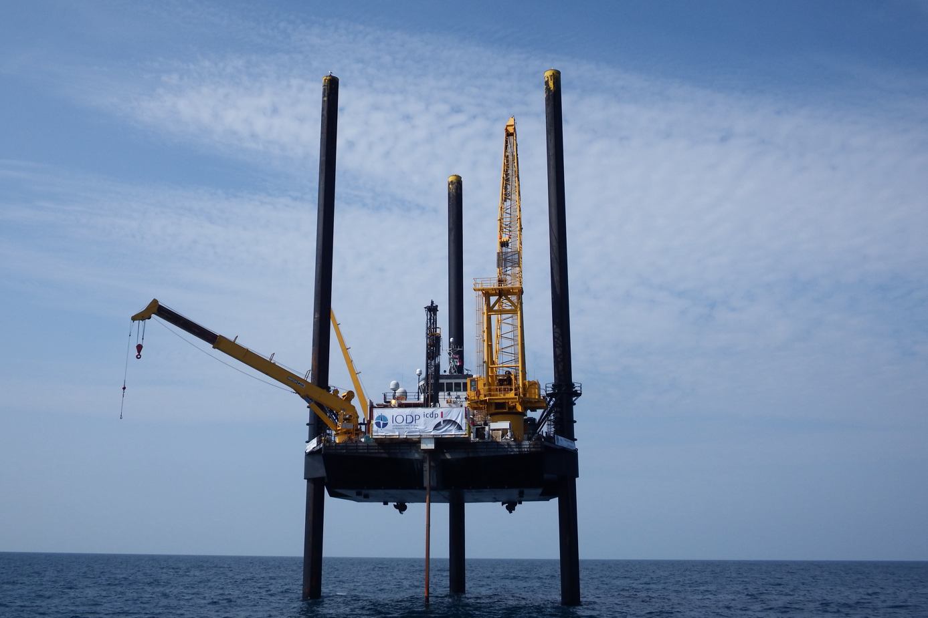
Lift boat L/B Myrtle used to drill the core.

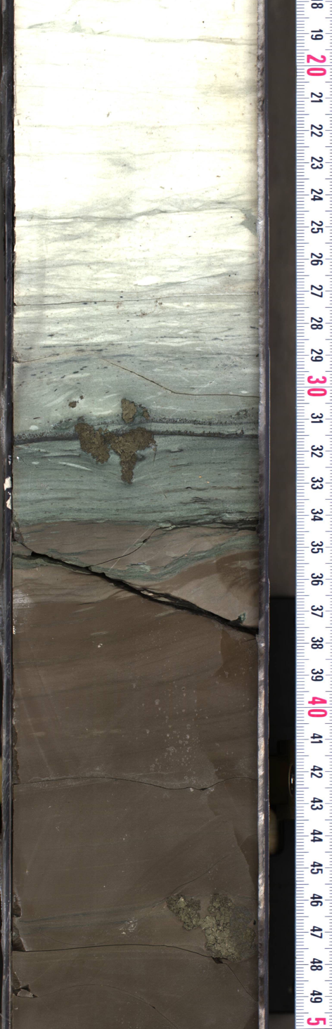
High-resolution line scan photo of Core 40R-1 made by the onshore science party. The interval with the highest iridium concentrations occurs at the contact between the dark brown silty claystone and the grey-green marlstone.

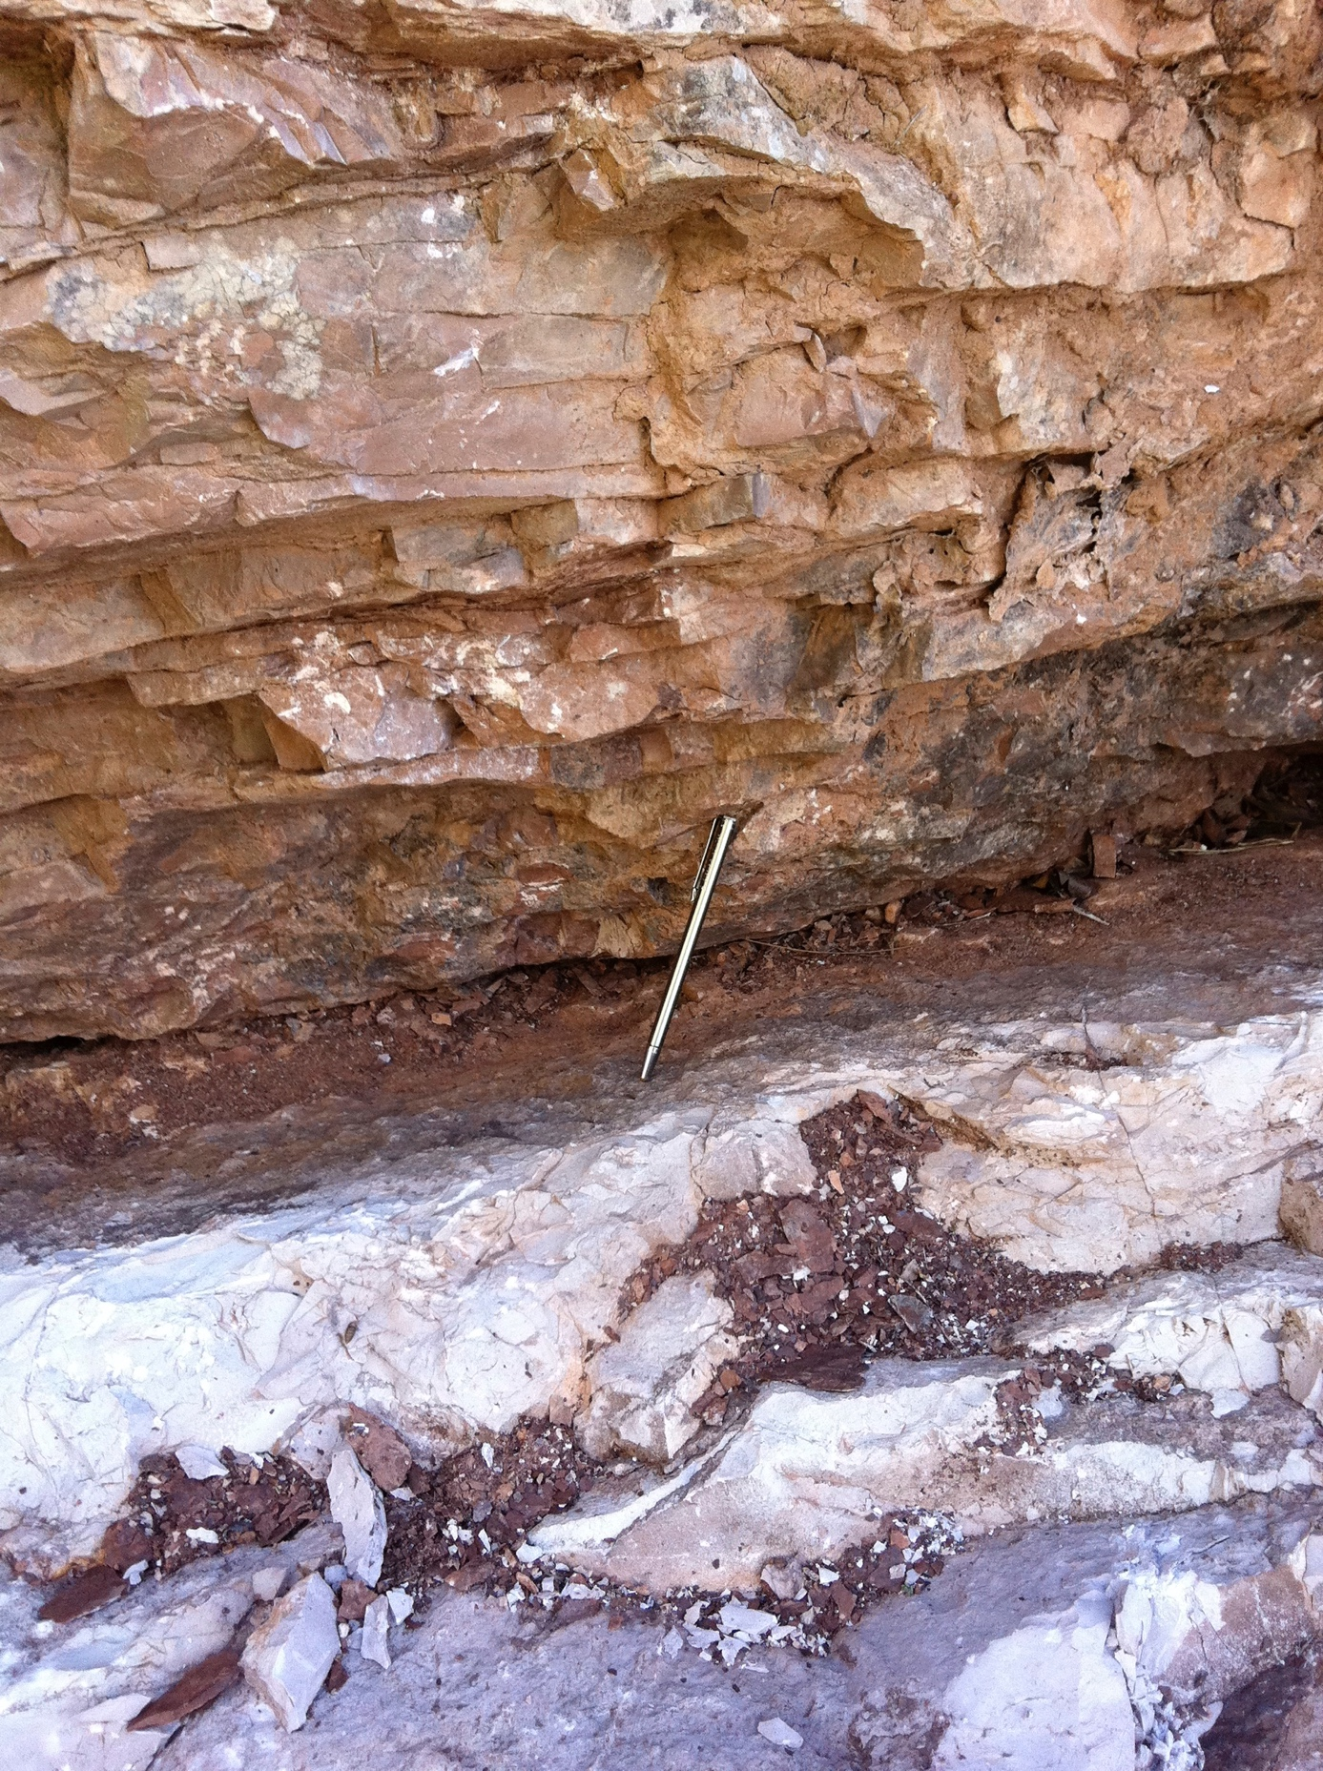
The Cretaceous-Paleogene boundary layer as found in Gubbio, Italy.

