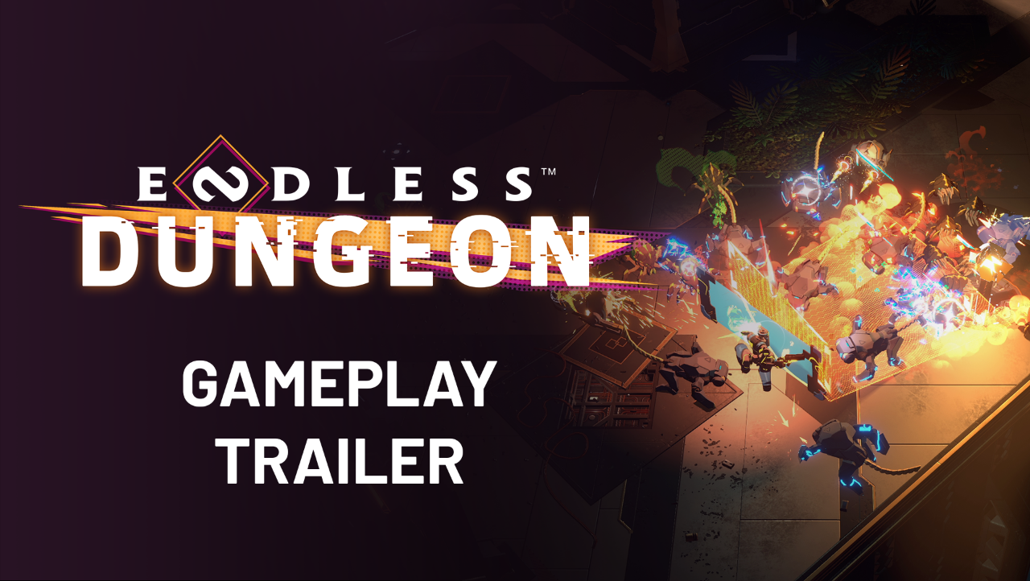

ENDLESS™ DUNGEON DROPS FIRST GAMEPLAY TRAILER

  - Them’s the rules – watch the first ENDLESS™ Dungeon Gameplay trailer and learn the basics. You’re going to need all the help you can get to get off this godforsaken space station!
Paris, June 10th – Today at the Summer Game Fest live kick-off, we were more than excited to drop the first enticing minute of gameplay for our upcoming rogue-lite die-and-retry bonanza, Endless™ Dungeon. The Endless™ Universe is back in action baby, and things are about to get wild!
What’s the deal? Well, you’re shipwrecked on a mysterious space station. You’ll need to recruit a team of heroes and protect your crystal against never-ending waves of monsters. Or die trying, get reloaded, and try again!
WATCH THE TRAILER

For those of you who prefer things in writing, here are the ground rules we’ve covered so far:
- Rule #1 – Certain weapons work best against certain monsters. Learn them for a leg up in the twin-stick action!
- Rule #2 – Protect your crystal by placing turrets, because if it dies, you die.
- Rule #3 – Teamwork makes the dream work. You can either control a whole squad by your lonesome or test your skills with friends in multiplayer.
- Rule #4 – Adapt your squad by unlocking new heroes and changing them out as you please!

Finally, we’d like to let everyone know that they can sign-up the Endless™ Dungeon mailing list here and get a free skin at release on the platform of their choice.
That’s it for now! Endless™ Dungeon will be released on PC and Consoles in 2022.
Hope you enjoy,

- The Ampliteam

