Mayday kicks off 2021 with a series of live concerts in Taiwan
New Sennheiser MM 435 and MM 445 capsules make their stage debut in the region

Wedemark, March 3, 2021 – When rock and pop super-band Mayday announced their “Mayday Fly to 2021” concerts, tickets to the six live shows sold out virtually immediately. Thanks to Taiwan’s low Covid-19 infection rate, Mayday’s concerts, held at Taoyuan International Baseball Stadium on December 31 and January 1, 2, 8, 9 and 10, were among the first large-scale events to happen in Asia, and perhaps even worldwide. Even more thrilling to the band’s huge and passionate fanbase, the spectacular shows were Mayday’s first tour in the country since 1999, even though the band had been touring worldwide before. The band’s performances, which more than lived up to the sky-high expectations, were captured by wireless and wired microphones from Sennheiser.

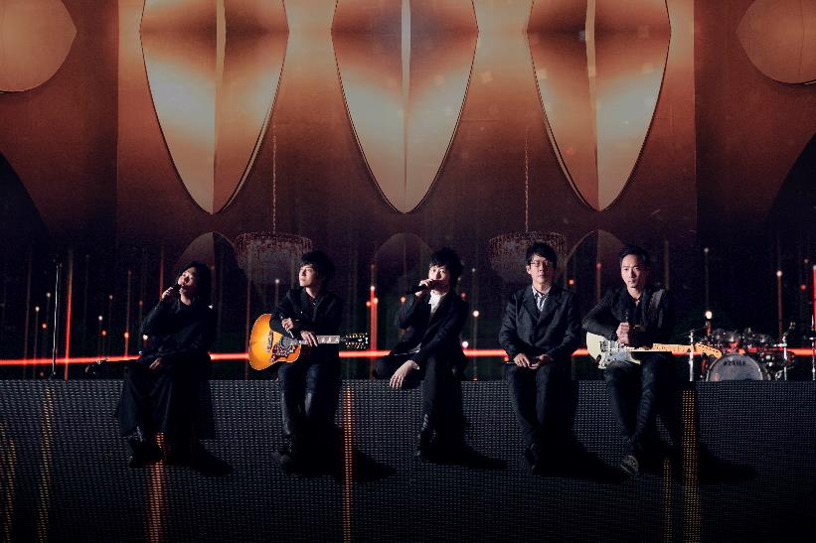

Dubbed the Asian Beatles by The Washington Post, band members Monster, Ashin, Stone, Masa and Kuan-you have had an exceptional career spanning more than two decades. They have sold more than 1000 million records and have held well over 1,000 live concerts across Asia Pacific, America and Europe.

This past year, even megastars had to adapt: The Mandarin-language rock and pop band had initially planned to kick off the concerts on Christmas Day but had to push back the dates by a week at short notice due to concerns related to the pandemic. Not wanting to disappoint fans excited by the Christmas Day concert, the band quickly decided to host a free online concert in the huge, spectacularly lit arena that would have otherwise been filled with fans. Only their second ever online concert, the virtual event was a global success, with more than 29 million fans watching the livestream, and the subsequent video garnering almost six million views.

Luckily, the live music was only on pause, and six live concerts would soon follow. As a gesture of gratitude and appreciation to medical workers during the pandemic, Mayday and their record company B’in Music gave out 6,000 free tickets to medical staff in Taoyuan, Taichung and Tainan for “Mayday Fly to 2021”.

Kicking off a new year with new mic heads from Sennheiser
For the six live concerts in Taoyuan, Chuang, Mayday’s Chief/Monitor Engineer, was also quickly adapting to change by introducing the brand-new Sennheiser MM 435 and MM 445 microphone heads launched just a few weeks earlier. He commented: “The 435/445 capsules have more presence at the sensitive 5kHz frequency, and the 445 has great ambient noise rejection, especially when used on catwalks. The new capsules are an improvement over their sister models and we look forward to using them at our upcoming concert tours.” After having employed the wireless capsules, Chuang is also keen to find opportunities to try out the wired versions - MD 435 and MD 445 – during the band’s next concerts.

Tyler Tan, relationship manager with Sennheiser: “We were blown away with the intensity of the virtual concert, and you can probably imagine how exhilarated and happy fans at the real-life concerts were! People around the globe are longing so much for live music to happen again! We are honored by Mayday using our flagship Digital 9000 wireless microphone system and trying out our new top-of-the-range dynamic capsules, and we are very much looking forward to be working with Chuang and the band for their next concerts.”

Sennheiser equipment used by Mayday
2 x EM 9046 digital receivers
6 x SKM 9000 handhelds with MM 435 and MM 445 microphone heads
10 x SK 9000 bodypack and instrument transmitters
5 x SR 2050 IEM two-channel wireless monitoring transmitters
15 x EK 2000 IEM bodypacks for artists and crew
Backline:
1 x e 901 boundary mic for the kick-drum
1 x e 902 bass instrument mic for the kick drum
3 x e 904 drum mics
4 x e 935 vocal mics
1 x e 945 vocal mic
8 x MKH 416 shotgun mics as audience mics

Useful links
For detailed product information, simply click the links in the above equipment list.
More information about Mayday
Official Facebook
Image link

About Sennheiser
Shaping the future of audio and creating unique sound experiences for customers – this aim unites Sennheiser employees and partners worldwide. Founded in 1945, Sennheiser is one of the world’s leading manufacturers of headphones, loudspeakers, microphones and wireless transmission systems. Since 2013, Sennheiser has been managed by Daniel Sennheiser and Dr. Andreas Sennheiser, the third generation of the family to run the company. In 2019, the Sennheiser Group generated turnover totaling €756.7 million. www.sennheiser.com

Global Press Contact

Stephanie Schmidt
stephanie.schmidt@sennheiser.com
+49 (5130) 600 – 1275

