

Biuro prasowe better. gaming agency
bettergamingagency.prowly.com

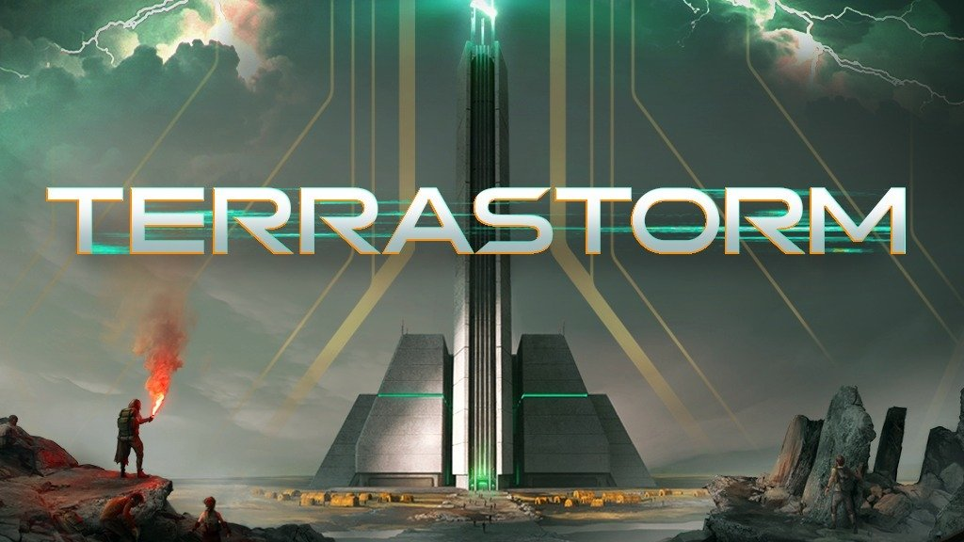

TerraStorm, a city-builder with an alternate World War II ending, in the first trailer

TerraStorm will take players to a universe where World War II ended in a completely different way. The world has been almost entirely destroyed, leaving humanity on the brink of extinction. All this has been caused by Viribus – a mysterious and powerful resource used by the Nazis as a weapon. Today, the developers from GameLoad released the first trailer for their game alongside the launch of their Kickstarter campaign. The game is coming to PC, and backers will receive early access to a special demo, which will be available on Steam later this year.

TerraStorm is a city-builder with survival mechanics, set in a post-apocalyptic world 70 years after the end of World War II. The conflict ended in a completely different way from what we know from history books. On this devastated planet, survivors fight for their existence, pinning their hopes on the Architects – roles that players will take on.

TerraStorm – announcement trailer

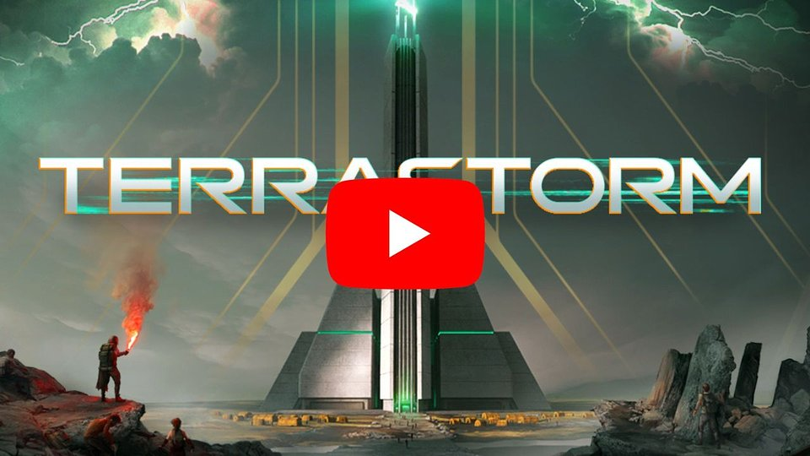
https://www.youtube.com/watch?v=0_UkjlMhhP0

Viribus – a resource that has become the planet's curse – after years has found a new, positive use. It is now a powerful source of energy that can be utilized to power self-sustaining towers. In TerraStorm, players will take on the role of leaders responsible for building and managing these structures, which become the last bastions of humanity. Refugees fighting for survival will come from all directions, and it is the Architects' task to provide them shelter. However, players must be prepared that not all lives can be saved, and the decisions made during gameplay will have consequences.

Players will manage massive towers where all life takes place. Each floor offers different features and capabilities, and can have specializations assigned to them. The possibilities are vast—ranging from energy-producing buildings to factories, water pumps, and research centers. However, the needs of the community will continually grow, so players cannot rest on their laurels for too long. Over time, not only will the number of residents increase, but also the number of towers to manage, giving the opportunity to build trade routes between them. All of this to give humanity another chance.

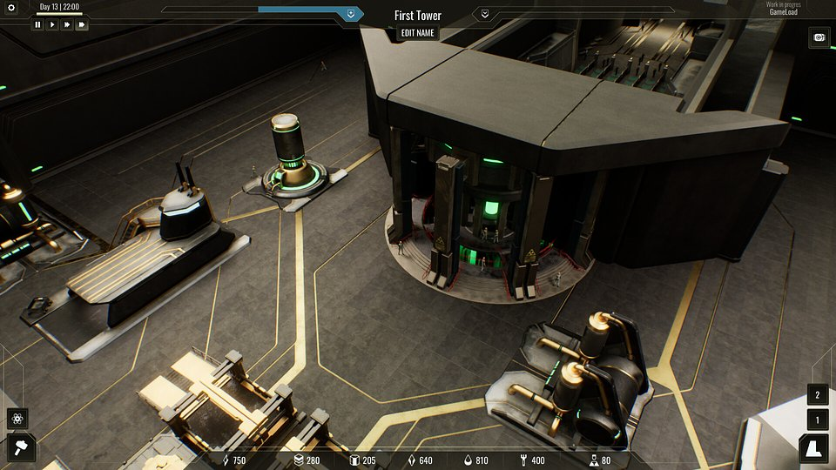

The dangers waiting for the Architects come not only from challenges related to skillful management of people and resources, but also from environmental anomalies that can disrupt even the best plans. It’s worth noting that the player is not the only Architect selected by ROSE Corp for the Project Towers program, and collaborating with other chosen ones can also prove to be a challenge.

TerraStorm – key features:

● The tower of wonders– lead a community of refugees fighting for survival within a self-sustaining tower. Plan, build, and manage to ensure that as many people as possible can find shelter under your care.
● The planet is still alive – with your help, humanity still has a chance to survive. Build mines, power plants, and various centers to support the development of the Project Towers. At the start of Early Access, the game will feature 40 unique buildings.
● Sometimes you have to say no – your main task is to help the survivors. However, this won't always be possible, and the line between being responsible and taking risks for the greater good is very thin. Be prepared that not all of your decisions will be met with applause.
● Brave expeditions – as an Architect, you'll have the opportunity to build additional towers and create connections between them. This will be possible through expeditions that can travel across various regions of the divided world map. Learn to manage your internal economy to ensure a steady supply of essential resources.
● Technological hope – as you progress in the game, you'll gain the ability to develop innovations that will lay the groundwork for your tower's advancement. Even in the early version, players will have access to 30 different technologies to discover.
● Architects of the new Earth – choose the character you will embody based on their unique strengths. Each available Architect has distinct passive bonuses that make them special.

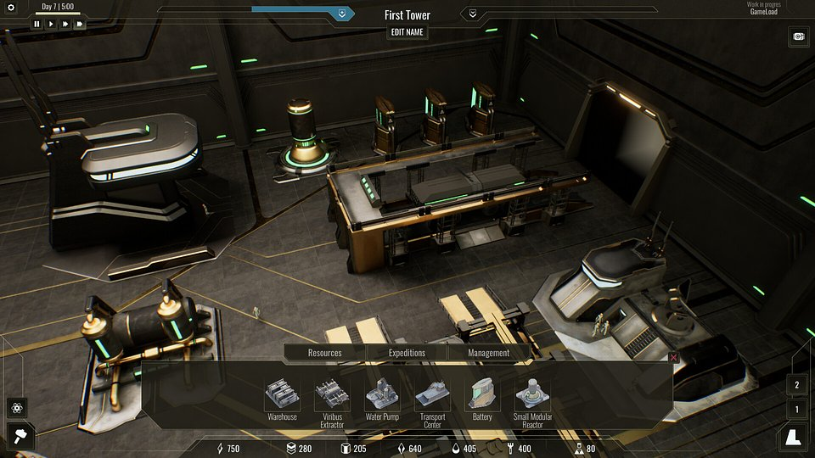

As announced by the developers at GameLoad, TerraStorm is being created for PC and is set to launch in Early Access next year. Today, a Kickstarter campaign has launched to support the project's ongoing development. A demo of TerraStorm will be available on Steam later this year, and backers will have the chance to access a special pre-release version.

It's worth noting that the game will be showcased at Gamescom (Indie Games Polska zone) and PAX West (Games from Poland, booth 1125). Anyone interested in TerraStorm can add it to their wishlist now.

The press kit is available here.

About GameLoad:
GameLoad is an independent team of enthusiasts from Poland known for creating and publishing games. The creators aim high, striving to produce high-quality titles for audiences around the world. Their projects are renowned for their creativity, engaging narratives, and diverse range of styles. In 2023, GameLoad released Your Story, and the team is currently focusing on TerraStorm—a city-builder with survival features—as well as an unannounced project.

